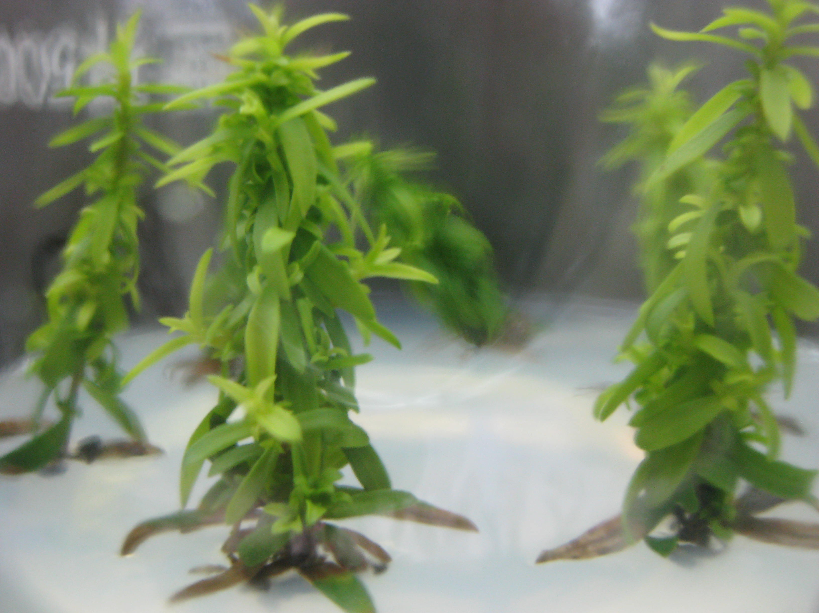
Regeneration of shoots on MS + BA (0.8 mg l⁻¹) + NAA (0.2 mg l⁻¹) + GA₃ (0.1 mg l⁻¹).

