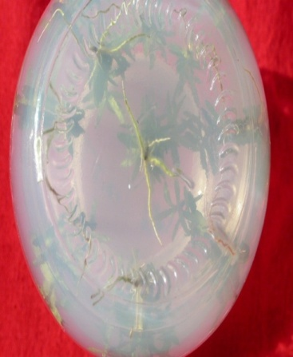
Rooted plantlet on 1/2 MS + NAA (0.5 mg l⁻¹).

