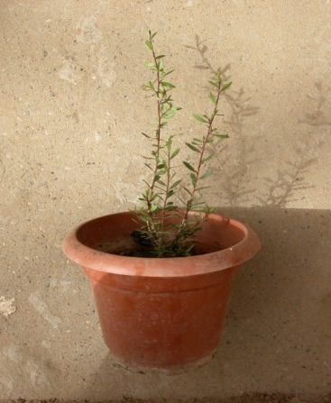
35 cm high plant after a 5-month in the outdoors.

