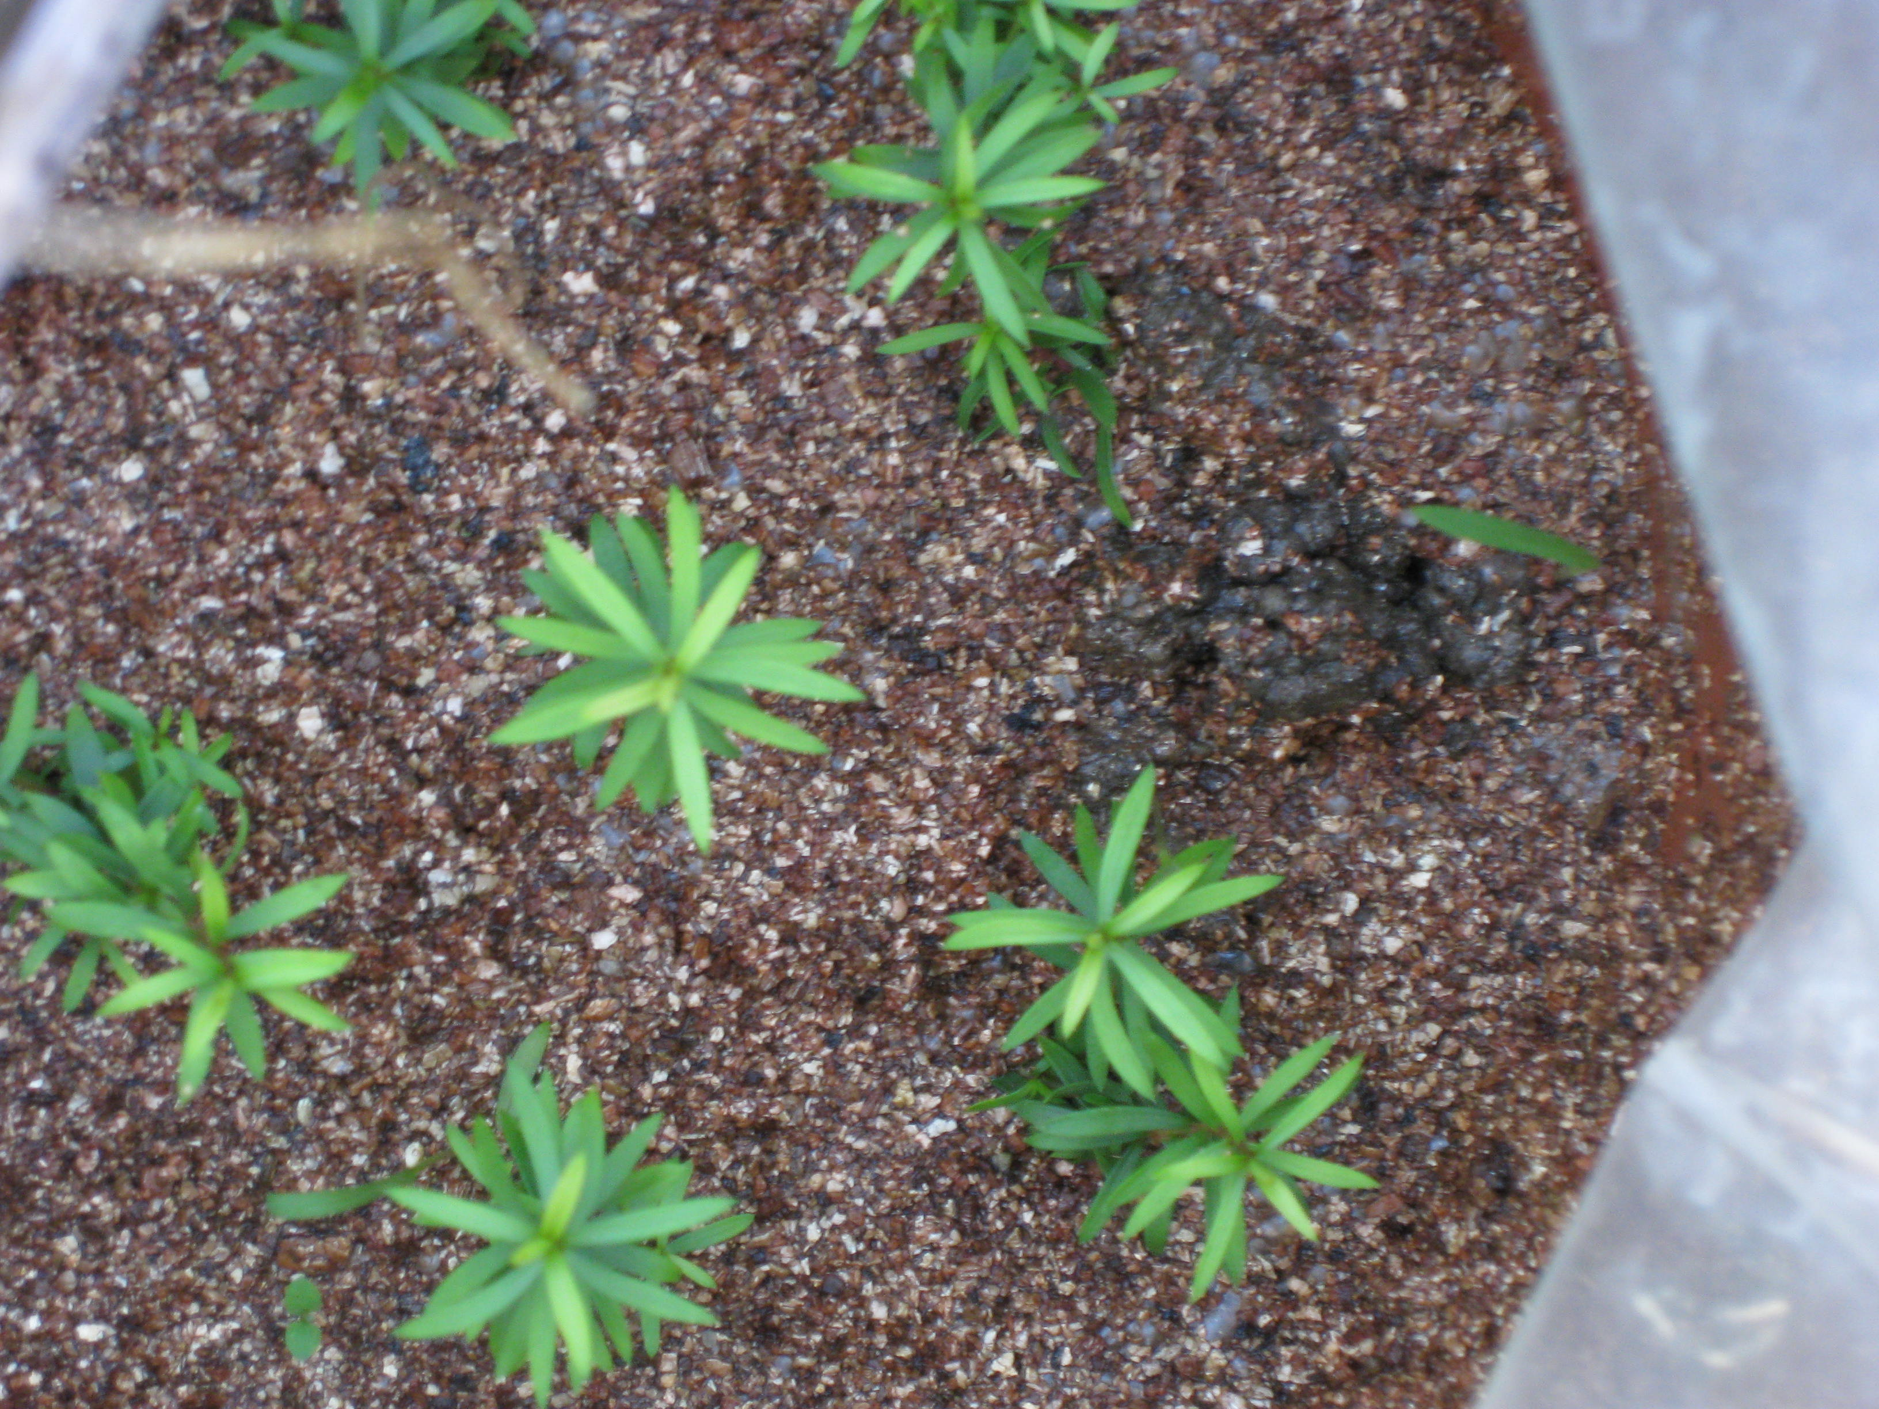

Plantlets with roots induced by NAA after 18 days

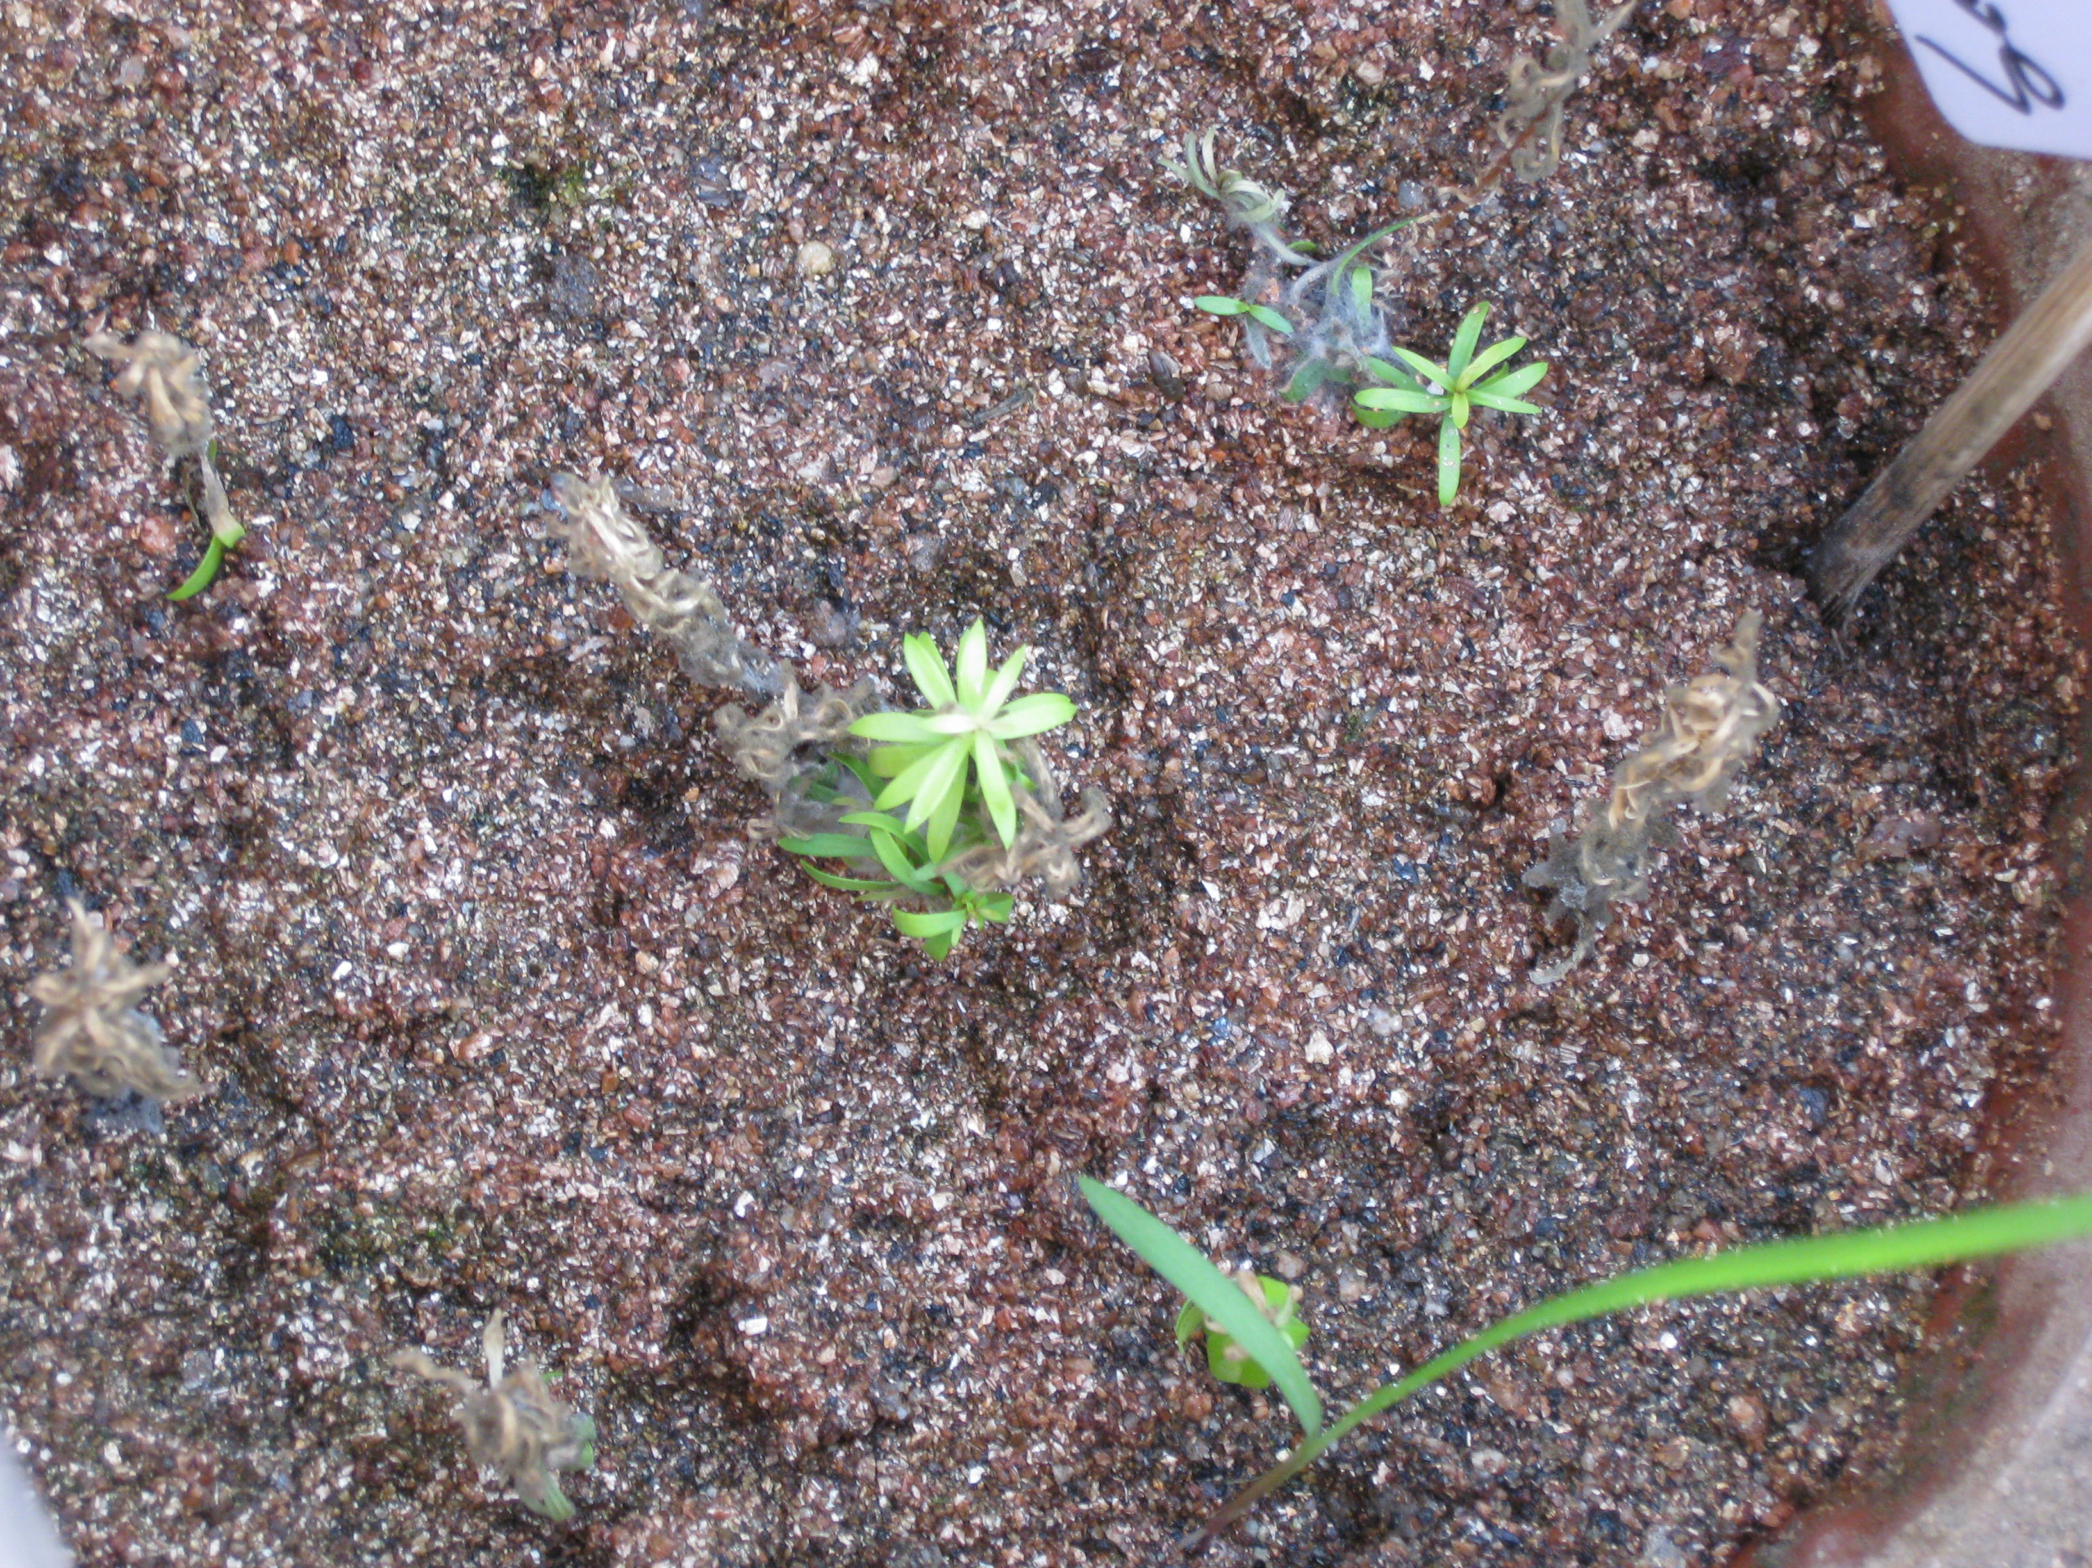

Plantlets with roots induced by IAA after 18 days

