Figures JPOP579 - Hebe

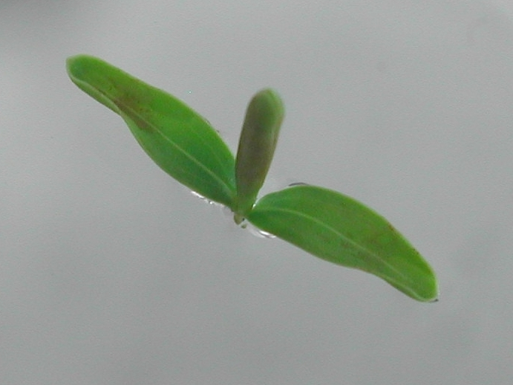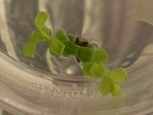
1 cm 1 cm

Figure 1 – Shoot tip of ‘Wiri Mist’ (left) and nodal explant of ‘Cobb’ (right) producing new shoots.

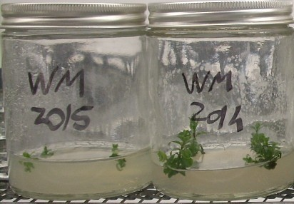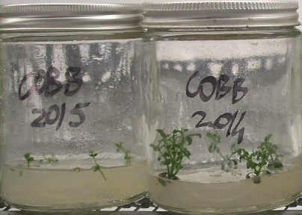
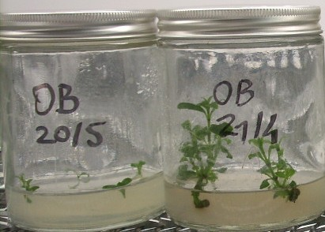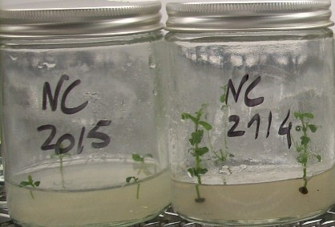
2 cm

Figure 2 - ‘Wiri Mist’ (top left), ‘Cobb’ (top right), ‘Oratia Beauty’ (bottom left) and ‘Nicola’s Blush’ (bottom right). Differences between the beginning and the end of a four week culture cycle (left and right respectively).

