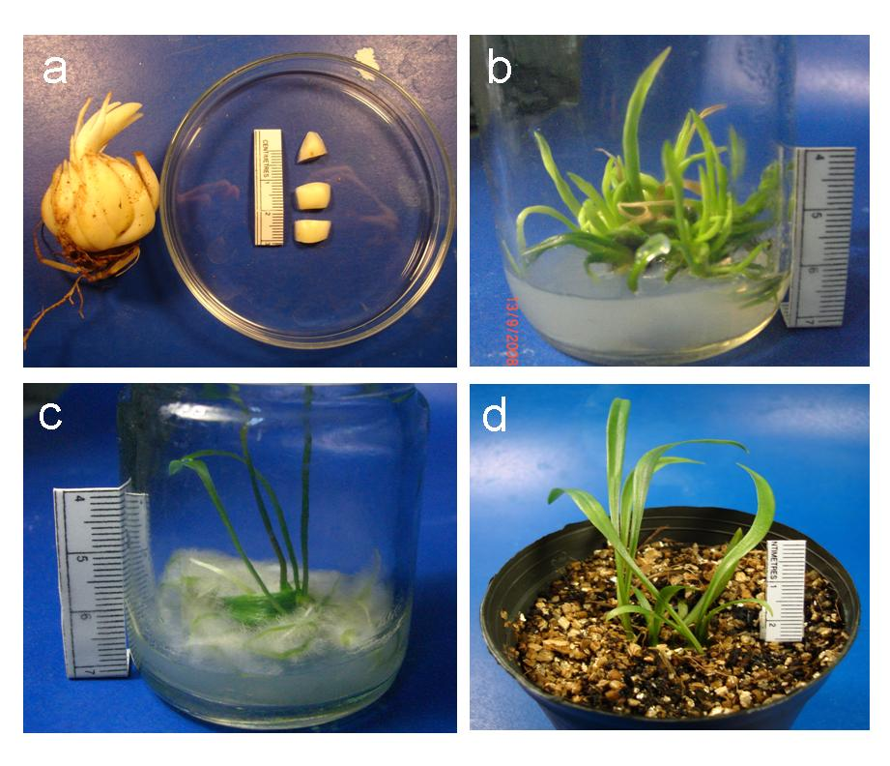
Fig. 1 Micropropagation of Lilium longiflorum ‘Ester lily’. (a) Bulb
and transverse sections of bulb scales. (b) Clumps of adventitious
shoots developed on MS medium containing 25 mg l⁻¹ chitosan.
(c) Root induction on MS medium supplemented with 1 mg l⁻¹ IBA.
(d) Complete plantlets in soil.

