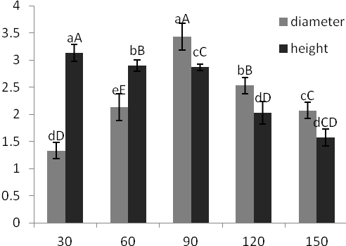
Fig 1 Effects of different concentrations of the sugars on growth state of the bulblets. Vertical bars represent mean values of three replications ± SD.

