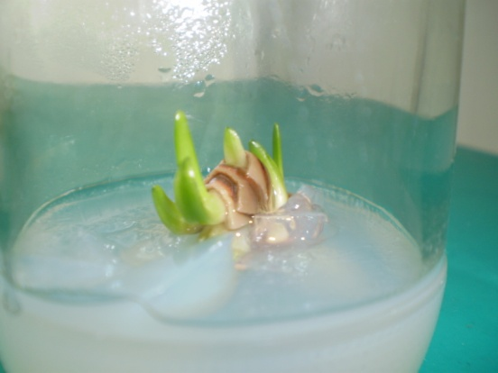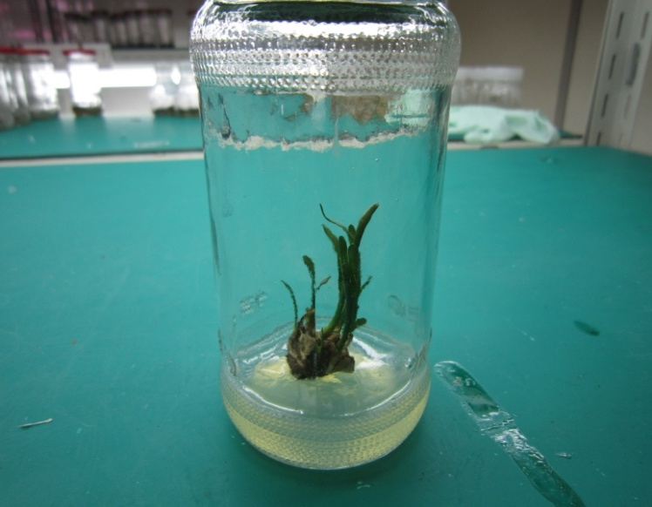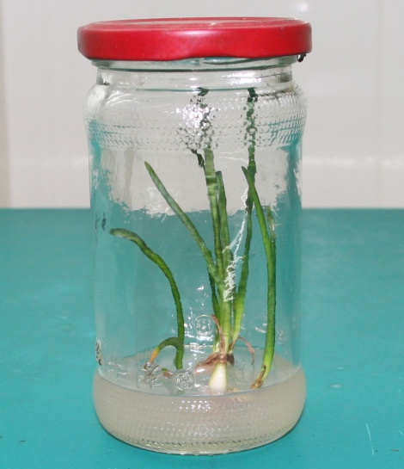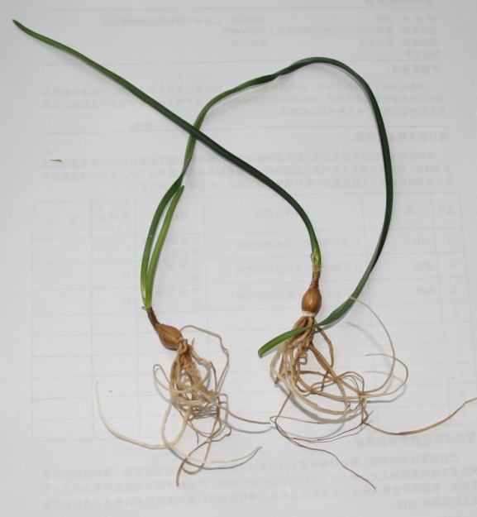
A
B
C
D

Fig.2 A) The axillary bud inducing formed on MS medium supplemented with 3.0mg/l6-benzyladenine (BA) in combination with α-naphthaleneacetic acid (NAA) 0.2 mg/l after 2-4 weeks. B) The elongated and shoots proliferated on medium supplement with BA 5.0 mg/l in combination with α-naphthaleneacetic acid (NAA) 0.5 mg/l. C) The roots inducted on MS medium supplement with IBA 1.0 mg/l and sucrose 90 mg/l. D) The roots and bulbs before being transferred to field conditions.

