Figures and table JPOP579 - MICROPROPAGATION RATES IN LONG TERM CULTURES OF FOUR CULTIVARS OF HEBE

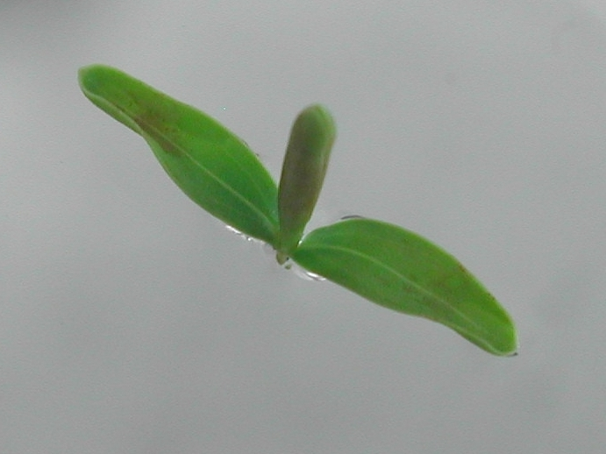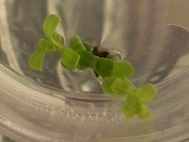
1 cm 1 cm

Figure 1 – Shoot tip of ‘Wiri Mist’ (left) and nodal explant of ‘Cobb’ (right) producing new shoots.

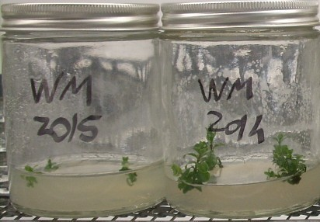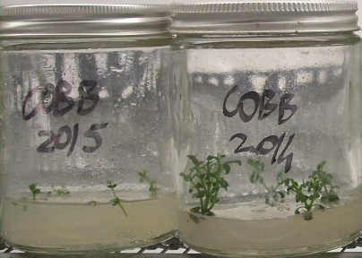
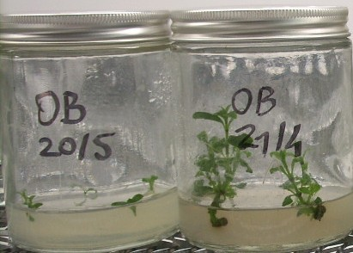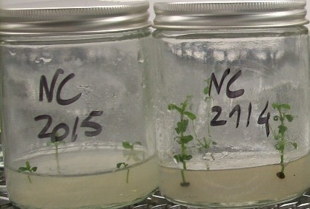
2 cm

Figure 2 - Differences between the beginning and the end of a typical four week culture cycle (left and right respectively). ‘Wiri Mist’ (top left), ‘Cobb’ (top right), ‘Oratia Beauty’ (bottom left) and ‘Nicola’s Blush’ (bottom right).
Table 3 – The mean micropropagation rates obtained over three culture periods in phase I and in the final three periods in phase II for cultivars: WM='Wiri Mist', Cobb='Cobb', OB='Oratia Beauty' and NB='Nicola's Blush'.

 | Phase I |  |  | Phase II
 | Months | Micropropagation | SE | Months | Micropropagation | SE | t- test
Cultivar | recorded | rate (mean) |  | recorded | rate (mean) |  | p values
WM | 10 to 12 | 3.17 | 0.49 | 24 to 26 | 3.91 | 0.37 | 0.2961
Cobb | 9 to 11 | 2.67 | 0.26 | 23 to 25 | 3.91 | 0.45 | 0.0762
OB | 2 to 4 | 7.90 | 2.08 | 13 to 15 | 7.92 | 1.40 | 0.9942
NB | 2 to 4 | 6.52 | 1.82 | 13 to 15 | 6.01 | 0.78 | 0.8089

