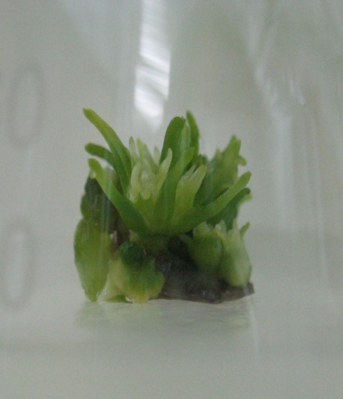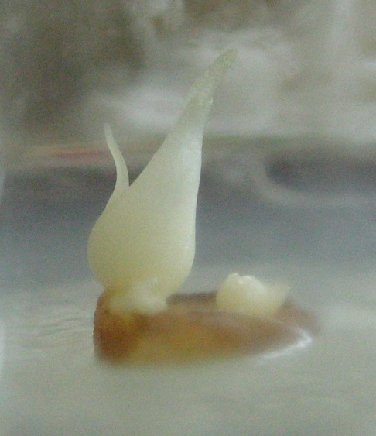
a
b
Fig. 1 Induction of bulb scales under different light conditions
(a): bulb scale cultured under 16h photoperiod; (b): bulb scale cultured under continuous darkness

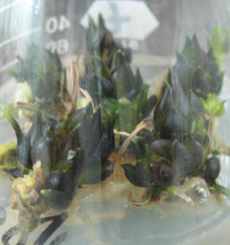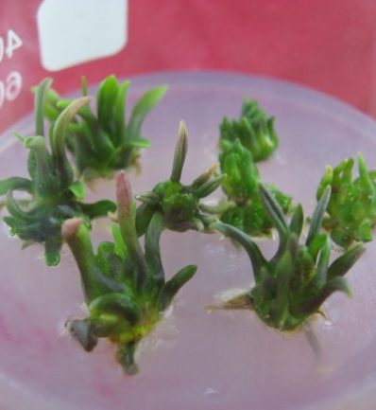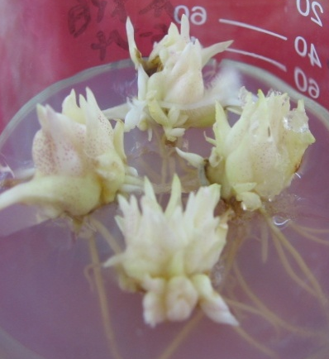
b
c
a
Fig.2 Bulblets swelling under different light condition
(a): Continuous light; (b): Differentiation under darkness and swelling under light; (c): Continuous light darkness

