Figures:
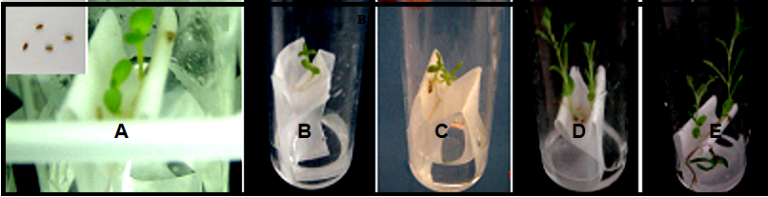
Figure 1. Seedlings of Artemisia herba-alba germinated on paper bridge with half MS liquid and Gibberellic Acid (GA₃ ) medium . (A-E): Seedlings after 1-5 weeks; respectively..

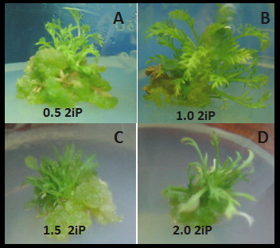
Figure 2. Effect of 2iP at different concentrations (A: 0.5, B: 1.0, C: 1.5 and D: 2.0 mg/l) on microshoot proliferation of Artemisia herba-alba.

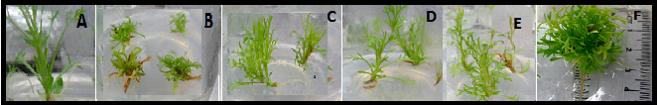
Figure 3. Effect of different GA₃ concentrations on in vitro Artemisia herba-alba grown on MS media (A): MS free medium, (B): 0.5 mg/l GA_{3,} (C): 1.0 mg l⁻¹ GA₃, (D): 1.5 mg l⁻¹ GA_{3,} (E): 2..0 mg l⁻¹ GA_{3,} (F): 3.0 mg l⁻¹ GA_{3.}

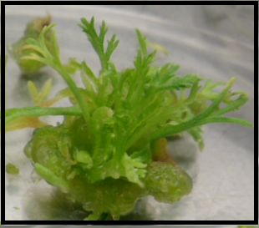
Figure 4. Effect of 1.5 mg l⁻¹ GA₃ with 1.0 mg l⁻¹ 2iP on in vitro grown Artemisia herba-alba.

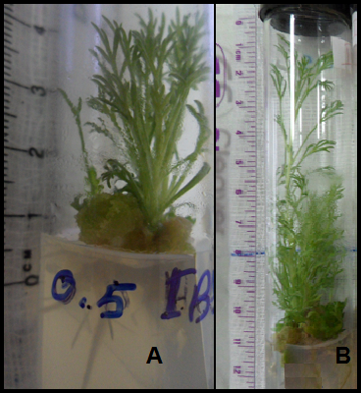
Figure 5. Effect of IBA at 0.5 mg l⁻¹ on in vitro rooting of Artemisia herba-alba after (A:4 weeks) and (B: 6 weeks).

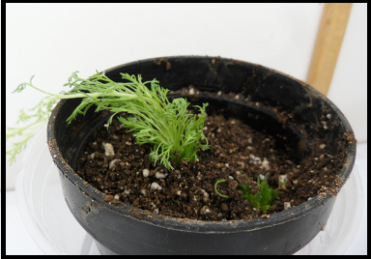
Figure 6. Acclimatization of Artemisia herba-alba.

