Figures and Legends

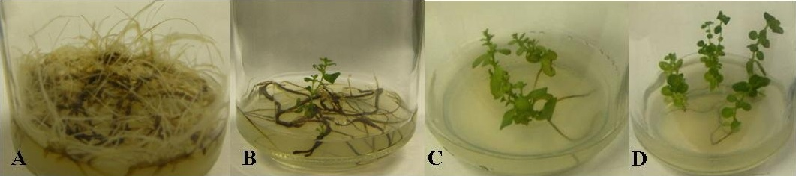

Figure 1. A. H. perforatum hairy root cultures developed from root explants co-cultivated with A. rhizogenes A4, after one month of culture on solid hormone-free MS/B₅ medium. B. Adventitious shoots spontaneously developed from hairy roots on hormone-free medium under a 16/8-h photoperiod. C. Hairy root regenerated plants showed dwarfism and shorter internodes. D. Transgenic plants with normal morphology.

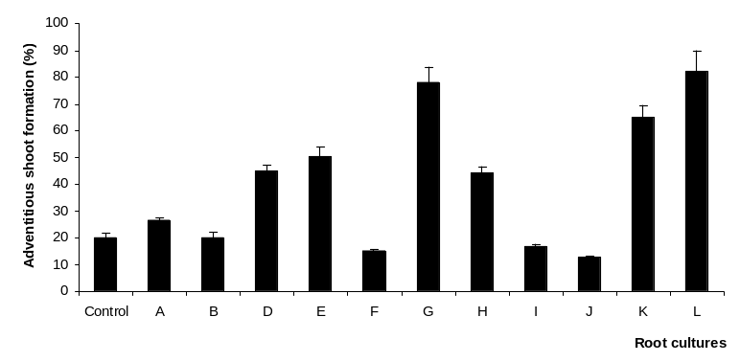

Figure 2. The frequency of adventitious shoot formation of H. perforatum hairy root lines on hormone-free medium. Eleven out of fifteen hairy root lines (A, B, D, E, F, G, H, I, J, K, L) were evaluated. Four hairy root lines (C, M, N, O) did not exhibit a potential for spontaneous shoot regeneration.

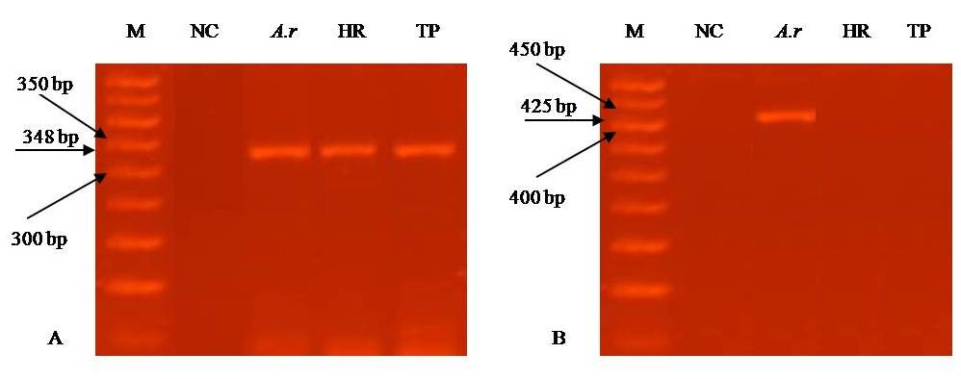

Figure 3. Gel electrophoresis of PCR products amplified from H. perforatum genomic DNA. A. PCR performed with rolB primers; the black arrow indicates the 348 bp amplification product. B. PCR performed with virC1 primers; the black arrow indicates the 421 bp amplification product. A.r: positive control (pRi A4); HR: hairy roots; M: molecular weight marker; NC: negative control; TP: transgenic plantlets.

