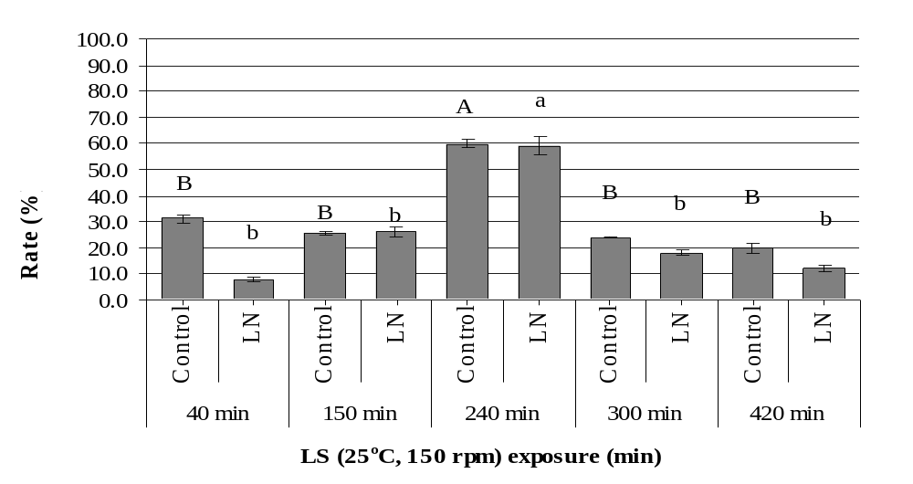
Figure 3. Effects of treatment time with LS (25°C, 150 rpm) on the regrowth rate(%) of C. speciosa without (Control) and with cryopreseration (LN). On the column top, the same letter in capital (for control) or small letter (for cryopreserved buds) mean not significantly different according to Duncan’s test after arcsin transformation (P < 0.05).

