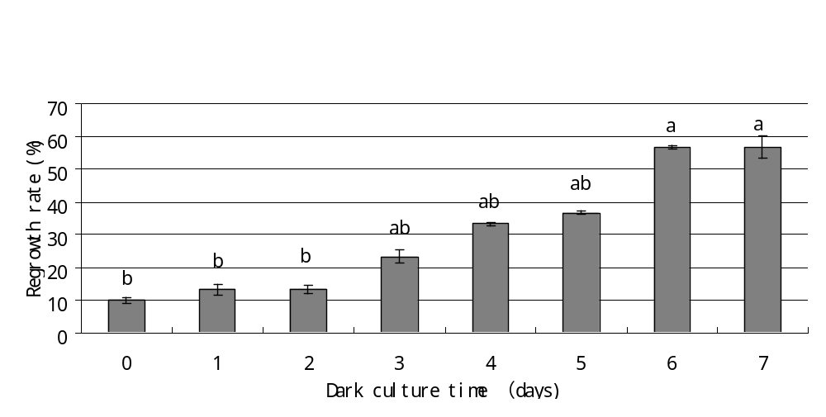
Figure 4 Effect of dark period (days) on post-thaw regrowth of C. speciosa. Recovery was performed on MS containing 2 µM BA. Error bars represent the standard error of regenerable regrowth. Means of regenerable regrowth marked with the same letter are not significantly different according to Duncan’s test after arcsin transformation (P < 0.05). Values are the average of 3 independent cryopreservation experiments and each experiments was performed with 10 frozen and 5 control explants (n = 45).

0.5

