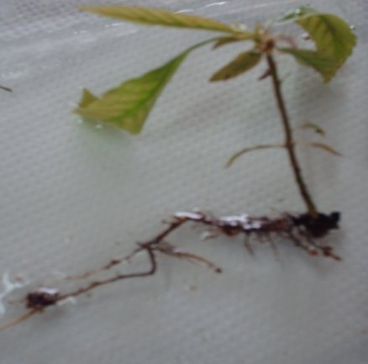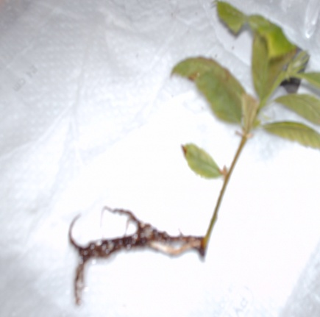

(a) (b)

Fig. 8. Rooted shoots of Castanea sativa mature plus-tree genotypes by using a concentration of 0.50 mg l⁻¹ NAA (a) and 1 mg l⁻¹ NAA (b).

