The effect of chitosan on regeneration of lily (Lilium longiflorum ‘Ester lily’) from bulb scale explants cultured in vitro

Kantamaht Kanchanapoom^{1*}, Pattaraporn Pimolthai¹, Kamnoon Kanchanapoom²

¹Center for Genomics and Bioinformatics Research, ² Department of Biology, Faculty of Science, Prince of Songkla University, Hat Yai, Songkhla, 90112, Thailand;

*Corresponding author e-mail: kamnoon.k@psu.ac.th

Abstract
Bulb scales of Lilium longiflorum ‘Ester lily’ were cultured in vitro on Murashige and Skoog (MS) medium containing several concentrations of chitosan or BA. High frequency regeneration of shoots was obtained on MS medium supplemented with 25 mg/L chitosan or 5 mg/L BA with 5 shoots and 4.7 shoots, respectively. When isolated shoots were transferred to MS medium containing 1 mg/L IBA complete plantlets were obtained. Acclimatization and survival in field conditions of the regenerated plants was 100%.

Key words: Easter lily, micropropagation, multiple shoots, plant regeneration, shoot
organogenesis

Running title: Effect of chitosan on growth of lily.

INTRODUCTION
The genus Lilium, a monocot belonging to the family Liliaceae is one of the most important bulbous crops (van Aartrijk et al., 1990). Lilium longiflorum Thunb., commonly known as Easter Lily, has large and attractive flowers. Therefore it is used worldwide in the flower industry as a cut flower and as potted plant (Priyadarshi and Sen, 1992). Lilies are typically propagated from bulb scaling. However, this is an inefficient propagation method for commercial purposes since the planting material has a very low multiplication rate and thus restricts large-scale cultivation of this plant. Plant tissue culture technique is currently applied to many plant species as a tool to obtain a large number of elite plants. Therefore, in vitro micropropagation is essential for rapid propagation of lily plantlets. Plant regeneration has been achieved from a vast array of lily explants including bulb scales (Stimart and Ascher, 1978; Kumar et al., 2005), leaves (Niimi, 1995), pedicel (Liu, 1986), flower organs (Mitsugu et al., 2002), anthers (Han et al., 1997) and callus (Tribulato et al., 1997).
The success of plant tissue cultures depends mainly on suitable culture medium. In general, BA is the most effective cytokinin for in vitro shoot induction. In recent years chitosan has attracted notable interest due to its biological activities such as antimicrobial, antitumor and stimulant of plant growth. Chitosan is a natural carbohydrate polymer and the deacetylated form of chitin that is present in shells of crustaceans, in cuticles of insects and in the cell wall of fungi and some algae (Nge et al., 2006). Therefore this communication aims to find the effect of chitosan as a growth stimulator on the regeneration of L. longiflorum ‘Ester lily’ via organogenesis.

MATERIALS AND METHODS
Plant materials
L. longiflorum ‘Ester lily’ bulblets were collected from field-grown plants . The bulb scales were washed thoroughly by running tap water. The explants were surface sterilized with 70% ethanol for 1 min, followed by immersion for 20 min in a sterilization solution of 20% (v/v) Clorox™ (5.25% NaOCl) containing 1-2 drops of Tween-20 emulsifier per 100 ml solution followed by 10% (v/v) Clorox™ for 10 min. After the surface sterilization, these explants were rinsed three times with sterile distilled water. Following disinfection, the bulb scale explants were excised transversely into 1-cm-long segments (Fig. 1a) prior to transferring to MS (Murashige and Skoog, 1962) basal medium for further study.

Micropropagation
After 2 weeks of initial culture on MS basal medium, the bulb scales were transferred to MS medium with plant growth regulators for shoot proliferation. In the first experiment, chitosan at the concentrations of 0, 5, 10, 15, 20, or 25 mg/L and BA at the concentrations of 0, 1, 3, or 5 mg/L were used. In the second experiment, the effects of chitosan were examined at the concentrations of 0, 5, 10, 15, 20, or 25 mg/L in the presence of 5 mg/L BA. The explants were subcultured to fresh medium every 4 weeks. After this period excised single shoot from multiple shoots were transferred to a fresh medium for root induction.

In vitro culture conditions
All culture media consisted of MS salts and vitamins supplemented with 3% sucrose and 0.82 % Mermaid agar. The pH of media was adjusted to 5.8 with 1 N NaOH or 1 N HCl prior to autoclaving at 1.05 kg/cm², 121˚C for 20 min. Cultures were maintained at 25±1˚C air temperatures in a culture room with a 16-h light photoperiod under an illumination of 20 μmol m⁻² s⁻¹ photosynthetic photon flux intensity provided by cool white fluorescent lamps. Plant material was cultured in glass-capped culture jars (115 ml capacity) each containing 20 ml of the medium.

Root induction and plant acclimatization
Regenerated shoots were transferred to MS medium containing 1 mg/L IBA for rooting. Well rooted plantlets were transferred to plastic pots containing sterilized vermiculite for 1-2 weeks before being planted in a glasshouse.

Statistical analysis
One explant was implanted per culture jar with 20 replicates per treatment. Each experiment was performed twice. Data of the 2 experiments were pooled? The percentage of shoot regeneration was monitored. Number of shoot regeneration was examined by analysis of variance followed by Duncan’s multiple range test at P≤0.05 using SPSS for Window version 11.5

RESULTS
After initial culture on MS basal medium, each basal parts of bulb scales swelled and began to change from a yellowish to a green color and subsequent differentiated shoots (Fig. 1b). Table 1 shows the number of shoot formation from bulb scales in L. longiflorum ‘Ester lily’. Number of shoots was enhanced on the media supplemented with chitosan and BA in comparison with control. Shoots were formed at a frequency of 5 and 4.7 (P≤0.05) on MS medium containing 25 mg/L chitosan and 5 mg/L BA, respectively. However, there was no significant difference in shoot number hence an experiment was subsequently conducted to determine the optimal concentrations of chitosan (0, 5, 10, 15, 20, or 25 mg/L) with BA held constant at 5 mg/L. Results revealed that number of shoots decreased as concentrations of chitosan increased and the low level of chitosan (10 mg/L) yielded the highest number of 3.3 shoots (P≤0.05, Table 2). Combinations of chitosan and BA were less effective in shoot multiplication when compared to chitosan or BA alone. These multiple shoots with green leaves continued to proliferate after several subcultures with an average of 5 shoots per cycle. Clonal propagation of shoots was achieved by repeating subculture at 4-week-intervals. Each regenerated shoot provided 125 shoots in 12 weeks, for a total production of 500 plantlets in 12 months. At all concentrations of chitosan and BA tested, direct organogenesis (no callus stage) occurred.
The induction of roots is an important step to form the complete plantlets. To establish a rooting protocol, regenerated shoots were excised and transferred to rooting medium. Root formation occurred on MS medium supplemented with plant growth regulator-free MS medium or with 1 mg/L IBA after 3 weeks of culture. However, MS medium supplemented with IBA was more effective in terms of initiation of roots per shoot. With 1 mg/L IBA incorporated in the medium, thick, long and fibrous roots arising from the basal end of shoots was obtained (Fig.1c). In vitro-derived plants did not show any phenotypic variation during subsequent vegetative development when compared to the original plants (Fig.1d).

DISCUSSION
It has been demonstrated that bulb scales of lily have a high regeneration potential hence they are most commonly used as explants for vegetative propagation (Niimi, 1995). Chitosan is a natural carbohydrate polymer derived by deacetylation of chitin which consists of N-acetyl-D-glucosamine and D-glucosamine residues linked by β-1, 4 glycosidic bonds and it has been shown to affect plant growth (Chibu and Shibayama, 2001). To stimulate efficient micropropagation in plant tissue culture, chitosan has been added to the culture medium in a number of plant species such as Dendrobium phalaenopsis (Nge et al., 2006) and Elaeis guineensis (Kanchanapoom et al., 2010). In this study, a protocol for shoot regeneration from bulb scales in L. longiflorum ‘Ester lily’ has been developed. The shoots occurred directly via organogenesis and without forming callus on the MS medium containing chitosan and BA. Chitosan and BA showed both individual and synergistic effects and the results indicated that differences in regeneration response were found on organ formation. A conjunction of chitosan and BA did not evoke a better response in shoot multiplication than BA or chitosan when applied singly and this is probably due to the difference in endogenous levels of growth regulators in this plant or to a difference in sensitivity (Trewawas and Cleland, 1983). Some other research obtained different results for other Lilium species with the combination of BA and IAA (Han et al., 2004; Han et al., 2005), TDZ and NAA (Xu et al., 2009). Regenerated shoots have been rooted and successfully acclimatized to greenhouse conditions indicated that IBA has a powerful ability to stimulate root initiation.

CONCLUSIONS
This research has demonstrated the practical procedure by which multiple shoots were achieved through direct organogenesis from bulb scales of L. longiflorum ‘Ester lily’. The interesting property of chitosan suggests its potential as a growth regulator for the micropropagation of lily.

Acknowledgements

This research was financially supported by the Faculty of Science, Prince of Songkla University, Hat Yai Campus, Songkhla, 90112.

REFERENCES
van Aartrijk J, Blom-Barnhoorn GJ, van der Linde PCG (1990). Lilies, pp 535-576. In: Ammirato PV Evans DA Sharp WR Yaspal P Bajaj S (Eds). Handbook of Plant Cell Culture. Vol 5 Ornamental Species.
Chibu H, Shibayama H (2001). Effects of chitosan applications on the growth of several crops, pp.235-239. In: Uragami T, Kurita K, Fukamizo T (Eds.). Chitin and Chitosan in Life Science, Yamaguchi.
Han BH, Yu HJ, Yae BW, Peak KY (2004). In vitro micropropagation of Lilium longiflorum ‘Georgia’ by shoot formation as influenced by addition of liquid medium Scientia Horticulturae 103:39–49.
Han BH, Yae BW, Yu HJ, Peak KY (2005). Improvement of in vitro micropropagation of Lilium oriental hybrid ‘Casablanca’ by the formation of shoots with abnormally swollen basal plates. Scientia Horticulturae 103:351–359.
Han DS, Niimi Y, Nakano, M (1997). Regeneration of haploid plants from anther cultures of the Asiatic hybrid lily ‘Connecticut King’. Plant Cell Tissue and Organ Cult. 47:153–158.
Kanchanapoom K, Phongdara A, Kanchanapoom K (2010). The effect of chitosan on the organogenesis of oil palm embryo-derived callus. Notulae Botanicae Horti Agrobotanici Cluj-Napoca 38(1):213-217.
Kumar S, Kashyap M, Sharma DR (2005). In vitro regeneration and bulblet growth from lily bulbscale explants as affected by retardants, sucrose and irradiance. Biologia Plantarum 49:629–632.
Liu L, Burger DW (1986). In vitro propagation of Easter lily from pedicels. HortScience 21, 1437-1438.
Mitsugu H, Hitomi M, Fuminori K (2002). Regeneration of flowering plants from difficile lily protoplasts by means of a nurse culture. Plantarum 215:880–884.
Murashinge T Skoog F (1962). A revised medium for rapid growth and bioassays with tobacco tissue culture. Physiologia Plantarum 15:473-497.
Nge KL, Nitar N, Chandrachang S, Stevens WF (2006).Chitosan as a growth stimulator in orchid tissue culture. Plant Sciences. 170:1185-1190.
Niimi Y (1995). In vitro propagation and post-in-vitro establishment of bulblets of Lilium
japonicum Thunb. Journal of Japan Society for Horticultural Sciences 63(4):843-852.
Priyadarshi S, Sen S (1992). A revised scheme for mass propagation of Easter lily. Plant Cell Tissue and Organ Culture 30:193-197.
Stimart DP, Ascher PD (1978). Tissue culture of bulb scale sections for asexual propagation of Lilium longiflorum Thunb. Journal of American Society for Horticultural Sciences 103:182–184.
Trewavas AJ, Cleland RE (1983). Is plant development regulated by changes in concentration of growth substances or by changes in the sensitivity? Trends in Biochemical Science 8:354-357.
Tribulato A, Remotti PC, Löffler HJM, van Tuyl JM (1997). Somatic embryogenesis and plant regeneration in Lilium longiflorum Thunb. Plant Cell Reports 17:113-118.
Xu LF, Ma FW, Liang D (2009). Plant regeneration from in vitro cultured leaves of Lanzhou lily (Lilium davidii var. unicolor) Scientia Horticulturae 119:458–461.
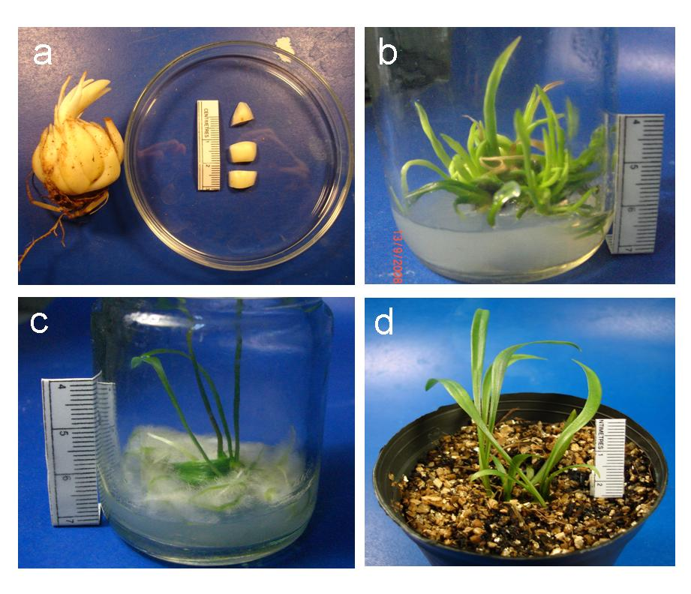
Fig. 1 Micropropagation of Lilium longiflorum ‘Ester lily’. (a) Bulb
and transverse sections of bulb scales. (b) Clumps of adventitious
shoots developed on MS medium containing 25 mg/L chitosan.
(c) Root induction on MS medium supplemented with 1 mg/L IBA.
(d) Complete plantlets in soil.

Table 1 Effect of chitosan and BA on shoot multiplication in Lilium
longiflorum ‘Ester lily’ bulb scale explants cultured on MS medium.
Chitosan  (mg/L) | BA  (mg/L) | Shoot induction  (%) | No. of shoots  (Mean ± SE)
0 | 0 | 100 | 1.7±0.36^{c}
0 | 1 | 100 | 1.7±0.56^{c}
0 | 3 | 100 | 4.4±0.83^{ab}
0 | 5 | 100 | 4.7±0.93ª
5 | 0 | 100 | 3.1±0.66^{abc}
10 | 0 | 100 | 2.3±0.83^{bc}
15 | 0 | 100 | 4.1±0.56^{ab}
20 | 0 | 100 | 3.8±0.80^{abc}
25 | 0 | 100 | 5.0±0.69ª

The different letters within column show significant difference
analyzed by Duncan’s multiple range test at P≤0.05.

Table 2 Effect of different chitosan concentrations with 5 mg/L BA on shoot
formation in Lilium longiflorum ‘Ester lily’ cultured on MS medium.

Chitosan  (mg/L) | BA  (mg/L) | Shoot induction  (%) | No. of shoots  (Mean ± SE)
5 | 5 | 100 | 1.0±0.4^{cd}
10 | 5 | 100 | 3.3±0.2ª
15 | 5 | 100 | 2.0±0.1^{b}
20 | 5 | 100 | 1.0±0.5^{cd}
25 | 5 | 100 | 0.8±0.2^{cd}

The different letters within column show significant difference
analyzed by Duncan’s multiple range test at P≤0.05.

