PROPAGATION OF ARTEMISIA ARBORESCENS L. BY STEM-CUTTING: ADVENTITIOUS ROOT FORMATION UNDER DIFFERENT CONDITIONS

Marcello Militello¹, Giancarlo Fascella^{2*}, Alessandra Carrubba¹
¹D/SAGA (Dipartimento dei Sistemi Agro-Ambientali), University of Palermo, 90128 Palermo, Italy.
²Agricultural Research Council, Research Unit for Mediterranean Flower Species, 90011 Bagheria (Palermo), Italy, Fax: +39091909089, E-mail: fascella@libero.it

ABSTRACT
Artemisia arborescens L. has gained a strong importance worldwide due to its many industrial uses and it has been recently considered as ornamental plant. Some problems arise, however, as concerns the availability of plant material having high-quality features; hence, it becomes attractive the definition of fast and effective methods for its vegetative propagation. An experiment was conducted to assess the effects of different harvest period, addition of exogenous auxin (naphthalene acetic acid, NAA), and growing media on rooting of stem cuttings of A. arborescens L. Softwood cuttings, collected from wild plants in February, April and November, were treated with two NAA concentrations (0 and 400 ppm) and placed on different mixtures of sphagnum peat and perlite (2:1, 1:1 and 1:2 v/v) under mist. The percentage of rooted cuttings was significantly influenced by the harvest period as cuttings collected in February showed the highest rooting rate, and by the growing media since lowest rate was recorded in 1:2 v/v sphagnum peat:perlite substrate, whereas the addition of NAA did not show any significant effect on rooting capacity. The best results, in terms of roots number and root length, were achieved on cuttings grown in a 1:1 v/v sphagnum peat:perlite mixture, without NAA addition.

Key words: Tree Wormwood, harvest period, naphthalene acetic acid, rooting substrates.

Running title: Stem-cutting propagation of Artemisia arborescens L.

INTRODUCTION
Artemisia arborescens L. is one of the Artemisia species (family Asteraceae) growing in wild flora of the southern Mediterranean area. It is a woody perennial shrub, bearing green-silvery leaves and yellow flowers that appear throughout the late spring until summer depending on the environmental conditions. The species finds a large number of uses in ethno-medicine (Palmese et al., 2001; Garcia et al., 2006; Vicidomini, 2007) as antispasmodic, antipyretic, anti-inflammatory and abortifacient (Dessi et al., 2001), as antiherpevirus (Saddi et al., 2007), and as active antimicrobial agent against Listeria monocytogenes (Militello et al., 2011). Moreover, as aridoresistant and nitrophilous plant, A. arborescens bears a great importance for its potential use in environmental engineering (Cella and Collu, 2004) and, for its hardiness, it may be strongly considered for ornamental purposes as other related species of the same genus (Deng et al., 2012) as hedge plant in low-maintenance gardens (Garcia et al., 2006).
Seed germination and micropropagation techniques were studied in different Artemisia species, such as A. frigida Willd. (Bai et al., 1995); A. tridentata Nutt. (Alvarez-Cordero and McKell, 1979; Young and Evans, 1975); A. genipi Weber and A. umbelliformis Lam. (Anon., 2004); A. judaica L. (Liu et al., 2004); A. vulgaris L. (Govindaraj and Bollipo, 2007; Govindaraj et al., 2008, Sujatha and Ranjitha Kumari, 2008); A. annua L. (Liu et al., 1998; Fulzele et al., 1995); A. herba-alba Asso. (Shatnawi, 2011) and A. absinthium L. (Zia et al., 2007), but only few studies are available about the vegetative propagation of this genus, as in A. ludoviciana Nutt. (Bradley Rowe and Cregg, 2002); A. tridentata Nutt. (Alvarez-Cordero and McKell, 1979, Bakker, 2010), A. arborescens (Cella and Collu, 2004) and A. vulgaris L. cv. ‘Variegata’ (Deng et al., 2012).
It is well known that micropropagation and seed multiplication are largely utilized practices, but they are not always suitable to all conditions. As a matter of fact, the first method is expensive (Saranga and Cameron, 2006) and time-consuming in order to obtain a good adaptation from in vitro culture to open field conditions, whereas the second one is characterized by high genetic variability and scarcely homogeneous production. Hence, propagation by stem cuttings remains the most valid and alternative method in order to obtain a rapid propagation with reduced costs, useful for a wide application in the nursery activity.
Rooting capacity in cuttings is influenced by internal factors, as genotype, nutritional status or phenological stage, and external factors, as temperature and light intensity (Hartmann et al., 1997; Agbo and Obi, 2008; Priadjati et al., 2010). Internal factors are strictly related to the amount of phytohormone that is physiologically necessary to the rooting phase (Copes and Mandel, 2000; Guo et al., 2009; Zobolo, 2010; Amri et al., 2010; Ofori et al., 1996); for such reason, it is also important to know the optimal growing conditions for plants (external factors) in order to select suitable rooting media (Cella and Collu, 2004; Tchoundjeu et al., 2002; Mesh et al., 1997; Shiembo et al., 1996; Ofori et al., 1996) and environmental parameters.
Adventitious root formation is mediated by multiple changes in plant metabolism and it is controlled by interdependent physiological phases where auxins play an important role stimulating the root formation. Exogenous auxins are commonly used to improve natural rooting efficiency in stem cuttings, but it was demonstrated in various plant species that relatively high auxins concentrations are required only during the induction phase, while during development these plant growth regulators become inhibitory (Cristofori et al., 2010; Hartmann et al., 1997). The effects of different hormones, as IBA (indole-3-butyiric acid) and NAA (α−naphtalene acetic acid), and concentrations on adventitious rooting of many plant species were previously studied (Copes and Mandel, 2000; Guo et al., 2009; Zobolo, 2010; Amri et al., 2010; Moura-Costa and Lundoh, 1994; Mesh et al., 1997; Shiembo et al., 1996; Ofori et al., 1996; Aminah et al., 1995; Tchoundjeu et al., 2002).
Root formation of stem-cuttings is also affected by growing media: physical and chemical characteristics of rooting substrates (bulk density, porosity, water-holding capacity, pH, etc.) are able to highly determine particular micro-environmental conditions which allow to promote or inhibit root growth main parameters as root number, length and weight (Hartmann et al., 1997). Numerous researches were already conducted on the effects of different growing media on rooting of stem-cuttings in different ornamental species (Ercişli et al., 2005; Lee et al., 2000; Pivetta et al., 1999; Rifaki et al., 2001).
Moreover, adventitious rooting is often related to the season during which cuttings are collected, as the availability of internal hormones as well as nutrients content of plant tissue may determine high/low root capacity of cuttings (Rosier et al., 2004).
Differently from other genera and botanical families, few studies about in vivo propagation in Artemisia species are available in literature (Pridham, 1963; Weglarz and Zalecki, 1984); hence, the aim of this work was to define an effective and low-cost propagation protocol by means of stem-cutting method, that is considered cheaper than the micropropagation (Saranga and Cameron, 2006) and that does not require a specific technical equipment. This work reports the results of a trial about different harvest periods, auxin (NAA) concentrations and rooting substrates in the vegetative propagation of wild Artemisia arborescens.

MATERIALS AND METHODS
Plant material and experimental design
The trial was carried out in 2010/11, in an EW oriented greenhouse (200 m²) with steel structure and polymethacrylate methyl cover, located at the Research Unit for Mediterranean Flower Species near Palermo (38°05’25.22’’ N, 13°31’18.15’’ E, 23 m above sea level), on the coastal area of North Western Sicily.
Softwood cuttings were harvested from mother plants of a wild population (38°06’47.74” N, 13°31’16.38” E, 31 m a.s.l.) of A. arborescens L. with distinct xerophytic traits growing on rocky shores and rocky slopes located in alkaline and nitrophilous substrates.
In order to evaluate the effect of harvest period on rooting capacity, cuttings were collected in February, April and November 2010. For each harvest period, a factorial experimental design (three rooting substrates in presence or absence of NAA), with three replications per treatment, was used. Each replication consisted of 22 cuttings (exp. unit).

Auxin addiction and growing media
In 50% of the harvested stem cuttings, after leaves removal, the basal end was treated with 400 ppm of α-naphthalene acetic acid (NAA) powder formulation (Germon, Gerlach Gmbh, Lubbecke, Germany), whereas the remaining cuttings were left untreated. Both treated and untreated cuttings were then inserted in 66-cell polystyrene seed trays containing three rooting media based on different combinations (2:1; 1:1, 1:2 v/v – also named substrate 1, 2 and 3, respectively) of sphagnum peat (TECNIC - Free Peat B.V., Sluiskade, Vriezenveen, Netherlands) and perlite Ø 2-5 mm (AGRIPAN 100, Perlite Italiana s.r.l., Corsico (MI), Italia); organic matter and organic nitrogen content of sphagnum peat were respectively 46% and 0.5%. The seed trays were placed into a bench (6 m x 1.2 m) covered with a polyethylene film and equipped with a mist nebulization system (relative humidity 75%), under natural photoperiod. Maximum and minimum temperature of the bench were monitored during the trial.

Sample collection and measurement
In each treatment, data on cuttings survival rate (%), cuttings rooting rate (%), number of roots/cutting, length of roots (cm) were collected forty days after the beginning of the trial.

Data Analysis
Collected data were subjected to ANOVA by means of the package “Statistica” (V. 6.0 for Windows, Statsoft Inc., Tulsa, OK) to determine treatment effects. Before statistical analysis, cuttings survival and rooting percentages were converted in angular values (arcsin transformation) (Gomez and Gomez, 1984).

RESULTS AND DISCUSSIONS
The rooting percentages of A. arborescens cuttings in the different harvest periods did not evidenced significant differences between rooted and non rooted cuttings in the first date, when all three groups of cuttings (dead, alive rooted and alive non rooted) expressed values ranging from 27.8 to 44.4% (Fig. 1).
A higher differentiation was recorded in the following periods, when the mortality rate of cuttings decreased sharply to 26.6% and to 5.3%, respectively in April and November.
Surprisingly, the counting of rooted cuttings did not arise but, on the contrary, decreased from 27.8% (February) to 5.3 and 12.7% recorded in cuttings collected in April and November, respectively (Fig. 1). This outcome agrees with that reported by other authors (Alvarez-Cordero and McKell, 1979) who observed that cuttings of Artemisia tridentata obtained in winter showed a greater rooting activity than those collected in other periods.
A clear increase throughout collecting dates (68.1 and 82.0% in April and November, respectively) may be observed in the number of cuttings that, although alive, did not produce roots (Fig. 1).
The influence of harvest period on rooting efficiency of cuttings, previously reported for several plant species (Hartmann et al., 1997; Sharma and Aier, 1989) and attributed to initial physiological characteristics of the vegetal material, like nutrient reserves such as carbohydrate and nitrogen in the plant tissues at the time of picking (Hambrick et al. 1991; Tsipouridis et al., 2006), often affected cuttings performances. Guo et al. (2009), for example, referred that cuttings of Paeonia collected in three different periods did not vary on percent mortality and number of roots but significantly differed on rooting percentage as well as on root length.
Cristofori et al. (2010) stated that the rooting ability of hazelnut cuttings was strongly influenced by the collection time as the highest rooting rate occurred in cuttings collected in late summer, whereas the lowest rate was found in those collected in July. Karami and Salehi (2010) reported that the rooting ability of Rohida was seasonal as the rate recorded in late winter was higher than rooting of cuttings harvested in late autumn.
Akoumianaki-Ioannidou et al. (2010a), during a year-round propagation trial of Eleagnus x ebbingei, observed that cuttings taken in autumn had the highest rate of rooting irrespective of hormone concentration. Likewise, for Pterocephalus perennis vegetative multiplication (Akoumianaki-Ioannidou et al., 2010b), the maximum rooting success was recorded in cuttings planted at spring with respect to those planted in autumn and summer.
Therefore, differences among the three harvest periods on mortality and rooting rate of Artemisia arborescens cuttings could be related to a specific level of nutrient reserves and/or to the interactions between the endogenous hormones, as observed by other authors on different plant species (Guo et al., 2004). In particular, with regard to the nutritional status of propagation material, it was previously observed that high carbohydrate and low nitrogen content of cuttings mainly contribute to the root formation (Rowe et al., 1999; Rapaka et al., 2005).
The addition of exogenous auxin (NAA) did not help in solving such dormancy problem, with average rooting rates of 15.2% recorded in the two treatments; in the same way, the percentage of deadly and non rooted cuttings remained almost unchanged (average 25.5% and 59.2%, respectively), with or without auxin application (Fig. 2). These results are in agreement with the outcomes from a study on southernwood (Artemisia abrotanum L.) propagation (Schroeder and Le Duc, 1996), where no significant difference was recorded between cuttings treated and untreated with rooting hormone.
On the contrary, such a response is not in line with Alvarez-Cordero and McKell (1979) who referred that indolebutyric acid treatment in cuttings of A. tridentata increased root formation as a function of increased auxin concentration. The different behavior of the latter species from that of A. arborescens could suggest that some propagative characteristics may be genotype-dependant, as observed in Grevillea (Krisantini et al., 2006) and in Magnolia (Sharma et al., 2006), with a high variability in rooting capacity of the cuttings. Moreover, the better performance of A. abrotanum treated with IBA than A. arborescens treated with NAA could be related to the different effectiveness of these two hormones, in particular to the higher efficiency of IBA with respect to NAA on promoting rooting, as reported by several authors for other plants (Ibàñez-Torres, 2004; Németh, 1986).
The inefficacy of auxin treatments on rooting response of Artemisia cuttings seemed to confirm earlier results recorded on different plant species (Myers and Still, 1979; Dirr and Heuser, 1987; Panetsos et al., 1994) where the hormone concentrations used had no effect in cuttings characterized by a natural high rooting potential. Therefore, the absence of differences on rooting percentage between treated and non-treated cuttings of our assay could be linked to a too low/high NAA concentration.
The application of unbalanced doses of rooting hormone are often reported in literature: Akoumianaki-Ioannidou et al. (2010b), for example, referred that rooting rate of Pterocephalus perennis cuttings was higher without the use of IBA than those treated with the same hormone; Grolli et al. (2005) reported that auxin treatments were unsuccessful or had negative effects on rooting of cuttings of Platanus acerifolia.
The adoption of different type of growing substrates moderately affected the rooting ability of cuttings, with average values of 19.7% recorded for substrate 1 and 2 and of 6.4% for substrate 3, respectively (Fig. 3); the use of a lower amount of sphagnum peat in the growing mixture (as in the 1:2 v/v peat:perlite substrate), although bringing to a certain increase of dormant cuttings (alive but not rooted, +18% with respect to the 2:1 v/v peat:perlite substrate), did not exert any evident effect on the mortality rate (-4% compared to the 2:1 substrate).
In the same way, Fascella and Zizzo (2009) previously observed that a progressive reduction of the peat percentage in the growing media partially affected growth performance of rooted cuttings of Euphorbia x lomi Thai hybrids. Ercişli et al. (2005) referred that the highest rooting percentage and root number of Rosa dumalis hardwood cuttings were obtained in peat/perlite substrates. King et al. (2011) reported that softwood baldcypress cuttings should be grown in a substrate with intermediate water-holding capacity (peat:perlite 1:1 v/v) to achieve an acceptable balance between rooting percentage and rooted cutting quality. A balanced composition of a growing medium based on peat and perlite seemed to be a frequent option, as in our experiment, in order to obtain high rooting success in cuttings of ornamental plants (Akoumianaki-Ioannidou et al., 2010a,b; Collado et al., 2010), probably due to a adequate equilibrium between air and moisture content.
A slight difference in number of roots seemed to be linked to the harvest date, and some tendency in counting a lower number of roots may be recognized in the cuttings obtained in November (2.6 roots/cutting) with respect to those harvested in February (4.7) (Fig. 4). In contrast, the use of a particular growing substrate as well as the addition of exogenous auxin did not have any effect on the number of roots (average 3.5 roots/cutting) (Fig. 4).
The harvest period and the growing substrate appeared to have some effect on the average length of roots, as in cuttings collected in November and grown in the 1:2 v/v peat:perlite medium seemed somehow shorter (less than 4 cm) than in those harvested in April and grown in the 1:1 v/v peat:perlite substrate (more than 8 cm) (Fig. 5). The addition of NAA to the growing substrate did not significantly affect the root length (average 5.9 cm), when present.
The latter results are supported by recent findings about some Euphorbia family species: Ibàñez-Torres (2004) observed that hormonal treatment (IBA and NAA applications) did not influence root length of Euphorbia lagascae cuttings after one month compared to control but differences were evident only after two months, a time that is often considered too long for the nursery industry. Fascella et al. (2008), after an experiment on in vivo propagation of Euphorbia milii x lophogona hybrids, did not observe any differences between no-treated and NAA-treated cuttings concerning cuttings viability, root length and plant establishment.

CONCLUSIONS
The present research tries to provide new useful information for the definition of a vegetative propagation protocol that permits a fast (40 days) and low-cost production of Artemisia arborescens plants, an aromatic species that could be exploited for many industrial uses, for environmental restoration as well as ornamental purposes for low-input gardens in Mediterranean area.
Results from the present study seem to point out that February was the best period for harvesting softwood cuttings suitable for rooting and that rooting rate, as well root number and length, is not affected by the addition of exogenous auxin like NAA. Moreover, the substrate in which cuttings showed the best growing aptitude (in terms of rooting rate, number and length of roots) may be identified with that one obtained with sphagnum peat and perlite at a 1:1 volume ratio.
However, further researches are needed to increase rooting performances and to record a more exhaustive response of cuttings by testing different auxin types (IBA, IAA, etc.), concentrations and formulations (dip immersion in water and/or alcoholic solution), as well other periods of the year.

ACKNOWLEDGEMENTS
The authors would like to thanks Dr. Zizzo G.V. for his kind collaboration.

REFERENCES:
Agbo C.U., Obi I.U. (2008). Patterns of vegetative propagation of stem-cuttings of three physiological ages of Gongronema latifolia Benth over two seasons in Nsukka. Journal of Tropical Agriculture, Food, Environment and Extension, 7: 193–198.
Akoumianaki-Ioannidou A., Papagianni M., Fasseas, C. (2010a). Propagation of Elaeagnus ×ebbingei by cuttings and its evaluation as an ornamental for use in urban and sub-urban areas. Acta Horticulturae, 885: 27-32.
Akoumianaki-Ioannidou A., Alexiou P., Fasseas C. (2010b). Propagation of Pterocephalus perennis by cuttings and its evaluation as ornamental. Acta Hort., 885: 21-25.
Alvarez-Cordero E., Mckell C.M. (1979). Stem cutting propagation of Big Sagebrush: Artemisia tridentata. Journal of Range Management, 32: 141-143.
Aminah H., Dick J.M.C.P., Leakey R. R. B., Grace J., Smith R.I. (1995). Effect of indole butyric acid (IBA) on stem cuttings of Shorea leprosula. Forest Ecology and Management, 72: 199-206.
Amri E., Lyaruu H.V.M., Nyomora A.S., Kanyeka Z.L. (2010). Vegetative propagation of African Blackwood (Dalbergia melanoxylon Guill. & Perr.): effects of age of donor plant, IBA treatment and cutting position on rooting ability of stem cuttings. New Forests, 39: 183–194.
Anonymous (2004). Riproduzione e valutazione della coltivazione di specie aromatiche indigene della montagna Lombarda. Regione Lombardia. Relazione attività del progetto. Fondazione Minoprio (in Italian). Available on-line: http://www.fondazioneminoprio.it/userfiles/attach/progetti/aromatiche%20di%20montagna.pdf [last accessed 2 September, 2011].
Bakker J.D. (2010). Plant Propagation Protocol for Artemisia tridentata ESRM 412 Native Plant Production Spring 2010. Available on-line: http://courses.washington.edu/esrm412/protocols/ARTR2.pdf . [last accessed 2 September, 2011].
Bai Y., Romo J.T., Young J.A. (1995). Influences of temperature, light and water stress on germination of fringed sage. Weed Science, 43: 219-225.
Bradley Rowe D., Cregg B.M. (2002). Effect of incorporating controlled-release fertilizer on adventitious rooting and growth of Artemisia, Gaura, and Nepeta. J. Environ. Hort., 20: 1–6.
Cella R., Collu M. (2004). Utilizzo di substrati artificiali nel recupero ambientale: modellizzazione della crescita di Artemisia arborescens L. su diversi substrati. Rendiconti Seminario Facoltà Scienze, Università Cagliari, 1-2: 74.
Collado L.M., Ribeiro M.M., Antunes A.M. (2010). Vegetative propagation of the hybrid × Cupressocyparis leylandii by cuttings: effect of indole-3-butyric acid and wounding. Acta Hort., 885: 91-98.
Copes D.L., Mandel N.L. (2000). Effect of IBA and NAA treatments on rooting Douglas-fir stem cutting. New Forests, 20: 249-257.
Cristofori V., Rouphael Y., Rugini E. (2010). Collection time, cutting age, IBA and putrescine effects on root formation in Corylus avellana L. cuttings. Scientia Hort., 124: 189–194.
Deng Y., Chen S., Chang Q., Wang H., Chen F. (2012). The chrysanthemum × Artemisia vulgaris intergeneric hybrid has better rooting ability and higher resistance to Alternaria leaf spot than its chrysanthemum parent. Scientia Hort., 134: 185–190.
Dessi M.A., Deiana M., Rosa A., Piredda M., Cottiglia F., Bonsignore L., Deidda D., Pompei R., Corongiu F.P. (2001). Antioxidant activity of extracts from plants growing in Sardinia. Phytother. Res., 15: 511–518.
Dirr A.M., Heuser C.W. Jr. (1987). The reference manual of woody plant propagation: from seed to tissue culture. Athens, GA, USA.
Ercişli S., Eşitken A., Anapali O., Şahin U. (2005). Effects of substrate and IBA-concentration on adventitious root formation on hardwood cuttings of Rosa dumalis. Acta Hort., 690: 149-152.
Fascella G., Zizzo G.V. (2009). Efficient propagation technique of Euphorbia x lomi Thai hybrids. HortScience, 44: 495–498.
Fascella G., Zizzo G.V., Agnello S. (2008). In vivo propagation of Euphorbia milii × lophogona hybrids for pot plant production. Acta Hort., 766: 163-168.
Fulzele D.P., Heble M.R., Rao P.S. (1995). Production of terpenoid from Artemisia annua L. plantlet cultures in bioreactor. Journal of Biotechnology, 40: 139-143.
Garcia S., Garnatje T., Twibell J-D., Valles J. (2006). Genome size variation in the Artemisia arborescens complex (Asteraceae, Anthemideae) and its cultivars. Genome, 49: 244–253.
Gomez K.A., Gomez A.A. (1984). Statistical procedures for agricultural research. John Wiley & sons Inc., New York, USA.
Govindaraj S., Bollipo D.R.K, Cioni P.L., Flamini G. (2008). Mass propagation and essential oil analysis of Artemisia vulgaris. Journal of Bioscience and Bioengineering, 105: 176–183.
Govindaraj S., Bollipo D.R.K. (2007). Efficient in vitro micropropagation and regeneration of Artemisia vulgaris L. Crop Breeding and Applied Biotechnology, 7: 117-124.
Grolli P.R., Morini S., Loreti F. (2005). Propagation of Platanus acerifolia Willd. by cutting. Journal of Hort. Science & Biotechnology, 80: 705-710.
Guo X., Fu X., Zang D., Ma Y. (2009). Effect of auxin treatments, cuttings collection date and initial characteristics on Paeonia ‘Yang Fei Chu Yu’ cutting propagation. Scientia Hort., 119: 177–181.
Guo S.J., Ling H.Q., Li F.L. (2004). Physiological and biochemical basis of rooting of Pinus bungeana cuttings. J. Beijing For. Univ., 26: 43–47.
Hambrick C.E., Davies F.T., Pemberton H.B. (1991). Seasonal changes in carbohydrate/nitrogen levels during field rooting of Rosa multiflora ‘Brooks 56’ hardwood cuttings. Scientia Hort., 46: 137–146.
Hartmann H.T., Kester D.E., Davies F.T., Geneve R.L. (1997). Plant propagation: principles and practises. 7th ed. Prentice-Hall, Englewood Cliffs, N.J., USA.
Ibanez-Torres A. (2004). Rooting experiments with Euphorbia lagascae cuttings. Ann. Biol., 26: 101–104.
Karami A., Salehi H. (2010). Adventitious root formation in Rohida (Tecomella undulata (Sm.) Seem) cuttings. Propagation of Ornamental Plants, 10: 163-165.
King A.R., Arnold M.A., Welsh D.F., Todd Watson W. (2011). Substrates, wounding, and growth regulator concentrations alter adventitious rooting of baldcypress cuttings. HortScience, 46: 1387-1393.
Krisantini S., Johnston M., Williams R.R., Beveridge C. (2006). Adventitious root formation in Grevillea (Proteaceae), an Australian native species. Scientia Hort., 107: 171-175.
Lee A.K., Suh, J.K., Roh M.S. (2000). Propagation of Ardisia species native to Korea by seeds or by rooting of stem tip cuttings. Acta Hort., 541: 135-145.
Liu C.Z., Murch S.J., El-Demerdash M., Saxena P.K. (2004). Artemisia judaica L.: micropropagation and antioxidant activity. Journal of Biotechnology, 110: 63–71.
Liu C.Z., Wang Y.C., Ouyang F., Ye H.C., Li G.F. (1998). Production of artemisinin by hairy root cultures of Artemisia annua L in bioreactor. Biotechnology Letters, 20: 265–268.
Mesh F., Newton A.C., Leakey R.R.B. (1997). Vegetative propagation of Cordia alliodora (Ruiz & Pavon) Oken: the effects of IBA concentration, propagation medium and cutting origin. Forest Ecology and Management, 92: 45-54.
Militello M., Settanni L., Aleo A., Mammina C., Moschetti G., Giammanco G.M., Blazquez M.A., Carrubba A. (2011). Chemical composition and antibacterial potential of Artemisia arborescens L. Essential Oil. Curr Microbiol., 62: 1274–1281.
Moura-Costa P.H., Lundoh L. (1994). The effects of auxins (IBA, NAA AND 2,4-D) on rooting of dry Obalanops lanceolata (Kapur - Dipterocarpaceae) cuttings. Journal of Tropical Forest Science, 7: 338-340.
Myers J.R., Still S.M. (1979). Propagating London plane tree from cuttings. Plant Propagator, 25: 8-9.
Németh G. (1986). Induction of rooting. In: Bajaj Y.P.S. (ed). Biotechnology in Agriculture and Forestry, vol. 1. Trees, Berlin Heidelberg, Springer-Verlag publisher: 49-64.
Ofori D.A., Newton A.C., Leakey R.R.B., Grace J. (1996). Vegetative propagation of Militia excelsa by leafy stem cuttings: effects of auxin concentration, leaf area and rooting medium. Forest Ecology and Management, 84: 39-48.
Palmese M.T., Uncini Manganelli R.E., Tomei P.E. (2001). An ethno-pharmacobotanical survey in the Sarrabus district (south-east Sardinia). Fitoterapia, 72: 619-643.
Panetsos K.P, Scaltsoyiannes A.V., Alizoti P.G. (1994). Vegetative propagation of Platanus orientalis x P. occidentalis F1 hybrids by stem cuttings. Forest Genetics, 1: 125-130.
Pivetta K.F.L., Martins A.G., Ruffini F.K., Ledra L.R. (1999). Effects of rooting media, indolbutyric acid and fertilization on the rooting of rose (Rosa sp. ‘Dalas’) leafy cuttings. Acta Hort., 482: 339-344.
Priadjati A., Smits W.T.M., Tolhamp G. W. (2010). Vegetative propagation to assure a continuous supply of plant material for forest rehabilitation. In: The Balance between biodiversity conservation and sustainable use of tropical rain forests. The Tropenbos Foundation, Wageningen, the Netherlands.
Pridham A.M.S. (1963). Propagation of Artemisia vulgaris from stem cuttings for herbicide test purposes. Proc. Northeastern Weed Contr. Conf., 17: 332.
Rapaka V.K., Bessler B., Schreiner M., Druege U. (2005). Interplay between initial carbohydrate availability, current photosynthesis, and adventitious root formation in Pelargonium cuttings. Plant Sci., 168: 1547–1560.
Rifaki N., Economou A., Scaltsoyiannes A. (2001). Factors affecting the rooting of Ilex aquifolium L. cuttings. Propagation of Ornamental Plants, 1: 31-35.
Rosier C.L., Frampton J., Goldfarb B., Blazich F.A., Wise F.C. (2004). Growth stage, auxin type, and concentration influence rooting of stem cuttings of Fraser fir. HortScience, 39: 1392–1396.
Rowe D.B., Blazich F.A., Weir F.R.J. (1999). Mineral nutrient and carbohydrate status of loblolly pine during mist propagation as influenced by stock plant nitrogen fertility. HortScience, 34: 1279–1285.
Saddi M., Sanna A., Cottiglia F., Chisu L., Casu L., Bonsignore L., De Logu A. (2007). Antiherpevirus activity of Artemisia arborescens essential oil and inhibition of lateral diffusion in Vero cells. Annals of Clinical Microbiology and Antimicrobials, 6: 10.
Saranga J., Cameron R. (2006). Adventitious root formation in Anacardium occidentale L. in response to phytohormones and removal of roots. Scientia Hort., 111: 164-172.
Schroeder J.R., Le Duc A. (1996). Propagation of selected culinary and ornamental herbs. HortScience, 31: 633-634.
Sharma J., Knox G.W., Ispida M.L. (2006). Adventitious rooting of stem cuttings of yellow-flowered Magnolia cultivars is influenced by time after budbreak and indole-3-butyric acid. HortScience, 41: 202-206.
Sharma S.D., Aier N.B. (1989). Seasonal rooting behavior of cuttings of plum cultivars as influenced by IBA treatments. Scientia Hort., 40: 297–303.
Shatnawi M.A. (2011). Multiplication and cryogenic storage of Artemisia herba-alba: A medicinal plant. Food, Agriculture & Environment, 9: 340-344.
Shiembo P.N., Newton A.C., Leakey R.R.B. (1996). Vegetative propagation of Irvingia gabonensis, a West African fruit tree. Forest Ecology and Management, 87: 185-192.
Sujatha G., Ranjitha Kumari B.D. (2008). Micropropagation, encapsulation and growth of Artemisia vulgaris node explants for germplasm preservation. South African Journal of Botany, 74: 93–100.
Tchoundjeu Z., Avana M.L., Leakey R.R.B., Simons A.J., Asaah E., Duguma B., Bell J.M. (2002). Vegetative propagation of Prunus africana: effects of rooting medium, auxin concentrations and leaf area. Agroforestry Systems, 54: 183-192.
Tsipouridis C., Thomidis T., Bladenopoulou S. (2006). Rhizogenesis of GF677, Early Crest May Crest and Arm King stem cuttings during the year in relation to carbohydrate and natural hormone content. Scientia Hort., 108: 200–204.
Vicidomini S. (2007). Proprietà alternative dei fitoestratti di Artemisia (Asteraceae): check-list di Virus, Procarioti, Micoti, trattabili con fitoestratti di Artemisia. Contributo sulla agro-ecologia delle colture oggetto del progetto Co.Al.Ta. Il Naturalista Campano, 10: 1-16.
Weglarz Z., Zalecki R. (1984). Evaluation of southernwood Artemisia-abrotanum semi hardwood cuttings as a reproductive material. Herba Polonica, 30: 101-108.
Young J.A., Evans R.A. (1975). Germinability of seed reserves in a Big Sagebrush community. Weed Science, 23: 358-364.
Zia M., Rehman R., Chaudhary M.F. (2007). Hormonal regulation for callogenesis and organogenesis of Artemisia absinthium L. African Journal of Biotechnology, 6: 1874-1878.
Zobolo A.M. (2010). Effect of temperature, light intensity and growth regulators on propagation of Ansellia africana from cuttings. African Journal of Biotechnology, 9: 5566-5574.
Figures

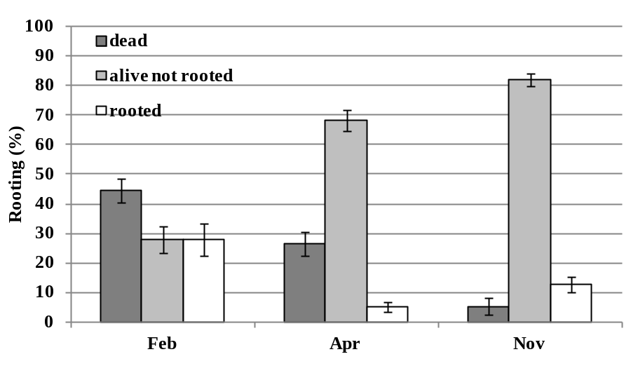
Fig. 1 – Rooting rate of A. arborescens cuttings in three harvest periods

(mean values ± standard error across growing substrates and auxin application).

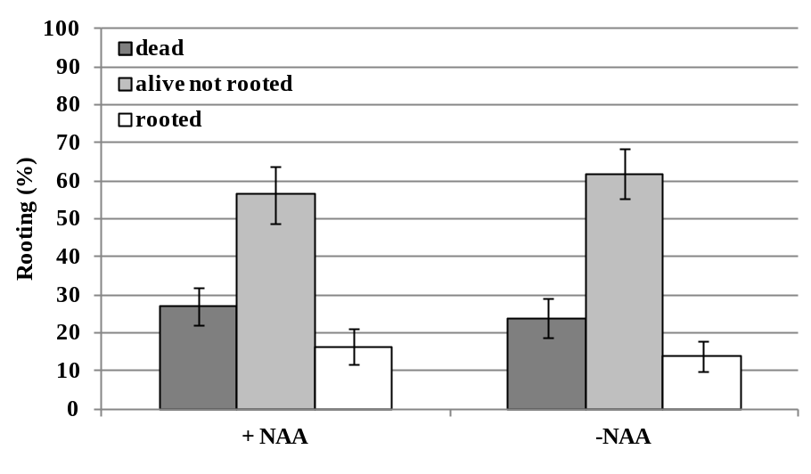
Fig. 2 – Rooting rate of A. arborescens cuttings with or without auxin application
(mean values ± standard error across growing substrates and harvest date).

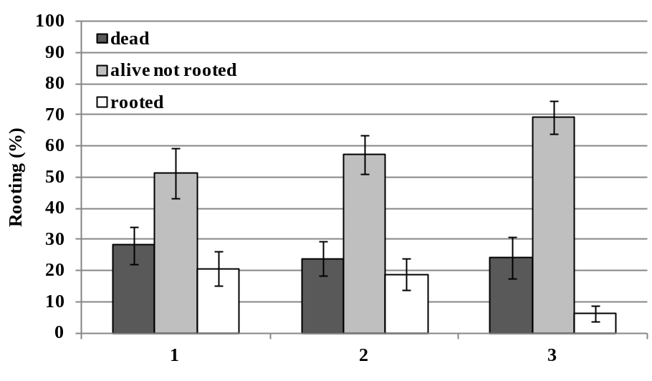
Fig. 3 – Rooting rate of A. arborescens cuttings on different growing substrates
(mean values ± standard error across harvest date and auxin application).

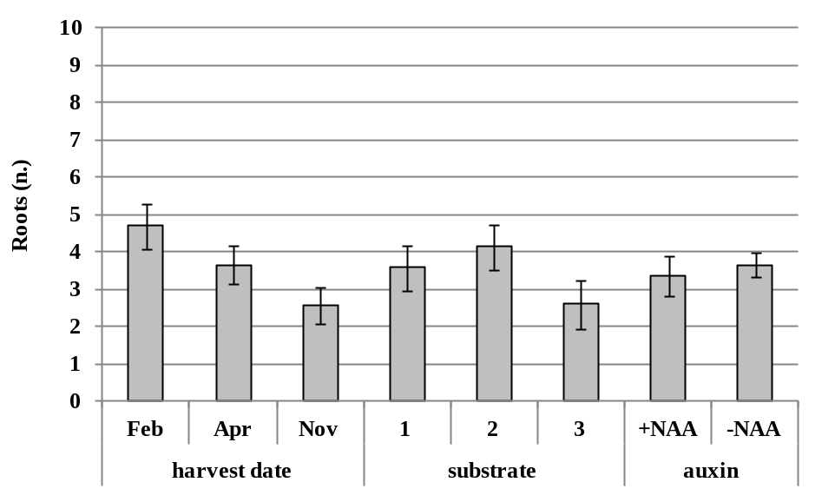

Fig. 4 – Average number of roots of A. arborescens cuttings according to harvest date, growing substrate and auxin application.
(Values are mean ± standard error)

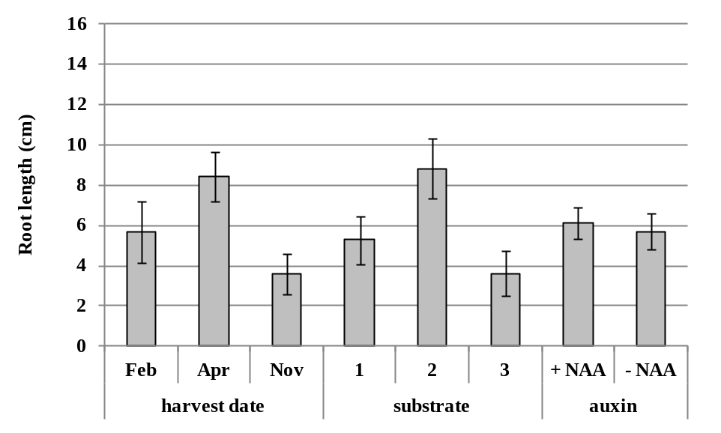

Fig. 5 – Average length of roots of A. arborescens cuttings according to harvest date, growing substrate and auxin application.
(Values are mean ± standard error)

