New cytokinins – meta-methoxytopolins in micropropagation of Cotinus coggygria Scop.

Małgorzata Podwyszyńska¹, Elżbieta Węgrzynowicz-Lesiak¹, Karel Doležal^{2,3}, Jan Krekule³, Miroslav Strnad^{2,3}, Marian Saniewski¹

¹Research Institute of Horticulture, Konstytucji 3 Maja 1/3, 96-100 Skierniewice, Poland, malgorzata.podwyszynska@inhort.pl, elzbieta.wegrzynowicz@inhort.pl, marian.saniewski@inhort.pl, fax: (48) 46 8333434
²Centre of the Region Haná for Biotechnological and Agricultural Research, Faculty of Science, Palacký University, Šlechtitelů 11, 783 71 Olomouc, Czech Republic, miroslav.strnad@upol.cz,
³ Laboratory of Growth Regulators, Institute of Experimental Botany ASCR, Šlechtitelů 11, CZ 783 71, Olomouc, Czech Republic, dolezel@risc.upol.cz, krekule@ueb.cas.cz

Abstract

The effects of the new cytokinin, meta-methoxytopolin (MemT), and its riboside (MemTR), on the micropropagation efficiency and microcutting quality of smoke bush (Cotinus coggygria Scop.) were studied. This plant species is recalcitrant both in conventional and in vitro propagation. In this study, the in vitro cultures of the axillary shoots of smoke bush ‘Royal Purple’ were used. In the experiment concerning the multiplication stage, new cytokinins were utilized at concentrations of 0.5, 1 and 2 mg l⁻¹. In the control, 6-Benzyladenine (BA) at a concentration of 0.5 mg l⁻¹ was selected based on the earlier studies. The Cotinus shoot cultures treated with MemT or MemTR at 1 and 2 mg l⁻¹ demonstrated multiplication rates that were higher by 30-40%. The microcuttings were longer by 40-50% and contained 60% more chlorophyll compared to the control. The shoots derived from the media containing meta-methoxy-topolins, produced ethylene on the same level as those from the control medium. In order to evaluate the carry-over cytokinin effects on rooting capacity, the shoots were subcultured on media containing all the cytokinins, including BA, at concentrations of 0.5, 1 and 2 mg l⁻¹. After the second subculture, the microcuttings were rooted on a medium containing 3 mg l⁻¹ IBA. The cytokinins applied during the multiplication stage had a carry-over effect on shoot capacity for rooting. Thus, meta-methoxytopolins used during the multiplication stage at the concentration of 0.5 mg l⁻¹, created carryover effect decreasing rooting percentage from 80% obtained for BA to 51.9% and 63.3% for MemT and MemTR, respectively. If the cytokinins were used at 2 mg l⁻¹, the strongest carryover effect, inhibitory-to-rooting was observed for BA, which almost completely retarded root formation on the rooting medium containing 3 mg l⁻¹ IBA.

Key words Early senescence, In vitro propagation, Meta-methoxytopolin, Cotinus coggygria

Running Title: Meta-methoxytopolins in micropropagation of Cotinus coggygria

Introduction

Smoke bush (Cotinus coggygria Scop.) is a beautiful shrub with decorative multi- branched inflorescences that have long purplish hairs. The fluffy grayish-buff flowers are clustered in large open-terminal panicles, 15-30 cm long. These ornamental shrubs are in demand. The cultivars with purple leaves such as, e.g., cultivar ‘Royal Purple’ are particularly popular. Cotinus sp. is propagated mainly by softwood cuttings. Smoke bush is considered to be difficult to root in conventional cutting propagation. The highest rooting ability is noted in softwood cuttings harvested in June. This is the phase when shoots stop growing but the youngest, top leaves are not yet completely developed (Blakesley et al. 1991). The authors found that good rooting ability occurring at this growth phase, was associated with the highest content of endogenous free auxins in shoots. Application of in vitro techniques could allow smoke bush to be produced on a wider scale. There are, however, only a few reports concerning the propagation of this ornaments shrub in vitro (Podwyszyńska et al. 2000b; Metivier et al. 2007; Călinescu et al. 2009). There were several problems associated with the micropropagation of this species. Problems encountered included: hyperhydricity, shoot tip necrosis, leaf senescence occurring as early as the 4th week of subculture, and difficulties with rooting. In all of the presented methods, shoot multiplication of Cotinus sp. was conducted in the presence of 6-benzyladenine (BA). This aromatic cytokinin is the most commonly used one in plant micropropagation due to its high activity and low price. We observed that culturing shoots on media containing BA at a concentration of 1 or 2 mg l⁻¹ for more than two subcultures, caused the formation of small, tenuous and hyperhydric shoots. Nearly all of these shoots were useless for further multiplication or rooting. Better quality shoots were obtained when BA was used at a concentration of 0.5 mg l⁻¹. However, extending a subculture period at such a BA level for more than five weeks caused a fast and considerable reduction in the multiplication rate and shoot quality due to early leaf senescence and shoot tip necrosis. In order to avoid these early senescence symptoms, the multiplying shoots had to be subcultured every four weeks, which was quite laborious. The phenomenon of early leaf senescence and shoot tip necrosis is often observed in micropropagation of other species, e.g. in roses (Podwyszyńska and Goszczyńska 1998). Such a phenomenon is attributed to, among others, calcium deficiency or rather its inefficient distribution. The reduced transpiration rate under high humidity in culture containers is the reason for the inefficient distribution (Podwyszyńska and Olszewski 1995). The calcium-related physiological disorder was also found to be stimulated by the supra-optimal exogenous auxin level at the rooting stage. Excessive ethylene production was the result of the supra-optimal auxin level (Podwyszyńska and Goszczyńska 1998). The ethylene proved to be the direct factor responsible for the leaf senescence and shoot tip necrosis. Raising the calcium and magnesium level and application of auxin at optimal concentration counteracted shoot-tip necrosis in rose either in the multiplication or rooting stages. But in Cotinus, an increased calcium concentration did not alleviate the senescence problem (data not presented).
During the last 15 years, several reports have been published on new aromatic cytokinin derivatives of BA, named topolins. The above mentioned problems which occur during the micropropagation of several plants, were alleviated when topolins were used (Werbrouck et al. 1995; Podwyszyńska et al. 2000a; Wojtania and Gabryszewska 2001; Bairu et al. 2008; Mala et al. 2009; Wojtania 2010; Amoo et al. 2011). The proper application of the cytokinin is one of the most important factors responsible for successful micropropagation of any plant. Cytokinins play a crucial role in the regulation of many developmental and physiological processes, including proliferation and differentiation of plant cells, apical dominance, leaf senescence, and transduction of nutritional signals. Cytokinin metabolism, action, and translocation were recently widely reviewed (Sakakibara 2006; Werner and Schmülling 2009). Naturally occurring cytokinins are adenine derivatives carrying an isoprene-derived or aromatic side chain at N⁶ terminus. Isoprenoid cytokinins have been more frequently found in plants than aromatic cytokinins. The aromatic cytokinins (ARCKs), however, do play an important role in the growth and development of several plants. A few publications have extensive reviews on the importance of ARCKs in plant physiology (Strnad et al. 1997; Werbrouck 2010; Aremu et al. 2012). The first naturally occurring aromatic cytokinin BA-derivative, ortho-topolin (oT), was detected in poplar leaves (Horgan et al. 1975). Subsequently, other derivatives of BA had been found in a number of species, including meta-topolin (mT) in poplar (Strnad et al. 1997) and methoxy derivatives such as 6-(2-methoxybenzylamino)purine (ortho-methoxytopolin, MeoT), 6-(3-methoxybenzylamino)purine (meta-methoxytopolin, MemT) and their ribosides in Populus x canadensis and Arabidopsis thaliana (Tarkowská et al. 2003). Since these ARCKs were synthesized, their high biological activity was confirmed in standard cytokinin bioassays and compared to the activity of other cytokinins, including BA (Tarkowská et al. 2003; Doležal et al. 2007). The topolins were also tested for their usability in micropropagation, as reviewed by Aremu et al. (2012). They reported the effects of various topolins examined in over 40 plant species. The effects of the topolins were compared to other cytokinins widespread in commercial plant tissue cultures such as BA, 6-(2-isopentenyl)adenine (iP), thidiazuron (TDZ) and kinetin. Among the topolins, mT and its riboside (mTR) were investigated most frequently. On the other hand, there were few reports concerned with meta-methoxytopolins.
In this experiments, we examined the usability of MemT and MemTR in order to counteract early leaf senescence and shoot tip necrosis. Micropropagation efficiency could be enhanced with the use of such a counteraction.

Material and Methods

Plant material
For the experiments, in vitro shoot cultures of Cotinus coggygria Scop. 'Royal Purple' were used. These cultures were established and cyclic multiplied during a two year period according to the procedure developed in the earlier studies (Podwyszyńska et al. 2000b). Stock plant material was subcultured every four or five weeks on Murashige and Skoog (1962) medium containing 0.5 mg l⁻¹ BA. The medium was solidified with agar.
The cytokinin 6-(3-Methoxybenzylamino)purine and its riboside were prepared and their purity characterized as described previously (Doležal et al. 2006; Doležal et al. 2007).

Multiplication experiment
Shoots were multiplied during the four succeeding subcultures. Each subculture lasted eight weeks, except for the last subculture, which was extended to 16 weeks. The single apical or lateral microcuttings containing 3-4 leaves were used as experimental explants. The culture media contained cytokinins, MemT and MemTR, at concentrations of 0.5, 1 and 2 mg l⁻¹. In the control, BA was used at a concentration of 0.5 mg l⁻¹. This concentration was selected based on earlier studies and was considered as the most advantageous for shoot multiplication in the BA treatments (data not presented). After the 2nd and 3rd subculture, the multiplication rate (number of shoots obtained from one primary shoot) and quality of shoots (number of yellow leaves and shoot tip necrosis per shoot clump) were evaluated.
The experimental plant material was cultured in 300 ml jars containing 40 ml of a medium, maintained in a growth room at a temperature of 23ºC. A sixteen hour photoperiod provided warm, white fluorescent light (photosynthetic photon flux density of 40 mol m⁻²s⁻¹).
Chlorophyll content in leaves and ethylene production were measured during the last subculture which had been extended to 16 weeks. The measurements were done at the 8th, 12th and 16th week, see below.

Carry-over effect of cytokinins on rooting and acclimatization
For this experiment, shoots were subcultured on media containing all of the cytokinins, including BA, at concentrations of 0.5, 1 and 2 mg l⁻¹. After the second subculture, the rooting ability of microcuttings was evaluated according to the cytokinin used for their multiplication. Shoot tips 1-2 cm in length were rooted for 5 weeks on the modified MS medium containing 3 mg l⁻¹ IBA, as described in an earlier report (Podwyszyńska et al. 2000b). The percentage of rooted shoots and root number per shoot were estimated. All microcuttings were then planted in a greenhouse in a substrate composed of peat and perlite (1:3, v/v), pH 6, supplemented with the complete fertilizer “Azofoska” at 0.5 g l⁻¹. The plants were protected with 0.2% Captan 50 WP and 0.1% Rovral Flo 255 Sc. The planting bed was shaded and covered with a polyethylene film. After two weeks, the young plants gradually acclimatized as the humidity was reduced.

Chlorophyll content
Chlorophyll content was analyzed according to Bruinsma (1963). Fresh leaf samples (100 mg) were ground with a bit of the sand and MgCO₃ in 5 ml of 80% acetone and centrifuged 5 min. at 10 000 rpm. Extracts were analyzed spectrophotometrically measuring light absorption by the pigment at wavelength of maximum absorption of 645, 653 and 665 nm. The chlorophyll content was calculated using the coefficients for chlorophyll a = (63.5 ∙ A₆₆₅)-(13.5∙ A₆₄₅); chlorophyll b = (114.5 ∙ A₆₄₅) – (23.5 ∙ A₆₆₅) and chlorophyll a+b = 139 ∙ A₆₅₂.
Five samples were collected from each treatment.

Ethylene production
Shoots from the experimental media were transferred into 10 ml vials with 0.5 ml of distilled water. Vials were then sealed tightly with rubber stoppers. Head space ethylene concentration in the vials was measured after 2 h by withdrawing a 1 ml sample which was analysed by gas chromatograph (Hewlett-Packard model 4890 D) equipped with a flame ionization detector and a glass column packed with chromosorb 102. The results were expressed as nl ethylene produced by 1 g fresh weight for 1 h. There were five replications for each treatment.

Data analysis
The experiment was repeated twice. Each treatment consisted of five replications, i.e. five jars containing five microcuttings. The data were subjected to analysis of variance. The means concerning the multiplication and rooting parameters were compared by Duncan’s multiple range test at p=0.05. Bliss transformation was used to analyse the data concerning the percentages of rooted microcuttings. In order to compare the means of the chlorophyll contents or ethylene production from the experiment’s two-way layout design (cytokinin treatment x subculture period), the least significant differences (LSD) were calculated.

Results

Application of the new cytokinins significantly enhanced the multiplication rates. The application of the cytokinins also improved shoot quality compared to the control treatment with BA. Thus, in the presence of MemT and MemTR at concentrations of 1 and 2 mg l⁻¹, the multiplication rates were larger by 30-40% than in the control (Table 1, Fig. 1). The highest rates, ranging from 9.5 to 10.7 were noted for these cytokinins after the 3rd subculture. The shoots multiplied with MemT and MemTR were also significantly longer; reaching 59.9-68.2 mm. In the control, the multiplication rate was 7.7 and the shoot length was 43.6 mm. The number of yellow leaves was reduced by meta-methoxytopolins to half that of the control (Table 2). In the treatments with MemT at 1 and 2 mg l⁻¹ and MemTR at 2 mg l⁻¹, the number of yellow leaves per shoot clump was approximately three, while in the control about six.
Cytokinins applied during the multiplication stage strongly influenced subsequent shoot rooting (Table 3). Generally, the rooting capacity decreased with an increased cytokinin concentration. Thus, meta-methoxytopolins used during the multiplication stage at the concentration of 0.5 mg l⁻¹, created carryover effect decreasing rooting percentage from 80% obtained for BA to 51.9% and 63.3% for MemT and MemTR, respectively. The shoots obtained on the media with meta-methoxytopolins formed 50% fewer roots than the shoots derived from the medium containing BA. From the cytokinins used during the multiplication stage at a concentration of 2 mg l⁻¹, the strongest inhibitory-to-rooting carryover effect was observed for BA which almost completely retarded root formation on the rooting medium containing 3 mg l⁻¹ IBA. After transplanting all of the rooted in vitro microcuttings to ex vitro conditions, growth continued if the microcuttings had been previously multiplied in the presence of 0.5 mg l⁻¹ BA, but approximately 50% survived from those micropropagated with MemT and MemRT (data not presented). Thus, in the next experiment, in the last subculture prior to rooting, we replaced meta-methoxytopolins with BA at 0.5 mg l⁻¹. The result was a rooting percentage of over 70%, and plant survival reached nearly 100%.
The chlorophyll content generally increased with the use of MemTR compared to both the control and MemT (Fig. 2). When MemTR was used at a concentration of 1 mg l⁻¹, significant increases in pigment contents were noted in all of the testing terms. In the case of MemTR at concentrations of 0.5 and 2 mg l⁻¹, distinctly higher pigment levels were noted at the end of the subculture, i.e. after 16 weeks. In the presence of MemTR, the level of chlorophyll a level was stable during all of the measurements and ranged from 122 to 168 μg 100 mg⁻¹ FW. Chlorophyll b content in shoots cultured on media containing MemTR at 0.5 or 2 mg l⁻¹ even increased significantly; from about 32-35 μg 100 mg⁻¹ FW to 40-45 μg 100 mg⁻¹ FW, during the period between the 8th and 16th week. In the case of the MemT treatments, the pigment levels were generally similar to the pigment levels of the control and decreased gradually during the subculture time. The pigment levels were the lowest at the end of the 16-w-subculture. This means that chlorophyll a+b contents for the control and chlorophyll a+b contents for MemT, ranged at 16th week from 78.7 to 103.6 μg 100 mg⁻¹ FW, and for MemTR from 167.1 to 193.9 μg 100 mg⁻¹ FW.
No significant differences in ethylene production were found among the cytokinins studied (Fig. 3).

Discussion

Our results showed that, in comparison with BA, the application of MemT or MemTR at 1-2 mg l⁻¹ significantly increased both multiplication rate and shoot length of Cotinus. Microcutting quality also improved since leaf yellowing and shoot tip necrosis were prevented. Moreover, in the shoots micropropagated with MemTR, the leaves contained 60% more chlorophyll than in the case of BA. Our results correlate well with the results of the evaluations of the new cytokinins in standard bioassays (Tarkowská et al. 2003). Activity of meta-methoxytopolins was compared to that of BA in three bioassays for ability to stimulate tobacco callus growth, to delay chlorophyll degradation in excised wheat leaves, and to induce betacyanin synthesis in Amaranthus caudatus var. atropurpurea cotyledons. Biological activity of the new compounds was slightly higher in tobacco and Amaranthus assays but approximately 200% higher in the senescence bioassay compared to BA. Moreover, MemTR counteracted with a 20% higher efficiency against chlorophyll degradation than MemT. The superiority of MemTR in preventing chlorophyll degradation can be attributed to the presence of ribose at the N⁶ position that protect this cytokinin compound against N-9-glucosylation, the irreversible cytokinin deactivation (Werbrouck et al. 1995). In turn, Amoo et al. (2011), citing the results of Bairu (2008), suggested that strong anti-senescence activity of MemTR might be due to the methoxy group present on a benzyl ring. Adding the methoxy group to oT caused a significant increase in the cytokinin activity.
Recently, the usefulness of these new cytokinins was estimated in the micropropagation of several recalcitrant plant species. Our results are generally consistent with the reported evidence described below. It was reported that MemTR had the strongest anti-senescence effect on rose shoots cultured in vitro compared to other cytokinins tested such as BA, mT, mTR, meta-fluorotopolin (FmT) and its riboside (FmTR) (Bogaert et al. 2006). Also, MemT counteracted leaf yellowing but its effect was not as strong as that of its riboside (MemTR). The highest multiplication rates were obtained for FmT and FmTR or BA. In a reliable multiplication of a leaf-variegated chimera of petunia, MemTR was found to be superior to BA (Bogaert et al. 2006). MemTR usage reduced a chimera segregation, and the highest number of true-to-type leaf-variegated plants was achieved. The authors suggested that BA was more active than MemTR in terms of the adventitious shoot induction. We recommended MemTR for micropropagation of chimeras. The implication is that this cytokinin could preferentially stimulate the development of axillary buds. It is widely accepted that propagation by means of axillary shoots is relatively safe for histogenic stability of periclinal chimeras. Since the most genetically stable micropropagation is via axillary shoots, this propagation system is recommended for commercial in vitro plant production (Karp 1995). Another positive example of applying meta-methoxytopolin in micropropagation was reported for Barleria greenii, an endangered plant with horticultural potential (Amoo et al. 2011). The highest adventitious shoot production of this plant was recorded on a medium containing MemTR at 7 µM. This cytokinin, was found to be superior in reducing the rate of abnormalities (hyperhydric shoots and shoot-tip-necrosis) compared to other ARCKs tested (BA, kinetin, mT and mTR). Besides, the most detrimental effect on Barleria shoot cultures was recorded when BA was used. In another study, application of MemT and MemTR for banana micropropagation also resulted in a higher multiplication rate and better shoot quality compared to the BA treatment (Bairu et al. 2008). Meta-topolins, mT and mTR, were superior to meta-methoxytopolins with regard to these growth parameters. The corresponding results were also reported for Camelia japonica (Wojtania et al. 2011). This plant was successfully propagated in vitro on medium containing TDZ combined with BA or MemT, however, the shoot quality was much higher for the combination of TDZ with MemT.
Contrary to our results and the reports mentioned above, MemTR was less effective than BA in shoot regeneration of Sclerocarya birrea, an African recalcitrant tree species (Moyo et al. 2011). The highest in vitro shoot formation was obtained for mT and mTR.
The second question in our study dealt with the carryover effect of cytokinins on the rooting capacity of microcuttings. It was well documented that cytokinins, especially BA, used during the multiplication stage can negatively influence subsequent rooting and acclimatization, in particular, when applied at relatively high concentrations (Maene and Debergh 1985). Therefore, in the numerous micropropagation procedures, e.g for Nephrolepis exaltata and Rosa sp. an additional stage has been recommended prior to rooting, i.e. the shoot elongation stage in which a cytokinin level should be lowered. Our results correspond well with those findings. All of the cytokinins we applied for the rooting of Cotinus microcuttings exhibited a tendency to reduce rooting percentage, when applied at higher concentrations. However, the rate of inhibition depended on the cytokinin. When the cytokinins were applied at the lowest concentration (0.5 mg l⁻¹), meta-methoxytopolins significantly reduced rooting capacity, compared to BA for which rooting percentage was satisfactory. At the highest concentration, all the cytokinins considerably inhibited root formation. The cytokinins MemT and MemTR, however, inhibited root formation to a lesser extent than BA, which almost completely retarded root formation. The meta-methoxytopolins detrimentally influenced subsequent acclimatization. The negative effect of the meta-methoxytopolins on plant survival could be overcome by replacing these cytokinins with BA.
A low concentration of BA should be used in the subculture preceding a rooting stage.
In their recent review, Werner and Schmülling (2009) described the molecular background of the cytokinin role in adventitious root formation. The analyses of various transgenic and mutant plants with altered cytokinin status revealed that cytokinins are negative regulators both of a root apical meristem activity and a lateral root formation. Cytokinin deficient plants, and plants with low cytokinin signal output, develop larger root apical meristem and roots which grow more intensively. Blocking the first division of xylem-pole pericycle cells is one of the reported mechanisms by which cytokinins specifically inhibit lateral root formation. Further development of established lateral root primordia was not affected by cytokinin (Laplaze et al. 2007).
In turn, Werbrouck et al. (1995) provided valuable evidence for better understanding the differences in the plant responses to the type of cytokinin. Much lower rooting and acclimatization abilities were recorded in Spathiphyllum microcuttings produced in the presence of BA compared to those microcuttings propagated with mT. The authors analyzed the content and pattern of endogenous cytokinins in various parts of microcuttings during their rooting, in relation to the cytokinin type used at the multiplication stage (BA and mT). The cytokinins differed in their metabolism. The cytokinin BA was mainly converted into stable 9-glucoside (BA9G) accumulating at the basal part of the shoot. The cytokinin mT was generally metabolized to mT-O-glucoside that was much faster degraded than BA9G. According to the authors, this dissimilarity in metabolism resulted from differences in structure due to a hydroxy group existing on the mT benzyl ring but absent on the BA benzyl ring. This slight structural difference makes mT easy to convert into O-glucoside that can be reconverted readily to free base and quickly degraded as needed (Werbrouck et al. 1996). This explains why meta-topolin does not inhibit root formation. It is the O-glucosides which are much less stable than N-glucosides, including 9-glucosides (Mok and Mok 2001). For this reason, mT was suggested as an alternative to BA in micropropagation of certain plants. Similar beneficial effects of mT or mTR on rooting were recorded in micropropagated Magnolia x soulangeana, Coccoloba uvifera and Aloe polyphylla (Podwyszyńska et al. 2000a; Bairu et al. 2007).
Other evidence concerning a beneficial-to-rooting mT effect was provided by Malá et al. (2009). The positive impact on root formation, observed in micropropagated Sorbus torminalis, was attributed to specific interactions between this cytokinin and auxin. The authors found that the endogenous level of free indole-3-acetic acid (IAA) in shoots pretreated with mT was twice as high as in those multiplied with BA. On the other hand, mT and mTR, significantly enhanced multiplication rates in micropropagated banana (Musa sp. AAA). These cytokinins completely inhibited the shoot rooting, whereas BA did not retarded root formation (Bairu et al. 2008).
However, little is known about the effects of meta-methoxytopolins on rooting. Amoo et al. (2011) reported that in Barleria greenii shoots which were induced for rooting with auxins, none of the tested cytokinins (BA, mT, mTR and MemTR) inhibited root formation frequency. In contrast, of the shoots which were not treated with auxins, the shoots derived from the medium containing mT or MemTR rooted to a lesser extent compared to those derived from BA containing medium. In the Amoo et al. study (2011), plant survival did not exceed 65%. In micropropagated Sorbus torminalis, a recalcitrant woody species, another methoxy derivative of BA, MeoTR, was reported to improve shoot rooting in comparison to BA (Mala et al. 2009). The strongest inhibitory-to-rooting effect of BA recorded in their study, was found to be associated with the highest level of BA9G. The authors of that study concluded that accumulation of BA9G might be one of the reasons for the rooting difficulties.
Differences in cytokinin action observed in plant tissue cultures dependent on cytokinin type and plant species, have been extensively discussed recently by Aremu et al. (2012). The have found many citations dealing with this issue. Differences in plant responses result from the cytokine-dependent variation in metabolism and transport. These are then dependent on plant species, organ/tissue, developmental phase and cytokinin structure. The latter is considered as a profound factor responsible for modulating the activity of the cytokinin. Interesting findings were reported by Mok et al. (2005). Thus, cytokinin O-glucosides, the reversible, inactive storage derivatives, are formed only from hydroxylated cytokinin free bases such as trans-zeatin (tZ) or cis-zeatin (cZ) (being the hydroxylated derivatives of iP), and topolins (being in fact, hydroxylated BA) or hydroxylated thidiazuron. It is worth noting that these compounds represent all cytokinin types: isoprenoid, aromatic and phenylurea. It was proved that the position of the hydroxy group on the isoprenoid chain (zeatin), benzyl ring (topolin) or phenyl ring (TDZ) is responsible for the ability of the particular cytokinin to be a substrate of an appropriate glucosyltransferase such as O-glucosyltransferase encoded by the Phaseolus lunatus ZOG1 gene (ZOG1) or O-glucosyltransferase encoded by the Zea mays cisZOG1 gene (cisZOG1). Thus, tZ (preferentially) and mT (exclusively) were the substrates for ZOG1 but cZ, oT and (o-OH)TDZ were substrates for cisZOG1. Other isomers such as para-topolin (pT) or (m-OH)TDZ and (p-OH)TDZ were not recognized by any of the enzymes. Neither TDZ, BA nor riboside of mT were converted to O-glucosides in these enzyme bioassays. The authors Mok et al. (2005), also found that biochemical characteristics influenced a tri-dimensional cytokinin structure that then predestined cytokinin affinity to the appropriate glucosyltransferases as well as to other cytokinin-binding proteins such as the receptors. These results imply that activity of the particular cytokinins is related to several structural features: presence of the hydroxy or ribose group and their position in cytokinin moiety. The authors Mok et al. (2005), further postulated that ability of a cytokinin to serve as a substrate for glucosyltransferase is correlated with its activity. Thus, cytokinin O-glucosylation is a reversible process in contrast to other mechanisms, such as N-glucosylation or degradation by oxidases/dehydrogenases, which decrease cytokinin activity in an irreversible manner. Other properties of cytokinin compounds dependent structure are well known, e.g. the reversible O-glucosides and nucleotides are resistant to degradation by oxidases. The free bases and nucleosides, on the other hand, are susceptible to these enzymes (Mok and Mok 2001).
In summary, our results as well as the evidence provided previously by several other authors imply that meta-methoxytopolins can be considered an alternative to other commonly used cytokinins in micropropagation of recalcitrant species. So far, information about the conversion and degradation of the new cytokinins has been limited. Investigating their metabolism could reveal the character of their high anti-senescence activity feature. This activity feature is confirmed both in standard bioassays and micropropagation systems. However, further studies are required to test the carryover effects of the meta-methoxytopolins on root formation and acclimatization ability. That could enable the use of meta-methoxytopolins on a wider scale in plant production.

Acknowledgements We wish to thank Grant Agency of the Czech Republic and the Centre of the Region Haná for Biotechnological and Agricultural Research (grant No. ED0007/01/01) are gratefully acknowledged.

References

Amoo S.O., Finnie J.F., Van Staden J. (2011). The role of meta-topolins in alleviating micropropagation problems. Plant Growth Regulation, 63: 197-206.
Aremu A.O., Bairu M.W., Doležal K., Finnie J.F., Van Staden J. (2012). Topolins: A panacea to plant tissue culture challenges? Plant Cell, Tissue and Organ Culture, 108: 1-16.
Bairu M.W., Stirk W.A., Van Staden J. (2008). The role of topolins in micropropagation and somaclonal variation of banana cultivars 'Williams' and 'Grand Naine' (Musa spp. AAA). Plant Cell, Tissue and Organ Culture, 95: 373-379.
Bairu M.W., Stirk W.A., Doležal K., Van Staden J. (2007). Optimizing the micropropagation protocol for the endangered Aloe polyphylla: can meta-topolin and its derivatives serve as replacement for benzyladenine and zeatin? Plant Cell, Tissue and Organ Culture, 90: 15–23.
Bairu M.W. (2008). Characterization and control of micropropagation problems in aloe, devil’s claw and banana. PhD Thesis, University of KwaZulu-Natal, Pietermaritzburg.
Blakesley D., Weston G..D., Elliott M.C. (1991). Endogenous levels of indole-3-acetic and abscisic acid during the rooting of Cotinus coggygria cuttings taken at different times of the year. Plant Growth Regulation, 10: 1-12.
Bogaert I., Van Cauter S., Werbrouck S.P.O., Doležal K. (2006). New aromatic cytokinins can make the difference. Acta Horticulturae, 725: 265–270.
Bruinsma J. (1963). The quantitative analysis of chlorophyll a and b in plant extracts. Photochemistry and Photobiology, 2: 241-249.
Călinescu M., Rovină (Posedaru) A., Isac V., Plopa C. (2009). In vitro propagation of 'Simfonia verii' and 'Royal Purple' Cotinus coggygria Scop. cvs. Scientific Papers of the Research Institute for Fruit Growing Pitesti. Romania, XXV: 196-201.
Doležal K., Popa I., Kryštof V., Spíchal L., Fojtíková M., Holub J., Lenobel R., Schmülling T., Strnad M. (2006). Preparation and biological activity of 6-benzylaminopurine derivatives in plants and human cancer cells. Bioorganic and Medicinal Chemistry, 14: 875-884.
Doležal K., Popa I., Hauserová E., Spíchal L., Chakrabarty K., Novák O., Kryštof V., Voller J., Holub J., Strnad M. (2007). Preparation, biological activity and endogenous occurrence of N6-benzyladenosines. Bioorganic & Medicinal Chemistry Letters, 15: 3737–3747.
Horgan R., Hewett E.W., Horgan J.M., Purse J., Wareing P.F. (1975). A new cytokinin from Populus x robusta. Phytochemistry, 14: 1005–1008.
Karp A. (1995). Somaclonal variation as a tool for crop improvement. Euphytica, 85: 295-302.
Laplaze L., Benkova E., Casimiro I., Maes L., Vanneste S., Swarup R., Weijers D., Calvo V., Parizot B., Harrera-Rodriguez M.B., Offringa R., Graham N., Doumas P., Friml J., Bogusz D., Beeckman T., Bennett M. (2007). Cytokinins act directly on lateral root founder cells to inhibit root initiation. Plant Cell, 19: 3889-3900.
Maene L., Debergh P. (1985). Liquid medium addition to establish tissue cultures to improve elongation and rooting in vivo. Plant Cell, Tissue and Organ Culture, 5: 23-33.
Malá J., Máchová P., Cvrčková H., Karady M., Novák O., Mikulík J., Hauserová E., Greplová J., Strnad M., Doležal K. (2009). Micropropagation of wild service tree Sorbus torminalis [L.] Crantz): the regulative role of different aromatic cytokinins during organogenesis. Journal of Plant Growth Regulation, 28: 341–348.
Metivier P.S.R., Yeung E.C., Patel K.R., Thorpe T.A. (2007). In vitro rooting of microcutting of Cotinus coggygria Mill. a woody ornamental plant. In Vitro Cellular & Developmental Biology-Plant, 43: 119-123.
Mok D.W.S., Mok M.C. (2001). Cytokinin metabolism and action. Annual Review of Plant Physiology and Plant Molecular Biology, 52: 89-118.
Mok M.C., Martin R.C., Dobrev P.I., Vankowa R., Ho P.S., Yonekura-Sakakibara K., Sakakibara H., Mok D.W.S. (2005). Topolins and hydroxylated thidiazuron are substrates of cytokinin O-glucosyltransferase with position specificity related to receptor recognition. Plant Physiology, 137: 1057-1066.
Moyo R.M., Finnie J.F., Van Staden J. (2011). Recalcitrant effects associated with the development of basal callus-like tissue on caulogenesis and rhizogenesis in Sclerocarya birrea. Plant Growth Regulation, 63: 187-195.
Murashige T., Skoog F. (1962). Revised medium for rapid growth and bioassays, with tobacco tissue cultures. Physiologia Plantarum, 15: 475-497.
Podwyszyńska M., Goszczyńska D. (1998). Effect of inhibitors of ethylene biosynthesis and action, as well as calcium and magnesium on shoot rooting, shoot-tip necrosis and leaf senescence in vitro. Acta Physiologiae Plantarum, 20: 91-98.
Podwyszyńska M., Olszewski T. (1995). Influence of gelling agents on shoot multiplication and uptake of macroelements by in vitro culture of rose, cordyline and homalomena. Scientia Horticulturae, 64: 77-84.
Podwyszyńska M., Wojtania A., Gabryszewska E. (2000a). Application of m-topolin for plant micropropagation. Zeszyty Naukowe Instytutu Sadownictwa i Kwiaciarstwa, 7: 174-180.
Podwyszyńska M., Wojtania A., Rojek A., Kowalczyk J. (2000b). Micropropagation of smoke tree (Mikrorozmnażanie perukowca podolskiego). Proceedings of Polish Conference „New Technology in Nursery Production”. Poznań – Kórnik, Poland 8-9.09.2000: 92-95 (In Polish).
Sakakibara H. (2006). Cytokinins: activity, biosynthesis, and translocation. Annual Review of Plant Biology, 57: 431-449.
Strnad M., Hanuš J., Vaněk T., Kamínek M., Ballantine J.A., Fussell B., Hanke D. (1997). Meta-toplin a highly active aromatic cytokinin from poplar leaves (Populus x canadensis Moench. cv. Robusta). Phytochemistry, 45: 213-218.
Tarkowská D., Doležal K., Tarkowski P., Åstot C., Holub J., Fuksová K., Schmülling T., Sandberg G., Strnad M. (2003). Identification of new aromatic cytokinins in Arabidopsis thaliana and Populus x canadensis leaves by LC-(+)ESI-MS and capillary liquid chromatography/frit-fast atom bombardment mass spectrometry. Physiologia Plantarum, 117: 579–590.
Werbrouck S.P.O. (2010). Merits and drowbacks of new aromatic cytokinins in plant tissue culture. Acta Horticulturae, 865: 104-107.
Werbrouck S., Van der Jeugt B., Dewitte W., Prinsen E., Van Onckelen H., Debergh P. (1995). The metabolism of benzyladenine in Spathiphyllum floribundum ‘Schott Petite’ in relation to acclimatisation problems. Plant Cell Reports, 14: 662–665.
Werbrouck S.P.O., Strnad M., Van Onckelen H.A., Debergh P.C. (1996). Meta-toplin an alternative to benzyadenine in tissue culture? Physiologia Plantarum, 98: 291-297.
Werner T., Schmülling T. (2009). Cytokinin action in plant development. Current Opinion in Plant Biology, 12: 527-538.
Wojtania A. (2010). Effect of meta-topolin on in vitro propagation of Pelargonium x hortorum and Pelargonium x hederaefolium cultivars. Acta Societatis Botanicorum Poloniae, 79: 101-106.
Wojtania A., Gabryszewska E. (2001). Effect of cytokinins and amino acids on multiplication of Pelargonium cultivars. Acta Societatis Botanicorum Poloniae, 70: 203–207.
Wojtania A , Gabryszewska E , Podwyszyńska M. (2011). The effect of growth regulators and sucrose concentration on in vitro propagation of Camelia japonica L. Propagation of Ornamental Plants, 11: 177-183.
Table 1. Effect of cytokinins on multiplication of Cotinus coggygria ‘Royal Purple’.
Cytokinin  (mg l⁻¹) |  | Multiplication rate |  | Shoot length
 |  | 2nd  subculture | 3rd  Subculture | 2nd  subculture | 3rd  subculture
BA | 0.5 | 6.2 ab | 7.7 b-d | 61.5 cd | 43.6 a
MemT | 0.5 | 5.7 a | 7.6 b-d | 65.3 cd | 56.1 bc
 | 1 | 8.7 ef | 10.4 fg | 78.3 e | 59.9 cd
 | 2 | 8.3 c-e | 8.1 c-e | 62.5 cd | 45.9 ab
MemTR | 0.5 | 5.0 a | 7.3 b-d | 63.8 cd | 63.7 cd
 | 1 | 5.5 a | 9.5 e-g | 63.8 cd | 68.2 d
 | 2 | 8.9 d-f | 10.7 g | 55.5 bc | 64.3 cd
Means followed by the same letter do not differ at significance level p=0.05; Duncan’s multiple range test

Table 2. Effect of cytokinins on leaf yellowing and shoot-tip necrosis of the microcuttings of Cotinus coggygria ‘Royal Purple’.

Cytokinin  (mg l⁻¹) |  | No. of yellow leaves per shoot clump |  | No. of shoots with soot-tip necrosis
 |  | 2nd  subculture | 3rd  Subculture | 2nd  subculture | 3rd  subculture
BA | 0.5 | 3.5 b-d | 6.2 f | 1.6 b-e | 2.6 ef
MemT | 0.5 | 2.1 ab | 3.1 b-d | 0.2 a | 1.9 c-e
 | 1 | 2.1 ab | 3.0 b-d | 1.1 a-d | 1.9 c-e
 | 2 | 2.6 a-c | 6.0 f | 1.5 a-e | 3.4 f
MemTR | 0.5 | 3.5 b-d | 4.1 de | 1.0 a-d | 0.8 a-c
 | 1 | 3.9 c-e | 5.1 ef | 1.0 a-d | 1.9 c-e
 | 2 | 1.3 a | 3.5 b-d | 0.3 ab | 2.2 de
Means followed by the same letter do not differ at significance level p=0.05; Duncan’s multiple range test

Table 3. Carryover effect of cytokinins on in vitro rooting of Cotinus coggygria ‘Red Purple’. Microcuttings were rooted on the medium containing 3 mg l⁻¹ IBA.

Cytokinin  (mg l⁻¹) |  | Rooted shoots  (%) | No. of roots per shoot
BA | 0.5 | 80.0 e | 7.7 c
 | 1 | 66.1 de | 2.8 ab
 | 2 | 2.3 a | 0.7 a
MemT | 0.5 | 51.9 bcd | 3.6 b
 | 1 | 31.4 b | 2.6 ab
 | 2 | 36.5 bc | 2.9 b
MemTR | 0.5 | 65.2 cde | 3.4 b
 | 1 | 63.4 cde | 4.0 b
 | 2 | 37.3 bcd | 2.5 b
Means followed by the same letter do not differ at significance level p=0.05;
Fig. 1. Shoot multiplication of Cotinus coggygria on medium containing BA, MemT and MemTR at the concentration of (from left) 0.5, 1 and 2 mg l⁻¹

Fig. 2. Chlorophyll content in shoots of Cotinus coggygria multiplied on medium containing BA at the concentration of 0.5 mg l⁻¹ (control) and MemT and MemTR at the concentrations of 0.5, 1 and 2 mg l⁻¹, measured after 8th, 12th and 16th week of the 4th experimental subculture.
Least significant difference (LSD) at significance level p=0.05

Fig. 3. Ethylene production by shoots of Cotinus coggygria multiplied on medium containing BA at the concentration of 0.5 mg l⁻¹ (control) and MemT and MemTR at the concentrations of 0.5, 1 and 2 mg l⁻¹, measured after 8th, 12th and 16th week of the 4th experimental subculture;
Least significant difference (LSD) at significance level p=0.05

Fig. 1.

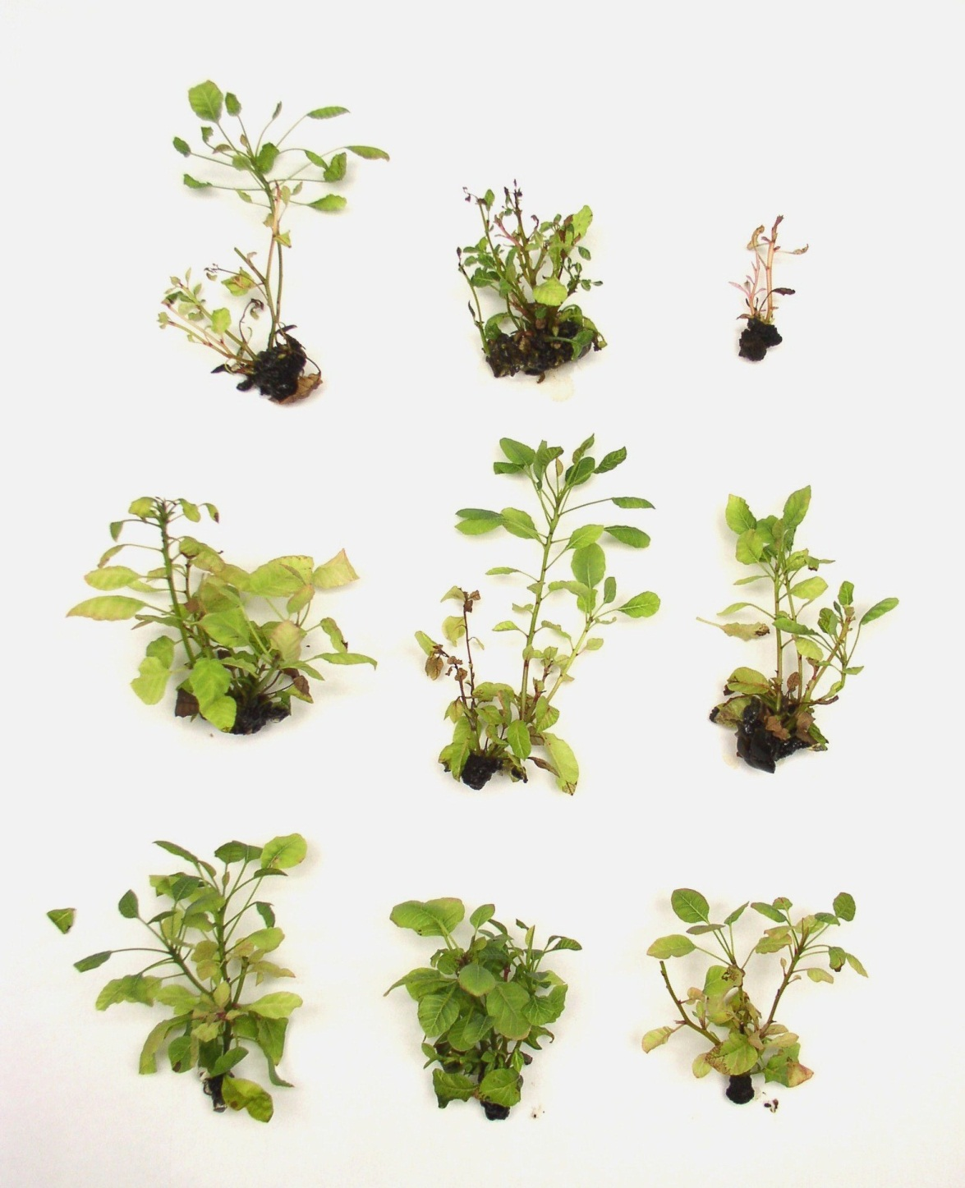
BA
MemT
MemTR
Fig. 2.

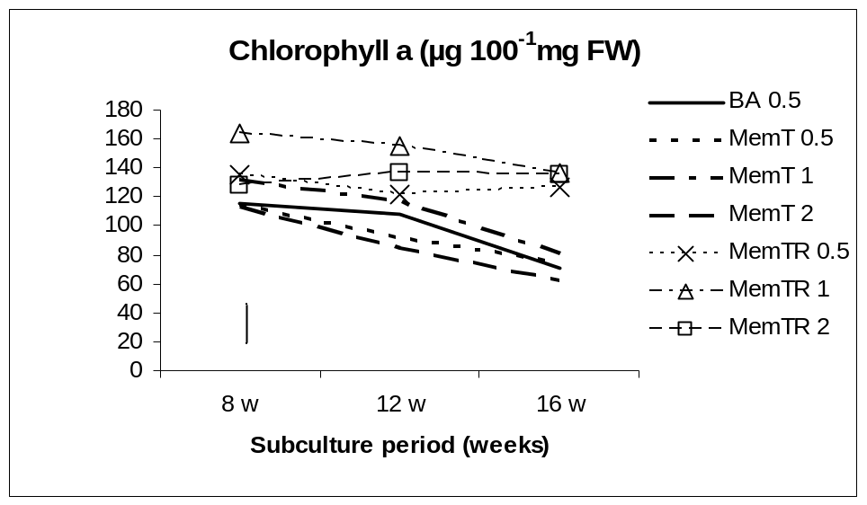

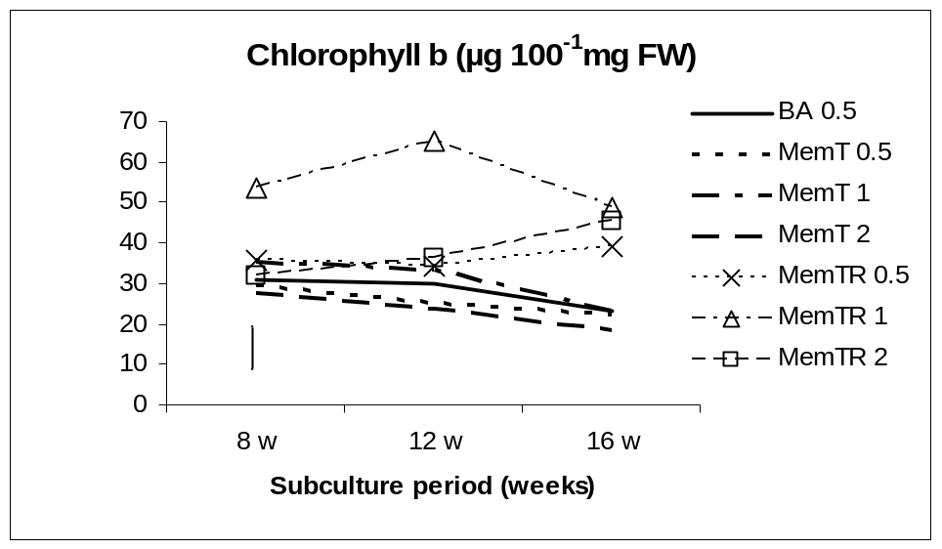

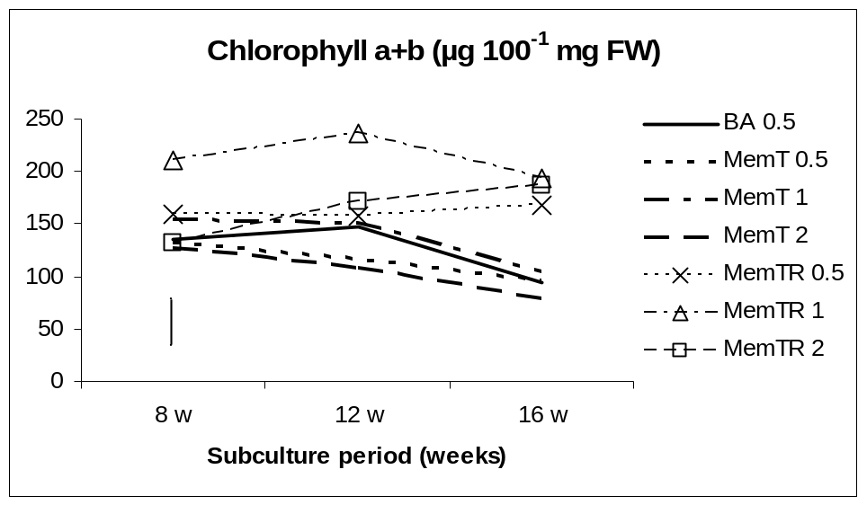
Fig. 3.

