Regeneration of Lycoris radiata plants by callus derived from bulbs explants
Jia He, Bing Xia, Yumei Jiang, Feng Peng, Ren Wang*
Institute of Botany, Jiangsu Province and Chinese Academy of Sciences, Nanjing 210014, China.
*Fax: +86 25 84347074, * E-mail: jswangren@aliyun.com

Abstract: Lycoris radiata is an important ornamental species of Amaryllidaceae family with medicinal value. There is a great need to develop in vitro propagation techniques for this species for the purpose of conservation and commercialization. In this regard, a protocol for in vitro plant multiplication of Lycoris radiata from bulbs was developed. Bulbs were selected as the explants. The highest rate of shoots initiation was observed on MS medium supplemented with 3.0mg/l 6-benzyladenine (BA) in combination with 0.2mg/l α-naphthaleneacetic acid (NAA) after 6 weeks of inoculation. The highest response of callus formation was observed in MS medium supplemented with 2.0mg/L 2, 4-D and 1.0mg/L BA. Shoot regeneration was developed in MS medium supplemented with 5.0 mg/l BA in combination with 0.5 mg/l NAA. This medium can not only induce shoot proliferation but also improve shoot length. Well-developed shoots were rooting on MS medium supplemented with 1 mg/lindole-3-butyric acid (IBA) with 100% rooting and 95% of the regenerated plantlets survived before being transferred to field conditions.
Key words: Lycoris radiata, Bulbs explants, Callus, Shoot regeneration.

Introduction
Lycoris radiata is a bulbous perennial plant. The presumed original form of Lycoris radiata, known as L. radiata var. pumila, occurs only in China. It normally distributes in the middle and lower reaches of Yangtze River. This Lycoris is a common ornamental plant in East Asia. Since these scarlet flowers usually bloom near cemeteries around the autumnal equinox, they are described in Chinese and Japanese translations of the Lotus Sutra as ominous flowers that grow in Hell. Many people like it because of its red beautiful flowers and legends in Buddhism. The whole plant, including the tubers are reported to possess alkaliods with antipyretic, detoxification, anti-inflammatory, and anti-virus effects. Galantamine (GAL), one of these alkaloids, is an important drug for the treatment of Alzheimer’s disease (Howes and Houghton 2003, Laurain-Mattar 2008).
Natural reproduction rate of Lycoris radiata is very low because its’ triploid forms are sterile, and reproduce only vegetatively, via bulbs. Artificial propagation of Lycoris radiata is done primarily by bulbs planting. However, these methods suffer disadvantages such as bulbs degradation, high expenses and poor transplanting survival of the plants. In vitro propagation offers great potential for the Lycoris radiata industry for large scale multiplication of selected clones and enables production of a high amount of constant quality plantlets within a very short time. The successful micropropagation of Amaryllidaceae plants has been reported by Sellés et al. (Narcissus, 1999), Zayed et al. (Hippeastrum, 2009), and Ptak et al. (Leucojum, 2010). Although elementary study in vitro propagation has been developed for Lycoris radiata (Zhu et al. 2002; He et al. 2003), efficient Lycoris radiata micropropagation was not achieved because of poor regeneration and large areas of explants browning. Dai et al. (2012) used seed embryoes of Lycoris chinensis as explants in the study of tissue culture and rapid propagation. Zhu et al. (2010) have used twin-scaling of bulbs explants to establish shoot proliferation. However, there were still some problems which should be resolved such as the multiplication of adventitious shoots of Lycoris radiata were few, high contamination rate and browning rate of explants, and no consistent callus induction and regeneration occurred. In this article, we report a reliable and efficient protocol for rapid in vitro shoot induction and rooting of Lycoris radiata plants. Thus, the different sterilization treatments on bulbs and the sucrose concentration on shoot and bulblets formation were examined.

Materials and methods
Plant material and initiation of in vitro shoot cultures
Bulbs form different season (Leaf phase: Mar.-Mary., Dormancy phase 1:Jun.-Aug., Flowering phase: Sep.-Oct., Dormancy phase 2:Nov.-Feb.in next year), inflorescence and seeds were used as explants. All the explants were stored in 4℃ for a month. Bulbs with the base were shucked off and cut into 4 pieces, then washed thoroughly in running tap water for 30 min. The explants were rinsed in 75% ethanol for 1 min, followed surface sterilized by immersing in solution with 20min 2~5% (w/v) hypochlorite or 10min 0.1~0.2% (w/v) mercuric chloride solution(each solution contains one or two drops of tween-20 or not), rinsed five times with sterile distilled water and inoculated in glass bottles containing approximately 15 ml MS (Murashige and Skoog 1962) basic medium or B5 (Gamborg et al. 1968) basic medium supplemented with 1.0-5.0 mg/l 6-benzyladenine (BA) in combination with α-naphthaleneacetic acid (NAA) at concentrations of 0, 0.2, 0.4 mg/l to promote sprouting of adventitious buds, media PH was adjusted to 5.8.

Callus induction
Bulbs were used as explants. The same surface sterilized method was used in explants preparation. Bulbs with the base were also shucked off and cut into 4 pieces, then cultured on MS medium supplemented with different with various combinations and concentrations of auxins 2, 4-D (0-4.0mg/L), NAA (0.2, 0.4 and 0.8 mg/L) and cytokines kinetin(0.1-0.8 mg/L), or BA (0,0.5,1.0 and 2.0 mg/L) with 3% (w) sucrose. The pH of the medium was adjusted to 5.8 before sterilization.

Shoot regeneration from calluses
The calluses were transferred to the adventitious shoot regenerations of MS medium after subculture. Two methods were used for the regeneration of the adventitious shoot. In the first method, the explants were cultured on the media containing 50 ml of MS basal medium with BA concentrations of 1, 2, 3, 5 mg/l alone or in combination with α-naphthaleneacetic acid (NAA) at concentrations of 0, 0.5, 1.0 mg/l.
In the second method, the calluses were cultured on MS medium supplemented with 2, 4-D concentrations of 0.5, 1, 2, 4 mg/l alone or in combination with α-naphthaleneacetic acid (NAA) at concentrations of 0, 0.5, 1.0 mg/l. After 6 weeks culture, the number of shoots per callus and the length of the shoots was recorded to evaluate the efficacy of cytokinin on shoot proliferation and growth. A medium without plant growth regulators was used as a control.

Rooting and acclimatization
When the shoots reached 4-5 cm long and the new bulblets began to take shape, they were separated and transferred to rooting medium consisting of MS medium supplemented with 2% sucrose and 0.7% agar. Indole-3-acetic acid (IAA), NAA, and indole-3-butyric acid (IBA) at different concentrations (0.5, 1, 2mg/l) were compared for rooting. Data on the percentage of rooting and the mean number of roots were recorded after 4 weeks. The well rooted shoots were washed thoroughly under running tap water and transplanted to pots with containing peat and perlite (2:1), hardened in an acclimatization chamber for 2 months, then transferred to field conditions.
The effects of different concentrations of sucrose (30, 60, 90, 120, 150g/L) on shoot and bulblets formation were also examined after 30 days.

Culture conditions:
All the media for adventitious shoot induction and proliferation contained 30 g l⁻¹ sucrose (except the rooting medium contained 90 g l⁻¹ sucrose) and 7 g l⁻¹ agar (Sanland Chemical Co. Ltd., USA). The pH of the media was adjusted to 5.8 before disinfecting in autoclave at a temperature of 121°C and under the pressure of 151 kPa for 16 min. The cultures were incubated at 25 ± 1°C with 14 h light (at a photosynthetic photon flux density of 50 μmol m^{–2} s^{–1})/25 ± 1°C with 10h dark cycle.

Statistical analysis:
Each treatment comprising 30 explants was repeated three times. The data was an average of the two periods of a year. The successful production of viable plantlets was evaluated after 30 days, and analysis of variance (ANOVA) was applied by using SPSS software (version 13.0). The mean differences were investigated at p ≤ 0.05 level.

Results and discussion
Adventitious buds initiation
Effects of explants growth in different seasons
Adventitious buds were induced from explants of all three sources. Compared to the other two sources, Bulbs were the best source of explants. Maximum shoot induction response was observed in explants grown in the second dormancy stage. (Nov.-Fed. in next year，Table 1）This results was in agreement with Zhu et al. (2010).

Effects of different sterilization treatments on bulbs contamination rate and inducing rate
Bulbs treated with sodium hypochlorite (5.65%) showed 21% contamination rate after two weeks of culture. But there was no buds initiation after several weeks. Bulbs treated with the lower concentration of sodium hypochlorite (3.39%,2.26%)and 2–3 drops of Tween－20 solution showed the similar contamination after two weeks and the higher buds inducing rate after four weeks of culture. Bulbs treated with 0.1%-0.2% mercuric chloride showed lower fungal contamination after two weeks of culture. But these treatments led to substantial decline in buds inducing rate. (Table 2) In the previous study, mercuric chloride often used as disfinector, so the buds inducing rate was lower and the bigger amount of explants browning (Zhu et al. 2002, He et al. 2003, Zhu et al.2010) compared to the explants treatment in sodium hypochlorite.

Effects of media and plant growth regulators
It was observed that the bud initiation started from the cut surface of the bulb basal(Fig2.A). Although there was not a significant difference between the different types of basal salt media in terms of their effect on buds initiation, in general, MS gave better results than B5 as the buds yields were higher. MS medium is frequently used for micropropogation of large number of Amaryllidaceae plants (Sellés et al., 1999; He et al., 2003).
Hormone regimes played as a key factor in buds formation. When the media contained both 6-BA and NAA, this would obviously increase the percentage of buds formation. It was found that 3mg/l 6-BA was better for buds initiation as it increased both the percentage of buds induction from the bulbs and the amount of buds produced per explants. If NAA was added to the medium, the percentage of buds initiation would increase significantly compared to the case when only 6-BA was present.Table3 showed the results of buds initiation from the bulbs on different media. When the concentration of 6-BA increased to 3mg/l in combination with 0.2mg/l NAA, the shoot inducing rate was higher than other treatments.

Callus Induction
Callus induction was observed after 21-28 days of culturing of bulbs samples(Fig2.C). The highest response of callus formation (74.6±1.8%) was observed in MS medium supplemented with 2.0mg/L 2, 4-D and 0.5mg/L BA which resulted in yellow soft callus. The combination of NAA with BA gave green hard callus. In general, it was observed that was the best source of auxin for callus induction along with BA; then NAA with BA (Table 4). Dai et al (2012) get the callus by used seed embryoes of Lycoris chinensis as explants. But the previous study showed that there were no callus induction could be observed in the process of in vitro propagation of Lycoris radiate. (Zhu et al. 2002, He et al. 2003)
The effect of increasing the kinetin concentration on callus initiation was also evaluated. The media containing 1mg/L kinetin did not produce any callus or produced significantly smaller amounts of callus compared to the other treatments. This was because of the detrimental effect of kinetin on the explants (the explants turned brown). Kinetin also gave the lowest percentage of callus initiation in all groups. (Data is not shown).

Shoot regeneration
After transferring these calluses to a basal medium supplemented with 1.0–2.0 mg/l of 2, 4-D and BA, two kinds of structures developed: somatic embryos, adventitious roots (mainly from the watery callus). In the watery callus, rhizogenesis was observed within 2 weeks of incubation, but the roots soon became brown and died (Fig2. D). The embryo-like structures developed small bulblets with shoots in 2–3 months after regeneration of culture (Fig 2. E and F). The effects of BA, 2, 4-D alone and in combination with NAA on shoot multiplication is present in Table 3.
Callus cultured on plant growth regulator-free MS medium showed reduced shoot formation. Without the addition of NAA, the optimum number of regenerated shoots (4.10) was observed when 3 mg/l of BA was added to the medium. There were fewer shoots (1-1.21) per explants when medium was supplemented with all concentrations of 2, 4-D. The results showed that BA was more effective than 2, 4-D in inducing shoot development and multiple shoot induction. With the addition of NAA, BA at all concentrations along with 0.5 mg/l NAA did not only show a marked effect on shoot number, but also increased shoot length. Both shoot number and shoot length were inhibited when 1.0 mg/l NAA was added in the medium combined with BA. (Table 5) The positive effect of BA on bud proliferation and multiple shoot formation has been recently reported for the propagation of other plants, including Bauhinia Tomentosa (Ruphi et al. 2011), Opuntia lanigera Salm–Dyck (Estrada-Luna et al. 2008), Trichodesmaindicum (Linn) R.Br. (Verma et al. 2008) and Jasminum Sambac L.(He at al. 2011). Our results also showed that BA 5.0 mg/l in combination with 0.5 mg/l of NAA can not only induce shoot proliferation but also improve shoot length. Compared with adventitious bud initiation from bulbs, the method of callus induction and shoot regeneration is more efficiency. (Propagation coefficient increased by 3-5 times)

Rooting and acclimatization
Regenerated shoots 4-5 cm long were excised and cultured on MS medium containing different concentrations of IAA, NAA or IBA. The rooting response to different auxin is shown in Table 4. Root induction occurred in 47% of the cuttings in the control treatment to which no auxin was added to the medium, but the roots were longer, thicker, and more robust when NＡA or IAA was present. From the three auxin tested, IBA was most effective and the percentage of rooting formation was observed to be 100% at all concentrations. IBA 1 mg/l produced a maximum of 8.91 roots per bulblet within 4 weeks. The roots were induced directly from the bulblet base on the medium supplemented with IBA. More shoots produced roots when the IAA concentration was increased, such that 77% of the explants formed roots at 0.5 mg/l compared to 100% at 2 mg/l IAA. NAA 0.5-2 mg/l resulted in 80-90% root formation with an average of 4.88-5.52 roots per shoot (Fig2.G). In the present investigation, various growth hormone were tested. The roots were shorter and swollen compared to those on media containing IBA at the same concentration. (Table 6)Contrary to our results, Zhu et al. (2002) and He et al. (2003) used IAA for root production from the bulblets. IBA was reported as the most effective auxin for rooting with some ornamental and medicinal plants in other studies, such as in PIPER NIGRUM L. (Hussain et al. 2011), Chrysanthemum plants (Thangmanee et al. 2011), Andrographis paniculata (Purkayastha et al. 2008), Phellodendronamurense Rupr (Azad et al. 2005), Mucunapruriens (L.) (Faisal et al., 2006), Balanitesaegyptiaca L. (Siddique and Anis, 2009) and Centellaasiatica L. (Mohapatra et al., 2008).

Effects of different sucrose concentration sucrose on the on growth state of the bulblets
The experimental results showed that a different sucrose concentration effects on the growth of the Lycoris radiata bulblet. The diameter of bulblet increased with increasing sucrose concentration in the sucrose concentration of 90 g/L was 2.6 times than the small diameter of the bulb to increase the maximum control (sucrose concentration of 30 g/L), small bulb leaves a high degree decreases with the increase of sucrose concentration. This is in agreement with previous results where the addition of sucrose to the nutrient medium also improved bulb development in Narcissus cultivars (Staikidou et al. 2005; Chow et al. 1992), L. aestivum (Berkov et al. 2009) and in Narcissus pseudonarcissus (Tahchy et al. 2011). But it was not reported in Lycoris radiata. Growth index and dry weight / fresh weight also increased with increasing sucrose concentration, but the effect was not significant.

Conclusion
The explants should be stored in 4℃ for a month can enhance buds and callus inducing rate, for the metabolites of Lycoris radiata would affect the propagation of bulbs. The lower temperature could eliminate these harmful metabolites. Different picking time can lead to different response of buds initiation. Explants growth in the second dormancy stage were the best source. Hypochlorite was the better disinfectant compared to mercuric chloride not only for the buds initiation but also for the shoots growth. The highest rate of shoots initiation was observed on MS medium supplemented with 3.0 mg/l 6-benzyladenine (BA) in combination with α-naphthaleneacetic acid (NAA) 0.2 mg/l BA. The highest response of callus formation was observed in MS medium supplemented with 2.0mg/L 2, 4-D and 1.0mg/L BA. 5.0mg/l in combination with α-naphthaleneacetic acid (NAA) 0.5 mg/l can not only induce shoot proliferation but also improve shoot length. The new bulblets formation was best in the medium with 90 mg/L concentrations of sucrose. Well-developed shoots were rooted on MS medium supplemented with 1 mg/lindole-3-butyric acid (IBA) with 100% rooting and 85% of the regenerated bulblets survived before being transferred to field conditions.
The present study established a protocol for the tissue culture of Lycoris radiata in vitro conditions via callus and meristem culture through bulbs segments of field-grown plants. Use of bulbs explants ensures clonal multiplication of selected species and helps to maintaining good traits, which is important for the quality of medicines. Using this regeneration method, we can quickly obtain a large number of plants for medicinal and ornamental use. This method is beneficial for the protection of wild resources.

Acknowledgements: This study was supported by the National Natural Science Foundation of China (grant no. 31270339) and the Jiangsu Agricultural Science and Technology Independent Innovation Fund [No.CX (11)1016]..

Reference:
Azad M. A. K., Yokota S., Ohkubo T., Andoh Y., Yahara S., Yoshizawa N. (2005). In vitro regeneration of the medicinal woody plant Phellodendron amurense Rupr. through excised leaves. Plant Cell Tissue Organ Cult, 80: 43-50.
Berkov S., Pavlov A., Ilieva M., Burrus M., Popov S., Stanilova M. (2005). CGC-MS of alkaloids in Leucojum aestivum plants and their in vitro cultures. Phytochemistry Analysis, 16(2): 98-103.
Chow Y. N., Selby C., Fraser T. W., Harvey B. M. R. (1992). Stimulation by sucrose of Narcissus bulbil formation in vitro. Journal of horticultural science, 62: 289-293.
Dai P., Zhang C. X., Zhang Z. (2012). Tissue Culture and Rapid Propagation of Lycoris Chinensis. Northern Horticulture, (22):95-98.
Estrada-Luna A. A., Martníez-Hernandez J. J., Torres-Torres M. E., Chablé-Moreno F. (2008). In vitro micropropagation of the ornamental prickly pear cactus Opuntia lanigera Salm-Dyck and effects of sprayed GA3 after transplantation to ex vitro conditions. Scientia Horticulturae, 117: 378-385.
Faisal M., Siddique I., Anis M. (2006). In vitro rapid regeneration of plantlets from nodal explants of Mucuna pruriens - a valuable medicinal plant. Annals of Apply Biology, 148: 1-6.
Gamborg O. L., Miller R.A., Ojima K. (1968). Nutrient requirements of suspension cultures of soybean root cell. Experimental Cell Research, 50: 148-151.
He S., Shu X., Yao Q., Xia B. (2003). Tissue culture of Lycoris radiate (LHer.) Herb. Journal of Jiangsu Forestry Science & Technology, 30(4): 124-127.
He L., He J., Xia B., Meng X., Peng F., He S., Wang R. (2011). In Vitro Propagation Of Jasminum Sambac L. ‘Double Petals’ by Axillary Buds. Propagation of Ornamental Plants, 11(4): 172-179.
Howes M. J. R., Houghton P. J. (2003). Plants used in Chinese and Indian traditional medicine for improvement of memory and cognitive function. Pharmacology Biochemistry and Behavior, 75: 513-527.
Hussain A., Shamma N., Hummera N., Zabta K. (2011). Tissue Culture Of Black Pepper (Piper Nigrum L.) In Pakistan. Pakistan Journal of Botany, 43(2):1069-1078.
Laurain-Mattar D. (2008). Production of alkaloids in plant cell and tissue cultures. In: Ramawat KG, Merillon JM (eds) Bioactive Molecules and Medicinal Plants. Springer, Berlin, pp 165-173.
Mohapatra H., Barik D., Rath S. (2008). In vitro regeneration of medicinal plant Centella asiatica. Biology of Plants, 52: 339-342.
Murashige T. and Skoog F. (1962). A revised medium for rapid growth and bioassays with tobacco tissue cultures. Physiologia Plantarium, 15: 473-497.
Purkayastha J., Sugla T., Paul A., Solleti S., Sahoo L. (2008) Rapid in vitro multiplication and plant regeneration from nodal explants of Andrographis paniculata: a valuable medicinal plant. In Vitro Cellular and Developmental Biology – Plant, 44(5):442-447.
Ptak A., Tahchy A. E., Wyzgolik G., Henry M., Laurain-Mattar D. (2010). Effects of ethylene on somatic embryogenesis and galanthamine content in Leucojum aestivum L. cultures. Plant Cell, Tissue and Organ Cult, 102: 61-67.
Ruphi N., Naseem A., Mohammad A., Ibrahim MA. (2011). In virtro cloning and histological evaluation of Bauhinia tomentosa L. Propagation of Ornamental Plants, 11(4): 189-196.
Sellés M., Viladomat F., Bastida J., Codina C.. (1999). Callus induction, somatic embryogenesis and organogenesis in Narcissus confusus: correlation between the state of differentiation and the content of galanthamine and related alkaloids. Plant Cell Reports, 18: 646-651.
Siddique I., Anis M. (2009). Direct plant regeneration from nodal explants of Balanites aegyptiaca L. (Del.): a valuable medicinal tree. New Forests, 37: 53-62.
Staikidou I., Watson S., Harvey BMR, Selby C. (2005). Narcissus bulblet formation in vitro: effects of carbohydrate type and osmolarity of the culture medium. Plant Cell, Tissue and Organ Cult, 80: 313-320.
Tahchy A. E., Bordage S., Ptak A., Dupire F., Barre E., Guillou C., Henry M., Chapleur Y., Laurain-Mattar D. (2011). Effects of sucrose and plant growth regulators on acetylcholinesterase inhibitory activity of alkaloids accumulated in shoot cultures of Amaryllidaceae. Plant Cell, Tissue and Organ Cult, 106: 381-390.
Thangmanee C., Kanchanapoom K. (2011). Regeneration of Chrysanthemum plants by callus derived from Ray Floret Explants. Propagation of Ornamental Plants, 11 (4): 204-209.
Verma N., Koche V., Tiwari KL., Mishra SK. (2008). Plant regeneration through organogenesis and shoot proliferation in Trichodesma indicum (Linn) R.Br. - a medicinal herb. African Journal of Biotechnology, 7: 3629-3634.
Zayed R., El-Shamy H., Berkov S., Bastida J., Codina C. (2011). In vitro micropropagation and alkaloids of Hippeastrum vittatum. In Vitro Cell Development Biology Plant, 47: 695-701.
Zhu J., Zhang Y., Liu C., MA M. (2010). Study on tissue culture and the plantlet regeneration of Lycoris radiata (LHer). Journal of Biology, 27 (6):159-163.
Table1 Effects of the collection times on the time of sprout and numbers of Lycoris radiata.
Time(min) | Leaf phase | Dormancy phase 1 | Flowering phase | Dormancy phase 2
Shoot initiation | 29±1bB | 30±0.5bB | 28±0.5bB | 39±1bB
Numbers of shoots per explants | 3.5±0.9bB | 3.5±0.5bB | 4.0±0.8bB | 7.5±0.5aA
Means followed by the same letters are not significantly different at p ≤ 0.05, according to LSD’s multiple range test.
Table2 Effects of different sterilization treatment in bulbs Contamination rate and inducing rate
Treatments | Contamination rate  (2 weeks) | Inducing rate  (4 weeks)
5.65%hypochlorite | 21% | 0
3.39%hypochlorite | 23% | 56%
2.26%hypochlorite | 27% | 74%
0.1%mercuric chloride | 11% | 26%
0.2%mercuric chloride | 8.3% | 12%
Means followed by the same letters are not significantly different at p ≤ 0.05, according to LSD’s multiple range test.
Table3 Result of orthogonal design experiments for of Lycoris radiata
Treatments | 6-BA | NAA | Inducing rate (%)
1 | 1.0 | 0 | 8%±0.01eD
2 | 1.0 | 0.2 | 11%±0.01efDE
3 | 1.0 | 0.4 | 7%±0.01deDE
4 | 3.0 | 0 | 74%±0.04bB
5 | 3.0 | 0.2 | 92%±0.02aA
6 | 3.0 | 0.4 | 62%±0.01cC
7 | 5.0 | 0 | 44%±0.04bB
8 | 5.0 | 0.2 | 52%±0.02cC
9 | 5.0 | 0.4 | 49%±0.01dD
Means followed by the same letters are not significantly different at p ≤ 0.05, according to LSD’s multiple range test.
Table4 Effect of different auxins combination with on callus induction in Lycoris radiata
Plant growth regulator | % of callus response
Plant growth regulator | 0 mg/l BA | 0.5mg/l BA | 1.0mg/l BA | 2.0mg/l BA
0 mg/l BA | -- | -- | -- | 14.7%±0.3ª
1.0mg/l 2,4-D | -- | 32.8%±1.6^{ab} | 29.3%±3.1^{d} | 15.6%±0.7^{ab}
2.0mg/l 2,4-D | 17.1%±1.2^{b} | 63.3%±2.5^{d} | 74.6%±1.8^{b} | 47.9%±2.1^{cd}
4.0mg/l 2,4-D | 11.6%±0.9ª | 42.1%±1.3^{c} | 48.4%±1.2^{c} | 39.5%±1.4^{ab}
0.2mg/lNAA | -- | 5.9%±2.4e | 7.8%±0.5ª | 11.3%±0.7ª
0.4mg/lNAA | -- | 6.7%±0.3ª | 10.9%±1.1^{ab} | 23.6%±1.5^{b}
0.8mg/lNAA | -- | 4.8%±0.8^{b} | 5.6%±0.4ª | 7.4%±1.2^{ab}
Means followed by the same letters are not significantly different at p ≤ 0.05, according to LSD’s multiple range test.
Table5 Effect of different cytokininsin combination with on shoot regeneration in Lycoris radiata
Plant growth regulator | Number of shoots per callus |  |  | Shoot length (cm)
Plant growth regulator | 0 mg/l NAA | 0.5 mg/l NAA | 1.0 mg/l NAA | 0 mg/l NAA | 0.5 mg/l NAA | 1.0 mg/l NAA
0 mg/l BA | 1.05±0.05e |  |  | 3.70±0.13^{ab}
1 mg/l BA | 2.26±0.14^{d} | 2.25±0.25^{b} | 1.40±0.24^{abc} | 3.69±0.17^{ab} | 3.88±0.24^{b} | 3.97±0.04^{b}
2mg/l BA | 2.93±0.22^{c} | 2.50±0.19^{b} | 1.43±0.20^{ab} | 4.30±0.14^{bc} | 4.62±0.21^{bc} | 4.73±0.15ª
3mg/l BA | 4.10±0.38^{b} | 4.00±0.52ª | 1.67±0.17ª | 5.08±0.12^{c} | 5.11±0.06^{cd} | 5.62±0.05^{c}
5mg/l BA | 5.33±0.21^{abc} | 7.27±0.66ª | 1.13±0.48ª | 5.35±0.11^{bc} | 5.89±0.18^{b} | 5.50±0.04^{c}
0.5mg/l2,4-D | 1.06±0.06e | 1.30±0.15^{c} | 1.00±0.0^{c} | 3.95±0.05ª | 3.69±0.19ª | 3.12±0.12^{b}
1 mg/l2,4-D | 1.10±0.07e | 1.20±0.20^{c} | 1.18±0.12^{bc} | 3.79±0.09ª | 3.31±0.09^{cd} | 3.17±0.09^{b}
2 mg/l2,4-D | 1.13±0.13e | 1.14±0.14^{c} | 1.00±0.0^{c} | 2.95±0.14^{c} | 3.25±0.16^{cd} | 3.92±0.10^{b}
4 mg/l2,4-D | 1.21±0.11e | 1.13±0.13^{c} | 1.00±0.0^{c} | 2.48±0.09^{d} | 2.06±0.15^{d} | 2.58±0.05^{c}
Means followed by the same letters are not significantly different at p ≤ 0.05, according to LSD’s multiple range test.

Table6 Effect of various concentrations of IAA, NAA and IBA on root formation from regenerated shoots on MS medium of Lycoris radiata.
Auxins | Percentage of  Rooting(%) | Number of roots per shoot
(Control) | 47^{d} | 3.88±0.18^{ef}
0.5 mg/l IAA | 77^{c} | 4.10±0.54^{def}
1 mg/lIAA | 97^{ab} | 6.32±0.43^{bc}
2 mg/lIAA | 100ª | 6.38±0.49^{bc}
0.5mg/lNAA | 83^{c} | 5.52±0.37^{cd}
1 mg/lNAA | 90^{b} | 4.96±0.40^{cde}
2 mg/lNAA | 80^{c} | 4.88±0.53de
0.5 mg/l IBA | 100ª | 7.31±0.38^{b}
1 mg/l IBA | 100ª | 8.91±0.72ª
2 mg/l IBA | 100ª | 8.75±0.31ª
Means followed by the same letters are not significantly different at p ≤ 0.05, according to LSD’s multiple range test.

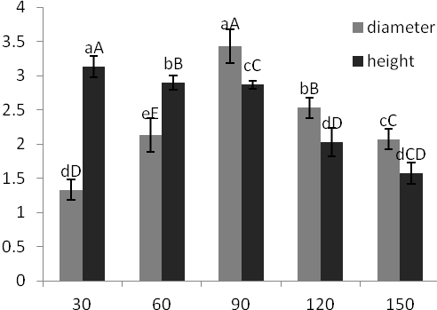
Fig 1 Effects of different concentrations of the sugars on growth state of the bulblets. Vertical bars represent mean values of three replications ± SD.

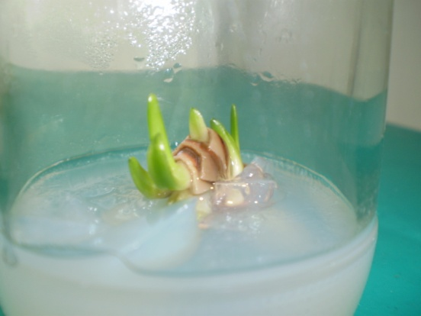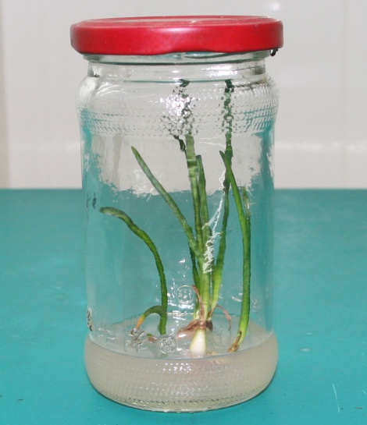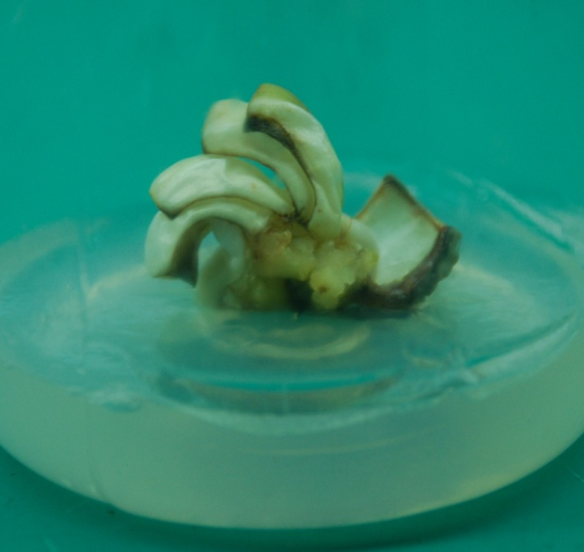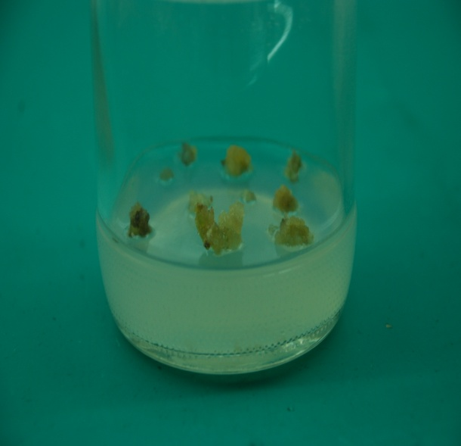
A
B
C
D
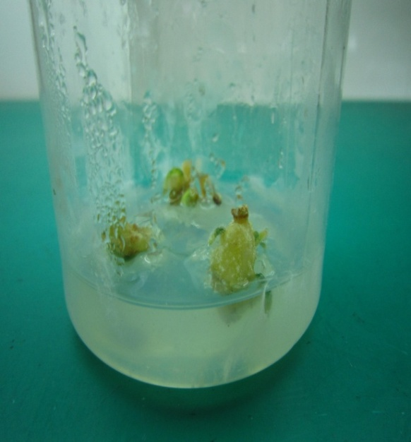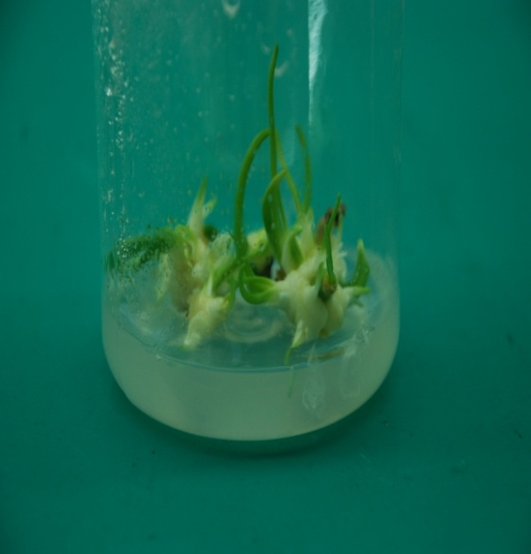
E
F
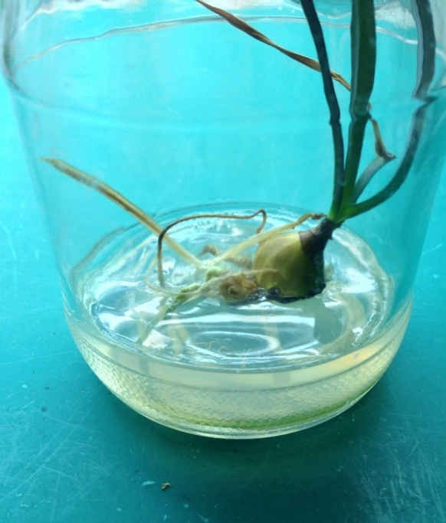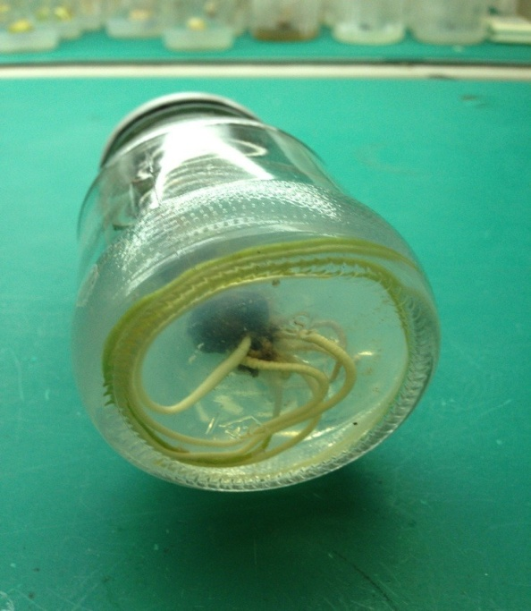
G
H

Fig.2 A) The axillary bud inducing formed on MS medium supplemented with 3.0mg/l6-benzyladenine (BA) in combination with α-naphthaleneacetic acid (NAA) 0.2 mg/l after 2-4 weeks. B) The roots inducted on MS medium supplement with IBA 1.0 mg/l and sucrose 90 mg/l C) The callus induction on MS medium supplemented with 2.0mg/L 2, 4-D and 0.5mg/L BA. D) watery callus soon became brown and died E) The embryo-like structures developed shoots F). The elongated and shoots proliferated on medium supplement with BA 5.0 mg/l in combination with α-naphthaleneacetic acid (NAA) 0.5 mg/l. G,H）The roots and bulbs before being transferred to field conditions.

