Micropropagation of Rhododendron keiskei var. hypoglaucum Suto & Suzuki and assessment of clonal fidelity of plantlets by RAPD
Iyyakkannu Sivanesan¹ and Byoung Ryong Jeong^{1, 2, 3*}
¹Institute of Agriculture and Life Science, Gyeongsang National University, Jinju, Korea 660-701
Fax: +82-55-757-7542, *E-mail:brjeong@gnu.ac.kr
²Department of Horticulture, Division of Applied Life Science (BK21 Program), Graduate School, Gyeongsang National University, Jinju, Korea 660-701
³Research Institute of Life Science, Gyeongsang National University, Jinju, Korea 660-701
Abstract
An efficient reproducible protocol has been developed for in vitro propagation of Rhododendron keiskei var. hypoglaucum. Nodal explants were cultured on Anderson basal salt (AM) medium supplemented with different concentrations and combinations of plant growth regulators for axillary shoot proliferation. The highest percentage of shoot induction (96%) was achieved when nodal explants were cultured on AM medium supplemented with 2.0 mg L⁻¹ 2-isopentyl adenine (2iP), 0.5 mg L⁻¹ indole-3-acetic acid (IAA) and 1.0 mg L⁻¹ gibberelic acid (GA₃) with a mean of 16 shoots per explant. Individual shoots, which were grown to about 2-3 cm long, were transferred onto a full or half strength AM medium with 0, 0.5, 1.0, 2.0 or 4.0 mg L⁻¹ indole-3-butyric acid (IBA) or NAA for rooting. The highest percentage of rooting (100%), with maximum number of 7.6 roots per shoot and the greatest root length (4.4 cm) were obtained on the half-strength AM medium supplemented with 0.5 mg L⁻¹ IBA. The regenerated plantlets were successfully acclimatized in the greenhouse with 95% of survival. The acclimatized plants grew normally without morphological abnormalities or variations. Further, random amplified polymorphic DNA analysis confirmed that the regenerated plantlets were genetically identical to their mother plant.
Key words: 2-isopentyl adenine, Anderson medium, conservation, endangered species, in vitro propagation
Introduction
Rhododendrons are among the most important woody landscape plants. The genus Rhododendron (Ericaceae) consists of around 1200 species distributed throughout Northeast Asia and Eurasia, Western Europe and North America (Mao et al. 2011). Gibbs et al. (2011) reported that about 25% of all Rhododendron taxa are under threat of extinction in the wild. Rhododendron keiskei var. hypoglaucum Suto and Suzuki is a low compact shrub with pale yellow or lemon-yellow flowers, native to Japan. It is rare and very small population remains in Kanto District of central Honshu (Gibbs et al. 2011). For the first time we found this important plant species in the rocky cliffs of Daesambudo islet in Yeosu, Korea. Rhododendrons are conventionally propagated through cuttings and seed. However, the rate of vegetative propagation is very slow and seed germination in nature is also very poor (Mao et al. 2011). The difficulties associated with propagation by conventional techniques may be overcome using tissue culture techniques (Sivanesan et al. 2011). In vitro propagation is an important asexual method that can be used for the production of clonal plants; it also forms the basis for the production of genetic variation or improvement of species by genetic transformation or somaclonal variations (Parveen et al. 2012). Although in vitro plant regeneration protocols have been developed for Rhododendron species (Iapichino et al. 1992; Marks and Simpson 1999; Tomsone and Gertnere 2003; Almeida et al. 2005; Hebert et al. 2010; Mao et al. 2011), there have been no reports on plant regeneration from explants of R. keiskei var. hypoglaucum.
The genetic homogeneity of in vitro-regenerated plants is very important for mass clonal propagation and conservation. Axillary shoot proliferation generally retains clonal fidelity, and variations are rarely observed among the regenerated plants (Sivanesan and Jeong 2012). Somaclonal variation is usually associated with point mutations, chromosomal rearrangements, DNA methylation, altered sequence copy number, and transposable elements (Bairu et al. 2011). Somaclonal variants can be detected using various methods such as phenotypic identification (Kong et al. 2012; Sivanesan and Jeong 2012), cytological analysis (Wang et al. 2012), estimation of nuclear DNA content (Rai et al. 2012), protein analysis (Northmore et al. 2012), and secondary metabolites analysis (Verma et al. 2012). Molecular analysis is being widely used for monitoring genetic homogeneity of in vitro-regenerated plants (Bairu et al. 2011). Random amplified polymorphic DNA (RAPD) techniques have been successfully used to assess genetic variations in rhododendrons (Dunemann et al. 1999; Lanying et al. 2008; Liu et al. 2012). Recently, RAPD has been successfully used to detect in vitro-induced Rhododendron mutants (Atak et al. 2011).
The objective of this study was to develop a simple and efficient in vitro plant regeneration protocol for R. keiskei var. hypoglaucum. We investigated the effects plant growth regulators (PGRs) on shoot regeneration. In addition, we evaluate the genetic homogeneity of in vitro-regenerated plants using RAPD technique.
Materials and methods
Plant materials
Plants were collected from the rocky cliffs of Daesambudo islet in Yeosu, South Korea and maintained in the greenhouse. Actively growing healthy shoots were separated from greenhouse-grown plants. Explants were washed thoroughly in running tap water for 30 min and soaked in Teepol solution (0.1%, v/v) for 5 min, and then washed three times with distilled water. Thereafter, in aseptic conditions, explants were decontaminated with solution of 70% (v/v) EtOH for 60 s, and 5.0% (v/v) sodium hypochlorite for 15 min. Finally, they were rinsed five times with sterile distilled water and cut into nodal segments (0.5-1.0 cm).
Culture medium and conditions
The medium consist of Anderson basal salts (Anderson 1984) supplemented with 3% (w/v) sucrose, and solidified with 0.8% (w/v) plant agar. The pH of the medium was adjusted to 5.70 before autoclaving at 121°C for 15 min. Gibberellic acid (GA₃) was filter-sterilized and added to the autoclaved medium. Other plant growth regulators were added to a basal medium prior to pH adjustment and sterilization. All cultures were maintained at 25 ± 1°C under a 16-h photoperiod with 45 µmol m⁻² s⁻¹ photosynthetic photon flux density (PPFD) provided by cool white fluorescent lamps (Philips 40 W tubes).
Effect of PGRs on shoot regeneration and proliferation
Nodal explants were cultured on Anderson basal salt (AM) medium supplemented with 0, 0.5, 1.0, 2.0 or 4.0 mg L⁻¹ 2-isopentyl adenine (2-iP) for shoot bud induction. For shoot proliferation, 1.0 or 2.0 mg L⁻¹ 2-iP along with 0.1 or 0.5 mg L⁻¹ indole-3-acidic acid (IAA), and 1.0 mg L⁻¹ gibberellic acid (GA₃) were studied. The number of explants initiating shoot buds and average number of shoot buds per explant were recorded after 8 weeks. For each treatment, 15 explants were used and each experiment was repeated three times.
Rooting and acclimatization
Individual shoots, which were grown to about 2-3 cm long, were transferred onto a full or half strength AM medium with 0, 0.5, 1.0, 2.0 or 4.0 mg L⁻¹ IBA or NAA for rooting. After 7 weeks, the percentage of root induction, number of roots per shoot and roots length were recorded. For each treatment, 50 shoots were used and experiment was repeated three times. Plantlets with well developed roots were removed from culture, washed thoroughly with sterile distilled water to remove media, and planted in 120-cell plug trays containing a greenhouse medium (Tosilee medium; Shinan Grow, Jinju, Korea), and irrigated every alternative day with quarter-strength nutrient solution (Sivanesan et al. 2010), and were maintained in a greenhouse. The plug trays were shielded with clear plastic covers to maintain plantlets at high relative humidity. After 2 weeks of hardening, their covers were removed. Plantlet survival was recorded after 4 weeks. All data collected were subjected to analysis of variance (ANOVA) by using SAS program (Release 9.1; SAS Institute, NC, USA), and Duncan’s multiple range test was used to asses significant differences between mean values.
Molecular analysis of regenerated plantlets by RAPD
To test the clonal fidelity, the acclimatized plants were chosen randomly. These plants were compared with the mother plant from which explants were taken. Total genomic DNA of the mother plant and in vitro raised plants was extracted from young leaf tissue by using the plant DNA isolation kit (Invitrogen, Seoul, Korea). The concentration and quality of DNA samples were calculated from the Optical Density (OD) values at 260 and 280 nm and they were prepared of standardized DNA (20 ng µL⁻¹). Sixty four RAPD primers (Enotech, Daejeon, Korea) were used for initial screening. The PCR amplifications were performed in a Thermal Cycler PCR (GeneAmp PCR System 9700). PCR amplification reactions were carried out in a total volume of 20 µL. The mixture contained 0.5 µM of each primer, 40 ng of extracted DNA, 200 µM of each dNTP, 1.5 mM MgCl₂, and one unit of DNA polymerase (EnZynomics, Daejeon, Korea). Standard PCR reaction conditions were as follows: an initial denaturizing at 94°C for 4 min followed by 40 cycles of 30 sec at 94°C, 30 sec at 45°C, 1 min at 72°C and finally extended at 72°C for 10 min. The amplified products were resolved by electrophoresis on 1.8% agarose gel in tris-borate EDTA (TAE) buffer stained with ethidium bromide. The fragment sizes were estimated with 100bp - 1500 bp DNA ladder (Bio Basic Inc, Canada).
Results and discussion
The disinfection procedure yielded 76% aseptic explants. Nodal explants failed to develop shoots in a PGR-free AM basal salt medium even after 8 weeks of culture. Although AM medium with vitamins has been widely used for shoot induction of Rhododendron species. The addition of PGRs to the culture medium required for shoot induction of many Rhododendron species (Almeida et al. 2005; Vejsadova 2008). As the mechanism of apical dominance has been demonstrated to be under the control of various PGRs, the proportion of these regulators in the media can be manipulated to induce the regeneration of each meristem into viable shoots (Sivanesan and Jeong 2007). When the AM medium was supplemented with different concentrations of 2-iP, multiple shoot initiated from the nodal explants by the release of axillary buds from apical dominance within 2 weeks of culture. The stimulating effect of 2-iP in multiple shoot induction has also been reported in some Rhododendron species (Marks and Simpson 1999; Vejsadova 2008; Singh and Gurung 2009; Mao et al. 2011). The percentage of shoot induction and average number of shoots per explant varied among the different concentrations of 2-iP studied (Table 1). An increase in the concentration of 2-iP from 0.5 to 2.0 mg L⁻¹ increased shoot induction percentage, although further increases in the 2-iP concentration decreased the percentage of shoot induction. Maximum percentage of shoot induction (63%), with a mean number of 3.6 shoots per explant, was obtained on AM medium supplemented with 2.0 mg L⁻¹ 2-iP. Similar result was also reported in Erica multiflora (Iapichino et al. 2012).

The effect of auxin and cytokinin combination was evaluated on shoot induction. A combination of 2-iP and IAA maximized shoot induction percentage and the average number of shoots per explant significantly than 2-iP alone. This agrees with the results of earlier studies on Rhododendron species (Singh and Gurung 2009; Mao et al. 2011). Of the various combinations studied, AM medium with 2.0 mg L⁻¹ 2-iP and 0.5 mg L⁻¹ IAA was optimum for axillary shoot proliferation (Table 1). On this medium, 92.4% of the explants responded, with a mean number of 12.3 shoots per explant. The synergistic effect of 2-iP and IAA on multiple shoot induction has also been reported in Rhododendron cultivars (Vejsadova 2008) and R. maddeni (Singh and Gurung 2009).
We also evaluated the effect of GA₃ on shoot proliferation. Addition of GA₃ at 1.0 mg L⁻¹ in shoot proliferation medium (2.0 mg L⁻¹ 2-iP and 0.5 mg L⁻¹ IAA) stimulated both shoot induction percentage and number of shoots per explant (Table 1). The positive effect of GA₃ on shoot regeneration has been reported in many plant species (Kaushal et al. 2005; Isogai et al. 2008; Perez-Tornero et al. 2010). The highest percentage of shoot induction (96%) was achieved when nodal explants were cultured on AM medium supplemented with 2.0 mg L⁻¹ 2iP, 0.5 mg L⁻¹ IAA and 1.0 mg L⁻¹ GA₃ with a mean of 16 shoots per explant (Fig. 1a, b). Similar result was also observed in Rosa rugosa (Xing et al. 2010).
For rooting regenerated shoots were transferred to full- or half-strength AM basal medium. The shoots failed to develop roots in full-strength AM medium even after 8 weeks of culture. Similar result was observed in R. maddeni (Singh and Gurung 2009). In contrast, root induction was observed on AM medium in R.dalhousiae var. rhabdotum, R. elliottii and R. johnstoneanum (Mao et al. 2011). The shoots developed roots on the half-strength AM medium and the percentage of root induction was 63.8%. Reduced strength of basal medium is often used for rooting of adventitious shoots (Sivanesan and Jeong 2007). Thus, half-strength AM medium was used for further rooting experiments. The addition of IBA or NAA at 0.5 mg L⁻¹ in the basal medium significantly promoted rooting (Table 2). The effectiveness of IBA and NAA on rooting of the in vitro-regenerated rhododendron shoots has been reported earlier (Singh and Gurung 2009; Mao et al. 2011). The highest percentage of rooting (100%), with maximum number of 7.6 roots per shoot and the greatest root length (4.4 cm) were obtained on the half-strength AM medium supplemented with 0.5 mg L⁻¹ IBA (Fig. 2a). The stimulating effect of IBA in root formation has been reported in Rhododendron species (Almeida et al. 2005; Sing 2008; Singh and Gurung 2009; Mao et al. 2011). An increase in concentration above 0.5 mg L⁻¹ IBA reduced root length and promoted callusing (Fig.2b). A total of 1200 plantlets hardened in plug trays shielded with clear plastic covers benefited from high relative humidity and showed 95% survival (Fig. 2c-f). The acclimatized plants grew normally without morphological abnormalities or variations.
The genomic variations in phenotypically normal regenerants have been documented in many plants (Hu et al. 2008; Wang et al. 2012). The genetic homogeneity is required for clonal propagation and germplasm conservation. In order to assess the genetic uniformity of the in vitro-regenerated plants, we carried out RAPD analysis on the genomic DNA of randomly-selected 8 regenerated plants, along with the donor mother plant. The RAPD technique has been applied to many plants to evaluate genetic homogeneity or heterogeneity among the micropropagated and the donor mother plants (Atak et al. 2011; Bairu et al. 2011; Bhatia et al. 2011; Ramesh et al. 2011; Thankappan and Morawala-Patell 2011). Out of 64 different RAPD primers screened, 17 generated clear, reproducible and scorable bands. The number of scorable bands for each primer varied from 2 (OPA-11) to 9 (OPJ-6) (Table 3). The 17 RAPD primers produced 71 distinct and scorable bands in the size range of 200 to >1500 bp, with an average of 4.18 bands per primer. No polymorphic bands were observed between the in vitro-regenerated plants and the donor mother plant (Fig. 3a-d). The absence of genetic variation in the micropropagated plants using RAPD technique has also been reported earlier in Camellia sinensis (Mondal and Chand 2002), Dendranthema grandiflora (Minano et al. 2009), Dianthus caryophyllus and D. chinensis (Kumawat et al. 2013), Dioscorea prazeri (Thankappan and Morawala-Patell 2011), and Swertia chirata (Chaudhuri et al. 2008). Thus, this micropropagation protocol can be utilized for in vitro mass clonal propagation of R. keiskei var. hypoglaucum.
Acknowledgements: This research was supported by Technology Development Program for Agriculture and Forestry, Ministry for Food, Agriculture, Forestry and Fisheries, Republic of Korea. Project No: 109096-5.
References
Almeida R., Goncalves S., Romano A. (2005). In vitro micropropagation of endangered Rhododendron ponticum L. subsp. baeticum (Boissier & Reuter) Handel-Mazzetti. Biodiversity and Conservation, 14: 1059-1069.
Anderson W. C. (1984). A revised tissue culture medium for shoot multiplication of rhododendron. Journal of the American Society for Horticultural Science, 109: 343-347.
Atak C., Celik O., Acik L. (2011). Genetic analysis of Rhododendron mutants using random amplified polymorphic DNA (RAPD). Pakistan Journal of Botany, 43: 1173-1182.
Bairu M. W., Aremu A. O., Van Staden J. (2011). Somaclonal variation in plants: causes and detection methods. Plant Growth Regulation, 63: 147-173.
Bhatia R., Singh K. P., Sharma T. R., Jhang T. (2011). Evaluation of the genetic fidelity of in vitro-propagated gerbera (Gerbera jamesonii Bolus) using DNA-based markers. Plant Cell, Tissue and Organ Culture, 104: 131-135.
Chaudhuri R. K., Pal A., Jha T. B. (2008). Conservation of Swertia chirata through direct shoot multiplication from leaf explants. Plant Biotechnology Report, 2: 213-218.
Dunemann F., Kahnau R., Stange I. (1999). Analysis of complex leaf and flower characters in Rhododendron using a molecular linkage map. Theoretical and Applied Genetics, 98: 1146-1155.
Gibbs D., Chamberlain D., Argent G. (2011). The red list of rhododendrons. Botanic Gardens Conservation International, Richmond, UK, 128 pp.
Hebert C. J., Touchell D. H., Ranney T. G., LeBude A. V. (2010). In vitro shoot regeneration and polyploidy induction of Rhododendron ‘Fragrantissimum Improved’. HortScience, 45: 801-804.
Hu J., Gao X., Liu J., Xie C., Li J. (2008). Plant regeneration from petiole callus of Amorphophallus albus and analysis of somaclonal variation of regenerated plants by RAPD and ISSR markers. Botanical Studies, 49: 189-197.
Iapichino G., Barraco G., Airo M. (2012). The effects of growth regulators on in vitro axillary shoot proliferation and rooting of Erica multiflora L. Propagation of Ornamental Plants, 12: 209-214.
Iapichino G., McCulloch S., Chen T. H. H. (1992). Adventitious shoot formation from leaf explants of Rhododendron. Plant Cell, Tissue and Organ Culture, 30: 237-241.
Isogai S., Touno K., Shimomura K. (2008). Gibberellic acid improved shoot multiplication in Cephaelis ipecacuanha. In Vitro Cellular & Development Biology-Plant, 44: 216-220.
Kaushal N., Modgil M., Thakur M., Sharma D. R. (2005). In vitro clonal multiplication of an apple rootstock by culture of shoot apices and axillary buds. Indian Journal of Experimental Biology, 43: 561-565.
Kong D-M., Preece J. E., Shen H-L. (2012). Somatic embryogenesis in immature cotyledons of Manchurian ash (Fraxinus mandshurica Rupr.). Plant Cell, Tissue and Organ Culture, 108: 485-492.
Kumawat S., Kachhwaha S., Kothari S.L. (2013). Micronutrient optimization in the basal medium improves in vitro plant regeneration in carnation (Dianthus caryophyllus L.) and Chinese pink (Dianthus chinensis L.). Propagation of Ornamental Plants, 13: 3-11.
Lanying Z., Yongqing W., Li Z. (2008). Genetic diversity and relationship of Rhododendron species based on RAPD analysis. American-Eurasian Journal of Agricultural & Environmental Science, 3: 626-631.
Liu Y. F., Xing M., Zhao W. (2012). Genetic diversity analysis of Rhododendron aureum Georgi (Ericaceae) located on Changbai Mountain using ISSR and RAPD markers. Plant Systematics and Evolution, 298: 921-930.
Mao A. A., Kaliamoorthy S., Ranyaphi R. A., Das J., Gupta S., Athili J., Yumnam J. Y., Chanu L. I. (2011). In vitro micropropagation of three rare, endangered, and endemic rhododendron species of Northeast India. In Vitro Cellular & Development Biology-Plant, 47: 674-681.
Marks T. R., Simpson S. E. (1999). Effect of irridiance on shoot development in-vitro. Plant Growth Regulation, 28: 133-142.
Minano H. S., Gonzalez-Benito M. E., Martin C. (2009). Molecular characterization and analysis of somaclonal variation in chrysanthemum cultivars using RAPD markers. Scientia Horticulturae, 122: 238-243.
Mondal T. K., Chand P. K. (2002). Detection of genetic variation among micropropagated tea [Camellia sinensis (L.) O. Kuntze] by RAPD analysis. In Vitro Cellular & Development Biology-Plant, 38: 296-299.
Northmore J. A., Zhou V., Chuong S. D. X. (2012). Multiple shoot induction and plant regeneration of the single-cell C4 species Bienertia sinuspersici. Plant Cell, Tissue and Organ Culture, 108: 101-109.
Parveen S., Shahzad A., Anis M. (2012). Enhanced shoot organogenesis in Cassia angustifolia Vahl. – a difficult-to-root drought resistant medicinal shrub. Journal of Plant Biochemistry and Biotechnology, 21: 213-219.
Perez-Tornero O., Tallon C. I., Porras I. (2010). An efficient protocol for micropropagation of lemon (Citrus limon) from mature nodal segments. Plant Cell, Tissue and Organ Culture, 100: 263-271.
Rai M. K., Phulwaria M., Harish, Gupta A. K., Shekhawat N. S., Jaiswal U. (2012). Genetic homogeneity of guava plants derived from somatic embryogenesis using SSR and ISSR markers. Plant Cell, Tissue and Organ Culture, 111: 259-264.
Ramesh M., Vijayakumar K. P., Karthikeyan A., Pandian S. K. (2011). RAPD based genetic stability analysis among micropropagated, synthetic seed derived and hardened plants of Bacopa monnieri (L.): a threatened Indian medicinal herb. Acta Physiologiae Plantarum, 33: 163-171.
Singh K. K., Gurung B. (2009). In vitro propagation of R. maddeni Hook. f. an endangered Rhododendron species of Sikkim Himalaya. Notulae Botanicae Horti Agrobotanici Cluj-Napoca, 37: 79-83.
Sivanesan I., Jeong B. R. (2007). Direct shoot regeneration from nodal explants of Sida cordifolia Linn. In Vitro Cellular & Development Biology-Plant, 43: 436-441.
Sivanesan I., Jeong B. R. (2012). Identification of somaclonal variants in proliferating shoot cultures of Senecio cruentus cv. Tokyo Daruma. Plant Cell, Tissue and Organ Culture, 111: 247-253.
Sivanesan I, Son MS, Lee JP, Jeong BR (2010) Effects of silicon on growth of Tagetes patula L. ‘Boy Orange’ and ‘Yellow Boy’ seedlings cultured in an environment controlled chamber. Propagation of Ornamental Plants, 10: 136-140.
Sivanesan I., Song J. Y., Hwang S. J., Jeong B. R. (2011). Micropropagation of Cotoneaster wilsonii Nakai-a rare endemic ornamental plant. Plant Cell, Tissue and Organ Culture, 105: 55-63.
Thankappan S. S., Morawala-Patell V. (2011). In vitro propagation studies and genetic fidelity assessment of endangered medicinal wild assessment of endangered medicinal wild Yam-Dioscorea prazeri. Plant Omics Journal, 4: 177-189.
Tiwari O. N., Chauhan U. K. (2006). Rhododendron conservation in Sikkim Himalaya. Current Science, 90: 532-541.
Tomsone S., Gertnere D. (2003). In vitro shoot regeneration from flower and leaf explants in Rhododendron. Biologia Plantarum, 46: 463-465.
Vejsadova H. (2008). Growth regulator effect on in vitro regeneration of rhododendron cultivars. Horticultural Science (Prague), 35: 90-94.
Verma P., Mathur A. K., Shanker K. (2012). Enhanced vincamine production in selected tryptophan-overproducing shoots of Vinca minor. Plant Cell, Tissue and Organ Culture, 111: 239-245.
Wang Q-M., Gao F-Z., Gao X., Zou F-Y., Sui X., Wang M., Hui Y-J., Wang L. (2012). Regeneration of Clivia miniata and assessment of clonal fidelity of plantlets. Plant Cell, Tissue and Organ Culture, 109: 191-200.
Xing W., Bao M., Qin H., Ning G. (2010). Micropropagation of Rosa rugosa through axillary shoot proliferation. Acta Biologica Cracoviensia Series Botanica, 52: 69-75.

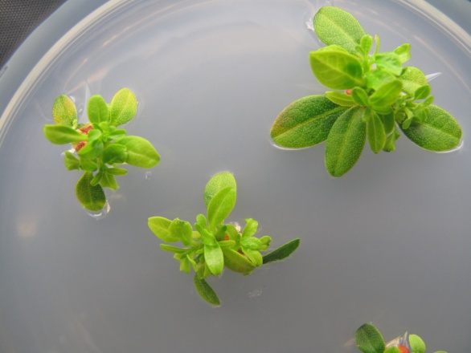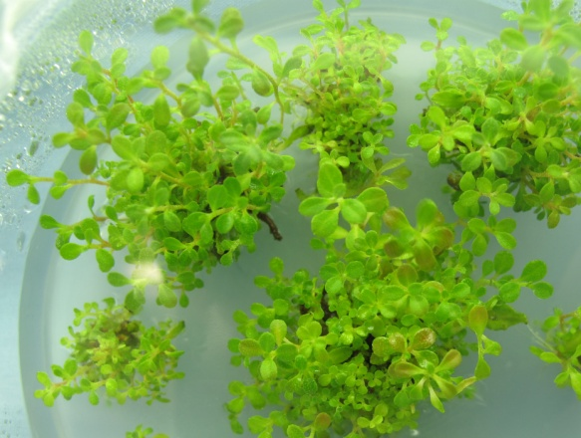
a
b
Fig. 1. Shoot regeneration from nodal explants of Rhododendron keiskei var. hypoglaucum cultured on AM medium supplemented with 2.0 mg L⁻¹ 2-iP, 0.5 mg L⁻¹ IAA and 1.0 mg L⁻¹ GA₃. a) after 4 weeks of culture and b) after 8 weeks of culture.

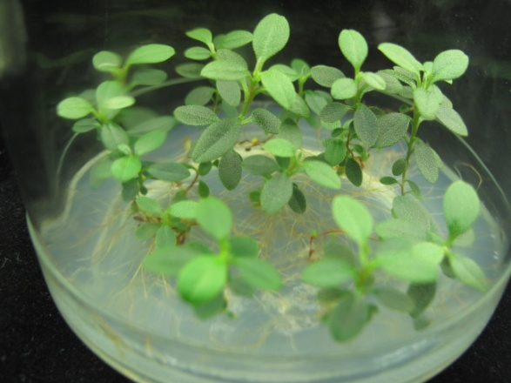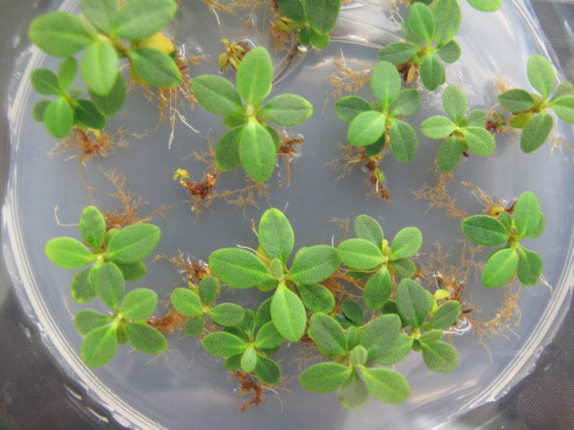
a
b
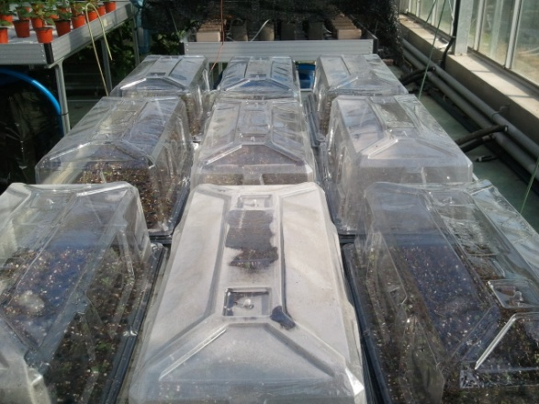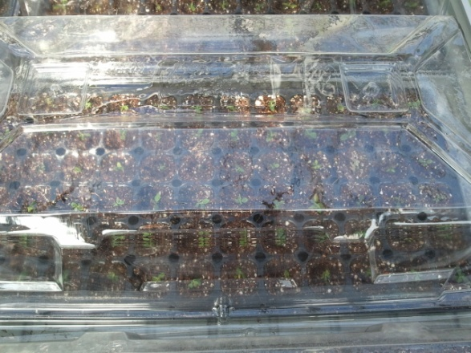
c
d
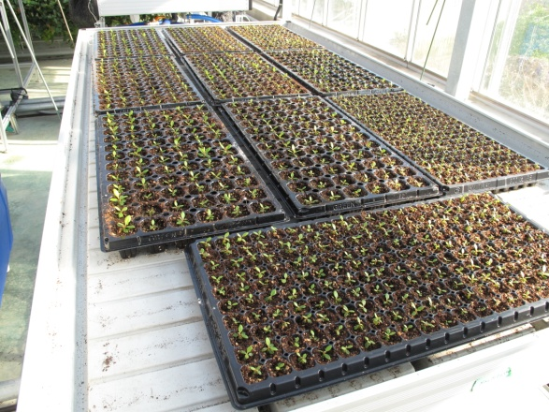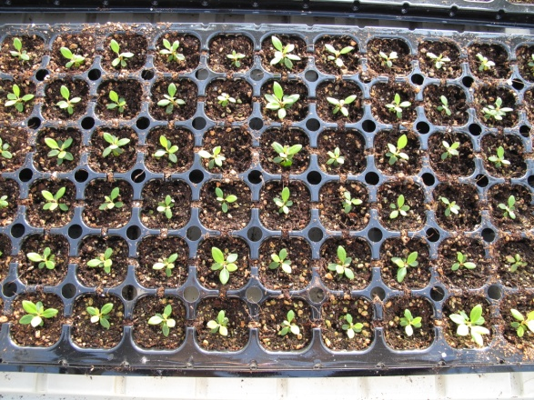
e
f
Fig. 2. Rooting and acclimatization of Rhododendron keiskei var. hypoglaucum.
Half-strength AM medium containing 0.5 mg L⁻¹ IBA (a) and 1.0 mg L⁻¹ IBA (b); acclimatization (c-f).

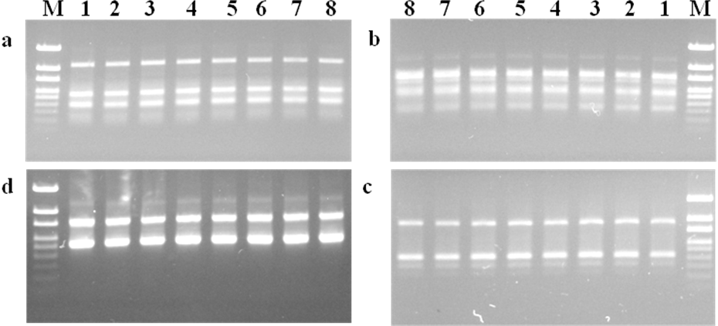
Fig. 3. Polymerase chain reaction (PCR) amplification products obtained with random amplified polymorphic DNA (RAPD) primers (a, OPA12; b, OPB5; c, OPC1 and d, OPD6). M represents 100bp-1500 bp ladder, 1 represents mother plant, Lane 2 to 8 represent in vitro raised clones of Rhododendron keiskei var. hypoglaucum.
Table 1. Effect of PGRs on multiple shoot formation from nodal explants of Rhododendron keiskei var. hypoglaucum.
PGRs (mg L⁻¹) |  |  | Shoot induction (%) | No. of shoots per explant
2-iP | IAA | GA₃ | Shoot induction (%) | No. of shoots per explant
0 | 0 | 0 | 0 | 0
0.5 | 0 | 0 | 43.6 ± 4.4 h | 1.6 ± 0.4 e
1.0 | 0 | 0 | 49.4 ± 2.6 g | 2.0 ± 0.6 e
2.0 | 0 | 0 | 63.0 ± 2.0 e | 3.6 ± 0.4 d
4.0 | 0 | 0 | 57.0 ± 3.0 f | 3.4 ± 1.0 d
1.0 | 0.1 | 0 | 76.4 ± 1.7 d | 6.7 ± 1.4 c
2.0 | 0.1 | 0 | 83.0 ± 1.0 c | 9.8 ± 1.2 b
1.0 | 0.5 | 0 | 87.4 ± 1.2 b | 8.6 ± 1.4 b
2.0 | 0.5 | 0 | 92.4 ± 1.6 ab | 12.3 ± 1.8 ab
2.0 | 0.5 | 1.0 | 96.0 ± 1.2 a | 16.0 ± 1.0 a
Means ± SE within a column followed by the same letters are not significantly different (p ≤ 0.05).

Table 2. Effect of different concentrations of auxins on root induction.
Conc. (mg L⁻¹) | Root induction (%) |  | No. of roots per shoot |  | Root length (cm)
Conc. (mg L⁻¹) | IBA | NAA | IBA | NAA | IBA | NAA
0 | 63.8 ± 3.2 b | 63.8 ± 3.2 c | 2.3 ± 0.7 c | 2.3 ± 0.7 b | 1.6 ± 0.4 c | 1.6 ± 0.4 b
0.5 | 100 ± 0.0 a | 91.2 ± 1.8 b | 7.6 ± 1.0 a | 5.8 ± 2.2 a | 4.4 ± 0.6 a | 3.0 ± 0.2 a
1.0 | 100 ± 0.0 a | - | 5.0 ± 1.0 b | - | 2.7 ± 0.4 b | -
2.0 | - | - | - | - | - | -
4.0 | - | - | - | - | - | -
- callus formation
Means ± SE within a column followed by the same letters are not significantly different (p ≤ 0.05).

Table 3. The random amplified polymorphic DNA (RAPD) primers utilized to verify Rhododendron keiskei var. hypoglaucum clones.
Primers | 5’-3’ motif | No. of scrorable bands | Range of amplification (bp)
OPA-12 | TCGGCGATAG | 3 | 350-1000
OPA-13 | CAGCACCCAC | 3 | 200-500
OPA-17 | GACCGCTTGT | 5 | 100-1500
OPA-18 | AGGTGACCGT | 3 | 200-500
OPB-01 | GTTTCGCTCC | 5 | 100-700
OPB-03 | CATCCCCCTG | 4 | 200-600
OPB-05 | TGCGCCCTTC | 4 | 300-1200
OPC-01 | TTCGAGCCAG | 3 | 300-1000
OPC-04 | CCGCATCTAC | 5 | 100-500
OPD-03 | GTCGCCGTCA | 5 | 300-1200
OPD-06 | ACCTGAACGG | 2 | 600-1000
OPE-03 | CCAGATGCAC | 3 | 500-1000
OPE-07 | AGATGCAGCC | 7 | 200->1500
OPG-02 | GGCACTGAGG | 2 | 200-700
OPG-03 | GAGCCCTCCA | 2 | 500-1100
OPJ-01 | CCCGGCATAA | 6 | 200->1500
OPJ-06 | TCGTTCCGCA | 9 | 200->1500

