ORIGINAL PAPER

ENHANCEMENT OF DIRECT SOMATIC EMBRYOGENESIS FROM LEAF EXPLANTS OF A PHAENOPSIS ORCHID BY POLYVINYLPYRROLIDONE AND ADJUSTING MEDIUM COMPOSITIONS

Wee-Peng Gow¹, Jen-Tsung Chen²* and Wei-Chin Chang¹

¹ Institute of Plant and Microbial Biology, Academia Sinica, Taipei, Taiwan, Republic of China
² Department of Life Sciences, National University of Kaohsiung, Kaohsiung 811, Taiwan, Republic of China

*Author to whom correspondence should be addressed: Email jentsung@nuk.edu.tw
Abstract
Medium compositions, including NaH₂PO₄, sucrose, active charcoal, polyvinylpyrrolidone (PVP) and strength of MS medium, were tested to optimize the culture medium for direct embryo induction from leaf explants of Phalaenopsis aphrodite subsp. formosana. The results showed that full- and 1/4-strength macro-elements of MS medium were not suitable for direct embryo induction from leaf explants. Thus, a suitable modified medium is proposed as 1/2-strength macro- and full-strength micro-elements of MS salts plus full-strength of MS vitamins, 170 mg/l NaH2PO4, 1 g/l peptone, 4.54 μM TDZ and 20 g/l sucrose. In addition, PVP at 0.25 g/l significantly promoted direct embryogenesis on the cut ends of the explant, but active charcoal at 0.5 - 1 g/l was inhibitory.

Key words: Active charcoal, direct somatic embryogenesis, embryogenic competence, polyvinylpyrrolidone
INTRODUCTION
Phalaenopsis orchids are popular in international flower markets with highly economical value for cut flower ant potted plant production. Conventional in vitro culture protocols had been developed in this genus and usually for the propagating purpose via protocorm-like body formation, shoot multiplication and callus culture (Tanaka et al. 1975, Arditti and Ernst 1993, Tokuhara and Masahiro 1993, Ernst 1994, Chen and Piluek 1995, Duan et al. 1996, Ishii et al. 1998, Islam and Ichihashi 1999, Chen et al. 2000, Young et al. 2000, Tokuhara and Mii 2001, Park et al. 2002). Recently, more efficient regeneration systems through direct somatic embryogenesis had been developed using leaf cultures (Kuo et al. 2005, Chen and Chang 2006, Gow et al. 2008, 2009). However, further systematic investigations on medium compositions and physiological status are needed to optimize the protocol for practical use in regenerating transgenic plants or mass propagation in this orchid. In this report, the leaf culture system of P. aphrodite subsp. formosana was used to study the effects of NaH₂PO₄, sucrose and strength of MS medium, active charcoal and polyvinylpyrrolidone on direct somatic embryogenesis.
Materials and methods
Plant materials and culture conditions
In vitro grown seedlings of Phalaenopsis aphrodite subsp. formosana (former name was Phalaenopsis amabilis) were purchased from Taiwan Sugar Corporation (TSC), Chiayi, Taiwan. These plants were maintained with a 2-months-interval subculture period on a hormone-free 1/2MS (Murashige and Skoog 1962) medium in 250 ml flasks under a 16/8-h (light/dark) photoperiod at irradiance of 28 - 36 μmol m⁻² s⁻¹ (daylight fluorescent tubes FL-30D/29, 40 W, China Electric Co., Taipei, Taiwan) and temperature of 26 ± 1 °C. The seedlings with 3 - 5 leaves and 2 - 4 roots were used as donor plants.
The basal medium for embryo induction is a modified MS medium containing 1/2-strength macro- and full-strength micro-elements of MS salts supplemented with [mg/l ]: myo-inositol (100), niacin (0.5), pyridoxine HCl (0.5), thiamine HCl (0.1), glycine (2.0), peptone (1,000), NaH₂PO₄ (170), sucrose (20,000) and Gelrite (2,200). Plant growth regulators were added according to the experimental design and the pH of the media was adjusted to 5.2 with 1 M KOH or HCl prior to autoclaving for 15 min at 121 °C. Leaf tip segments (about 1 cm in length) taken from the donor plants were used to induce direct somatic embryogenesis on a modified MS medium (medium compositions were as experimental design) supplemented with 4.54 μM TDZ. The leaf explants were placed adaxial-side-up on the culture medium and were incubated in 90 × 15 mm² Petri dishes under darkness for 2 months in an incubator at temperature of 26 ± 1 °C. Modification of medium compositions including sucrose (0, 10, 20, 30 and 40 g/l), NaH₂PO₄ (0, 42.5, 85 and 170 mg/l), medium strength (full-strength macro- plus full-strength micro-elements of MS salts as full-strength MS, 1/2-strength macro- plus full-strength micro-elements of MS salts as 1/2-strength MS and 1/4-strength macro- plus full-strength micro-elements of MS salts as 1/4-strength MS), active charcoal (0, 0.5, 1 and 2 g/l) and PVP (0, 0.1, 0.25 and 0.5 g/l) were used to test their effects on the amount of direct embryo formation from different locations (LT: leaf tips; Ad: adaxial sides; Ab: abaxial sides; CE: cut ends) on leaf explants. Five replicates (dishes) each with four leaf explants were performed for each treatment.

Histological analysis
Tissues for histological observations were fixed in FAA (95 % ethyl alcohol : glacial acetic acid : formaldehyde : water, 10:1:2:7), dehydrated in a tertiary-butyl-alcohol series, embedded in paraffin wax, sectioned at 10 µm thickness and stained with 0.5 % safranin-O and 0.1 % fast green (Jensen 1962).

Scanning electron microscopy (EM) observation
Samples for scanning EM were fixed in 2.5% glutaraldehyde in 0.1 M phosphate buffer (pH 7.0) for 4 h at 4℃, dehydrated in ethanol (Dawns, 1971), dried using a critical point dryer (HCP-2, Hitachi), and coated with gold in an ion coater (IB-2, Giko Engineering Co.). A scanning EM (DSM-950, Carl Zeiss) was used for examination and photography of the specimen.

Data analysis
The percentage of explants forming somatic embryos was recorded as formed from entire explants or different locations of the explants. The number of embryos formed from each responding explant was counted under a stereomicroscope (SZH, Olympus, Tokyo, Japan) at the protocorm stage. Data expressed as percentage were transformed using arc sine prior to ANOVA and converted back to the original scale (Compton 1994). Treatment means were compared by following Duncan's Multiple Range Test (Duncan 1955).
Results and discussion
The morphogenetic pathway of direct embryogenesis
When leaf explants of P. aphrodite were cultured on 1/2 MS medium plus 4.54 μM TDZ, pale yellow-green globular embryos with absorbing hairs were obtained after 45 days of culture in darkness (Fig. 1a). These embryos subsequently turned green, enlarged and developed scale leaves after 45 days of culture on hormone-free 1/2 MS medium in light (Fig. 1b). The histology study reveals that the epidermal cells underwent a process of dedifferentiation and gained mitotic ability to form meristematic cells (Fig. 2a). Subsequently, the meristematic cells gave rise to form somatic embryos without the intervening of callus tissues (Fig. 2b). Under suitable conditions, these leaf-derived embryos developed and got their maturity on the parent explants (Fig. 2c). Scanning EM observation reveals that the subepidermal cells also have the ability to divide into meristematic cells and became a protuberance to break through the epidermis (Fig. 3a). Single-state embryos were obtained on adaxial surfaces of explants with scattering dedifferentiated leaf cells (Fig. 3b). When a mass of leaf cells were induced to dedifferentiate, it became easier to form multiple-state of embryos (Fig. 3c). In addition, asynchronous formation of embryos was found frequently on explants (Fig. 3c). The foliar embryos have the ability to form secondary embryos form their anterior end when they were still on the parent explants (Fig. 3d).

Effect of sucrose
Most media used in plant tissue culture contain sucrose as carbon and energy source. Concentration of sucrose could significantly affect somatic embryogenesis of Oncidium orchids (Chen and Chang 2002, Sue et al. 2006). Leaf explants of P. aphrodite failed to form embryos, but became necrotic after 2 month of culture on TDZ-containing medium without sucrose (Table 1). Sucrose at 20 g/l was the most suitable with highest percentage of embryogenesis and numbers of embryos per explant (Table 1). Higher concentrations of sucrose resulted in lower embryogenic responses and higher browning rates (Table 1).

Effect of NaH₂PO₄
Phosphate plays an important role in plant growth and development. Besides, the process of somatic embryogenesis may greatly influenced by phosphate (Pedroso and Pais 1995). NaH₂PO₄ was usually supplemented in media as the additive phosphate source for in vitro culture in Dendrobium, Epidendrum, Oncidium and Paphiopedium (Chen et al., 1999; Chen et al., 2000; Chen et al., 2002; Chen et al., 2004; Chung et al., 2005, 2007). In Oncidium, NaH₂PO₄ was found to be effective in induction of direct embryogenesis from leaf cultures and the optimal concentrations was between 85 to 170 mg/l (Chen and Chang, 2002). Table 2 shows the effects of different concentrations of NaH₂PO₄ on the amount of direct embryo formation of P. aphrodite. NaH₂PO₄ at 170 mg/l resulted the highest amount of direct embryogenesis with 65% of explants formed an average of 7.8 embryos per responding explants. By contrast, other concentrations of NaH₂PO₄ had no significant effects on direct embryogenesis.

Effect of medium strength
High concentration of salts in culture medium seems not favored in vitro culture of Phalaenopsis (Arditti and Ernst, 1993). In this study, the result showed that 1/2-strength MS was the most suitable for induction of direct embryo formation from leaf explants of P. aphrodite (Table 3). Full-strength and 1/4-strength MS both gave lower embryogenic response and higher browning rate (Table 3). Indeed, 1/2-strength MS medium was used to be the basal medium for in vitro culture of Dendrobium, Epidendrum and Oncidium (Chen et al., 1999; Chen et al., 2000; Chen et al., 2002; Chung et al., 2005, 2007).

Effect of active charcoal
Active charcoal was usually used in conventional in vitro culture medium of Phalaenopsis to reduce the toxic effect of phenolic compounds secreted by explants (Arditti and Ernst, 1993). However, in this study, active charcoal resulted in a negative effect on direct embryo induction from leaf explants of P. aphrodite (Table 4). Active charcoal at 0.5, 1 and 2 g/l were all totally inhibitory and gave the explant browning rates between 55 to 80% (Table 4). Suggestion is that active charcoal may absorb TDZ or reduce the activity of TDZ to induce embryogenesis, and further testes should be performed to clarify the action of active charcoal in Phalaenopsis cultures.

Effect of polyvinylpyrrolidone (PVP)
PVP is soluble in water. It binds to polar molecules exceptionally well, owing to its polarity. In plant tissue culture media, PVP adsorb not only toxic exudates (phenolics) but also growth regulators and nutrients (Bhat and Chandel, 1991). In this study, PVP resulted in a significant enhancement on direct embryo induction from cut ends of explants (Table 5). In Dioscorea alata L., an exudate from the cut end of the explant was responsible for browning of the culture medium (Bhat and Chandel, 1991). Therefore, the suggestion is that PVP may absorb the toxic exudate from cut ends and result a promotion of embryogenesis. The suitable concentration of PVP was at 0.25 g/l (Table 5).
In summary, according to the present results, a suitable modified medium is proposed as 1/2-strength macro- and full-strength micro-elements of MS salts plus MS vitamins, 170 mg/l NaH₂PO₄, 0.25 g/l PVP and 20 g/l sucrose.
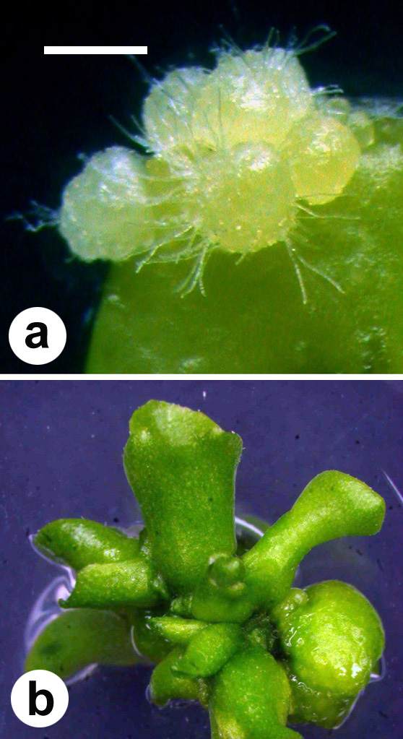
Fig. 1 Direct somatic embryogenesis from leaf explants of P. aphrodite: a somatic embryos with absorbing hairs formed on a leaf explant after 45 days of culture in darkness (Scale bar 1.5 mm); b 45-day-old embryos turned green, enlarged and formed leaves after 45 days of culture in light (Scale bar 4 mm)
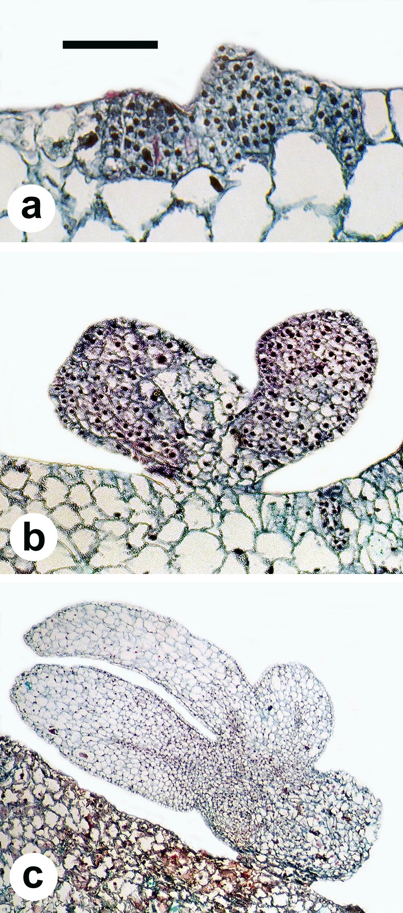
Fig. 2 Histology of direct somatic embryogenesis from leaf explants of P. aphrodite: a embryogenic cells originated from the epidermal layer of a leaf explant after 30 days of culture in darkness (Scale bar 350 μm); b globular embryos formed after 40 days of culture (Scale bar 500 μm); c a mature embryo showed vascular tissues (Scale bar 1.5 mm)
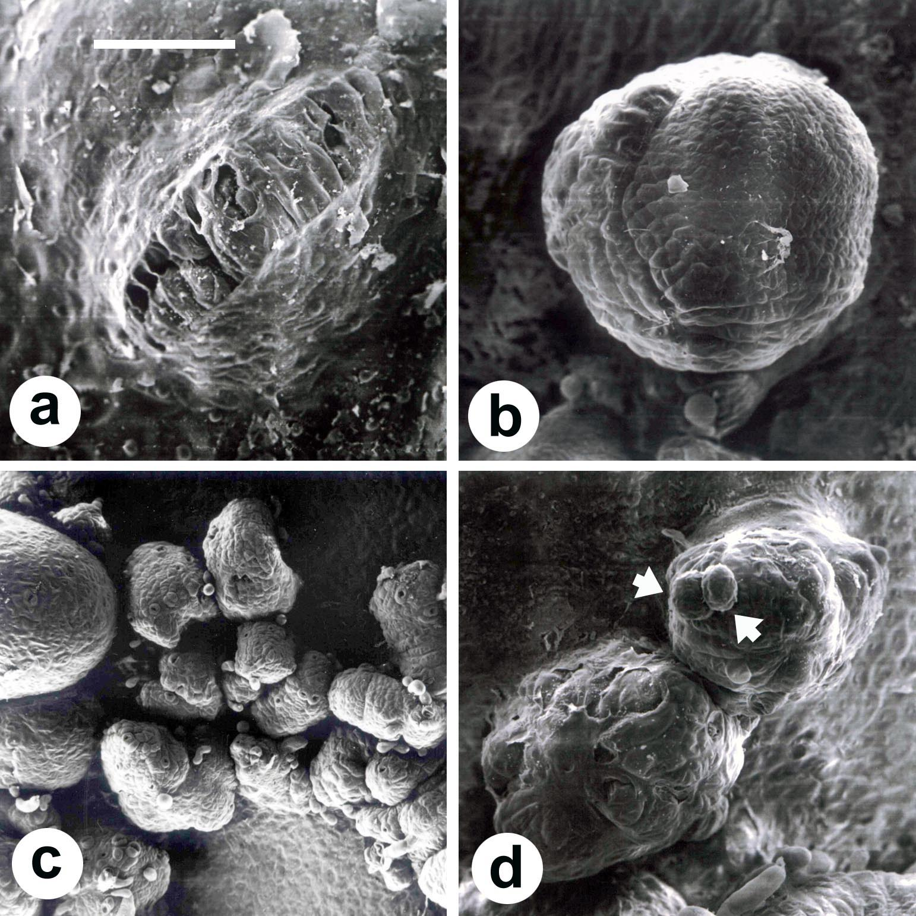
Fig. 3 Scanning electron microscopic observation on direct somatic embryogenesis from leaf explants of P. aphrodite: a the early event of direct embryogenesis from subepidermal cells (Scale bar 100 μm); b a globular embryo (Scale bar 200 μm); c embryos with scale leaves formed on a leaf explant (Scale bar 350 μm); d secondary embryos (arrow) formed on a primary embryo (Scale bar 200 μm)
Table 1 Effect of sucrose on direct somatic embryogenesis from leaf explants of P. aphrodite
Sucrose (g/l) | Percentage of emrbyogenesis on the entire explant (%) | Percentage of browning (%) | Percentage of embryogenesis on different explant locations (%) |  |  |  | No. of embryos per responding explant
Sucrose (g/l) | Percentage of emrbyogenesis on the entire explant (%) | Percentage of browning (%) | CE | Ad | Ab | LT | No. of embryos per responding explant
Control | 0 d | 65 a | 0 c | 0 b | 0 b | 0 b | 0
10 | 40 ab | 35 ab | 25 b | 30 a | 0 b | 5 b | 7.5
20 | 65 a | 15 b | 55 a | 25 a | 15 a | 40 a | 7.8
30 | 10 cd | 50 a | 0 c | 10 ab | 0 b | 0 b | 10.5
40 | 5 bc | 65 a | 10 c | 10 ab | 0 b | 0 b | 11.0
Data were scored after 60 days of culture. The amounts of direct embryo formation were counted at entire explants or at different explant locations (LT: leaf tips; Ad: adaxial sides; Ab: abaxial sides; CE: cut ends). Data expressed as percentage were transformed using arc sine prior to ANOVA and converted back to the original scale for demonstration in table (Compton, 1994). Five replicates (dishes) each with four leaf explants were performed for each treatment. Means with the same letters within columns are not significantly different at p＜0.05 (Duncan, 1955).
Table 2 Effect of NaH₂PO₄ on direct somatic embryogenesis from leaf explants of P. aphrodite
NaH₂PO₄ (mg/l) | Percentage of emrbyogenesis on the entire explant (%) | Percentage of browning (%) | Percentage of embryogenesis on different explant locations (%) |  |  |  | No. of embryos per responding explant
NaH₂PO₄ (mg/l) | Percentage of emrbyogenesis on the entire explant (%) | Percentage of browning (%) | CE | Ad | Ab | LT | No. of embryos per responding explant
0 | 10 b | 50 a | 0 b | 10 a | 5 ab | 5 b | 13.5
42.5 | 25 b | 30 a | 10 b | 25 a | 0 b | 10 b | 13.5
85 | 20 b | 30 a | 10 b | 10 a | 0 b | 10 b | 4.3
170 | 65 a | 15 a | 55 a | 25 a | 15 a | 40 a | 7.8
Data were scored after 60 days of culture. The amounts of direct embryo formation were counted at entire explants or at different explant locations (LT: leaf tips; Ad: adaxial sides; Ab: abaxial sides; CE: cut ends). Data expressed as percentage were transformed using arc sine prior to ANOVA and converted back to the original scale for demonstration in table (Compton, 1994). Five replicates (dishes) each with four leaf explants were performed for each treatment. Means with the same letters within columns are not significantly different at p＜0.05 (Duncan, 1955).
Table 3 Effect of MS medium strength on direct somatic embryogenesis from leaf explants of P. aphrodite
Strength of MS medium | Percentage of emrbyogenesis on the entire explant (%) | Percentage of browning (%) | Percentage of embryogenesis on different explant locations (%) |  |  |  | No. of embryos per responding explant
Strength of MS medium | Percentage of emrbyogenesis on the entire explant (%) | Percentage of browning (%) | CE | Ad | Ab | LT | No. of embryos per responding explant
Full-strength | 30 b | 40 a | 15 b | 25 a | 0 b | 0 b | 5.2
1/2-strength | 65 a | 15 a | 55 a | 5 ab | 15 a | 40 a | 7.8
1/4-strength | 20 b | 40 a | 20 b | 0 b | 0 b | 0 b | 10.0
Data were scored after 60 days of culture. The amounts of direct embryo formation were counted at entire explants or at different explant locations (LT: leaf tips; Ad: adaxial sides; Ab: abaxial sides; CE: cut ends). Data expressed as percentage were transformed using arc sine prior to ANOVA and converted back to the original scale for demonstration in table (Compton, 1994). Five replicates (dishes) each with four leaf explants were performed for each treatment. Means with the same letters within columns are not significantly different at p＜0.05 (Duncan, 1955).
Table 4 Effect of active charcoal on direct somatic embryogenesis from leaf explants of P. aphrodite
Active charcoal (g/l) | Percentage of emrbyogenesis on the entire explant (%) | Percentage of browning (%) | Percentage of embryogenesis on different explant locations (%) |  |  |  | No. of embryos per responding explant
Active charcoal (g/l) | Percentage of emrbyogenesis on the entire explant (%) | Percentage of browning (%) | CE | Ad | Ab | LT | No. of embryos per responding explant
0 | 65 a | 15 b | 55 a | 25 a | 15 a | 40 a | 7.8
0.5 | 0 b | 55 ab | 0 b | 0 b | 0 b | 0 b | 0
1 | 0 b | 70 a | 0 b | 0 b | 0 b | 0 b | 0
2 | 0 b | 85 a | 0 b | 0 b | 0 b | 0 b | 0
Data were scored after 60 days of culture. The amounts of direct embryo formation were counted at entire explants or at different explant locations (LT: leaf tips; Ad: adaxial sides; Ab: abaxial sides; CE: cut ends). Data expressed as percentage were transformed using arc sine prior to ANOVA and converted back to the original scale for demonstration in table (Compton, 1994). Five replicates (dishes) each with four leaf explants were performed for each treatment. Means with the same letters within columns are not significantly different at p＜0.05 (Duncan, 1955).
Table 5 Effect of PVP on direct somatic embryogenesis from leaf explants of P. aphrodite
PVP (g/l) | Percentage of emrbyogenesis on the entire explant (%) | Percentage of embryogenesis on different explant locations (%) |  |  |  | No. of embryos per responding explant
PVP (g/l) | Percentage of emrbyogenesis on the entire explant (%) | CE | Ad | Ab | LT | No. of embryos per responding explant
0 | 45 a | 25 b | 20 a | 0 a | 25 a | 7.8
0.1 | 50 a | 40 ab | 30 a | 5 a | 25 a | 10.7
0.25 | 60 a | 60 a | 35 a | 10 a | 45 a | 15.5
0.5 | 50 a | 50 a | 25 a | 5 a | 25 a | 10.6
Data were scored after 60 days of culture. The amounts of direct embryo formation were counted at entire explants or at different explant locations (LT: leaf tips; Ad: adaxial sides; Ab: abaxial sides; CE: cut ends). Data expressed as percentage were transformed using arc sine prior to ANOVA and converted back to the original scale for demonstration in table (Compton, 1994). Five replicates (dishes) each with four leaf explants were performed for each treatment. Means with the same letters within columns are not significantly different at p＜0.05 (Duncan, 1955).
References
Arditti J, Ernst R (1993) Micropropagation of Orchids. New York, John Wiley. pp311-365
Bhat SR, Chandel KPS (1991) A novel technique to overcome browning in tissue culture. Plant Cell Rep 10:358-361
Chen JT, Chang C, Chang WC (1999) Direct somatic embryogebesis on leaf explants of Oncidium 'Grower Ramsey' and subsequent plant regeneration. Plant Cell Rep 19:143-149
Chen JT, Chang WC (2002) Effects of tissue culture conditions and explant characteristics on direct somatic embryogenesis in Oncidium ‘Grower Ramsey’. Plant Cell Tiss Org Cult 69:41-44
Chen JT, Chang WC (2006) Direct somatic embryogenesis and plant regeneration from leaf explants of Phalaenopsis amabilis. Biol Plant 50:169-173
Chen LR, Chen JT, Chang WC (2002) Efficient production of protocorm-like bodies and plant regeneration from flower stalk explants of the sympodial Orchid Epidendrum radicans. In Vitro - Plant 38:441-445
Chen TY, Chen JT, Chang WC (2004) Plant regeneration through shoot bud formation from leaf explants of Paphiopedilum orchids. Plant Cell Tiss Org Cult 76:11-15
Chen Y, Piluek C (1995) Effects of thidiazuron and N⁶-benzylaminopurine on shoot regeneration of Phalaenopsis. Plant Growth Regul 16:99-101
Chen YC, Chang C, Chang WC (2000) A reliable protocol for plant regeneration from callus culture of Phalaenopsis. In Vitro - Plant 36:420-423
Chung HH, Chen JT, Chang WC (2005) Cytokinins induce direct somatic embryogenesis of Dendrobium Chiengmai Pink and subsequent plant regeneration. In Vitro - Plant 41: 765-769, 2005.
Chung HH, Chen JT, Chang WC (2007) Plant regeneration through direct somatic embryogenesis from leaf explants of Dendrobium. Biol Plant 51:346-350
Compton ME (1994) Statistical methods suitable for the analysis of plant tissue culture data. Plant Cell Tiss Org Cult 37:217-242
Duan JX, Chen H, Yazawa S (1996) In vitro propagation of Phalaenopsis via culture of cytokinins-induced nodes. J Plant Growth Regul 15:133-137
Duncan DB (1955) Multiple range and multiple F test. Biometrics 11:1-42
Ernst R (1994) Effects of thidiazuron on in vitro propagation of Phalaenopsis and Doritaenopsis (Orchidaceae). Plant Cell Tiss Org Cult 39:273-275
Gow WP, Chen JT, Chang WC (2008) Influence of growth regulators on direct embryo formation from leaf explants of Phalaenopsis orchids. Acta Physiol Plant 30:507-512
Gow WP, Chen JT, Chang WC (2009) Effects of genotype, light regime, explant position and orientation on direct embryo formation from leaf explants of Phalaenopsis orchids. Acta Physiol Plant 31:363-369
Ishii Y, Takamura T, Goi M, Tanaka M (1998) Callus induction and somatic embryogenesis of Phalaenopsis. Plant Cell Rep. 17:446-450
Islam MO, Ichihashi S (1999) Effects of sucrose, maltose and sorbitol on callus growth of Phalaenopsis, Doritaenopsis and Neofinetia. J Jap Soc Hort Sci 68:1124-1131
Kuo HL, Chen JT, Chang WC (2005) Efficient Plant regeneration through direct somatic embryogenesis from leaf explants of Phalaenopsis ‘Little Steve’. In Vitro – Plant 41:453-456
Murashige T, Skoog F (1962) A revised medium for rapid growth and bioassays with tobacco tissue cultures. Physiol Plant 15:495-497
Park SY, Murthy HN, Paek KY (2002) Rapid propagation of Phalaenopsis from floral stalk-derived leaves. In Vitro - Plant 38:168-172
Pedroso MC, Pais MS (1995) Factors controlling somatic embryogenesis. Plant Cell Tiss Org Cult 43:147-154
Su YJ, Chen JT, Chang WC (2006) Efficient and repetitive production of leaf-derived embryos of Oncidium. Biol Plant 50:107-110
Tanaka M, Hasegawa A, Goi M (1975) Studies on the clonal propagation of monopodial orchids by tissue culture. I. Formation of protocorm-like bodies from leaf tissues in Phalaenopsis and Vanda. J Jap Soc Hort Sci 44:47-58
Tokuhara K, Masahiro M (1993) Micropropagation of Phalaenopsis and Doritaenopsis by culturing shoot tips of flower stalk buds. Plant Cell Rep 13:7-11
Tokuhara K, Mii M (2001) Induction of embryogenic callus and cell suspension culture from shoot tips excised from flower stalk buds of Phalaenopsis (Orchidaceae). In Vitro - Plant 37:457-461
Young PS, Murthy HN, Yoeup PK (2000) Mass multiplication of protocorm-like bodies using bioreactor system and subsequent plant regeneration in Phalaenopsis. Plant Cell Tiss Org Cult 63:67-72

