DEVELOPMENT OF DORMANCY IN SEEDS OF SAPIUM SEBIFERUM DURING MATURATION

Jing Hou, Hailin Liu, Qiuyue Ma, Wenting Wei, Tongming Yin and Shuxian Li

The National Southern Tree Seeds Inspection Center, Nanjing Forestry University, Nanjing 210037, China

Running title: Development of seed dormancy in Sapium sebiferum

Jing Hou Fax : 01186-25-85427402, Email: zhucai4425@126.com
Hailin Liu Fax : 01186-25-85427402, Email: lhl21@foxmail.com
Qiuyue Ma Fax : 01186-25-85427402, Email: yue.870808@163.com
Wenting Wei, Fax : 01186-25-85427402, Email: 308499336@qq.com
Tongming Yin Fax : 01186-25-85427402, Email: tmyin@njfu.com.cn

To whom correspondence should be addressed:
Dr. Shuxian Li
The National Southern Tree Seeds Inspection Center,
Nanjing Forestry University, 159# Longpan Road, Nanjing, 210037, China
Email: shuxianli@njfu.com.cn
Phone: 01186-25-85427403
Fax: 01186-25-85427402
Abstract
Sapium sebiferum seeds were harvested from the same plant at five stages of maturity to study the changes in fresh weight, dry weight, moisture content, germination percentage, endogenous inhibitor activity and endogenous hormone content. Moisture content declined from 46.98% (1 September, about 85 days after anthesis) to 18.47% (1 November). Fresh weight decreased while dry weight increased significantly during seed development. Germination inhibitor activity in the seed coat and endosperm increased during seed maturation and, at the same developmental stage, activity in the seed coat was higher than that in the endosperm. Excised embryos were capable of germinating from 16 September and maximum percentage germination was observed on 16 October. With increasing seed maturation, gibberellins (GAs) content decreased whereas abscisic acid (ABA) content increased in the controls. At all development stages, ABA content of treatment was lower and GAs content higher than those of the controls. During the course of seed development, the GAs:ABA ratio steadily decreased in control and stratified seeds, except for an initial increase observed on 1 October in stratified seeds. With increasing seed maturity, the germination percentage of control seeds initially increased but declined after 1 October. Stratified seeds showed the same trend but, at each developmental stage, percentage germination of stratified seeds was higher than that of the control. The results showed that seeds harvested in September are immature and incapable of germinating, whereas seeds harvested in November are fully mature but show strong dormancy. Harvesting seeds in October is the optimal time to collect seeds for rapid and efficient germination.

Key words: endogenous hormone, endogenous inhibitor, excised embryo, Sapium sebiferum, seed dormancy

INTRODUCTION
Seed maturation is an important phase of seed development during which embryo growth ceases, storage products accumulate, the protective tegument differentiates and tolerance to desiccation develops, leading to seed dormancy (Gutierrez1 et al. 2007). Determination of the timing of seed maturity is essential for optimal, economic harvesting of healthy, viable and germinable seeds (Phartyal and Thapliyal 2006).
Chinese tallow tree (Sapium sebiferum (L.) Roxb.), a member of the Euphorbiaceae, is a large, deciduous tree distributed in most regions of China. It has potential use in landscaping and as a roadside tree owing to its ornamental qualities, which include colorful foliage and decorative fruit in autumn. The species is useful for production of biodiesel because it is the third-most productive vegetable oil-producing crop in the world, after algae and oil palm (Potts 1946, Ruskin and Eckholm 1983, Yang and Kinghorn 1985). Thus, S. sebiferum is also considered an economically valuable forest tree.
S. sebiferum is best propagated from seeds, but dormancy of the seeds seriously impedes germination, especially of freshly collected seeds, resulting in poor germination (Li et al. 2012). Previous studies have indicated that seed dormancy in S. sebiferum is mainly caused by the seed coat and an endogenous inhibitor present in the endosperm (Li et al. 2011). However, quantitative assessment of the development of dormancy during seed maturation has not previously been investigated. Therefore, we conducted an analysis of S. sebiferum seed maturation to gain a better understanding of changes in endogenous inhibitor and endogenous hormone contents in the seeds.

Materials and methods
Plant material
S. sebiferum usually starts to flower in early July, and seeds mature in late October and November in Nanjing. The experiments were carried out during 2012 in a natural stand of 10- to 15-year-old plants in Nanjing, China. Fruits were collected from a single tree by hand at 14- to 15-day intervals from 1 September (85 days after anthesis) until natural dispersal. After collection, the capsule wall was carefully removed to release the seeds. The fresh weight, dry weight and moisture content were measured in seeds with the white waxy aril intact. All seeds used for other analyses were washed in 1% NaOH for 1 h to remove the white tallow. Subsequently, the seeds were rinsed with tap water, dried at room temperature, and stored in sealed plastic bags in a refrigerator at 0–5°C until use.

Seed fresh and dry weights
Four replicates of 50 seeds each, with the white tallow intact, from each harvest were weighed (to 0.001 g accuracy) to obtain the fresh weight. The dry weight was determined after drying at 80°C to a constant weight and cooling in a desiccator containing silica gel (Pinfield and Gwarazimba 1992).

Seed moisture content
The moisture content of seeds was determined by means of a constant-temperature oven method according to the International Seed Testing Association Rules (ISTA 2011). Three replicates of 20 seeds each were dried in a drying oven at 103°C for 17 h, then cooled in a desiccator with silica gel, and reweighed for estimation of the moisture content on a fresh weight basis.

Germinability of excised embryos
Seeds at the different developmental stages were soaked for 2 d in running water. After excision from their enclosing seed, the embryos were placed in plastic boxes containing wet absorbent cotton and incubated at 25°C with an 8 h photoperiod. During the incubation, the seeds were watered every 2 d to maintain the moisture level. Germination was recorded every 2 d for a total of 16 d. The percentage germination of the excised embryos was calculated at the end of the experimental period. Four replicates of 50 seeds each were used in the experiment. Unless stated otherwise, the following experiments were the same.

Effect of extracts from the seed coat and endosperm on germination of cabbage seeds
The effect of inhibitors present in aqueous solvent extracts from the seed coat and endosperm S. sebiferum, and the activity of each extract, were determined by incubating the non-dormant seeds of cabbage (Brassica rapa L. Chinese Group) on filter paper moistened with the extracts.
The seed coat and endosperm were excised from seeds harvested on 16 September, 16 October and 1 November. They were separately ground into powder in liquid nitrogen and the powder was extracted with methanol. Samples (5 g) of each tissue were extracted three times for 24 h each with 100 ml of 80% (v/v) aqueous methanol at 5°C. After filtration, the combined supernatants were evaporated under vacuum at 37°C to remove the methanol. The final volume was made up to 50 ml by distilled water (the extract concentration was approximately 20%).
Germination of cabbage seeds was conducted using three replicates of 100 seeds each, which were soaked in 5 ml of the extract solution for 3 h. The control seeds were soaked in distilled water. The seeds were incubated in a controlled environmental chamber maintained at 25°C with an 8 h light photoperiod. Seedling emergence was counted daily after 6 d. Seedlings were recorded as emerged when the cotyledons were visible in accordance with ISTA rules (ISTA 2011).

Endogenous hormone content of seeds
The contents of gibberellins (GAs), abscisic acid (ABA) and the ratio of GAs:ABA were investigated in freshly harvested seeds and seeds that were treated with cold stratification for one month. The hormone contents were determined using an indirect enzyme-linked immunosorbent assay (ELISA) technique (Bai et al. 2011, Yuan et al. 2009) with some modifications. In detail, 500 mg of seeds were ground into powder in liquid nitrogen and extracted in cold 80% (v/v) methanol containing 1 mM butylated hydroxytoluene as an antioxidant. The extracts were incubated at 4°C for 4 h under agitation. The samples were centrifuged using a Allegra 25R centrifuge (Beckman Coulter, Inc.) at 3500 r/min for 8 min at 4°C and the supernatant was recovered through Chromosep C₁₈ columns (C₁₈ Sep-Pak Cartridge, Waters Corp., Millford, MA, USA), then prewashed with 1 ml of 80% (v/v) methanol. The hormone fractions from the columns were eluted with 5 ml of 100% (v/v) methanol and 5 ml ether. The supernatant was air-dried to remove residual methanol. The dried supernatant was dissolved in 2 ml phosphate-buffered saline (PBS) containing 0.1% (v/v) Tween-20 and 0.1% (w/v) gelatin for the ELISA assay.
The concentrations of GAs and ABA were determined using a competitive ELISA method. ELISA was performed using a 96-well ELISA plate. Each well was filled with 50 μl of extract. All samples were run in triplicate, and GAs or ABA standards were included in each run for construction of a standard curve. Standard and sample absorbency was recorded at 490 nm using a microplate reader, and GAs or ABA content was measured by interpolation from the standard curve of Weiler et al. (1981).

Germination test at standard conditions
Seeds of S. sebiferum from each harvest were immersed in Milli-pore filtered water for 24 h at room temperature on the same day. After soaking, the seeds were placed in plastic boxes with moistened sand and stored in a refrigerator at 0–5°C for 30 d. Seeds soaked in water for 24 h with no cold stratification were used as the control. After that, seeds were incubated at 25°C. Germinated seeds were counted every second day. Two months later, the final germination percentage was calculated as the proportion of normal seedlings relative to the total number of seeds sown as recommended by ISTA (2011).

Statistical analysis
Data from the different experiments were analyzed separately. The significance of treatments was tested by one-way analysis of variance and Duncan’s multiple range test was used to identify significant differences between means.

RESULTS
Fresh weight, dry weight and moisture content of the seed
The fresh weight, dry weight and moisture content of seeds with the tallow coating on each harvest date are listed in Table 1. The seeds showed a significant decrease in fresh weight from 5.240 g to 4.128 g (p < 0.05) from 1 September to 1 November and a significant increase in dry weight from 1 September to 16 October (p < 0.05), with only a small increase in dry weight observed on 1 November. The moisture content of seeds decreased throughout the maturation period. By the time the seeds attained full maturity, the moisture content had declined from a maximum of 46.98% to 18.47%.

Germination of excised embryos
Differences in the germination capability of excised embryos from seeds collected on different dates were observed (Table 2). Embryos excised from seeds collected on 1 September were not viable and failed to germinate. The germination percentage of embryos excised from seeds collected on 16 September was still low (42.5%) and most embryos were incapable of developing into normal seedlings. From seeds collected on 1 October, when the fruit was still green, about 90% of the excised embryos were capable of germinating. The percentage germination of embryos excised from seeds collected on subsequent dates showed no significant difference from those collected on 1 October.
Germination of seeds with increasing maturity and cold stratification treatment
The germination percentage of S. sebiferum seeds soaked in water coupled with 0 or 30 d cold stratification, then incubated at 25°C for two months, is shown in Fig. 1. Generally, with increasing seed maturity, the germination percentage of the control increased initially, up to 66.3% in seeds harvested up to 1 October, but thereafter declined to 18.5% for seeds harvested on 1 November (when seeds undergo natural dispersal). This revealed that the comparatively high germinability present at earlier developmental stages was gradually lost as the propagules approached maturity, resulting in strong dormancy of seeds in mature fruits. With increasing seed maturity, the percentage of fresh seeds increased from 10.5% to 75.3%. The results also indicated that the seeds harvested on 1 November possessed strong dormancy.
The seeds that were cold stratified for 30 d (treatment) showed similar trends to the control. However, for seeds harvested on the same date, germination of cold-stratified seeds was higher than that of the control, e.g. on 16 September the germination percentage was 28.7% in the control and 39.5% in the stratification treatment. Seeds collected on 1 September were incapable of germinating in both the control and stratification treatment. This result was consistent with the germinability of excised embryos described above. The percentage of viable seeds (germinated and fresh seeds) on 16 September was about 40%, which was much lower than that of the seeds collected on subsequent dates.

Effect of seed coat and endosperm extracts on germination of cabbage seeds
All extracts from the seed coat and endosperm of S. sebiferum significantly decreased the germination percentage of cabbage seeds (p=0.05; Table 3). For each extraction date, the seed coat extract had a stronger inhibitory effect than the endosperm extract. The inhibitory effect of the extracts on germination of cabbage seeds was enhanced with increasing maturity of S. sebiferum seeds. For example, the seed coat extract from seeds harvested on 1 November severely reduced the germination of cabbage seeds to 25.7% from 78.3% observed for the extract from seeds collected on 16 September. Naturally dispersed seeds contain a higher content of the inhibitor.

Endogenous hormone content in seeds
The levels of GAs and ABA in the seeds with increasing maturity and cold stratification treatment, as indicated by ELISA, are shown in Figs. 2 and 3. The control seeds harvested on 16 September and 1 October showed no significant difference in GAs content (Fig. 2). However, on the subsequent harvest dates the GAs content decreased from 17.86 ng g⁻¹ (on 1 October) to 9.56 ng g⁻¹ (on 1 November). Cold stratification for one month had a significant effect on the GAs content of seeds collected on all harvest dates. With regard to seeds at the same developmental stage, the GAs content of stratified seeds was always higher than that of the control.
For both stratified and control seeds, free ABA levels at the earliest stages investigated (harvest dates up to 1 October) were comparatively low. An appreciable increase in seed ABA content was observed from 1 October to 16 October and thereafter a smaller increase was recorded on 1 November. At all four stages the ABA content in stratified seeds was much lower than that in the control throughout the experimental period (Fig. 3).
The GAs:ABA ratio is an important factor that affects seed germination and a high ratio leads to improved germination (El-Araby et al. 2006, Sudhakar et al. 2011). With increasing seed maturity, the GAs:ABA ratio of control seeds showed a steady decrease from 0.18 to 0.04. In seeds stratified for one month the ratio also declined except in seeds harvested on 1 October, and the ratio showed a greater decrease, from 0.31 (on 1 October) to 0.13 (on 1 November), than that observed in the control (Fig. 4). The results indicated that mature seeds contain a lower GAs:ABA ratio.

DISCUSSION
Changes in inhibitor activity during seed maturation
Previous studies have revealed that chemical inhibitors play a major role in suppressing seed germination (Phartyal et al. 2003). In the present study, we observed that at the same developmental stage, the activity of inhibitors in the seed coat was higher than that in the endosperm, as indicated by their inhibitory effects on cabbage seed germination. However, in an individual seed, these results did not necessarily mean the activity of inhibitors in the seed coat was higher than that in the endosperm, because different quantities of seeds were needed to obtain the two extracts. In this experiment twenty seeds were used in obtaining extracts from the seed coat and 10 seeds used for the endosperm extracts. On the other hand, with increasing seed maturity, the germination percentage of cabbage seeds decreased significantly. Given that the decrease in cabbage seed germination reflected inhibitor activity, it can be concluded that inhibitor activity increased with seed maturation. This may be one reason that mature seeds of S. sebiferum have strong dormancy. However, this result differed from those of Zhang (2008) for Fraxinus mandshurica Rupr. He found that the strength of seed dormancy did not reflect inhibitor activity. The different conclusions in the two experiments indicate that the factors contributing to seed dormancy differ among plant taxa. The present study only determined inhibitor activity in the seed coat and endosperm. Further investigations are required to elucidate the role of germination inhibitors in seed dormancy and the identity of the inhibitors in S. sebiferum seeds.

Changes in endogenous hormone content during seed maturation
Plant hormones play an important regulatory role in the dormancy and germination of seeds (Ritchie and Gilroy 1998, John et al. 2002). Among endogenous hormones, ABA plays a pivotal role during the development of dormancy (Koornneef et al. 2002, Kucera et al. 2005), and GAs are involved in the induction of germination (Brady and McCourt 2003, Bai et al. 2011). ABA and GAs have antagonistic effects on seed dormancy and germination. The present study showed that free ABA levels of the control seeds were low during seed development, but reached maximum levels at seed maturity. On the same harvest date, the ABA content of stratified seeds was lower than that of control seeds, which was in accordance with the higher germination percentage of stratified seeds compared with the control (Fig. 1).
The GAs content of the control seeds showed the opposite trend to that of ABA. This trend may reflect a decline in the synthesis and deposition of seed reserves, and the general retardation of metabolism due to seed desiccation (Bewley and Black 1978). After seeds were treated by cold stratification, the GAs content was markedly higher than that of the control seeds, which is presumed to reflect the breaking of dormancy by stratification.
Increasingly mature seeds contained a lower GAs:ABA ratio than immature seeds, whereas seeds possessing weak dormancy (showing high percentage germination) had a high GAs:ABA ratio. These results are in agreement with those of Amen (1968).
In summary, seed coat and endosperm extracts and free ABA effectively suppressed the germination of S. sebiferum seeds, even at the earliest developmental stages investigated; e.g. 66.3% of seeds harvested on 1 October germinated (Table 3), whereas 89.3% of embryos excised from seeds collected on the same date were capable of germinating (Table 2). This result was consistent with the findings of Koornneef et al. (1989).

Optimal time for seed harvest
Seed dormancy represents a complex sequence of events controlled by the physiological or structural properties of a seed and the external conditions (Pawłowski 2009). As S. sebiferum seeds matured, several phenomena appeared to be closely correlated: the capsule walls turned brown, the seed coat turned black, the fresh weight declined, the dry weight increased steadily but then increased more gradually in advanced stages of maturation, the moisture content decreased (Table 1) and germination percentage declined from 1 October (Fig. 1).
With the development of S. sebiferum seeds, excised embryos showed a high increase in germination percentage to more than 89% for seeds harvested on and after 1 October. No embryo excised from seeds collected on 1 September was capable of germinating and the size of these excised embryos was smaller than those from seeds harvested on subsequent dates. Thus, the seeds collected in September were immature and unsuitable for the harvest of viable S. sebiferum seeds. Germination tests showed that the seeds collected in October had higher percentage germinability than those harvested in November. These results indicated that S. sebiferum seeds harvested in advance of maturity, coupled with cold stratification can promote its germination efficiency. This conclusion is in accordance with F. mandshurica (Zhang 2008). Further studies are required to establish whether harvesting seeds in advance of maturity will affect their storage longevity.

Acknowledgments
Funding for this work was provided by the Key Forestry Public Welfare Project (201304102), the Natural Science Foundation of China (31270711) and Jiangsu Province (BK20130968). The research was also supported by the program for Innovative Research Team in Universities of Jiangsu Province and the Educational Department of China.

References
Amen R. D. (1968). A model of seed dormancy. Botanical Review, 34(1): 1-31.
Bai T. H., Yin R., Li C. Y., Ma F. W., Yue Z. Y. and Shu H. R. (2011). Comparative analysis of endogenous hormones in leaves and roots of two contrasting Malus Species in response to hypoxia stress. Journal of Plant Growth Regulation, 30: 119-127.
Bewley J. D., Black M. (1978). Physiology and biochemistry of seeds, vol.1, Springer-Verlag, New York.
Brady S. M., McCourt P. (2003). Hormone cross-talk in seed dormancy. Journal of Plant Growth Regulation, 22: 25-31.
El-Araby M. M., Moustafa S. M. A., Ismail A. I., Hegaz Z. A. (2006). Hormone and phenol levels during germination and osmopriming of tomato seeds, and associated variations in protein patterns and anatomical seed features. Acta agronomica hungarica, 54(4):441-457.
Ellis R. H., Pieta Filho C. (1992). The development of seed quality in spring and winter cultivars of barley and wheat. Seed Science Research, 2: 9-15.
Gutierrez1 L., Wuytswinkel Van O., Castelain M., Bellini C. (2007). Combined networks regulating seed maturation. Trends in Plant Science, 12(7), 294-299.
International Seed Testing Association (2011). International Rules for Seed Testing. Zurich, Switzerland.
John V. J., David W. P., Andre T. P., Richard P. R., Lewis N. M. (2002). Abscisic acid, phaseic acid and gibberellin contents associated with dormancy and germination in barley. Physiologia plantarum, 115: 428-441.
Koornneef M., Bentsink L., Hilhorst H. (2002). Seed dormancy and germination. Growth and Development, 5(1): 33-36.
Koornneef M., Hanhart C. J., Hilhorst H. W. M., Karssen C. M. (1989). In vivo inhibition of seed development and reserve protein accumulation in recombinants of abscisic acid biosynthesis and responsiveness mutants in Arabidopsis thaliuna. Plant Physiology, 90: 463-469.
Kucera B., Cohn M. A., Leubner-Metzger G. (2005). Plant hormone interactions during seed dormancy release and germination. Seed Science Research, 15: 281-307.
Li S. X., Gu H. B., Mao Y., Yin T. M., Gao H. D. (2012). Effects of tallow tree seed coat on seed germination. Journal of Forestry Research, 23(2): 229-233.
Li S. X., Liu J. J., Tian S. X., Yin T. M. (2011). Study on the causes of Sapium sebiferum seed dormancy and the methods for dormancy breaking. Journal of Nanjing Forestry University, 35(5): 1-4. (In Chinese)
Pawłowski T. A. (2009). Proteome analysis of Norway maple (Acer platanoides L.) seeds dormancy breaking and germination: influence of abscisic and gibberellic acids. BMC Plant Biology, 9:48
Phartyal S.S., Thapliyal R. C. (2006). Pattern of fruit and seed maturation in Himalayan Maple (Acer caesium Wall ex Brandis). Seed Technology, 28(1): 64-70.
Phartyal S. S., Thapliyal R. C., Nayal J. S., Joshi, G. (2003). Seed dormancy in Himalayan maple (Acer caesium) II: Bioassay of inhibitors. Seed Science & Technology, 31: 13-20.
Pinfield N. J., Gwarazimba V. E. E. (1992). Seed dormancy in Acer: The role of abscisic acid in the regulation of seed development in Acer platanoides L. Plant Growth Regulation, 11: 293-299.
Potts W. M. (1946). The Chinese tallow tree as a chemurgic crop. The Chemurgic Digest, 22: 374-375.
Ritchie S., Gilroy S. (1998). Gibberellins: regulating genes and germination. New phytologist, 140: 363-383.
Ruskin F. R., Eckholm E. (1983). Firewood crops: shrub and tree species for energy production. Vol. 2, National academy press, Washington, D.C. 46-49 pp.
Sudhakar N., Nagendra-Prasad D., Mohan N., Bradfor H., Gunasekaran M., Murugesan K. (2011). Assessing influence of ozone in tomato seed dormancy alleviation. American Journal of Plant Sciences, 2:443-448.
Weiler E. W., Jordan P. S., Conrad W. (1981). Levels of indole-3-acetic acid in intact and decapitated coleoptiles as determined by a specific and highly sensitive solid-phase enzyme immunoassay. Planta, 153: 561–571.
Yang P. Q., Kinghorn A. D. (1985). Coumarin constituents of the chinese tallow tree(Sapium sebiferum). Journal of Natural Products, 48(3): 486-488.
Yuan Y., Liu Y. J., Huang L. Q., Cui G. H., Fu G. F. (2009). Soil acidity elevates some phytohormone and β-eudesmol contents in roots of Atractylodes lancea. Russian Journal of Plant Physiology, 56(1): 133-137.
Zhang P. (2008). The dormancy and germination physiology of Manchurian Ash seeds in different development stage. PhD dissertation, Northeast Forestry University. (In Chinese)

Table 1. Fresh and dry weights and moisture content of Sapium sebiferum seeds on each harvest date
Collection date | Fresh weight (g) | Dry weight (g) | Moisture content (%)
September 1 | 5.240 a | 2.435 d | 46.98 a
September 16 | 4.907 b | 2.868 c | 42.59 b
October 1 | 4.697 c | 3.089 b | 35.55 c
October 16 | 4.507 c | 3.628 a | 30.18 d
November 1 | 4.128 d | 3.654 a | 18.47 e

Table 2. Germination percentage of seeds excised embryos at different collection time
Collection date | Germination percentage (%)
September 1 | 0 c
September 16 | 42.5 b
October 1 | 89.0 a
October 16 | 94.3 a
November 1 | 93.3 a

Table 3. Effect of seed coat and endosperm extracts from Sapium sebiferum seeds, collected on different dates during seed maturation, on germination of cabbage seeds
Collection date | Germination (%)
Collection date | Control | Treatment1 | Treatment 2
September 16 | 100 | 78.3 a | 89.3 a
October 16 | 100 | 38.0 b | 67.7 b
November 1 | 100 | 25.7 c | 41.7 c
Note: control, treatment1 and treatment 2 were the experiments that cabbage seeds were soaked for 3h in water, extracts from the seed coat, and extracts from the endosperm, respectively.

Figure legends
Fig. 1. Germination percentage of Sapium sebiferum seeds collected on different dates during seed maturation
Fig. 2. Gibberellins (GAs) content of Sapium sebiferum seeds collected on different dates during seed maturation
Fig. 3. Abscisic acid (ABA) content of Sapium sebiferum seeds collected on different dates during seed maturation
Fig. 4. Gibberellins:abscisic acid (GAs:ABA) ratio of Sapium sebiferum seeds collected on different dates during seed maturation

Fig. 1.
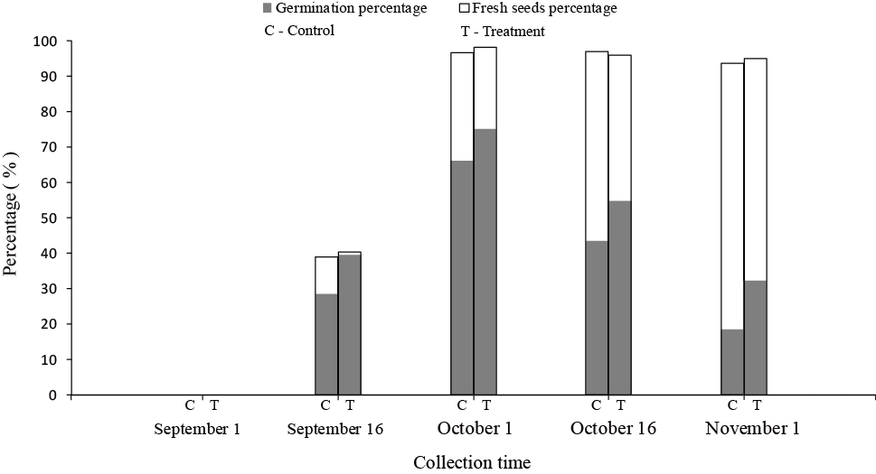

Fig. 2.
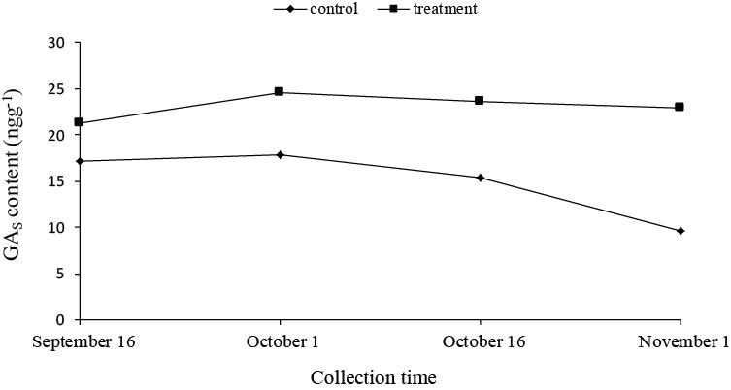

Fig. 3.
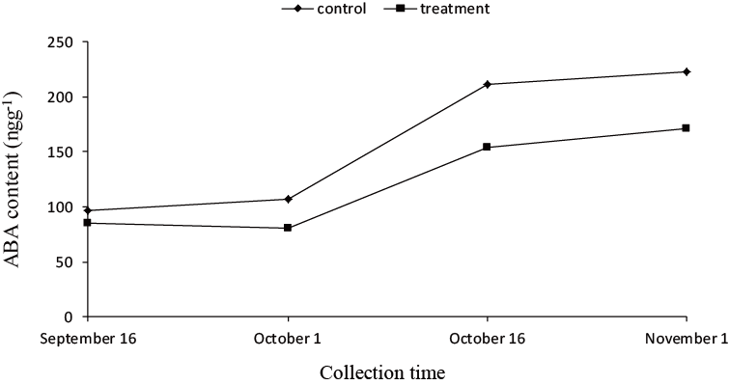

Fig. 4.
