Title:
Elucidation of optimal conditions for rooting of cuttings prepared from a plus tree clone of Eucalyptus globulus

Authors:
Kunihisa Iwasaki,^{1), 2) *} Shunji Omori,¹⁾ Shinya Kajita^{2) *}

Key Word:
Eucalyptus globulus, cutting, rooting ability, seasonal variation, auxin treatment, diphenylurea derivative

Addresses:
1) Tsukuba R&D Laboratory, Mitsubishi Paper Mills Limited, 46 Wadai, Tsukuba, Ibaraki 300-4247, Japan
2) Graduate School of Bio-Applications and Systems Engineering, Tokyo University of Agriculture and Technology, 2-24-16 Nakacho, Koganei, Tokyo 184-8588, Japan

*Corresponding authors:
Shinya Kajita
E-mail: kajita@cc.tuat.ac.jp
Fax: +81.42.388.7391

Kunihisa Iwasaki
E-mail: iwasaki_kunihisa@mpm.co.jp
Abstract
Eucalyptus globulus is an important tree species used for timber and pulpwood production. In contrast to eucalyptus species that have higher rooting ability of cuttings (e.g., E. grandis and E. urograndis), E. globulus is known to be difficult to propagate clonally because of its lower rooting ability.
To determine the optimal conditions required for rooting of cuttings, we investigated different factors that may influence the efficiency of rooting. Cloned mother trees from a plus tree of E. globulus with high rooting ability and high pulping yield were used for preparation of cuttings. Effects of internode position within shoots on the preparation, seasonal timing, and type and concentration of auxins on rooting of cuttings were examined.
The experimental results showed that the highest rooting ability was observed around the seventh internode. Rooting efficiency of the cuttings was higher in the summer season (mid-July). In addition, the lower efficiency observed in the winter season (mid-November and February) was improved by heating the soil with an electric cable. Among the auxins tested, indole butyric acid (IBA) at a concentration of 8,000 mg/kg was the best rooting inducer. Moreover, combined application of IBA and a diphenylurea derivative, N,N′-bis-(3,4-methylenedioxyphenyl)urea, to cuttings increased rooting efficiency and survival rate of the cuttings compared to the application of IBA alone. These findings provide fundamental knowledge for the large-scale vegetative propagation of E. globulus.
Introduction
The genus Eucalyptus, which belongs to the family of Myrtaceae, is native to Australia and includes more than 700 species. Eucalyptus species are one of the most widely planted hardwood trees in the tropical and subtropical regions because of its superior growth rate and wood quality. The wood of Eucalyptus trees is used for firewood, charcoal, and pulp, and the essential oil extracted from the leaves is used as a source of perfume, medicines, and detergents. Eucalyptus trees are currently planted in many regions of the world, including South America, Oceania, and South East Asia. According to a report released by the Food and Agriculture Organization of the United Nations in 2005, the plantation area of Eucalyptus species has reached 12.751 million ha in tropical and subtropical regions. Owing to a plantation project undertaken in these regions, E. grandis and E. globulus constitute a large part of the forested area, followed by other species, such as E. nitens, E. pilularis, E. dunnii, E. regnans, E. camaldulensis, and their hybrids (Lungo et al., 2006).
In most plantations, Eucalyptus trees are grown from either seedlings or rooted cuttings. The preparation of rooted cuttings can be problematic, but seedlings are easier to propagate at a lower cost. Efficiency of the propagation of Eucalyptus clones by cutting differs among species and depends on the inheritable and biochemical characteristics of the mother tree. The rooting ability of cuttings in E. grandis and E. urograndis is relatively higher than that of other Eucalyptus species (Denison and Kietzka, 1993; Souvannavong, 1992). In contrast, E. globulus is known to be difficult to propagate clonally because of the lower rooting ability of its cuttings (Borralho and Wilson, 1994; Hartney, 1980; Ito 2006; Ruad et al., 1999).
Previous studies with eucalyptus and other species have reported the relationship between rooting ability and various characteristics of cuttings, such as the size and maturity of leaves (Kawase, 1972; Wilson, 1994), presence of active buds (Fadl and Hartmann, 1967; Howard, 1968), proximity of nodes to the base of the cutting (Hansen, 1986), exo- and/or endogenous levels of phytohormones, and growth conditions of the cuttings and their mother trees (Fogaça and Fett-Neto, 2005; Mankessi et al., 2011; Marques et al., 1999; Schwambach et al., 2008). In addition, rooting ability has been discussed in relation to stem size and original portion of the mother plant used (Howard, 1991; Howard and Ridout, 1991; Mankessi et al., 2011; Paton et al., 1970; Sach et al., 1988; Wilson, 1993). There is a gradient in rooting ability that is dependent on the within-shoot position; in some eucalypt species, rooting ability seems to be higher in cuttings from juvenile parts than from mature parts (Paton et al., 1970, Wilson, 1993). Furthermore, it is well known that rooting efficiency varies depending on the season in which cutting is performed (Anand and Heberlein, 1975; Bhusal, 2001).
While there are many in vitro studies on the micropropagation of E. globulus and its rooting ability, ex vitro studies are limited. To further investigate the factors that influence rooting ability, we examined the relationship between internode positions within shoots and seasonal variation and rooting efficiency of the cutting using a plus tree clone of E. globulus that exhibited high density and pulp yield. The effect of the application of auxin and another root inducer to cuttings is also discussed.
Materials and methods
Growth conditions of mother trees
All experiments were carried out in Tsukuba, Japan (36°09′N; 140°02′E) between 2010 and 2011. Young E. globulus trees (1 and 2-year-old) obtained by clonal propagation (clone SI-10) were used as mother trees for the preparation of cuttings. Mother trees were grown individually in 24-liter containers. Trees were cultivated in an open-air field from spring to autumn and in a greenhouse during the winter. The soil used was a mixture of peat moss, vermiculite, akadama soil, and black soil (2:1:1:8, v/v).

Preparation of cuttings for rooting
Figure 1 summarizes the procedure for preparing cuttings. Cuttings with 1 node were prepared from axillary shoots (Fig. 1A) of mother trees grown as described above (Fig. 1B). The leaves on each cutting were trimmed with scissors to approximately one-third of the total area to avoid wilting (Fig. 1C). A 2-mm-wide section of the cortex base of each cutting was scraped off with a knife to expose the cambium (Fig. 1D). After the cuttings were immersed for 10 seconds in a solution of benomyl fungicide (3 g L⁻¹, Sumitomo Chemical Company, Ltd., Tokyo) (Fig. 1E), the base of each cutting was treated with talc powder containing auxin (Fig. 1F), and cuttings were planted singly in an artificial medium (Jiffy plugs, Jiffy Pot Products Co. of Japan Ltd., Yokohama) (Fig. 1G). The propagation medium was placed in plastic containers (90 cm³) and filled with peat moss and vermiculite (1:1, v/v) (Fig. 1H). During experiments, cuttings were cultivated in a greenhouse with a relative humidity between 70% and 90% during the night and 40% and 60% during the daytime. Emergence of roots on cuttings was checked 8 weeks after the start of the experiment. The temperature in the greenhouse averaged 28°C in the summer and 13°C in the winter. Day length was approximately 12 h during the summer and 10 h during the winter season.
Fig.1
Experiments with cuttings prepared from different shoots positions
Experiments were performed during the summer (between July 24 and September 18, 2010) and spring (between March 16 to May 10, 2011) seasons. The cuttings prepared in the first experiment were designated as summer cuttings and the second as spring cuttings. Eight cuttings per each internode position were prepared from harvested shoots of clone SI-10. Three replications were performed for a single experimental condition with 8 cuttings. The basal parts of the cuttings were treated with talc powder containing 8,000 mg/kg indole-3-butyric acid (IBA, Wako Pure Chemical Industries, Ltd., Osaka).

Experiments of cutting during the year
A total of 10 experiments were performed between July 27, 2010 and September 6, 2011. To examine the effect of soil temperature on the rooting ability of cuttings, an electric heating cable (1-250, Nihon Noden, Inc., Tokyo) with thermostat (ND-610, Nihon Noden, Inc., Tokyo) set at 50°C was used to heat the propagation medium between November 19, 2010 and January 7, 2011 and February 7 and April 3, 2011. Twenty-five cuttings at each concentration were prepared from the internode positions with the higher rooting ability. Three replications were conducted for each experimental period. The basal part of the cuttings was treated with talc powder containing 8,000 mg/kg IBA. The sensor of the data logger (TR-52S, T&D Co., Nagano) was buried in the soil at a depth of 5 cm. Maximum, minimum, and average soil temperatures were measured during each experimental period.

Auxin application
The experiment was performed between March 28 and May 23, 2011. Auxin types used in this experiment were indole-3-butyric acid (IBA), naphthalene acetic acid (NAA, Junsei Chemical Co., Ltd., Tokyo), and indole acetic acid (IAA, Tokyo Chemical Industry Co., Ltd., Tokyo). The basal part of each cutting was treated with talc powder containing 2,000; 8,000; 16,000; and 32,000 mg/kg of each auxin. A control without auxin was also included. Twenty-five cuttings at each concentration were prepared from an internode position with high rooting ability. Four replications were conducted for each condition. To estimate the root-promoting effects of these auxins, the number of roots, length of the longest root and the percentage of survival and rooting were examined.

Combined application of auxin and N,N′-bis-(3,4-methylenedioxyphenyl)urea (3,4-MDPU)
The experiment was performed between August 3 and September 28, 2011. The basal part of each cutting was treated with talc powder containing 8,000 mg/kg IBA in addition to different levels (500-15,000 mg/kg) of N,N′-bis-(3,4-methylenedioxyphenyl)urea (3,4-MDPU), synthesized according to the literature (RICCI et al., 2001). Twenty-five cuttings at each concentration were prepared and estimated as described above. Three replications were performed for each condition.

Statistical analysis
Except for temperature, all data were reported as means ± standard deviation of 3 or 4 replicates. The survival and rooting percentages, number of roots, and length of the longest root were analyzed by one-way analysis of variance (ANOVA) using KaleidaGraph 4.1 (Hulinks Inc., 2009, Tokyo). Tukey’s HSD test was used to compare treatment means. The significant level of statistical tests was set at p = 0.05.
Results

Rooting ability of the cuttings from different shoot positions
Rooting ability was investigated using cuttings prepared from different internode positions within axillary shoots. The average shoot length was 66.8 cm in summer and 36.7 cm in spring. The internode including the axillary shoot apex was defined as the “first internode”. Since the first to third internodes were generally short and soft, cuttings were prepared from the fourth to the thirteenth internode.
The results were shown in Figure 2. Rooting ability in summer cuttings varied from 20% to 80% depending on the internode position within shoots. Cuttings prepared from the seventh internode exhibited the highest rooting efficiency (83%) and values gradually decreased with further distances from the seventh internode. However, while spring cutting prepared from the seventh internode position were also found to have higher rooting ability, spring cuttings prepared from the fourth to the ninth internodes were relatively lower (29%–58%) than those from summer cuttings.
Fig.2

Seasonal variation in rooting ability of the cuttings
Experiments were performed in 10 periods throughout the year (A–J, Table 1). Cuttings were prepared from the fifth to ninth internodes of mother trees. Table 1 shows the survival and rooting percentages of cuttings, as well as the maximum, minimum, and average soil temperature, for each experimental period. Survival and rooting percentages varied from 64% to 92%, and 27% to 67%, respectively.
Rooting percentages were relatively higher in summer than in other seasons (61% in set A and 56% in set J). In autumn (sets B and C), rooting percentages decreased gradually with decreasing soil temperature. From autumn to winter (sets D, E, and G), rooting percentages further decreased to less than 35%, although survival percentage was maintained at over 75%. When the soil was heated (sets F and H), rooting percentages of the cuttings almost doubled (sets E and G). Increasing the soil temperature during winter appears to promote rooting percentage in cuttings. Overall, a high rooting percentage of E. globulus stem cuttings was obtained in the summer season, followed by spring, autumn, and winter, respectively.
Table1

Effect of the type and concentration of auxin on a cuttings’ rooting efficiency
Cuttings were prepared from the fifth to ninth internodes, and basal parts were treated with talc powder containing different amounts of IBA, NAA, and IAA. Survival and rooting percentages, number of roots, and length of the longest root for each treatment are shown in Table 2. Regardless of the type of auxin, its application appeared to promote rooting efficiency, and number and length of roots in cuttings.
The most effective concentration of IBA to promote rooting was 8,000 mg/kg. The rooting percentage at this concentration was 3 times higher than that with 2,000 mg/kg. In contrast to the effect of root elongation, the application of IBA at higher concentrations had a negative effect on the survival of cuttings. At 32,000 mg/kg, the survival percentage decreased to 38%, which was the minimum value measured in this experiment.
Rooting percentages were relatively higher with applications of 16,000 and 32,000 mg/kg of NAA or IAA. However, their efficiencies were relatively lower than that of the best treatment level of IBA. As found with IBA, survival efficiency decreased at higher concentrations of NAA and IAA. Among the auxins tested, a high concentration of IAA was the most effective in increasing of the number of roots induced.
Table2

Supplemental effect of 3,4-MDPU on rooting
While 3,4-MDPU is a diphenylurea derivative with no hormonal activity, it can promote rooting when applied together with auxins (Ricci et al. 2001; Ricci et al. 2008). We examined the effect of 3,4-MDPU on cuttings from the fifth to ninth internodes in the presence of IBA at 8,000 mg/kg (Table 3). In the absence of 3,4-MDPU, the survival and rooting percentages of cuttings were 53% and 47%, respectively. On the other hand, the survival percentage with 3,4-MDPU increased to 83%. Cuttings treated with 5,000 mg/kg 3,4-MDPU and IBA showed 1.6 and 1.3 times higher survival and rooting percentages, respectively, than those without 3,4-MDPU. In contrast, 3,4-MDPU did not show an additive effect on either root number or root elongation.
Table3
Discussion

As in other plant species, the rooting ability of eucalyptus is affected not only by the cultivation conditions of the cuttings, but also by the growth conditions of the mother trees from which the cuttings are taken (Assis et al., 2004). We examined the effect of shoot position from which cuttings were prepared, seasonal variation, and response of cuttings to auxin application and to another additive on rooting ability. A plus tree clone of E. globulus, SI-10, was used as a mother tree for preparation of the cuttings in this study. Between 1998 and 1999, we investigated a 4242-ha planted area of E. globulus in Chile, where we selected 232 trees as candidates for a plus tree. After several cycles of screening in the field and pulping tests, SI-10 was designated as one of our plus trees. The mean annual increment (MAI), wood density, and pulp yield of 8-year-old SI-10 was 34.6 m³/ha/y, 523 kg/m³, and 58.0%, respectively. In previous studies, the average wood density of 7-year-old E. globulus in Chile and 8-year-old E. globulus in New Zealand was 491 and 490 kg/m³, respectively (Ramírez et al., 2009; Kibblewhite et al., 2001). The pulp yield of 9-year-old E. globulus in Tasmania varied from 53.6% to 55.5% (Downes et al., 2003). Growth rates in milder sites in Chile approached 25 to 30 m³ ha^{–1} y^{–1} at 8 to 10 years (Jayawickrama et al., 1993). However, 10 to 15 m³/ha/y is generally regarded as an achievable yield for this species (Eldridge et al., 1993). Thus, the wood properties of SI-10 are thought to be superior to those of other E. globulus trees.
In the present study, cuttings were prepared using the fourth to thirteenth internodes and rooting ability of the cuttings was investigated. Although juvenile parts (i.e., first to third internodes) might have high rooting ability (Wilson, 1993), using these parts was not possible due to a lack of mist equipment for water management. Our results show that the rooting ability of cuttings depends on their internode positions; furthermore, the seventh internode is the best part for cutting preparation in both summer and spring. The higher rooting activity of this part might be due to its high cambial activity and/or better state of nutritive storage. In contrast, the rooting ability of mature parts (twelfth and thirteenth internodes) during the summer was quite low compared to other parts (Figure 2). This was partially due to their poor ability of water transport. The color of cuttings from these parts easily turned purple and the leaves died rapidly during the experiment.
As shown in Table 1, the cutting experiments were performed throughout the year. Normally, the viability of mother plants is too low to perform cutting experiments in winter. Thus, we transferred mother plants to a greenhouse during this season. The survival and rooting efficiencies of cuttings varied between experimental periods (Table 1). The changes in the efficiencies were partially due to the air and soil temperatures. As indicated in previous studies (Bhusal, 2001; Correa and Fett-Neto, 2004; Stenvall et al., 2005), the survival and rooting efficiencies of cuttings may be affected by both air and soil temperatures via changes in endogenous conditions. Low rooting ability in winter appears to cause lower cambial activity (Anand and Heberlein, 1975). Heating the soil with an electric cable during the winter could alleviate the reduced rooting activity. The rooting ability observed in our study increased up to the same level as reported in aspen (Stenvall et al., 2005) and Japanese black pine (Mori et al., 2004) during summer season. These results indicate that the potential rooting activity of cuttings in winter is the same as that in summer.
Auxin, a substance believed to promote rooting, was also examined in this study. Application of IBA at 8,000 mg/kg was found to be a better rooting inducer than other types of auxins. While IAA and NAA did improve rooting efficiency, the effect was less than that of IBA. The usefulness of IBA treatment for the rooting of eucalyptus cuttings has also been reported in previous studies (Fogaça and Fett-Neto, 2005; Wendling et al., 2000). As shown in Table 2, rooting efficiency was not correlated with survival efficiency or the number of roots developed. A similar tendency was observed in experiments conducted during different seasons (Table 1). These results indicate that inducing higher viability of cuttings does not ensure their rooting.
In addition to auxin, other plant regulators are known to effectively induce roots from cuttings. For example, growth retardants such as gibberellins-biosynthesis inhibitors have a positive effect on root induction in some plant species (Wiesman and Lavee, 1994; Wiesman and Riov, 1989). Diphenylurea derivatives are also known as root inducers in pine and apple (Ricci et al., 2001 and 2008). In this study, we examined the effect of one of the diphenylurea derivatives, 3,4-MDPU, on rooting of E. globulus cuttings. As shown in Table 3, application of 3,4-MDPU at a concentration of 5,000 mg/kg increased the survival and rooting percentages of cuttings (Table 3). Although the mechanism of action of 3,4-MDPU is unclear, our results suggest that combined application of 3,4-MDPU and IBA positively effect root induction without affecting the number and length of the inducing root. However, our data was obtained under a particular condition (IBA at 8,000 mg/kg during the summer season) and thus should be confirmed using different auxin types and seasons.
Acknowledgements
The authors thank Isiake Kawasaki and Tatsumi Shiba of the Agricultural Advisory Service in Matsuyama, Akira Ito of Tsukuba R&D Laboratory, Mitsubishi Paper Mills Limited for their skilful support.
References
Anand V.K. and Heberlein G.T. (1975) Seasonal change in the effects of auxin on rooting in stem cuttings of Ficus infectoria. Physiologia Plantarum, 34: 330-334.

Assis T.F., Fett-Neto A.G., Alferas A.C. (2004) Current techniques and prospects for the clonal propagation of hardwoods with emphasis on Eucalyptus. In: Fort PO, Carson M, Walter C (Eds) Proceedings of lantation Forest Biotechnology for the 21st century. Research Signpost 37/661 (2), Kerala, India: 303-333.

Bhusal, R.C., Mizutani F., Moon D.G., Rutto K.L. (2001) Propagation of citrus by stem cuttings and seasonal variation in rooting capacity. Pakistan Journal of Biological Sciences, 4: 1294-1298.

Borralho N.M.G., Wilson P.J. (1994) Inheritance of initial survival and rooting ability in Eucalyptus globulus Labill. stem cuttings. Silvae Genetica, 43: 238-242.

Correa L.D.R., Fett-Neto A.G. (2004) Effects of temperature on adventitious root development in microcuttings of Eucalyptus saligna Smith and Eucalyptus globulus Labill. Journal of Thermal Biology, 29: 315-324.

Denison N.P., Kietzka J.E. (1993) The development and utilisation of vegetative propagation in mondi for commercial afforestation programmes. South African Forestry Journal, 166: 53-60.

Downes G., Evans R., Wimmer R., French J., Farrington A., Lock P. (2003) Wood, pulp and handsheet relationships in plantation grown Eucalyptus globulus. Appita Journal, 56: 221-228.

Eldridge K., Davidson J., Harwood C., van WYK G. (1993) Eucalyptus domestication and breeding. Oxford University Press Inc.

Fadl M.S., Hartmann H.T. (1967) Endogenous root promoting and root inhibiting factors in pear cuttings in relation to bud activity. International Plant Propagator’s Society, 17: 62–72.

Fogaça C.M., Fett-Neto A.G. (2005) Role of auxin and its modulators in the adventitious rooting of eucalyptus species differing in recalcitrance. Plant Growth Regulation,45: 1-10.

Hansen J. (1986) Influence of cutting position and stem length on rooting of leaf-bud cuttings of Schefflera arboricola. Scientia Horticulturae, 28: 177-186.

Hartney V.J. (1980) Vegetative propagation of the eucalypts. Australian Forest Research, 10: 191-211.

Howard B.H. (1968) Effects of bud removal and wounding on rooting of hardwood cuttings. Nature, 220: 262–264.

Howard B.H. (1991) Stock plant manipulation for better rooting and growth from cuttings. International Plant Propagators Society, 41: 127-130.

Howard B.H. Ridout M.S. (1991) Rooting potential in plum hardwood cuttings. II. Relationships between shoot variable and rooting in cuttings from different sources. Journal of Horticultural Science, 66: 681-687.

Ito K. (2006) Clonal plantation of Eucalyptus globulus: Selection of plus trees and trial plantation. Japan TAPPI Journal, 60: 476-485. (in Japanese)

Jayawickrama K.J.S., Schlatter J.E., Escobar R. (1993) Eucalypt plantation forestry in Chile. Australian Forestry Journal, 56: 179-192.

Kawase M. (1972) Centrifugation and rooting of cuttings. Rivista Ortoflorofrutt Italia, 60: 96–112.

Kibblewhite R.P., Johnson B.I., Ashelbourne C.J.A. (2001) Kraft pulp qualities of Eucalyptus nitens, E. globulus and E. maidenii, at ages 8 and 11 years. New Zealand Journal of Forestry Science, 30: 447-457.

Lungo A.L., Ball J., Carle J. (2006) Global planted forests thematic study: results and analysis. Planted forests and trees working paper FP38E. available at: www.fao.org/forestry/webview/-media?mediaId=12139&langId=1

Mankessi F., Saya A., Toto M., Monteuuis O. (2011) Cloning field growing Eucalyptus urophylla x Eucalyptus grandis by rooted cuttings: age, within-shoot position and season effects. Propagation of Ornamental Plants, 11: 3-9.

Marque C.M., Vasquez-Kool J., Carocha V.J., Ferreira J.G., O'Malley D.M., Liu B.H., Sederoff R. (1999) Genetic dissection of vegetative propagation traits in Eucalyptus tereticornis and E. globulus. Theoretical and Applied Genetics 99: 936-946.

Mori Y., Miyahara F., Goto S. (2004) The usefulness of rooted cuttings for producing nematode-resistant Japanese black pine plantlets. Journal of the Japanese Forest Society, 86: 98-104.

Paton D.M., Willing R.R., Nicholls W., Pryor L.D. (1970) Rooting of stem cuttings of Eucalyptus: a rooting inhibitor in adult tissue. Australian Journal of Botany, 18: 175-183.

Ramírez M., Rodríguez J., Balocchi C., Peredo M., Elissetche J.P., Mendonca R., Valenzuela S. (2009) Chemical composition and wood anatomy of Eucalyptus globulus clones: variations and relationships with pulpability and handsheet properties. Journal of Wood Chemistry and Technology, 19: 43-58.

Ricci A., Carra A., Torelli A., Maggiali C.A., Morini G., Branca C. (2001) Cytokinin-like activity of N,N’-diphenylureas. N,N’-bis-(2,3-methylenediocyphenyl)urea and N,N’-bis-(3,4-methylenedioxyphenyl)urea enhance adventitious root formation in apple rootstock M26 (Maluspumila Mill.). Plant Science, 160: 1055-1065.

Ricci A., Rolli E., Dramis L., Diaz-Sala C. (2008) N,N’-bis-(2,3-Methylenedioxyphenyl)urea and N,N’-bis-(3,4-methylenedioxyphenyl)urea enhance adventitious rooting in Pinus radiata and affect expression of genes induced during adventitious rooting in the presence of exogenous auxin. Plant Science, 175: 356-363.

Ruad J.N., Lawrence N., Pepper S., Potts B.M., Borralho N.M.G. (1999) Genetic variation of in vitro rooting ability with time in Eucalyptus globulus. Silvae Genetica, 48: 4-7.

Sach R.M., Lee C., Ripperda J., Woodward R. (1988) Selection and clonal propagation of eucalyptus. California Agriculture, 42: 27-31.

Schwambach J., Ruedell C.M., de Almeida M.R., Penchel R.M., de Araújo E.F., Fett-Neto A.G. (2008) Adventitious rooting of Eucalyptus globulus x maidennii mini-cuttings derived from mini-stumps grown in sand bed and intermittent flooding trays: a comparative study. New Forests, 36: 261-271.

Souvannavong, O. (1992) Development of high-yielding clonal plantations of Eucalyptus hybrids in the Congo. In: Baker FWG (eds), Rapid propagation of fast-growing woody species. Wallingford (United Kingdom): CAB International. pp 109-113.

Stenvall N., Haapala T., Aarlahti S., Pulkkinen P. (2005) The effect of soil temperature and light on sprouting and rooting of root cuttings of hybrid aspen clones. Canadian Journal of Forest Research, 35: 2671-2678.

Wendling, I., Xavier A., Gomes J.M., Pires I.E., Andrade H.B. (2000) Effect of the growth regulator IBA on propagation of Eucalyptus spp. clones by microcutting. Revista Arvore, 24: 187-192.

Wiesman Z., Lavee S. (1994) Vegetative growth retardation, improved rooting and viability of olive cuttings in response to application of growth retardants. Plant Growth Regulation, 14: 83-90.

Wiesman Z., Riov J. (1989): Paclobutrazol and urea-phosphate increase rooting and survival of peach ‘Maravilha’ softwood cutiings. Hortscience, 24: 908-909.

Wilson P.J. (1993) Propagation characteristics of Eucalyptus globulus Lablill. ssp. globulus stem cuttings in relation to their original position in the parent shoot. Journal of Horticultural Science, 68: 715-724.

Wilson P.J. (1994) Contributions of the leaves and axillary shoots to rooting in Eucalyptus grandis Hill ex Maid. stem cuttings. Journal of Horticultural Science, 69: 999-1007.
Figure legends

Figure 1.
Overview of cutting preparation. (A) Axillary shoot harvested from a mother tree. (B) Cutting with a pair of leaves and 1 node. (C) Cutting with its leaves trimmed to approximately one-third of the total area. (D) Basal part of cutting scraped off with a knife. (E) Cutting immersed in a solution of benomyl fungicide. (F) Cutting treated with talc powder containing auxin. (G) Single cutting planted into an artificial medium. (H) Plastic containers filled with artificial medium (peat moss and vermiculite, 1:1, v/v).

Figure 2.
Rooting percentage of SI-10 clone cuttings prepared from different internodes. Experiments were performed during the summer (July 24 to September 18, 2010) and spring (March 16 to May 10, 2011). Twenty-four cuttings (8 cuttings × 3 replicates) were used for each internode position. Each value was calculated based on initial number of cuttings tested. Bars represent standard deviations and different letters indicate that are significantly different at the 5% level.

Figure 1.

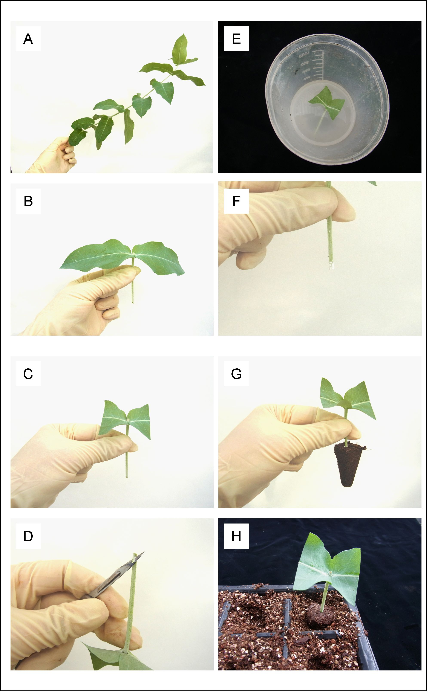

Figure 2.
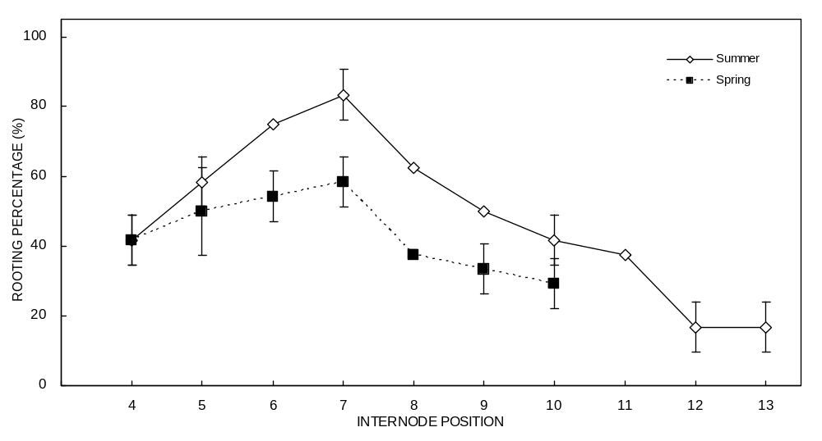

Table 1. Seasonal variation in the percentage of survival and rooting, and maximum, minimum, and mean temperature at cutting propagation during different experimental periods.
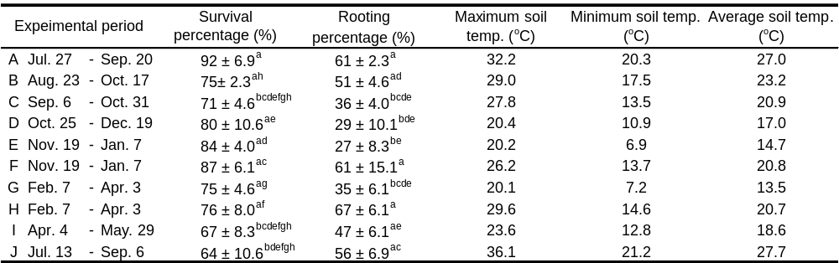

Seventy-five cuttings (25 cuttings × 3 replicates) were used during different collection times of the year. The experimental period was classified into 10 sets (A – J). Survival and rooting percentages were calculated based on the initial number of cuttings tested. Means ± SD followed by different letters within a column indicate significant difference by Tukey’s test (α = 0.05).
Table 2. Survival and rooting percentages, number of roots, and length of the longest root in E. globulus cuttings treated with different auxin types (IBA, NAA, and IAA).
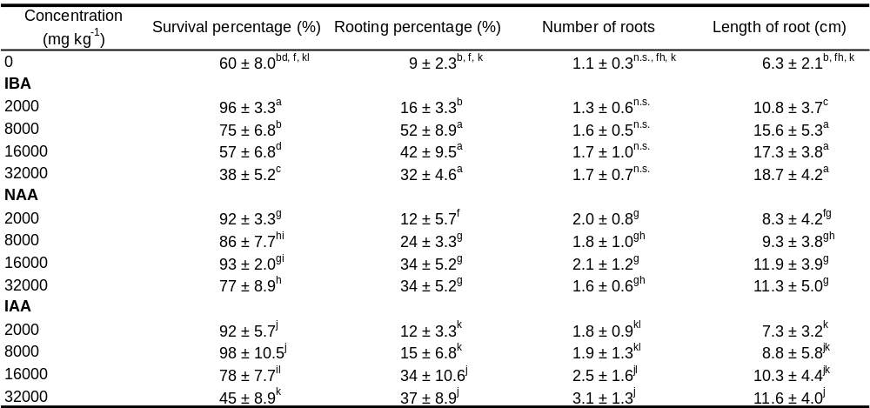

Experiments were performed during the spring (between March 28 and May 23, 2011). Date were recorded at the end of the experimental period. One hundred cuttings (25 cuttings × 4 replicates) were used to test each concentration. Survival and rooting percentages were calculated based on the initial number of cuttings tested. Means ± SD followed by a different letter within a column denote significant difference by Tukey’s test (α = 0.05). n.s. implies that there are no significant differences.

Table 3. Effect of IBA and 3,4-MDPU on rooting of E. globulus cuttings.
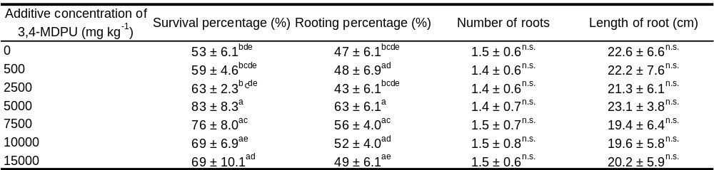

Experiments were performed during the summer (between August 3 and September 28, 2011). Data were recorded at the end of the experimental period. Seventy-five cuttings (25 cuttings × 3 replicates) were used for each concentration. Survival and rooting percentages were calculated based on the initial number of cuttings tested. Means ± SD followed by a different letter within a column denote significant difference by Tukey’s test (α = 0.05). n.s. implies that there are no significant differences.

