Direct adventitious shoot regeneration from cotyledonary explants of Jeffersonia dubia Benth et. Hook
Iyyakkannu Sivanesan¹ and Byoung Ryong Jeong^{1,2,3*}
¹Institute of Agriculture and Life Science, Gyeongsang National University, Jinju, Korea 660-701
*Fax: + 82-55-757-7542, *E-mail: brjeong@gnu.ac.kr
²Division of Applied Life Science (BK21 Program), Graduate School, Gyeongsang National University, Jinju, Korea 660-701
³Research Institute of Life Science, Gyeongsang National University, Jinju, Korea 660-701
Abstract We investigated the effects of culture media [Murashige and Skoog (MS) or Chu (N6)] and cytokinins [N⁶-(2-isopentenyl) adenine (2iP), N⁶-benzyladenine (BA) or (1-Phenyl-3-(1,2,3,-thiadiazol-5-yl)urea (thidiazuron, TDZ)] on adventitious shoot regeneration from cotyledonary explants of Jeffersonia dubia. Adventitious shoot regeneration was achieved only on N6 medium. Of the three cytokinins studied, TDZ was the most effective for shoot induction. The mean number of shoots varied among the different concentrations of TDZ studied. The frequency of shoot induction decreased with increasing concentrations of TDZ in the culture medium. The highest frequency of shoot induction (72.1%), with a mean number of 10.5 shoots was obtained on N6 medium supplemented with the lowest concentration of TDZ (0.25 mg l⁻¹). Callus formation was observed when the medium was supplemented with the highest concentration of TDZ (2.0 mg l⁻¹).
Key words: Asian Twinleaf, Berberidaceae, Chu (N6) medium, cytokinin, shoot regeneration, thidiazuron
INTRODUCTION
Genus Jeffersonia (Berberidaceae) includes only two species of herbaceous perennials and occurring in northeast Asia and Eastern North America (Weaver 1977). Jeffersonia species become popular ornamentals due to their attractive flowers and heart-shaped leaves. Plants are in full flower the first week of April, and seeds ripen by late May. Leaves are fully expanded by mid-April, and they senesce from early June to late July (Baskin and Baskin 1989). Jeffersonia dubia commonly known as Asian Twinleaf, is native to Korea and adjacent Eastern Asia. It is more attractive than J. diphylla, since the flowers are pale blue-lavender (Weaver 1977). The plant is endangered in the wild due to continuous reforestation and illegal collection (Kim 2006). It is typically propagated by division of rhizomes or by seeds. However, the rate of vegetative propagation is very slow and seed germination in nature is also very poor due to morphophysiological dormancy of seed (Baskin and Baskin 1989, Rhie et al. 2010). Therefore, efficient propagation methods are needed to conserve this rare ornamental plant. Recent years, in vitro culture has emerged as an alternative method for conservation of rare plants. Several reports are available on in vitro propagation of Berberidaceae members (Pitta-Alvarez et al. 2008, Mihaljević and Vršek 2009, Chakraborty et al. 2010, Jiang et al. 2012). However, to the best of our knowledge, there are no published reports on in vitro propagation of Jeffersonia species. The present study describes a protocol for adventitious shoot regeneration from cotyledonary explants of J. dubia.
MATERIALS AND METHODS
Seed capsules of J. dubia were collected on 22 May 2011 from healthy plants growing in a mesic deciduous woodland in Hantaek Botanical Garden, Gyeonggi-do, Korea. Seeds were removed from the capsules, dried at room temperature (25±3°C) for 3 days and stored at 5°C for 2 weeks. To break the morphophysiological dormancy, seeds were soaked in 1000 mg l⁻¹ gibberellic acid (GA₃) at 25±3°C for 24 h, dried at room temperature and kept at 12h/12h daily alternating thermo-periods of 15/6°C for 30 days followed by 90 days at 5°C. Embryos were dissected out from the control and treated seeds and length of embryo was recorded. For each treatment 15 seeds were used. The treated seeds were surface disinfested with 70% (v/v) ethanol for 60 s, 1.5% sodium hypochlorite (NaOCl) solution with a drop of Tween 20 for 15 min and 0.01% (w/v) mercuric chloride (HgCl₂) for 10 min. Each treatment was followed by 3-4 rinses with sterile distilled water. The zygotic embryos were dissected out from the seeds and cultured on Murashige and Skoog (MS) medium (Murashige and Skoog 1962) containing 3% (w/v) sucrose and 0.8% (w/v) agar. Cultures were maintained at 25±1°C under a 12 h photoperiod with 45 µmol m⁻² s⁻¹ photosynthetic photon flux density (PPFD) provided by cool white fluorescent light (Philips 40 W tubes). Germination percentage was calculated after 30 days.
Cotyledonary (0.5-1.0 cm) explants (14 days old) were cultured on MS or N6 (Chu et al. 1975) media supplemented with 3% (w/v) sucrose and 0, 0.25, 0.50, 1.0, or 2.0 mg l⁻¹ N⁶-(2-isopentenyl) adenine (2iP), N⁶-benzyladenine (BA) or (1-Phenyl-3-(1,2,3,-thiadiazol-5-yl)urea (thidiazuron, TDZ). The medium was solidified with 0.8 % (w/v) agar (Plant Agar, Duchefa Biochemie, The Netherlands). The pH of the medium was adjusted to 5.8 using 0.1 N NaOH before autoclaving at 121°C for 15 min. Thidiazuron was filter-sterilized and added to autoclaved medium. Other plant growth regulators were added to basal medium prior to pH adjustment and sterilization. Cultures were maintained at 25±1°C under a 16 h photoperiod with 45 µmol m⁻² s⁻¹ photosynthetic photon flux density (PPFD) provided by cool white fluorescent light (Philips 40 W tubes). Number of explants initiating shoots, and average number of shoots per explant were recorded after 5 weeks.
For each experiment, 50 zygotic embryos or explants were used and the experiment was repeated three times. All data were statistically processed by analysis of variance (ANOVA) followed by Duncan multiple range test at a 5% probability level by using SAS computer package (SAS Institute Inc., NC, USA).
RESULTS AND DISCUSSION
Twinleaf fresh seeds have underdeveloped embryos (0.5 mm length) and require a period of warm and/or cold stratification to complete germination. For embryo growth seeds must first be exposed to high (30/15°C) temperatures and then they were cold (5°C) stratified to break dormancy. Gibberellic acid (GA₃) treatment increased the rate of embryo growth in seeds of J. diphylla (Baskin and Baskin 1989) and J. dubia (Rhie et al. 2010). Thus, GA₃ substitute for high temperature. The length of embryo in fresh seed of J. dubia was 0.4 ± 0.03 mm. In seed treated with 1000 mg l⁻¹ GA₃ for 24 h and incubated under darkness at 15/6°C for 30 days followed by 90 days at 5°C, embryo length was 5.6 ± 0.13 mm.
The surface sterilization method yielded 100% aseptic cultures. Ninety-three percent of embryos (± 3.9 SE) were germinated on MS medium containing 3% (w/v) sucrose. The explants failed to develop shoots on MS medium supplemented with various concentrations of cytokinins such as 2iP, BA, and TDZ. However, callus formation was observed when cotyledonary explants were cultured on MS medium supplemented with 0.5-2.0 mg l⁻¹ TDZ (Table 1). Adventitious shoots were formed directly from the cut ends of explants cultured on N6 medium supplemented with TDZ but not with 2iP or BA. The effect of cytokinins on tissue or organ culture can vary according to the particular compound used (van Staden et al. 2008). The nutrient media, plant growth regulators (PGRs) and their concentrations influenced the in vitro shoot formation in cultures. Of the two media studied, adventitious shoot regeneration was achieved only on N6 medium. This might be due to its low nutrient and nitrogen content. Although differences in basal nutrient formulation exist between MS and N6 media, the critical factor is the ratio of ammonium and nitrate ions (Visarada et al. 2002). The nitrogen NO₃⁻/NH₄⁺ ratio on MS and N6 media were 66:34 and 80:20 respectively. The nitrogen supply in the form of nitrates is known to accelerate the growth and development of plants (Ramage and Williams 2002). Further, high content of ammonia inhibit shoot regeneration in apricot (Perez-Tornero and Burgos 2000), buddleia (Dai and Castillo 2007) and chokecherry (Dai et al. 2004).
Of the three cytokinins studied, TDZ was the most effective for shoot induction. Thidiazuron, a synthetic phenylurea derivative, is more effective than adenine-based compounds (2iP or BA) for promoting adventitious shoot regeneration in several plant species (Lu 1993, Akram and Aftab 2011, Sivanesan et al. 2011a). When N6 medium was supplemented with different concentrations of TDZ, adventitious shoot initiated from the cut ends of cotyledonary explants within 2 weeks of culture. The mean number of shoots varied among the different concentrations of TDZ studied. The frequency of shoot induction decreased with increasing concentrations of TDZ in the culture medium (Table 1). The highest frequency of shoot induction (72.1%), with a mean number of 10.5 shoots was obtained on N6 medium supplemented with the lowest concentration of TDZ (0.25 mg l⁻¹). High cytokinin activity of TDZ at lower concentration has been reported in Ajuga multiflora (Sivanesan et al. 2011a), banana (Arinaitwe et al. 2000) and Hedera helix (Sivanesan et al. 2011b). Thidiazuron is resistant to all cytokinin oxidases and it may stimulate the accumulation, or biosynthesis, of natural purine-based cytokinins, or alter the metabolism of these compounds (van Staden et al. 2008). Different stages of adventitious shoot regeneration from cotyledonary explants of J. dubia cultured on N6 medium supplemented with 0.25 mg l⁻¹ TDZ are shown in Fig. 1. Callus formation was observed when the medium was supplemented with the highest concentration of TDZ (2.0 mg l⁻¹). Similar results were observed in other plant species (Lu 1993, Sivanesan et al. 2011a, b).
Acknowledgements: This research was supported by Technology Development Program for Agriculture and Forestry, Ministry for Food, Agriculture, Forestry and Fisheries, Republic of Korea. Project No: 109096-5.
REFERENCES
Akram M., Aftab F. (2011). Adventitious shoot regeneration from cotyledons of Heterophragma adenophyllum (Wall. ex G. Don) Seem. ex Benth. & Hook. F. seedlings. Propagation of Ornamental Plants, 11: 197-203.
Arinaitwe G., Rubaihayo P. R., Magambo M. J. S. (2000). Proliferation rate effects of cytokinins on banana (Musa spp.) cultivars. Scientia Horticulturae, 86: 13-21.
Baskin J. M., Baskin C. C. (1989). Seed germination ecophysiology of Jeffersonia diphylla, a perennial herb of mesic deciduous forests. American Journal of Botany, 76: 1073-1080.
Chakraborty A., Bhattacharya D., Ghanta S., Chattopadhyay S. (2010). An efficient protocol for in vitro regeneration of Podophyllum hexandrum, a critically endangered medicinal plant. Indian Journal of Biotechnology, 9: 217-220.
Chu C.C., Wang C.S., Sun C.C., Hsu C., Yin K.C., Chu C.Y. (1975). Establishment of an efficient medium for anther culture of rice, through comparative experiments on the nitrogen sources. Scientia Sinica, 18: 659-668.
Dai W., Castillo C. (2007). Factors affecting plant regeneration from leaf tissues of Buddleia species. HortScience, 42: 1670-1673.
Dai W., Jacques V., Walla J., Cheng Z. M. (2004). Plant regeneration of chokecherry (Prunus virginiana L.) from in vitro leaf tissues. Journal of Environmental Horticulture, 22: 225-228.
Jiang W., Chen L., Pan Q., Qiu Y., Shen Y., Fu C. (2012). An efficient regeneration system via direct and indirect organogenesis for the medicinal plant Dysosma versipellis (Hance) M. Cheng and its potential as a podophyllotoxin source. Acta Physiologiae Plantarum, 34: 631-639.
Lu C.-Y. (1993). The use of thidiazuron in tissue culture. In Vitro Cellular & Developmental Biology-Plant, 29P: 92-96.
Mihaljević S., Vršek I. (2009). In vitro shoot regeneration from immature seeds of Epimedium alpinum induced by thidiazuron and CPPU. Scientia Horticulturae, 120: 406-410.
Murashige T., Skoog F. (1962). A revised medium for rapid growth and bio assays with tobacco tissue cultures. Physiologia Plantarum, 15: 473-497.
Perez-Tornero O., Burgos L. (2000). Different media requirements for micropropagation of apricot cultivars. Plant Cell Tissue and Organ Culture, 63: 133-141.
Pitta-Alvarez S. I., Medina-Bolivar F., Alvarez M. A., Scambatto A. A., Marconi P. L. (2008). In vitro shoot culture and antimicrobial activity of Berberis buxifolia Lam. In Vitro Cellular & Developmental Biology-Plant, 44: 502-507.
Ramage C. M., Williams R. R. (2002). Mineral nutrition and plant morphogenesis. In Vitro Cellular & Development Biology-Plant, 38: 116-124.
Rhie Y. H., Jung H. H., Kim K. S. (2010). Seed dormancy and germination of Jeffersonia dubia. Korean Journal of Horticultural Science & Technology, 28 (Suppl. II): 36-37.
Sivanesan I, Ko C. H., Lee J. P., Jeong B. R. (2011a). Influence of cytokinins on adventitious shoot regeneration from leaf and petiole explants of Ajuga multiflora Bunge. Propagation of Ornamental Plants, 11: 156-158.
Sivanesan I., Song J. Y., Jeong B. R. (2011b). Micropropagation of Hedera helix L. ‘Mini’. Propagation of Ornamental Plants, 11: 125-130.
van Staden J., Zazimalova E., George E. F. (2008). Plant growth regulators II: cytokinins, their analogues and antagonists. In: George E. F., Hall M. A., Klerk G.-J. D. (Eds). Plant propagation by tissue culture 3rd edition, vol. 1. The background, Springer, Dordrecht: 205-226.
Visarada K. B. R. S., Sailaja M., Sarma N. P. (2002). Effect of callus induction media on morphology of embryogenic calli in rice genotypes. Biologia Plantarum, 45: 495-502.
Weaver R. E. Jr. (1977). Wildflowers from East and West. Arnoldia, 37: 169-197.
Table 1. Effects of culture media and TDZ on direct adventitious shoot regeneration from codyledonary explants of J. dubia.
TDZ (mg l⁻¹) | Shoot induction (%) |  | No. of shoots per explant
TDZ (mg l⁻¹) | MS | N6 | MS | N6
0.00 | - | - | - | -
0.25 | - | 72.1 ± 3.8 a^{z} | - | 10.5 ± 1.6 a
0.50 | * | 66.3 ± 2.6 b | * | 8.0 ± 1.0 b
1.00 | * | 60.0 ± 3.0 c | * | 5.6 ± 1.4 c
2.00 | * | * | * | *
- no response, * callus formation
^{z}Means ± SE within a column followed by the same letters are not significantly different (P≤ 0.05). Data were recorded after 5 weeks of culture.
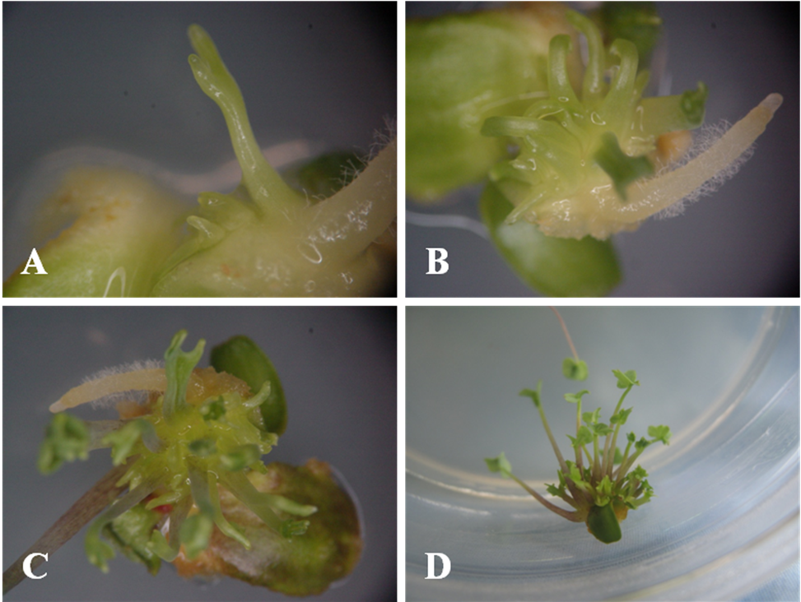
Fig.1. Different stages of adventitious shoot regeneration from cotyledonary explants of J. dubia cultured on N6 medium supplemented with 0.25 mg l⁻¹ TDZ. A) after 2 weeks, B) after 3 weeks, C) after 4 weeks, and D) after 5 weeks.

