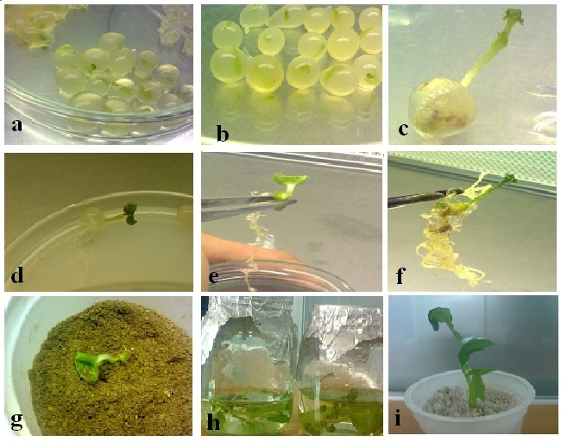Figure1 Plant regeneration from encapsulated shoot tips of *Brassica napus* L.;**a** Sodium alginate beads formed by the encapsulation of shoot tips using 2% sodium alginate and 1.4% CaCl2. 2H2O;**b** shoot tips encapsulated with 4% sodium alginate **c** Shoot emergence from encapsulated shoot tip after 1–2 wks of culture; **d** Shoot ad root elongation from clusters of stunted shoot tips. **E** Root initiation from capsule beads after 3 weeks **f** Root developed after 4 wks in encapsulated shoots on MS medium **g** Healthy plant established in sterile soil under lab. Conditions **h** plantlet with well-developed shoot obtained from an encapsulated shoot tip (after 5wks)in root induce medium(liquid MS medium containing different concentration of IAA); **I** Healthy plant contain fresh and huge shoot and root established in pot under lab. conditions.