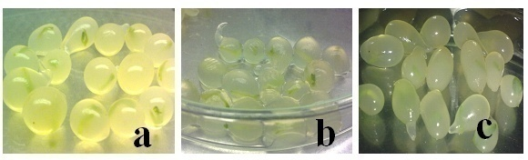

Figure 2 Effects of different sodium alginate concentrations in 1.4% calcium chloride; **a**2% sodium alginate (with clear, isodiametric bead); **b** 4% sodium alginate(with soft capsules);**c**6% sodium alginate (with hard and non-isodiametric beads).