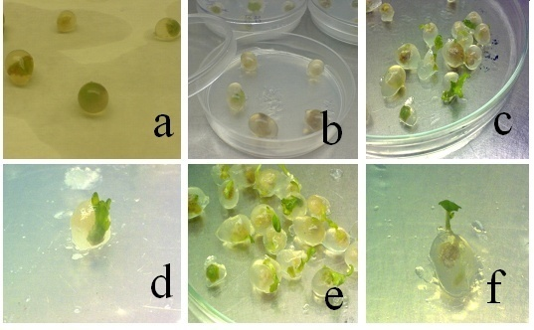

Figure 3 Encapsulation of *Brassica napus* cv. Tallayeh somatic embryos.**(a)**encapsulated somatic embryos on sterile Whatman paper.**(b)**somatic embryos plated on MS free medium after cold storage.**(c)**germinating artificial seed after 10 days of culture from encapsulated somatic embryos.**(d)**sprouted shoots from on Encapsulated somatic embryos after 10 days.**(e)**germinated encapsulated somatic embryo on MS basal solid medium after 2 wks.**(f)**plantlet development from encapsulated somatic embryo after 3 wks.