Effect of method of IBA application on rooting of *Tabernaemontana coronaria* (Chandani) softwood cuttings

J M S Rawat*, K K Singh, Y K Tomar and 1Bhupendra Singh

Department of Horticulture, Chauras Campus, HNB Garhwal Central University, Srinagar (Garhwal) 246174, Uttarakhand, India

1Department of Forestry, Post Box-59, H.N.B. Garhwal University, Srinagar Garhwal, 246 174,

Uttarakhand, India

**Abstract**

The softwoods cutting of *Tabernaemontana coronaria* were collected from healthy plants under pruning. The cuttings were collected in the month of June. 10-15 cm long cuttings were prepared and treated with different concentration of IBA by quick dip and powder preparation method. The cuttings were planted in root trainers of 100 cc capacity filled with vermi-compost and kept under mist chamber for rooting. The study pointed out that among quick dip and powder preparation of IBA, the powder preparations resulted in better and faster induction of rooting characters and root numbers than quick dip method and control ones in mist chamber.

Key words: softwood cutting, IBA, Tabernaemontana coronaria, rooting percent, quick dip, powder preparation

**INTRODUCTION**

Cuttings are probably the most important method for starting new plants. Softwood stem cuttings are taken from woody plants when growth is still relatively soft and succulent before tissues have matured and lignified, or become woody. Softwood cuttings usually root easier and faster than other types of stem cuttings. The purpose of treating cuttings with "hormones" is to increase the rooting percentage of cuttings, to hasten root initiation, to increase the number of roots per cutting and to increase uniformity of roots produced.

Results from the use of rooting hormones are variable, and the range between promoting and inhibiting effects are narrow. Improved results can be expected for many species of evergreens, if the cuttings are taken at the right time of year and the proper hormonal material and concentration used. The dilute solution soaking method of applying hormones can be used satisfactorily, although it is more difficult and time consuming for commercial growers. It should be remembered that treatment with hormones is not a substitute for good propagation procedures and will not ensure rooting if other factors are limiting. The environmental conditions necessary

*Correspondence author- Tel.: +91 9412948487, E-mail address: [jms_rawat99@yahoo.co.in](mailto:jms_rawat99@yahoo.co.in)

for successful rooting of cuttings are: proper air temperature (65° -75° F or l8° -24° C), a humid atmosphere, ample light, and a moist but well-drained and well-aerated medium.

Normally known as *Moonbeam*, *Chandani* (in Urdu) and *Crape Jasmine*, *Tabernaemontana coronaria* is an excellent evergreen and ornamental bush for lawns and gardens. *Tabernaemontana* can be grown from layers or cuttings. Keeping these points in view, the research work was conducted to study the effect of growth regulators and their concentration for inducing rooting in cuttings of *T. Coronaria* under mist house conditions.

**MATERIALS AND METHODS**

The present investigation was conducted in 2011 in the mist house located at the Horticultural Research Centre, HNB Garhwal University, Srinagar Garhwal, Uttarakhand, India. The research centre is situated in the Alaknanda valley at 300 13’ 25.26’’ N and 780 48’ 04.93’’ E and 563 m above mean sea level, and exhibits a subtropical climate with dry summer and rigorous winters with occasional dense fog in the morning hours from mid December to mid February. The average temperature inside the mist house during experiment was 75+5% relative humidity and 35+3 0C temperature. The temperature of the soil measured was around 26+2 0C. Softwood cuttings of *Tabernaemontana coronaria* (Chandani) were collected from 3 to 4 year old plants and 15 cm long cuttings having 4 to 5 nodes with apical portion and one pair of leaves prepared. Vermicompost was used as the rooting media. It was filled in the root trainers of size 100 cc. There were seven treatments of growth regulator formulations used at different concentrations; twenty cuttings were used for each treatment which was replicated thrice. The prepared cuttings were planted in pots after dipping in solutions of IBA at 3000 mg.L-1, 4000 mg.L-1 and 5000 mg.L-1 for dilute medium and 3000 mg.Kg-1, 4000 mg.Kg-1 and 5000 mg.Kg-1 for powder formulation. The experiment was laid out in completely randomized design and replicated thrice with 10 cuttings in each treatment. Experiment was conducted in the mist house which had the arrangement for intermittent misting to 60 seconds at every 10 minutes interval between 8 am and 8 pm. The basal 1.5-2.0 cm portion of the cuttings was dipped in growth regulator formulation for 10 minutes and immediately planted in medium to a depth of 6-8 cm. After cuttings were planted, the misting was started. The planted cuttings were allowed to root for 30 days. The cuttings were carefully removed from the pots and dipped in water to remove the soil particles adhering to roots to record the observations pertaining to roots viz., days taken for root initiation, percentage of cutting rooted, per cent success after 30 days, number of roots per cutting. Length of longest root, except for the observations on various stem leaf characters and all other were recorded after planting. The data pertaining to root and shoot character were tabulated and statistically analysed as per the methods outlined by **Cochran and Cox (1992)** by adopting Fishers analysis of variance techniques and means were subjected to Duncan’s Multiple Range Test (DMRT).

**RESULT AND DISCUSSION**

The significant (P<0.05) variations was recorded between different concentrations of IBA and different method of plant growth regulator application. However, the minimum days (4.33 days) taken to callus formation in softwood cuttings of *Tabernaemontana coronaria* was noticed in IBA powder formulation at 4000 mg.Kg-1 and 5000 mg.Kg-1 and maximum days (8.67 days) taken was found with control set of cuttings (Table 1). The rooting percentage was successfully achieved 100% in all the treatments of IBA except control set.

The production of sprouts were maximum (2.67 number) in IBA 5000 mg.L-1 treatment. The minimum (1.00) sprouts were noticed with IBA powder formulation at 5000 mg.Kg-1, IBA dilute formulation at 3000 mg.L-1 and control set. The maximum length of sprouts (32.33 mm), diameter of sprout (0.43 mm), length of roots (6.67 cm) were recorded under IBA powder formulation at 4000 mg.Kg-1 while, the minimum values of these characters were found with control set. The maximum numbers of leaves (10.00) were recorded in IBA powder formulation at 5000 mg.Kg-1 however minimum (3.33) were produced in control set.

The maximum number of roots (71.67) were recorded in IBA powder formulation at 3000 mg.Kg-1 while, minimum (7.33) were recorded in control set of cuttings. The numbers of roots in quick dip method were maximum (27.67) in IBA at 3000 mg.L-1. The diameters of roots were maximum (0.23 mm) recorded in IBA at 3000 mg.L-1 /mg.Kg-1 in both powder and dilute formulations. The minimum diameter (0.10 mm) was recorded in control set of cuttings.

This study of suitability and effectiveness of application method of plant growth regulator in soft wood cuttings of *T. coronaria* planted in mist chamber has found rooting percent, number of sprouts, length of sprouts, diameter of sprouts, number of leaves, length of roots, diameter of roots and number of roots (Table 2). It is possible that the variation in rooting of soft wood cuttings between treatments is due to strength of plant growth regulator used. The powder prepared hormone concentration and quick dip method was significantly influence number of leaves and number of roots/cuttings, while, concentration of hormones were significantly influence the rooting and sprouting parameters of cuttings (Table 2). However, the powder preparation method which produces upto 877.76% more rooting than control, while quick dip application method initiated 277.49% more roots in comparison to control set (Figure 1).

In present study of different IBA concentration significantly affect the rooting in *T. coronaria* when applied as powder preparation or quick dip method. This is confirmed by **Thimann and Koepfli (1935)** study. They reported that IBA was even more effective than the naturally occurring or synthetic IAA for rooting. It has been repeatedly confirmed that auxin is required for initiation of adventitious roots on stem, and indeed, it has been shown that division of the first root initial cells are dependent upon either applied or endogenous auxin **(Stromquist and Hansen, 1980).**

Mist chamber creating a humid atmosphere by means of artificial mist around the planted cuttings enhanced the process of rooting **(Lynn and Hartmann, 1957 and Vijaya Kumar, 1973)**. **Koremastu and Shinno (1975)** stated that mist propagation increased the percent of rooting and reduced time in many garden trees and shrubs. Mist chamber provides most favourable environment for better rooting of patchouli cuttings **(Selvarajan and Madhava Rao, 1982).** The results of present study also suggested that callus or rooting initiation was quickly in mist chamber in *T. coronaria* softwood cuttings.

**Thimmappa and Bhattacharjee (1990)** observed that IBA treatment at 2000 ppm proved to be best for rooting. While **Patil and Shirol (1991)** recorded highest rooting percentage, number of primary roots in oleander cutting treated with 3000 ppm IBA. **Bhattacharjee and Balakrishna (1992)** recorded maximum rooting in stem cuttings of *Ixora singaporensis* with IBA at 4000 ppm and 6000 ppm. The rooting response of *T. coronaria* after IBA application at different concentration showed different response which confirmed by the earlier study, but in this study powder medium give best results as compared to the quick dip method.

**Gupta et al. (2002)** reported that treatment of *Bougainvillea* cuttings with 1000 ppm IBA gave maximum rooting (100%) with higher number of roots in soaking method.

**Tewary et al. (2004)** studied the cuttings treated with stick (NAA with sodium as active ingredient) showed maximum effect on rooting (100%) with 500-1500 ppm followed by IAA at 1500 ppm (80%) in *Vitex negundo* which confimed by this study. The promotion effect of powder preparation in more number of roots may be due to that when cuttings are basal portion dipped in powder, a large proportion of powder stick at base which remains at cutting surface and it’s surrounding when these were inserted in rooting media. This powder with plant growth regulator around cutting surface in media helps in development of more roots and other rooting features.

**Conclusion**

In light of the results obtained and discussion given above, it can be concluded that powder preparation application method is capable not only increasing the number of produced roots, but also improving the other rooting characters of softwood cuttings in *Tabernaemontana coronaria* (Chandani). Therefore, it is best method to produce new plants having good roots by soft wood cuttings under mist chamber.

**REFERENCES**

Bhattacharjee S. K., Balakrishna M. (1992). Studies on propagation of *Hamelia patens* and *Ixora singaporensis* from stem cuttings*.* Prog. Hortic., 24: 157-164.

Cochran W. G., Cox G. M. (1992). Experimantal Designs. John Wiley and Sons Inc. New York.

Gupta V. N., Banerj B. K., Datta S. K. (2002). Effect of auxin on rooting and sprouting behaviour of stem cuttings of *Bougainvillea* under mist. Haryana J. Hortic. Sci., 31: 42-44.

Korematsu M., Shinno H. 1(975). Studies on propagation of cuttings of garden trees and shrubs. Bul. Hiroshima Prefec. Agric. Expt. Stn, 36: 87-96.

Lynn C., Hartmann H. T. (1957). Rooting cuttings under mist. Calfonia Agric, 11, 145.

Patil A. A., Shirol A. M. (1991). Studies on rooting of oleander cuttings. South Indian Hortic, 39, 48-53.

Selvrajan M., Madhava Rao V. N. (1982). Studies on rooting of patchouli cuttings under different environments. South Indian Hortic, 30: 107-111.

Stromquist L., Hansen J. (1980). Effects of auxin and irradiance on the rooting of cuttings of *Pinus sylvestris.* Physiol. Plant, 49: 346-50.

Tewary D.K., Vasudevan P., Santhosh (2004). Effect of plant growth regulators on vegetative propagation of *Vitex negundo* L. Indian Forester, 230: 45-52.

Thimann K. V., Koepfli J. B. (1935). Identity of the growth promoting and root forming substances of plants. Nature, 135: 101-02.

Thimmappa D.K., Bhattacharjee S. K .(1990). Standardization of propagation of scented geranium from stem cuttings. Indian Perf., 34: 56-60.

Vijay Kumar N (1973). Studies on the propagation of guava (*Psidium guajava* L.) by cuttings. Ph. D. Thesis, University of Udaipur.

Table 1. Effect of method of IBA application on rooting of *Tabernaemontana coronaria* soft wood cuttings

|  |  |  |  |  |  |  |  |  |  |
| --- | --- | --- | --- | --- | --- | --- | --- | --- | --- |
| Treatments | Days taken to callus formation | Rooting % | Number of sprouts | Length of sprouts (mm) | Diameter of sprouts (mm) | Number of leaves | Length of roots (cm) | Diameter of roots | Number of roots |
| **Powder preparation** | | | | | | | | | |
| IBA 3000 mgKg-1 | 4.67c | 100.00a | 2.00ab | 29.07b | 0.43a | 10.00a | 6.67a | 0.23a | 71.67a |
| IBA 4000 mgKg-1 | 4.33c | 100.00a | 1.67bc | 32.33a | 0.42a | 7.33ab | 5.33ab | 0.20a | 70.33a |
| IBA 5000 mgKg-1 | 4.33c | 100.00a | 1.00c | 24.67c | 0.30a | 5.33bc | 5.00b | 0.20a | 48.33b |
| **Quick dip method** | | | | | | | | | |
| IBA 3000 mgL-1 | 5.33b | 100.00a | 1.00c | 27.73bc | 0.43a | 4.67bc | 4.83b | 0.23a | 27.67c |
| IBA 4000 mgL-1 | 4.67c | 100.00a | 1.33bc | 25.07c | 0.30a | 5.00bc | 5.33ab | 0.20a | 25.67c |
| IBA 5000 mgL-1 | 4.67c | 100.00a | 2.67a | 25.37c | 0.43a | 7.00ab | 5.17b | 0.20a | 12.00d |
| Control | 8.67a | 90.33b | 1.00c | 19.67d | 0.10b | 3.33c | 3.00c | 0.10b | 7.33d |
| **SEM±** | **0.18** | **0.33** | **0.23** | **1.00** | **0.05** | **1.10** | **0.45** | **0.02** | **3.50** |
| **CD at 5%** | **0.55** | **1.03** | **0.71** | **3.10** | **0.16** | **3.40** | **1.37** | **0.06** | **10.80** |

Means followed by same letter within each column are not significant (P < 0.05).



Figure 1. Percent roots increased over control by method of IBA application in soft wood cuttings *Tabernaemontana coronaria*

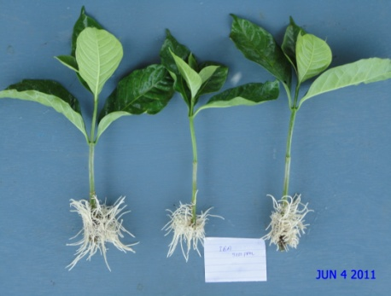 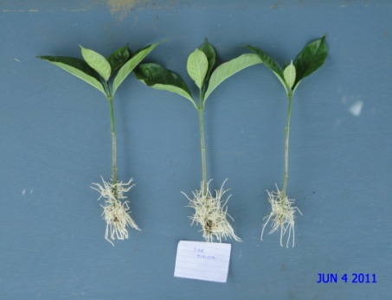

IBA powder formulation

IBA quick dip

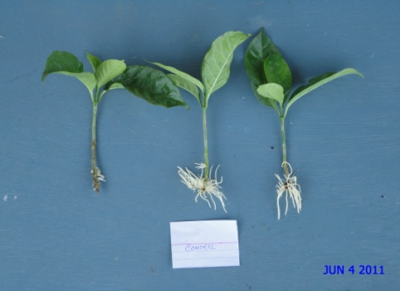 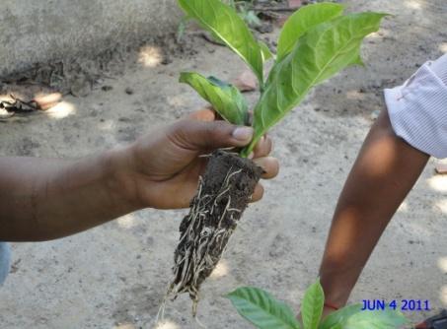

Cutting showing rooting

Control

Plates. Figure showing rooting under various IBA applications in soft wood cuttings *Tabernaemontana coronaria*