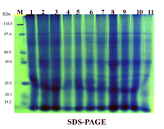

**Fig (1): Patterns of SDS- PAGE electrophoretic protein *Solidago altissima* after salinity stress.**

1-control 2- 1000ppm 3- 2000 ppm 4- 3000 ppm

5- 4000 ppm 6- 5000 ppm 7- 6000 ppm 8- 7000 ppm

9 8000 ppm 10- 9000 ppm 11- 10000 ppm