**Table 1: Quantitative characters of anthers and pollen**

|  |  |  |  |
| --- | --- | --- | --- |
| Cultivar | No. of Anther/flower | No. of pollens/anther | Pollen size (L/D) * |
|  | Mean | Mean | Mean |
| Autumn Sunset | 85.000a | 1358.3bcd | 1.1933 a |
| Ice Berg | 102.00c | 1078.7e | 1.0833 a |
| Paradise | 88.000d | 1537.0ab | 1.1667 a |
| Angel Face | 130.67a | 1588.7ab | 1.1100 a |
| Casino | 90.333d | 1187.0cde | 1.1100 a |
| Louise Odier | 24.333e | 1131.3de | 1.1100 a |
| Grand Margina | 95.333cd | 1394.0abc | 1.2200 a |
| Handel | 115.33b | 1612.3a | 1.1100 a |
| Gruss-an-Teplitz | 29.667e | 1248.7cde | 1.2200 a |
| LSD at P=0.05 |  |  |  |

* Pollen size is ratio of length to diameter it has no Unit

**Table 2: Correlation among pollen vigor parameters**

|  |  |  |  |  |  |
| --- | --- | --- | --- | --- | --- |
| Pollen vigor Parameters | No. of anther/flower | No. of pollens/anther | Pollen size (L/D) | Viability (%) | Pollen germination (%) |
| No. of pollens/anther | 0.582 |  |  |  |  |
| Pollen size (L/D) | -0.334 | 0.149 |  |  |  |
| Viability (%) | 0.302 | 0.216 | -0.287 |  |  |
| Pollen germination (%) | -0.193 | 0.411 | 0.738* | 0.731* |  |
| Pollen tube length (µm) | -0.115 | 0.536 | 0.733* | -0.164 | 0.77* |

**Table 3: Number of crosses made, successful cross and fertility status (Make sure this table based on crosses made only using pollen/ Pollen donor parent)**

|  |  |  |  |  |  |  |  |  |  |  |
| --- | --- | --- | --- | --- | --- | --- | --- | --- | --- | --- |
| Pollen donor parent | Pollen viability (%) | Pollen germination on 15% Sucrose | No. of. crosses made | Successful Crosses | Success Crossing (%) | Total Hip set | Hip set (%) | Total  seeds  obtained | Ave. no of  seeds/hip | Fertility Status |
| Autumn Sunset | 35 | 38.88 | 80 | 36 | 45 | 31 | 38.7 | 713 | 23 | Fertile |
| Ice Berg | 58 | 1.33 | 80 | 0 | 0 | 0 | 0 | 0 | 0 | Sterile |
| Paradise | 51 | 29.11 | 80 | 15 | 18.75 | 13 | 16.25 | 320 | 25 | Low Fertile |
| Angel Face | 60 | 33.88 | 80 | 5 | 6.25 | 5 | 6.25 | 100 | 20 | Low Fertile |
| Casino | 63 | 28.11 | 80 | 12 | 15 | 11 | 13.75 | 253 | 23 | Low Fertile |
| Louise Odier | 42 | 18.00 | 80 | 13 | 16.25 | 9 | 11.25 | 162 | 18 | Low Fertile |
| Grand margina | 51 | 23.88 | 80 | 17 | 21 | 14 | 17.5 | 378 | 27 | Moderate Fertile |
| Handel | 70 | 25.88 | 80 | 43 | 53.75 | 35 | 43.75 | 595 | 17 | Fertile |
| Gruss-an-Teplitz | 64 | 46.55 | 80 | 22 | 27.5 | 18 | 22.5 | 630 | 35 | Moderate Fertile |

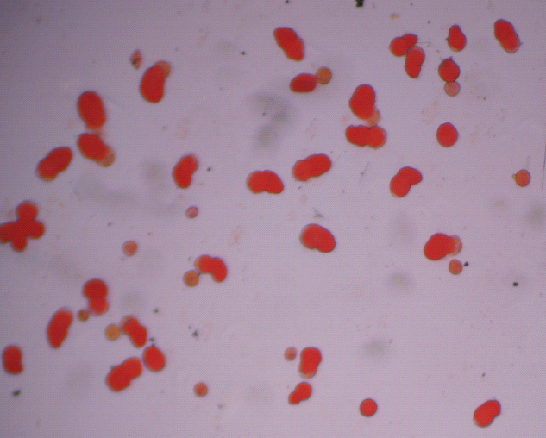 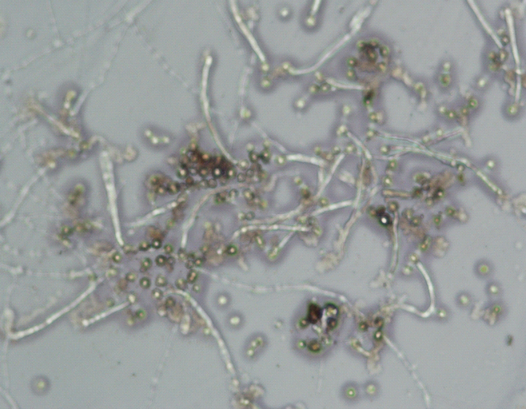

Figure 1: Staines and unstained pollen of Cv. “Handel” Figure 2. Pollen germination of Cv. Gruss- an- Teplitz

Figure 3. Pollen germination percentage at various levels of Sucrose

Figure 4. Pollen tube length at different sucrose concentrations

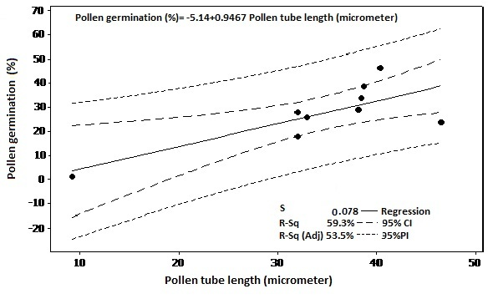

Figure 5: Regression among pollen germination %age and Pollen tube length

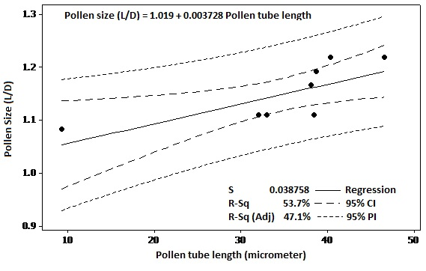

Figure 6: Regression between pollen tube length and pollen size



Figure 7: Tree diagram showing grouping of the cultivars based on pollen physical characters, viability and germination

Figure 8: Relationship between various invitro and invivo fertility status of parent cultivars.