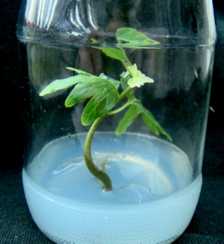 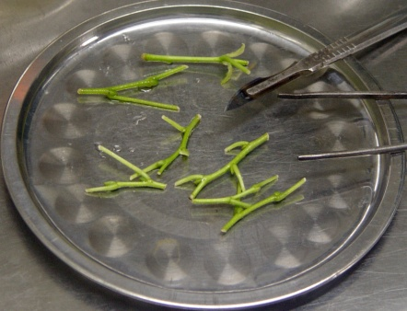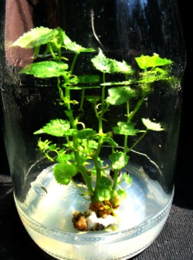

**A**

**D**

**C**

**B**

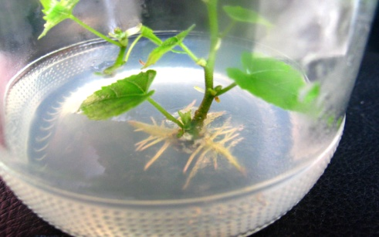 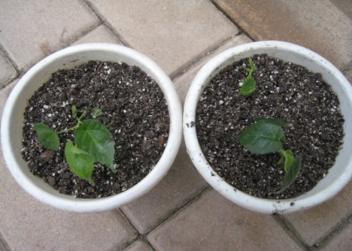 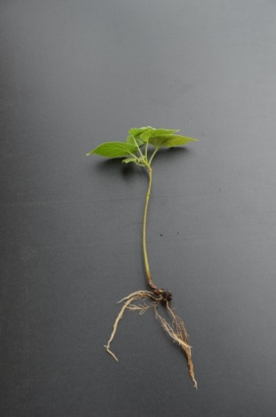

**F**

**G**

**E**

Fig.1. Micropropagation of Nanjing linden (*T. miqueliana*) A) Seedling developed from disinfected seed, B) Nodal explants used for culture, C) Elongated shoots on elongation medium supplemented with 0.04 mg l-1 IBA, 0.5mg l-1 ZT, D) Multiplication of axillary shoots, E) Roots induced on rooting medium, F) Plantlets transferred into small pots, G) Fully established pot plants of Nanjing linden.