DDiameter(cm) and height(g) of the bulblets

Concentrations of the sugars (g)

Fig 1 Effects of different concentrations of the sugars on growth state of the bulbs. Vertical bars represent mean values of three replications ± SD.

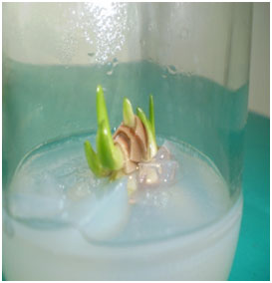 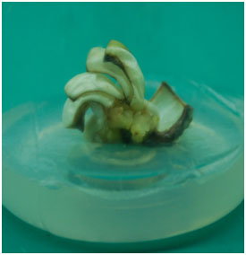 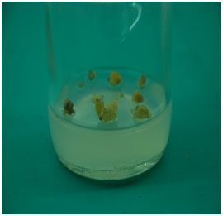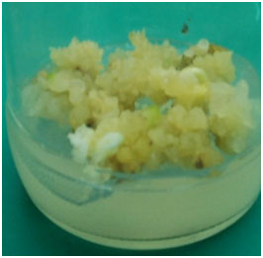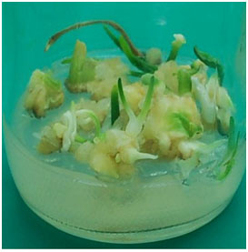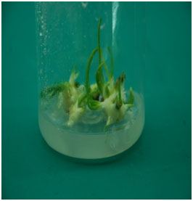

B

A

F

D

C

E

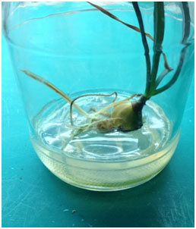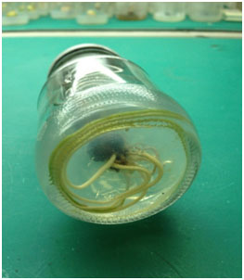

H

G

Fig.2 A) The axillary bud inducing formed on MS medium supplemented with 3.0mg/l6-benzyladenine (BA) in combination with α-naphthaleneacetic acid (NAA) 0.2 mg/l after 2-4 weeks. B) The callus induction on MS medium supplemented with 2.0mg/L 2, 4-D and 0.5mg/L BA. C) Watery callus soon became brown and died D) Embryo-like structures calli on multiplication medium E) The shoots regeneration from embryo-like structures F). The elongated and shoots proliferated on medium supplement with BA 5.0 mg/l in combination with α-naphthaleneacetic acid (NAA) 0.5 mg/l. G,H）The roots and bulbs before being transferred to field conditions.