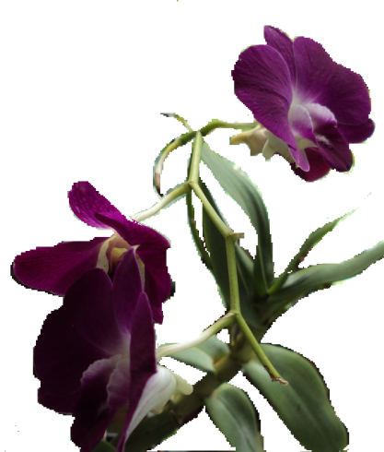

**Fig. 1.** Fully grown Banayat Pink plant with flowers