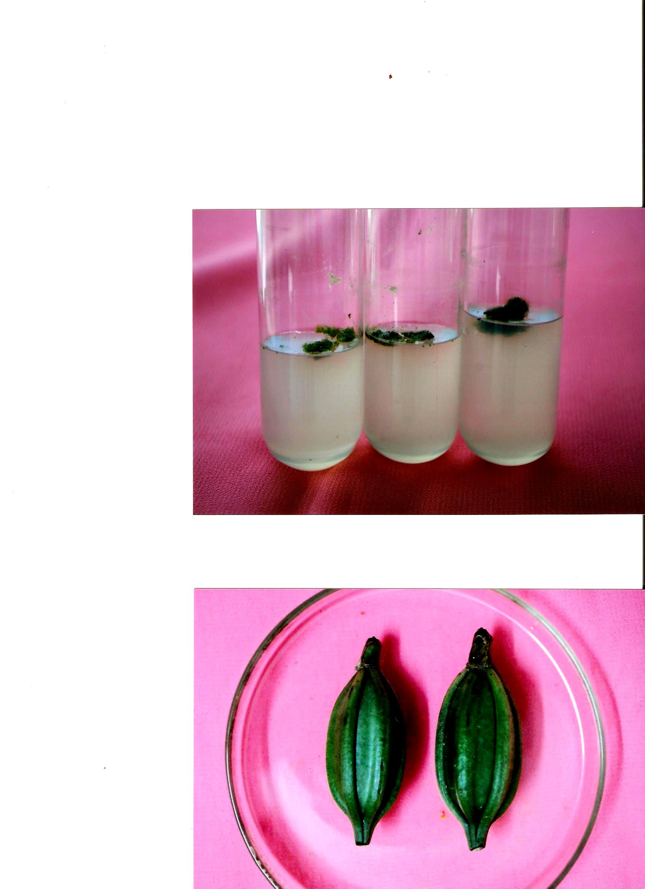 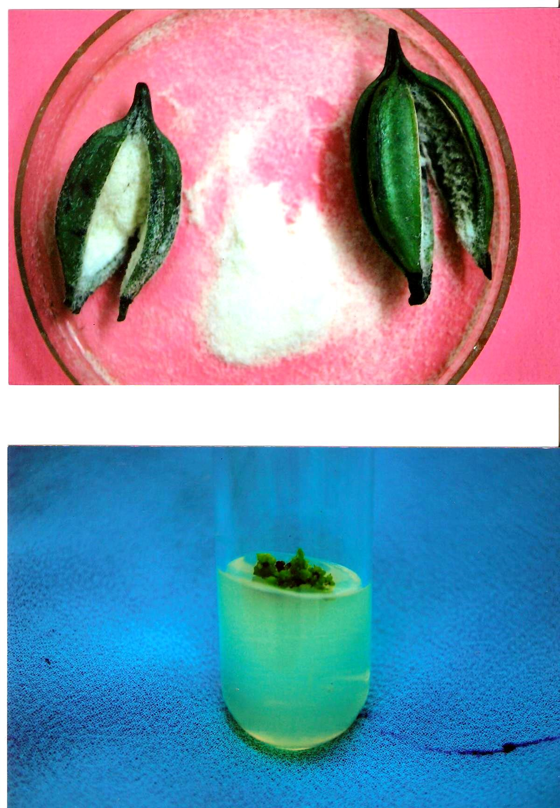

**Fig. 2(A-B).** Mature pods and seeds of Banyat Pink. A) Green mature pods, B) Powder like seeds taken out of the pod, which is used as explant