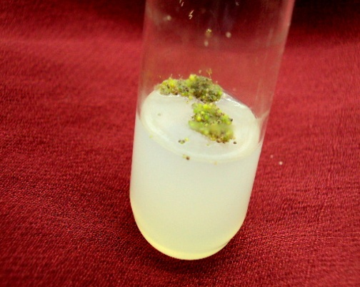 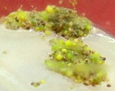

Protocorms

**Fig. 3(A-B).** Protocorm proliferation and development of Banyat Pink. A) Protocorm proliferation in MS medium + BAP 1.5 mg/l, B) magnified view of the protocorm proliferation showing development of protocorms.