**THIDIAZURON-INDUCED SOMATIC EMBRYOGENESIS AND SHOOT REGENERATION IN COTYLEDON EXPLANTS OF *MELIA VOLKENSII* GÜRKE.**

**Eliud Sagwa Mulanda*, Mark Ochieng Adero, Daniel Kirimocho Wepukhulu, Nelson Onzere Amugune, Elijah Akunda, and Jenesio Ikindu Kinyamario.**

Plant Tissue Culture Laboratory, School of Biological Sciences, University of Nairobi, P.O. Box 30197, Nairobi 00100, Kenya, *Fax:………*E-mail: [emulanda123@yahoo.com](mailto:emulanda123@yahoo.com)

**Abstract**

*Melia volkensii* Gürke is a drought-tolerant multipurpose tree species suitable for greening and hardwood timber production in the East African arid and semi-arid lands (ASALs). Conventional propagation is problematic due to seed extraction difficulties, seed dormancy and poor rooting of cuttings. We developed a simple, rapid and efficient protocol for *in vitro* regeneration of *M. volkensii* plants from cotyledon explants using Thidiazuron (TDZ). Mature cotyledons cultured on half-strength MS medium supplemented with eight TDZ concentrations from 0 to 4 mg l-1 formed multiple green globular structures within 8 to 14 days, without an intervening callus phase. Regeneration was confined to the upper-facing, directly illuminated surfaces of the explants. Regeneration frequency was 88% in 0.05 mg l-1 TDZ and 100% in 0.125 - 4 mg l-1 TDZ. Explants in control media remained non-morphogenic. Scanning photomicrography and histological examination revealed multiple globular somatic embryos similar in shape and size to the zygotic embryos. Mature somatic embryos with shoot apices converted into leafy microshoots whilst still on induction media. Microshoots elongated when whole or half segments of cotyledons were subcultured to half-strength MS supplemented with 0.1 mg l-1 BAP alone or in combination with 0.01mg l-l IAA or 10% coconut water (CW). The yield of transplantable shoots ranged from 5 to 18 per cotyledon. Medium containing BAP and IAA was superior for elongation, giving shoots of up to 101 mm in 35 days. Shoots rooted in half-strength MS supplemented with either 0.1 mg l-1 IBA or 0.2 mg l-1 NAA, with NAA inducing up to 12 roots per shoot. This protocol could be applied in mass production of *M. volkensii* planting material for extension of plantations. It can also be applied in genetic modification of the species.

**Key words:** drought-tolerant, multipurpose tree, popagation,

**Running title:** *Shoot regeneration from M. volkensii cotyledons*.

**Received:** January 12, 2014

**Accepted:** March 6, 2014

**INTRODUCTION**

Efficient plant regeneration via tissue and organ is a prerequisite for many biotechnological applications such as *in vitro* genetic improvement of crop plants, elimination of viruses from planting stock, micro-grafting, *in vitro* conservation and *in vitro* screening and selection for tolerance to various abiotic stresses (Benson 2002, Akin-Idowu et al. 2009, Loyola-Vergas and Ochoa-Aleyo 2012, Jamsheed et al. 2013). It is also vital for rapid clonal micropropagation of elite genotypes (Brown and Thorpe 1995), which could be vital in the rescue of medicinal, pesticidal and timber plant species threatened with extinction arising from the combined effects of over-exploitation and loss of habitat.

*Melia volkensii* Gürke (Meliaceae) is a drought-tolerant tree species endemic to the arid and semi-arid lands (ASALs) of East Africa (Orwa et al. 2009). It is a multipurpose tree suitable for use in dry land agro-forestry, apiary, greening of the ASALs, supply of emergency animal fodder during drought and as a source of medicinal drugs and botanical pesticides (Stewart and Blomley 1994, Orwa et al. 2009). Its use as an ornamental tree is alluded to by Rajab and Bentley (1992). The species has vast potential for use as a shade and ornamental tree in homesteads, in fence rows on farms and along roads and highways in the ASAL areas. Its most attractive features are valuable mahogany timber, drought-tolerance, fast growth and short maturity periods of 10 to 15 years, coppicing ability and resistance to termites.

*M. volkensii* natural populations have been depleted considerably as a result of over-exploitation for timber and habitat destruction (Runo et al. 2004, Hanaoka et al. 2012). This decline has been accelerated by difficulties in propagation from seed and cuttings (Stewart and Blomley 1994, Kidundo 1997, Indieka et al. 2007). Its seeds are trapped in a woody endocarp making extraction difficult. Germination is also hampered by mechanical and physiological dormancy, which are compounded by high post-germination mortality due to high susceptibility of seedlings to endogenous and exogenous fungal pathogens (Kimondo and Kiamba 2005).

In view of these constraints to seedling production, there is need for tissue culture protocols for rapid and efficient micropropagation of *M. volkensii*. There are only two previous reports of tissue culture in this species. The first report (Indieka et al. 2007) attained somatic embryogenesis in 60% of cotyledon explants using combinations of 6-benzylaminopurine (BAP) and 2,4-Dichlorophenoxyacetic acid (2,4-D). The second report, by the present authors (Mulanda et al. 2012), attained high frequency (up to 96.67%) regeneration via callus-mediated somatic embryogenesis in mature zygotic embryos of *M. volkensii* using low-cost agrochemical (1-Phenyl-3-(1,2,3,-thiadiazol-5-yl)urea (Thidiazuron).

The present study explored, for the first time, the use of Thidiazuron (TDZ) in regeneration of *M. volkensii* from cotyledon explants. Thidiazuron is a urea derivative originally developed as a cotton defoliant but was later found to have potent cytokinin activity (Mok et al. 1982, Huetteman and Preece 1993). TDZ has since then been used as a growth regulator in tissue cultures of many plant species (Guo et al. 2011). Its use simplifies the regeneration process by avoiding use of combinations of PGRs.

The aim of this study was to determine if use of TDZ could elicit a higher frequency of direct somatic embryos and plants from the cotyledon explants than that reported earlier by Indieka et al. (2007) using other plant growth regulators.

**MATERIALS AND METHODS**

***Plant materials***

Mature fruits of *Melia volkensii* were collected in February 2013, from domesticated trees growing on farms in Mbathani-A village in Katulani District, Kitui County, South Eastern Kenya. The collection site was geo-referenced as follows: GPS coordinate 1o 28.528’S, 37o 58.050’E and altitude 1,028 meters above sea level. Collection was done within 200 meter radius from this coordinate.

***Extraction and disinfection of the explants***

The processing offruitsand seed extraction was done using our earlier published method (Mulanda et al. 2012). Cotyledons extracted from the seeds were used as explants. Explants were disinfected using 10% v/v Jik and 2 drops of Teepol liquid detergent as reported in Mulanda et al. (2012). Inoculation of the culture medium was done in a laminar-flow chamber.

***Culture medium***

The culture medium consistedofhalf-strength Murashige and Skoog (MS) (1962) basal salts plus vitamins mixture sourced from Duchefa Biochemie B.V., Netherlands. The induction medium was half-strength MS mixture supplemented with 0, 0.05, 0.125, 0.25, 0.5, 1.0, 2.0, and 4.0 mg l-1 of low-cost agrochemical Thidiazuron from Kingtai Chemicals Ltd., China (Mulanda et al. 2012). Four variants of half-strength MS medium were tested for shoot elongation: Plant growth regulators (PGRs)-free medium, medium with 0.1 mg l-1 BAP alone or 0.1 mg l-1 BAP combined with either 0.01 mg l-1 IAA or 10% CW. Eight variants of half-strength MS medium were tested for rooting: PGRs-free medium, medium supplemented with 0.05, 0.1 or 0.2 mg l-1 indole-3-butyric acid (IBA), medium supplemented with 0.05, 0.1 or 0.2 mg l-1 NAA and medium with 0.1 mg l-1 IBA and 0.1 mg l-1 NAA combined.

The variants of the medium used for induction and elongation medium contained 20 g l-1 sucrose while those used for rooting contained 15 g l-1 sucrose. All medium variants were gelled with 8 g l-1 of agar (Thomas Baker, India). The pH of the medium was measured by Exstick® digital pH meter and adjusted to 5.80 + 0.1 using 1M HCl or 1M NaOH. Fifty ml aliquots of the medium were dispensed into honey jars of 400 ml capacity. These were covered with foil and autoclaved at 121oC for 15 min.

***Culture conditions***

The cultures were incubated in a growth chamber with a light level of approximately 60 µM m-2 s-1 suppliedby Phillips® cool daylight fluorescent tubes. A 16 h photoperiod was used. The mean maximum and minimum room temperatures during the culture period were 29.8 ± 0.8 and 25.5 ± 0.1oC.

***Histological studies and imaging***

Cotyledon explants at different stages of regeneration were fixed for 24 h in FAA fixative (200 ml fixative: 100 ml of 95% ethanol, 70 ml distilled water, 20 ml of 37% formaldehyde and 10 ml of concentrated glacial acetic acid). Fixed cotyledons were dehydrated for three hours in alcohol series (80, 90, 95, and 100%) and another three hours in absolute xylene series. Wax infiltration was done at 56oC for 8 hours using McCormick® paraplast tissue embedding wax. Tissues were processed using a Shandon Elliot® automatic tissue processor.

Processed tissues were embedded in paraplast blocks before trimming and sectioning at 5 to 8 µm thickness using a rotary microtome. Sections were mounted onto slides and stained using Johansen’s Safranin and Fast green staining method (Johansen 1940).

Topographicalimagingof the early stages of regeneration was done using a Keyence (Z35) VHX digital scanning photomicroscope. Macroscopic images of shoot development and rooting were taken using a Sony digital camera (Model DSC-W390). Histological sections were observed using a Leica ICC 50 photomicroscope and images taken using its integrated LAS EZ digital imaging system.

***Research design and statistical analysis***

The study used a completely randomized design with three replicates per experiment. Each replicate had six explants. The experiment was repeated four times. Data were analyzed using IBM SPSS statistics software version 17.0. The quadratic model of curvilinear regression was applied to data for percentage of explants with somatic embryos and shoots and significance was determined at *p* ≤ 0.05 using the ANOVA test for regression. Data for shoot elongation and rooting in different PGR combinations was subjected to one-way ANOVA and the means were separated using Tukey’s HSD test at *p* ≤ 0.05. Percentage values from count data were arcsine transformed using the equation *Y* = arcsine *√p*, where *p* = the proportion obtained by dividing the respective percentage value by 100, before carrying out the ANOVA test as suggested by Rangaswamy (2010).

**RESULTS AND DISCUSSION**

Cotyledon explants turned green and curved within5 to 7days in culture, with the surfaces of the explants facing the medium lifting upwards away from the medium. The greening and curving responses occurred in media supplemented with TDZ as well as in the TDZ-free controls, showing that these responses were not dependent on the presence TDZ. Explants in the TDZ-free medium remained non-morphogenic before turning brown and undergoing necrosis after 35 days in culture. Morphogenesis was only observed in TDZ-treated medium, showing that the presence of TDZ was essential for regeneration. This is consistent with findings of Murthy and Saxena (1998) who reported direct somatic embryogenesis from mature cotyledons of *Azadirachta indica* A. Juss. (Meliaceae) using MS medium with 0.3 - 10 mg l-1 TDZ and those of Vila et al. (2003) who reported direct somatic embryogenesis from immature zygotic embryos of *Melia azedarch* L. (Meliaceae) using MS medium with 0.1 to 3 mg l-1 TDZ.

Regeneration commenced in 7 to 10 days with explants developing numerous tiny green nodular structures. Within 10 to 16 days, these green nodules gave rise to well defined green globular somatic embryos ranging from 200 to 1500µm in diameter (Figures 4B and C). These globular somatic embryos formed directly from the surfaces of explants without an intervening callus phase, except for the low TDZ concentrations of 0.05 and 0.125 mg l-1 where slight callusing occurred at the proximal ends and on the margins of the cotyledons before the globular embryos emerged. The globular embryos had remarkable similarity in size and morphology to the zygotic embryos of mature seeds (Fig. 4A,B,C). They were also strikingly similar to the scanning electromicographs of somatic embryos of *Melia azedarach* obtained by Vila et al. (2003).

There are no previous reports of TDZ-induced regeneration from *M. volkensii* cotyledons. However, Indieka et al. (2007) reported direct somatic embryogenesis from mature cotyledons of *M. volkensii* using combinations of BAP (0.5 - 4 mg l-1) and 0.2 mg l-1 2,4-D, with a maximal regeneration efficiency of 60% of explants and mean yield of 6.25 somatic embryos per explant. The present study attained much higher regeneration efficiency with 100% of explants forming dense clusters of somatic embryos in medium containing TDZ at concentrations of 0.125 - 4 mg l-1.

In the present study, the regeneration occurred in a polarized pattern with the response confined to the upper-facing and directly illuminated surfaces of the explants. This pattern of regeneration was observed irrespective of whether the upper-facing surface was abaxial or adaxial (Fig. 4B,C,D). The restriction of regeneration response to the illuminated surfaces of explants appears to be in conformity with the findings of Baweja et al. (1995) where higher light intensity was reported to promote somatic embryogenesis in hypocotyls of *Albizzia lebbeck* L.

The plot of percentage of explants with somatic embryos against TDZ concentration revealed a curvilinear relationship (Fig. 1). Regression analysis under quadratic model showed that TDZ concentration had a significant effect (*p* < 0.05) on the percentage of explants with somatic embryos (Fig. 1). The plot of percentage of explants with conversion of somatic embryos to microshoots was also curvilinear and quadratic, and regression was significant (*p* < 0.05, Fig. 2). The same trend and pattern was observed in the plot of number of shoots per explant against TDZ concentration (Fig. 3).

Variants of the medium with ≥ 0.5 mg l-1 TDZ showed qualitatively and quantitatively better somatic embryo induction but lower conversion to shoots than medium variants with lower (< 0.5 mg l-1) TDZ concentrations (Fig. 1, 2, 3) . Medium with 0.25 mg l-1 TDZ was the best for shoot development. The embryos converted to shoots whilst still attached to the explant (Fig. 3A,B,C). Occassional simultaneous rooting was observed as some embryos converted into microshoots.

Histological study revealed that somatic embryos (SEs) originated as nodular structures formed directly from epidermal and sub-epidermal cells. The nodular growths consisted of a distinct protoderm covering a dome-shaped mass of ground meristem cells. These meristematic cells were small, isodiametric, with densely staining cytoplasm (Fig. 5A). The nodular structures gave rise to globular stages of somatic embryos, then heart-shaped and mature somatic embryos that could be easily separated from the mother explant (Fig. 5B to E). Some torpedo stages were also observed (Fig. 5E). This is in conformity with the findings of Indieka et al. (2007) in *M. volkensii* and Vila et al. (2003, 2010) in *M. azedarach*. Mature somatic embryos were bipolar, with a well developed shoot apical meristem and a root meristem at opposite poles (Fig. 5F). Leaf primordia were evident at the plumular poles of the mature embryos. The embryos lacked vascular connection to the mother explant but most of them had well-defined procambium strands extending from the apical meristem to the radicular pole (Fig. 5B and E).

The initiation of somatic embryos as green globular structures, their bipolar nature, lack of vascular connections to the mother explants, presence of procambial strands and ease of separation of the embryos from the explant have been reported for representatives of Meliaceae (Murthy and Saxena 1998, Vila et al. 2003, Indieka et al. 2007) and in other plant species (Quiroz-Figuera et al. 2006, Vega et al. 2009). Some heterogeneity was observed in the size and morphology of somatic embryos in the present study, which calls for further study for characterization of the extent of heterogeneity and its implications on the conversion of embryos into plants. Similar heterogeneity of TDZ-induced somatic embryos was reported in *M. azedarach* by Vila et al. (2010).

Elongation of microshoots was achieved when whole or half segments of cotyledons having microshoots were subcultured on half-strength MS supplemented with 0.1mg l-1 BAP, 0.1 mg l-1 BAP + 0.01 mg l-1 IAA or 0.1 mg l-1 BAP + 10% coconut water (CW). Medium containing BAP in combination with IAA caused the best elongation of the microshoots formed earlier on induction medium, with no morphological abberations observed (Table 1). However, variants of the medium containing BAP combined with IAA or CW also allowed some somatic embryos that had failed to convert to microshoots on the induction media to do so, though the conversion frequency was generally low.

The elongation of the microshoots on medium containing 0.1 mg l-1 BAP alone or in combination with either coconut water or 0.01 mg l-1 IAA is in conformity with our previous findings (Mulanda et al. 2012) for *M. volkensii* shoots regenerated from mature zygotic embryos using TDZ, and with the findings of Shahin-uz-zaman et al. (2008) in *Azadirachta* *indica*. In the present study the shoots also continued to elongate after transfer to rooting medium containing 0.05 or 0.1 mg l-1 IBA. The mean shoot height after 30 days on the IBA supplemented medium was 42.20 ± 5.10 and 34.50 ± 4.40 mm respectively on half-strength MS + 0.05 mg l-1 IBA and half-strength MS + 0.1 mg l-1 IBA. The mean number of leaf nodes per shoot were 7.94 ± 0.60 and 7.31 ± 0.44. However, there was no significant difference in either shoot height or number of leaf nodes between these two variants of the medium when the independent samples *t*-test was applied to the data.

Significant rooting (*F* test, *p* < 0.001) was observed only in medium containing 0.2 mg l-1 NAA alone or 0.1 mg l-1 NAA in combination with 0.1 mg l-1 IBA (Table 2). Although NAA was superior to IBA in root induction, rooting medium containing 0.05 to 0.2 mg l-1 NAA was not as effective in stimulating shoot elongation as medium with IBA. NAA-supplemented variants of the medium also caused variable extents of leaf chlorosis in the shoots. These findings suggest that the restoration of apical growth and removal the stunting of shoots typically associated with plants regenerated using TDZ could be attained by exogenous application of an indole-type auxin. In general, IBA induced a single taproot per shoot (Table 2, Fig. 6D) while NAA induced multiple roots (Table 2).

The frequency of rooting obtained in this study is similar to that reported by Indieka et al. (2007) for *M. volkensii*. Low rooting frequency is the only remaining barrier to the utilization of tissue culture for mass propagation of the species and there is need for further study for its optimization. Further work on the germination of isolated somatic embryos could be a means of avoiding these rooting difficulties.

The high frequency of regeneration attained in this study confirms our earlier report (Mulanda et al. 2012), based on mature zygotic embryos, of high potency and efficacy of low-cost agrochemical Thidiazuron as a substitute for the exorbitant conventional TDZ in tissue culture of *Melia volkensii*. This agrochemical may be useful in commercial propagation of other tree species.

The findings of this study demonstrate the high regenerative ability of *M. volkensii* cotyledon explants and amenability of the species to mass propagation via tissue culture technology. This study also opens up possibilities for genetic transformation of the species.

**Acknowledgements:** This work was funded by a Research Grant to the first author by the Kenya National Commission for Science, Technology and Innovation. The authors are also grateful to Mr. Julius Matano, Technician, School of Biological Sciences, University of Nairobi, for technical assistance in histological work.

**REFERENCES**

Akin-Idowu P. E., Ibitoye D. O., Ademoyegun O. T. (2009). Tissue culture as a plant production technique for horticultural crops. African Journal of Biotechnology, 8: 3782-3788.

Baweja K., Khurana J. P., Khurana-Gharyal P. (1995). Influence of light on somatic embryogenesis in hypocotyls of *Albizzia lebbeck*. Current Science, 68: 544-546.

Benson E. E. (2002). An introduction to plant conservation biotechnology. *In*: Benson E. E. (Ed.) Plant conservation biotechnology. Taylor and Francis, London: 3-9.

Brown D. C. W., Thorpe T. A. (1995). Crop improvement through tissue culture. World Journal of Microbiology and Biotechnology, 11: 409-415.

Guo B., Abbasi B. H., Zeb A., Xu L. L., Wei Y. H. (2011). Thidiazuron: A multidimensional plant growth regulator- Review. African Journal of Biotechnology, 10: 8984 -9000.

Hanaoka S., Muturi G. M., Watanabe A. (2012). Isolation and characterization of microsatellite markers in *Melia volkensii* Gurke. Conservation Genetic Resources, 4: 395-398.

Huetteman C. A., Preece J. E. (1993). TDZ a potent cytokinin for woody plant tissue culture. Plant Cell, Tissue and Organ Culture, 33: 105 -119.

Indieka S. A., Odee D. W., Muluvi G. M., Rao K. N., Machuka J. (2007). Regeneration of *Melia volkensii* Gurke (Meliaceae) through direct somatic embryogenesis. New Forests, 34: 73-81.

Jamsheed S., Rasool S., Koul S., Azooz M. M., Ahmad P. (2013). Crop improvement through plant tissue culture. *In*: Hakeem K. R., Ahmad P., Ozturk M. (Eds). Crop Improvement: New approaches and modern techniques, Springer Publishers: 123-148.

Johansen D. A. (1940). Plant microtechnique. McGrawhill Book co., New York, 551pp.

Kidundo M. (1997). *Melia volkensii*- propagating the tree of knowledge. Agroforestry Today, 9: 21-22.

Kimondo J. M., Kiamba K. (2005). Overview of natural distribution, propagation and management of *Melia volkensii*. *In*: Kamondo B. M., Kimondo J. M., Mulatya J. M., Muturi G. M. (Eds). Recent Mukau (*Melia volkensii* Gürke) Research and Development. Proceedings of the First National Workshop, Kenya Forestry Research Institute (KEFRI), Kitui Regional Research Center, November 16 to 19, 2004: 7-11.

Loyola-Vargas V. M., Ochoa-Alejo N. (2012). An introduction to plant cell culture: The future ahead. Methods in Molecular Biology, 877: 1-8.

Mok M. C., Mok D. W. S., Armstrong D. J., Shudo K., Isogai Y., Okamoto T. (1982). Cytokinin activity of N-phenyl-N¢-(1,2,3-thiadiazol-5-yl)urea (Thidiazuron). Phytochemistry 21: 1509-1511.

Mulanda S. E., Adero O. M., Amugune N. O., Akunda E., Kinyamario I. J. (2012). High frequency regeneration of the drought-tolerant tree *Melia volkensii* Gurke using low-cost agrochemical Thidiazuron. Biotechnology Research International, Volume 2012, Article ID 818472, 5 pages doi: 10.1155/2012/818472.

Murashige T., Skoog F. (1962). A revised medium for rapid growth and bioassays with tobacco cultures. Physiologia Plantarum, 15: 473-497.

Murthy B. N. S., Saxena P. K. (1998). Somatic embryogenesis and plant regeneration from neem (*Azadirachta indica* A. Juss). Plant Cell Reports, 17: 469-475.

Orwa C., Mutua A., Kindt R., Jamnadass R., Simons A. (2009). Agroforestree database: a tree reference and selection guide version 4.0, World Agroforestry Centre, Kenya. (http://www.worldagroforestry.org/af/treedb/)

Quiroz-Figuera F. R., Rojas-Herrera R., Galaz-Avalos R. M., Layola-Vargas V. M. (2006). Embryo production through somatic embryogenesis can be used to study cell differentiation in plants. Plant Cell, Tissue and Organ Culture, 86: 285 -301.

Rajab M. S., Bentley M. D. (1992). Further minor tetranortriterpenes from *Melia volkensii*. Bulletin of the Chemical Society of Ethiopia, 6: 97-103.

Rangaswamy R. (2010) A textbook of agricultural statistics. New Age International Publishers, New Delhi, 531 pp.

Runo M. S., Muluvi G. M., Odee D. W. (2004). Analysis of genetic structure in *Melia volkensii* (Gurke) populations using random amplified polymorphic DNA. African Journal of Biotechnology, 3: 421-425.

Shahin-Uz-Zaman M., Ashrafuzzaman M., Haque, M. S., Luna L.N. (2008). *In vitro* clonal propagation of the neem tree (*Azadirachta indica* A. Juss). African Journal of Biotechnology, 7: 386-391.

Stewart M., Blomley T. (1994). Use of *Melia volkensii* in a semi-arid agroforestry system in Kenya. Commonwealth Forestry Review, 73: 128-131.

Vega R., Vasquez N., Espinoa A. M., Valdez-Melara M. (2009). Histology of somatic embryogenesis in rice (*Oryza sativa* cv 5272). Revista de Biologia Tropical, 57: 141 -150.

Vila S., Gonzalez A., Rey H., Mroginsky L. (2003). Somatic embryogenesis and plant regeneration from immature zygotic embryos of *Melia azedarach* (Meliaceae). In Vitro Cellular &. Developmental Biology- Plant, 39: 283 – 287.

Vila S., Gonzalez A., Rey H., Mroginski L. (2010). Effect of morphological heterogeneity of somatic embryos of *Melia azedarach* on conversion into plants. Biocell,34: 7-13.

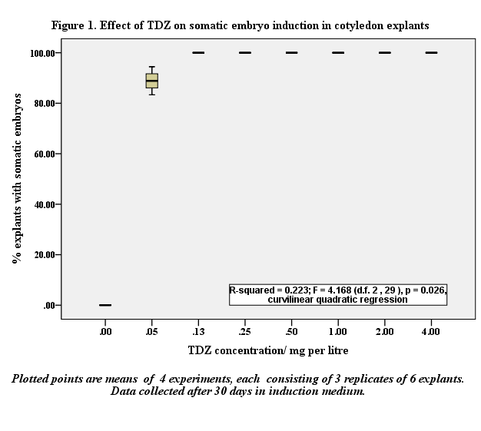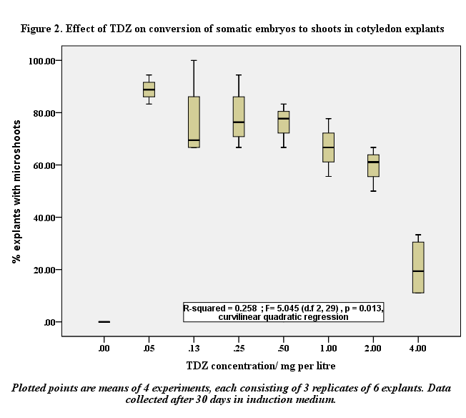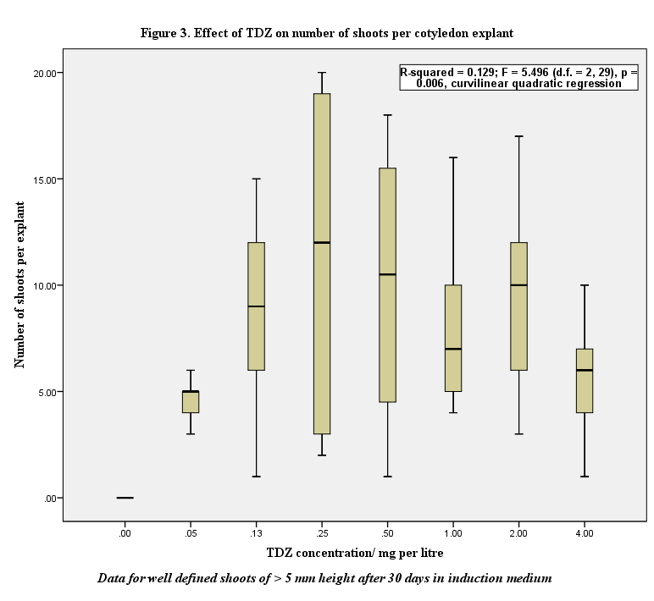

**Table 1. Effect of different PGR treatments on elongation of *M. volkensii* microshoots 20 days after transfer of cotyledon halves from induction medium to elongation medium.**

|  |  |  |
| --- | --- | --- |
| PGR combination in half-strength MS medium | Days on  medium | Mean shoot length (± SE) (mm) |
| 0 PGR | 22 | 8.00 ± 1.08a |
| 0.1mg l-1 BAP  0.1mg l-1 BAP + 10% CW  0.1 mg l-1 BAP + 0.01mg l-1 IAA | 22  24  24 | 16.16 ± 1.94 b  15.57 ± 1.85 b  18.17 ± 1.58 b |

Values followed by the same letter in a column do not differ significantly using Tukey’s HSD test at *p* ≤ 0.05.

**Table 2. Effect of NAA and IBA on rooting of shoots after 22 days in rooting medium.**

|  |  |  |  |
| --- | --- | --- | --- |
| PGR (mg l-1) on half-strength MS medium | Days to start of rooting | Rooting (%)  (Mean ± SE) | Number of roots (Mean ± SE) |
| 0 | 12 | 5.71 ± 3.69 a | 1.00 ± 0.00 a |
| 0.05 NAA | - | 0.00 ± 0.00 a | 0.00 ± 0.00 a |
| 0.1 NAA | 8 | 8.88 ± 5.87 a | 5.40 ± 1.29 b |
| 0.2 NAA | 8 | 32.40 ± 8.90 b | 4.65 ± 0.67 b |
| 0.05 IBA | - | 0.00 ± 0.00 a | 0.00 ± 0.00 a |
| 0.1 IBA | 10 | 6.67 ± 4.22 a | 1.00 ± 0.00 a |
| 0.2 IBA | - | 0.00 ± 0.00 a | 0.00 ± 0.00 a |
| 0.1 NAA + 0.1 IBA | 9 | 39.31 ± 6.14 b | 5.64 ± 0.86 b |

Values followed by the same letter in a column do not differ significantly using Tukey’s HSD test at *p* ≤ 0.05.

Text to figures:

**Fig. 1.** Effect of TDZ on somatic embryo induction in cotyledon explants.

Plotted points are means of 4 experiments, each consisting of 3 replicates of 6 explants. Data collected after 30 days in induction medium.

**Fig. 2.** Effect of TDZ on conversion of somatic embryos to shoots in cotyledon explants.

Plotted points are means of 4 experiments, each consisting of 3 replicates of 6 explants. Data collected after 30 days in induction medium.

**Fig. 3.** Effect of TDZ on number of shoots per cotyledon explants

Data for well defined shoots of > 5 mm height after 30 days in induction medium.

**Fig. 4.** Scanning photomicrographs (x 25): A) Mature zygotic embryo (z.e)of *M. volkensii* attached to the cotyledon (cot); included to show the close similarity in the globular nature and size of the zygotic embryo to the somatic embryos in shown in Figs. 1 B to D. B to D) Cotyledon explants in various stages of somatic embryogenesis after 20 days of culture on half-strength MS + 0.125 mg l-1 TDZ, showing globular (g) and torpedo (t) stages and mature somatic embryos in early stages of conversion into microshoots (**m**). In Fig. 1C the cotyledonwas turned upside downto show the polarized nature of the regeneration response, which occurred only on the upper-facing, directly illuminated surfaces of explants. Scale bars = 1mm.

**Fig. 5.** Histology of cotyledon explants showing pro-embryonic masses (pem) arising from isodiametric, densely-staining epidermal and sub-epidermal cells, globular (g) heart-shaped (h) and torpedo (t) stages of somatic embryogenesis as well as mature somatic embryos (m) Mature somatic embryos showed well defined procambial strands (pc) and clear polarity with a distinct shoot pole (sp) and root pole (rp). Scale bars = 30 µm (Fig. 2A and D) and 140µm (Fig. 2B,C,D,E,F).

**Fig. 6.** A) Scanning photomicrograph of a segment of cotyledon explant showing high frequency shoot regeneration after 16 days on half-strength MS + 0.5 mg l-1 TDZ, B) Scanning photomicrograph of a well-defined microshoot formed after 20 days on half-strength MS + 0.05 mg l-1 TDZ (For A and B, scale bar = 1 mm), C) Macroscopic view of cotyledon explants showing shoot regeneration after 24 days on half-strength MS + 0.5 mg l-1 TDZ induction medium, D) Rooting after 14 days on half-strength MS + 0.1 mg l-1 IBA.