# Snake

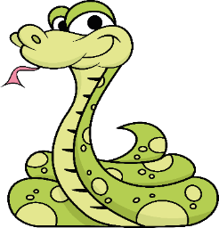 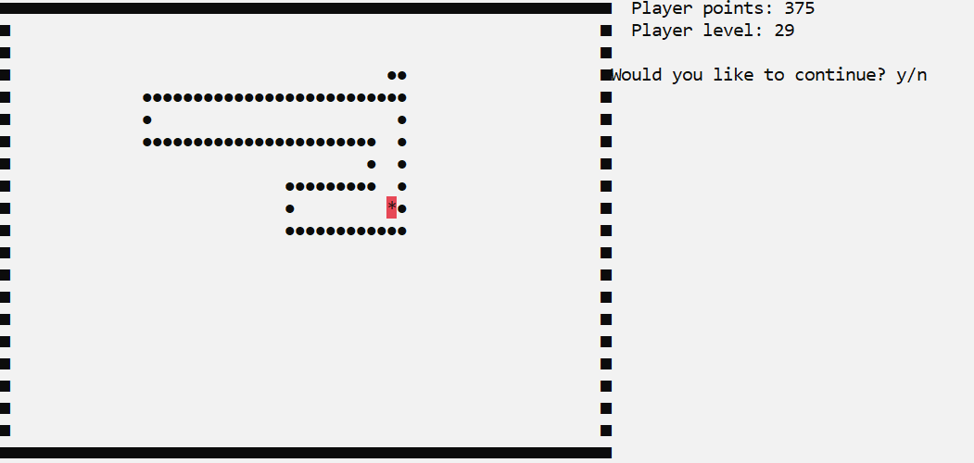

### Overview

In this workshop, you need to build a snake game on your own, following the basic principles of OOP.

### Setup

You are provided with a **skeleton**,which contains the following items:

- StartUp class – your program entry point

- Core folder – the main program functionality

- Enums folder – data about directions for the snake

- GameObjects folder – holding the main objects for our game

- Utilities folder – already written (contains information about your ConsoleWindow)

## Task 1: Structure

**Game Objects**

In the GameObjects folder create the following classes:

#### Point

The Point class contains information about the **2D space** where all the objects exist. It has two properties, which indicate the **horizontal and vertical position** of the object. You can give them the names LeftX and TopY and both are **integers**.

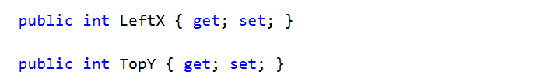

We are almost done with this class, but lastly, we need to create **two methods** for **drawing** on the **console**, accepting a different number of arguments. The first Draw method accepts a **symbol** and calls the Console.SetCursorPosition method with the current **point** **coordinates** and writes the current **symbol** on the console. The second Draw method accepts LeftX, TopY and symbol as arguments.

Your code should look like this:

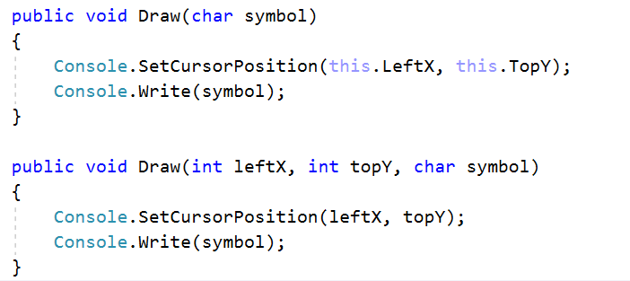

#### Constructor

A Point accepts the following values upon initialization:

int leftX, int topY

### Wall

The Wall class inherits Point and its parent constructor. It must have methods (which are inaccessible from outside the class) for setting the **horizontal** and **vertical** **lines**. The SetHorizontalLine method accepts an argument of type int for the topY position. In its body, it iterates from zero to the current LeftX position.

The Draw method is called inside of the loop with the following parameters:

int leftX, int topY, char wallSymbol

The wallSymbol is a **constant value** for the Wall class and uses Unicode code point **\u25A0** (represents a square symbol for the right and left borders of the wall). It looks like this: ■

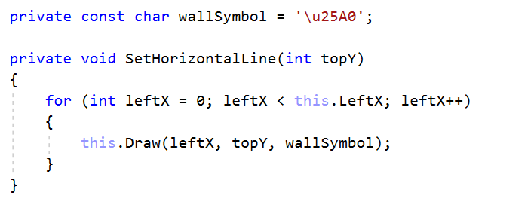

The SetVerticalLine method has the same logic, but accepts leftX as parameter and iterates through topY

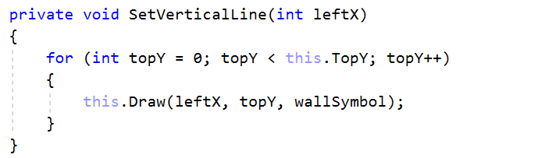

#### Constructor

Calls InitializeWallBorders method, where the **horizontal** and **vertical** lines for each **four** sides of the wall are set:

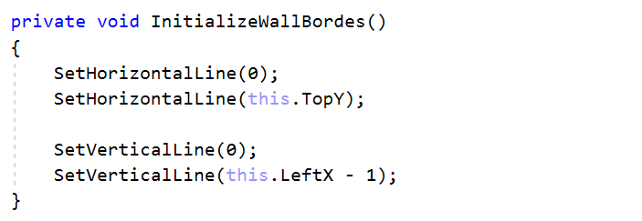

### Food

Food is an **abstract class** which inherits Point and implements all the logic for the types of food our game will have. We must have a property for the points given by each type of food.



Declare a SetRandomPosition method which will set the position of the current food at a random place inside the boundaries of our wall. It accepts a Queue of type Point as its only argument, which contains all the snake parts at this moment. Our method should generate a random position for the LeftX and TopY points.

We must also check if the position of our random points is **equal to** the snake’s position and if it is, we set **new** random positions. If we want our type of food to be colorful, we can set the Console BackgroundColor property to choose a color for our food. Finally, we call the Draw method with the correct food symbol for the type of food (we will see the different symbols when we implement the types of food)

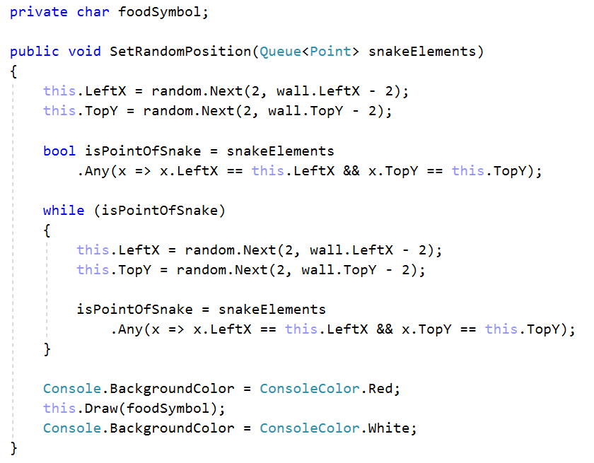

We must know if the food is in front of the snake’s head and if it, is the snake **eats** it (implement later). Create a IsFoodPoint bool method which accepts the current snake position. Compare the snake position with the current food position and return the result of the comparison.

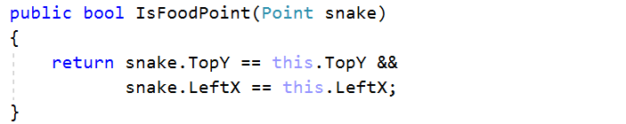

#### Constructor

Your constructor should look like this:

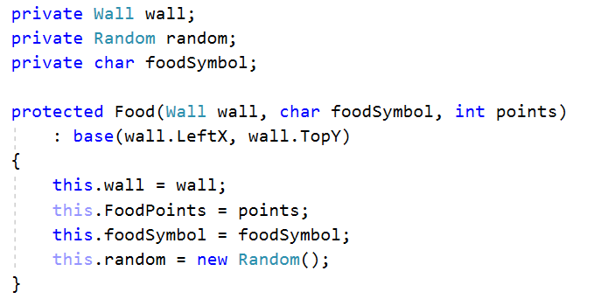

#### Child Classes

There are several concrete types of **food**:

* FoodAsterisk
* FoodDollar
* FoodHash

FoodAsterisk implements Food and its constructor. It has two constant values. One for the food symbol (“*”) and one for the points it gives to the snake - **1**

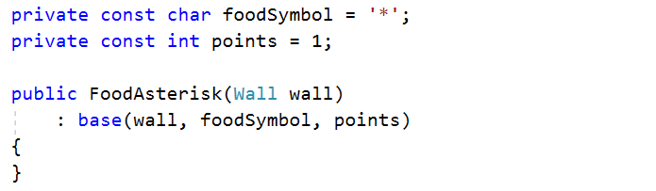

Implement the same logic for the other types of Food. The FoodDollar has “**$**” symbol and gives **2** points. The FoodHash has “#” symbol and gives **3** points.

### Snake

TheSnake class is a class, which is used to draw, design, control movement and define Snake behavior. This class has the most complex logic. Here we are going to implement methods for the movement of the snake and the types of food she eats. Let’s create our snake. Create a field, which holds all point positions of the snake parts. Declare a CreateSnake method which iterates from **1** to **6** (this is our snake’s starting length) and each time, adds a new Point in its queue of snake parts.

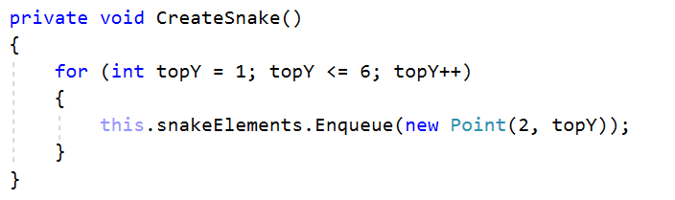

At this time, we don’t have any food which our snake can eat. Create a GetFoods method which will initialize all the types of food we already have.

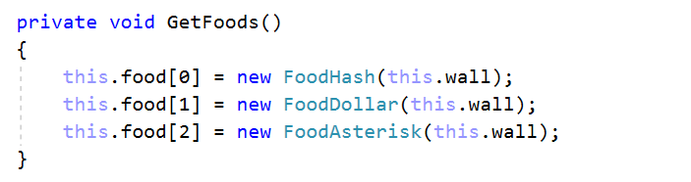

For now, our snake can’t move. Let’s change that. Create a bool method IsMoving, which takes a Point as parameter, representing the current **direction**. To move the snake, we must first find its head. This happens when we take the **last element** of our queue of snake parts. We have to check which the next position of the snake is. That’s why we are going to implement the GetNextPoint method, which accepts a **point direction** and the snake’s head’s position. All this method does is sum the snake’s head’s leftX point and leftX direction and write the result of the operation in our Snake nextX field. The same logic is inside our Snake’s nextTopY field.

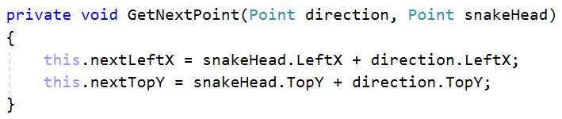

After that, in our IsMoving method, we have to check if our snake has bitten herself. If she has, our IsMoving method must return false. Now we need to check if the snake has stepped on one of the walls’ borders and if it has, the snake can’t move anymore. To do this we have to implement a new method in the Wall class IsPointOfWall. This method must accept a Point, which contains the coordinates of the snake and check if they are on the border of the wall:

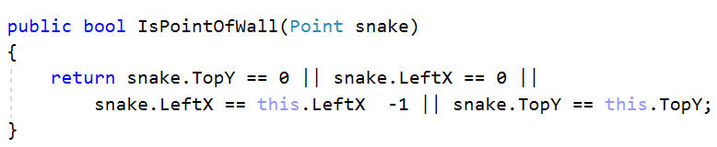

For now, our IsMoving method should look like this:

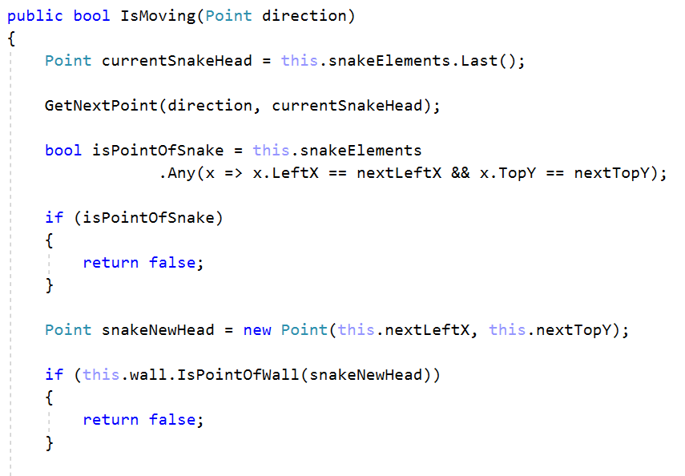

We have to make our snake move without leaving dots behind on the console. To do that, we must create a new point for the next position of the head and add it to our snake parts. After that, we should draw the snake symbol.



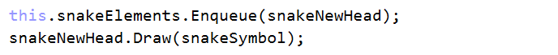

We are almost done with this class, but before that, we need to check for food at the position of the new head. If there is food, the snake must eat it.

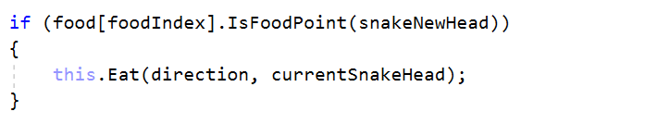

Create a new method with the name Eat, which accepts two points – onefor the **direction** and one for the **current snake head**. Because we have different points for the different foods, we have to check how much score the current food **gives**. After that, we have to increase the length of the snake with the count of the score. Finally, we have to create a **new food** at a new random position.

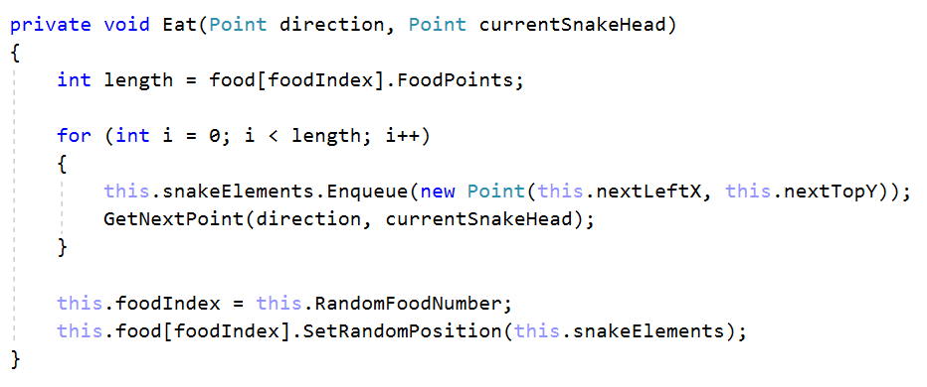

As you can see on the image above, we have RandomFoodNumber property which we haven’t implement . Think about how to get a new random position for the food each time this property is called.



Finally, we have to take the position of the snake tail and we have to remove this point with drawing an empty space on the console. If we have managed to complete all the functionality in this method, we must return true.

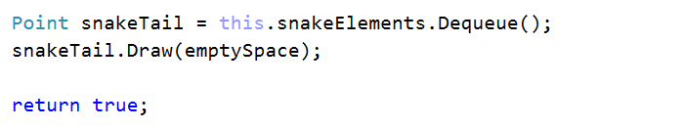

#### Constructor

If you have managed to implement this class, your constructor should look like this:

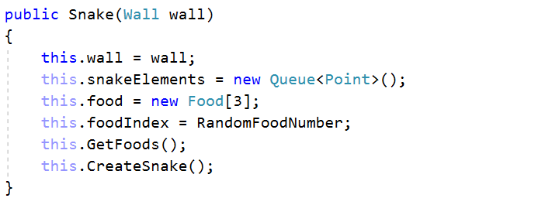

### Engine

Our engine class will be responsible for the user interface. This class will take care of all the buttons clicked by the user and visualize all the logic we have already written. It will have only one public method Run() which will do the main logic for the application.

First, we need to create a collection of points where we will collect our possible directions (up, down, left, right). To fill up our points collection we need to create a method which will initialize four points with different leftX and topY positions. For the right direction we need to create point with leftX equal to **1** and topY equal to **0**. For the left we need **-1** for leftX and **0** for topY. Think about the other two directions 😊

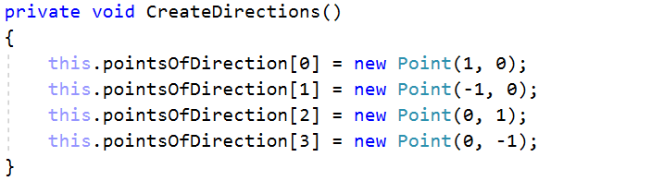

Now let’s implement a GetNextDirection method which will be responsible for the buttons the user clicks. To do that first we need to know which part of the keyboard the user clicks, and this happens by calling the class Console and its ReadKey method. Next, we need to know if the button is **Right**/**Left**/**Up**/**Down** arrow and call the correct type of enum in our Direction enumeration.

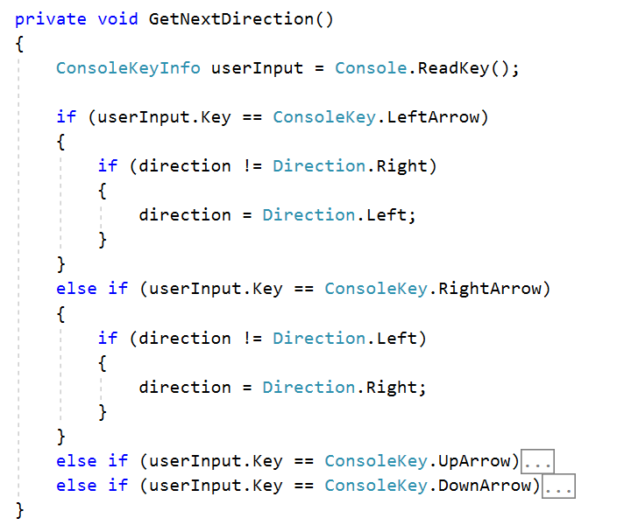

Use the same logic for the other arrows. Finally, in this method set the cursor to invisible.



Let’s check is our snake moving. To do that we need to have private field of type Snake which will represent our console snake and we can call the IsMoving method with the correct direction.



If our snake is not moving, she might be dead, and we must ask the user for restart. Create method AskUserForRestart.

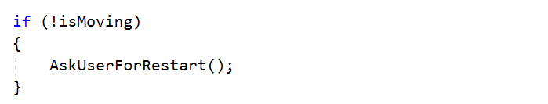

This method will print a message to the console "Would you like to continue? y/n". If the user press y on the keyboard we must clear the console and call our StartUp Main method again.

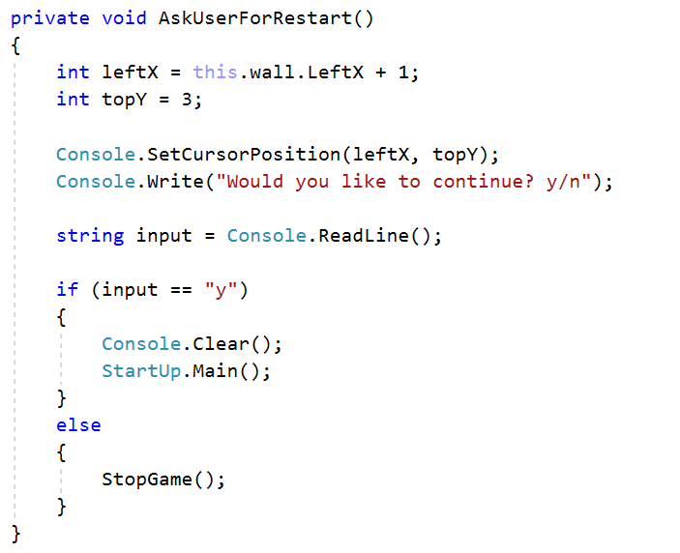

If he presses n create a StopGame method which writes GameOver and exits from the console.

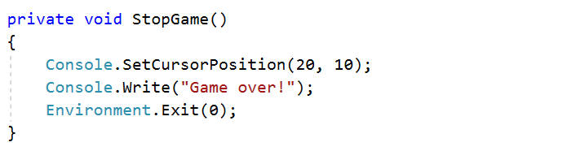

Your Run() method should already look like this:

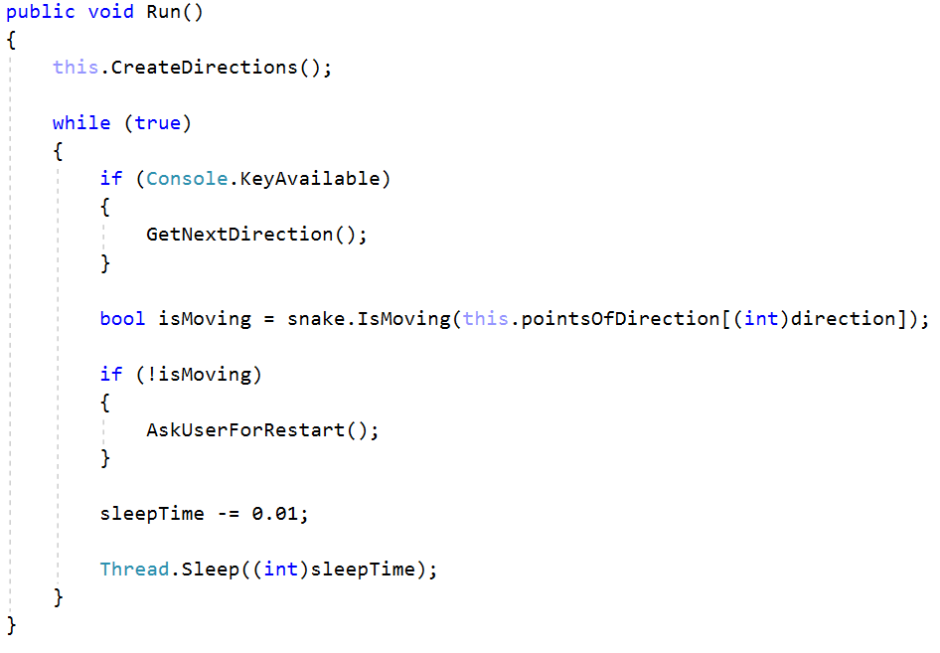

#### Constructor

Your engine constructor will take Wall and Snake as parameters. It will also initialize our for points and set a default sleep time of one hundred milliseconds.

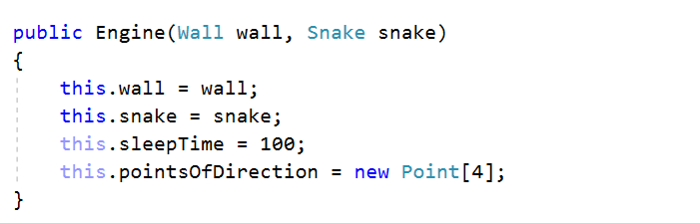

### StartUp

Our StartUp class should only initialize our wall, snake and call the Engine Run method!

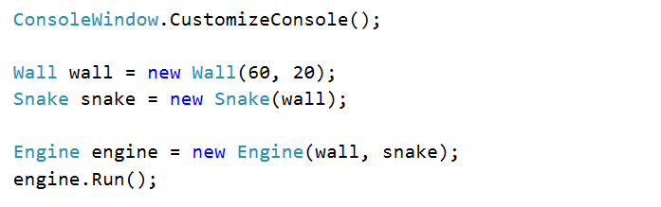

As you can see on the image of the game on the right side you have game statistic. You can think of a way to show on the console these game stats.

Start the game and have a nice play 😊!