Sample application using React-Redux-Router

# Implementation details:

* I used Microsoft Visual Code as an IDE
* The sample application used the latest React version
* Other libraries:
  + React-Router – is used to navigate between the main page and about page
  + Redux – is used to filter the list based on character name
  + Webpack – it is used as the code bundler and loader
  + Babel is used by Webpack to transpile the code
  + JSX is used for React components
  + Styles are coded in SCSS and translated into CSS by a npm plugin
  + Airbnb lint plug-in is used to check for coding style (in addition to regular lint)
  + Bootstrap is used to give the overall style page (buttons for navigation, headers, etc)
  + The application uses also a plug-in for ‘hot-loaded’; if code is changed, the code is automatically updated
  + The application can be built and run in two modes:
    - Debug mode - using ‘npm start’; this starts the node server and it runs the application from the root path
    - Production mode – using live-server; the final deployment is done in dist directory, where all the js files are bundled in a single file, and all css files are also bundled in a single file

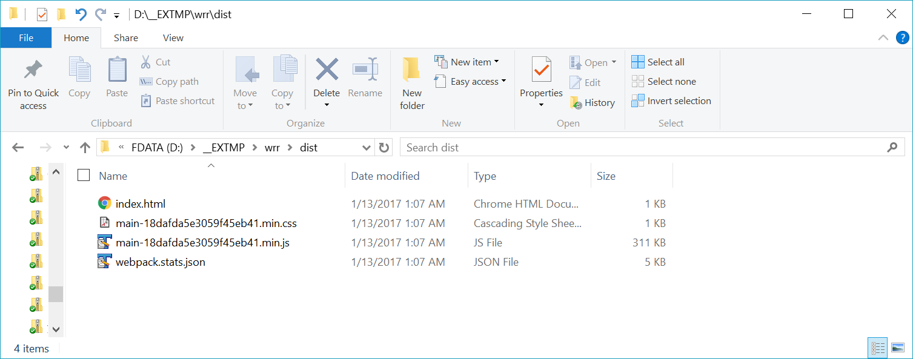

What is missing (due to time constraints):

* Implement a lifecycle hooks into a React component
* Add testing using Jest (for Actions, Reducer, Middleware, and Component)
* Retrieve the data using Axios from HTTP endpoint instead of coding it as a JSON constant
* Add comments to the code
* Introduce a library like Baobab to handle the data store (this way it can scale into the future)
* Add Immutable.js for states and properties
* Organize better the SCSS files using a library like Bourbon

# Final design

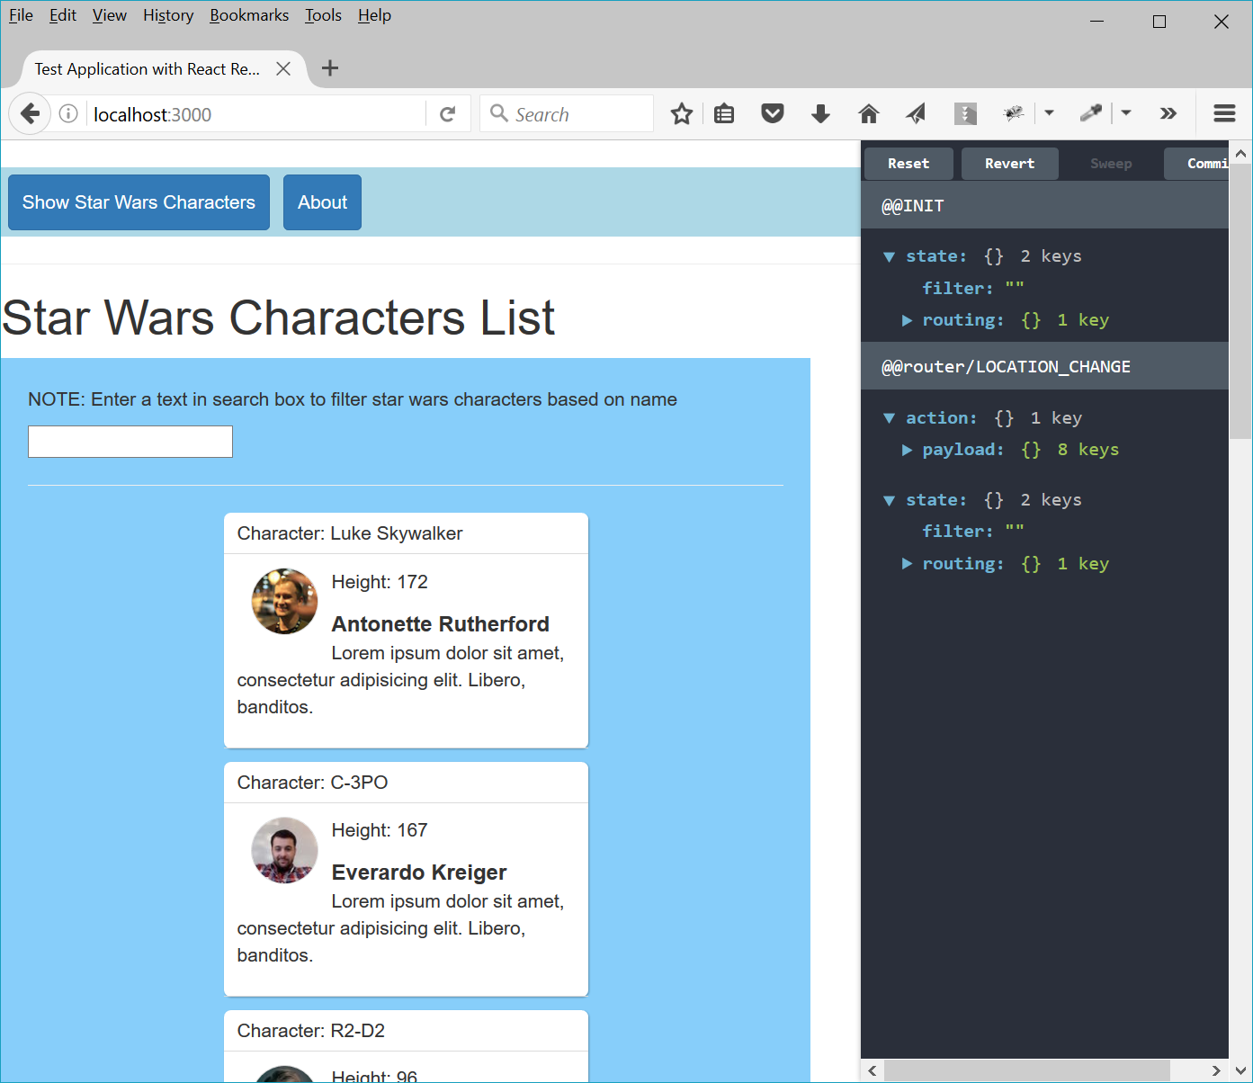

* It uses React for the overall implementation
* It uses React-Router for the two pages (Home and About)
* Uses Redux for filtering characters based on their name
* On the right side is the React debug panel

Filtered:

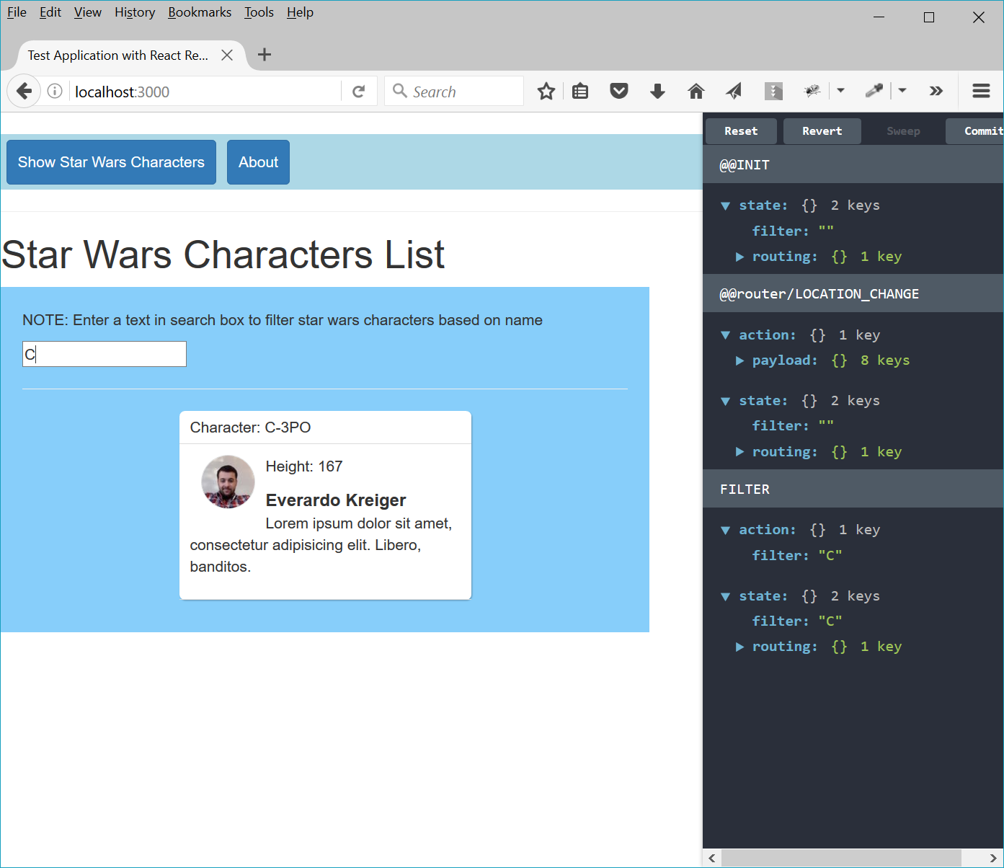

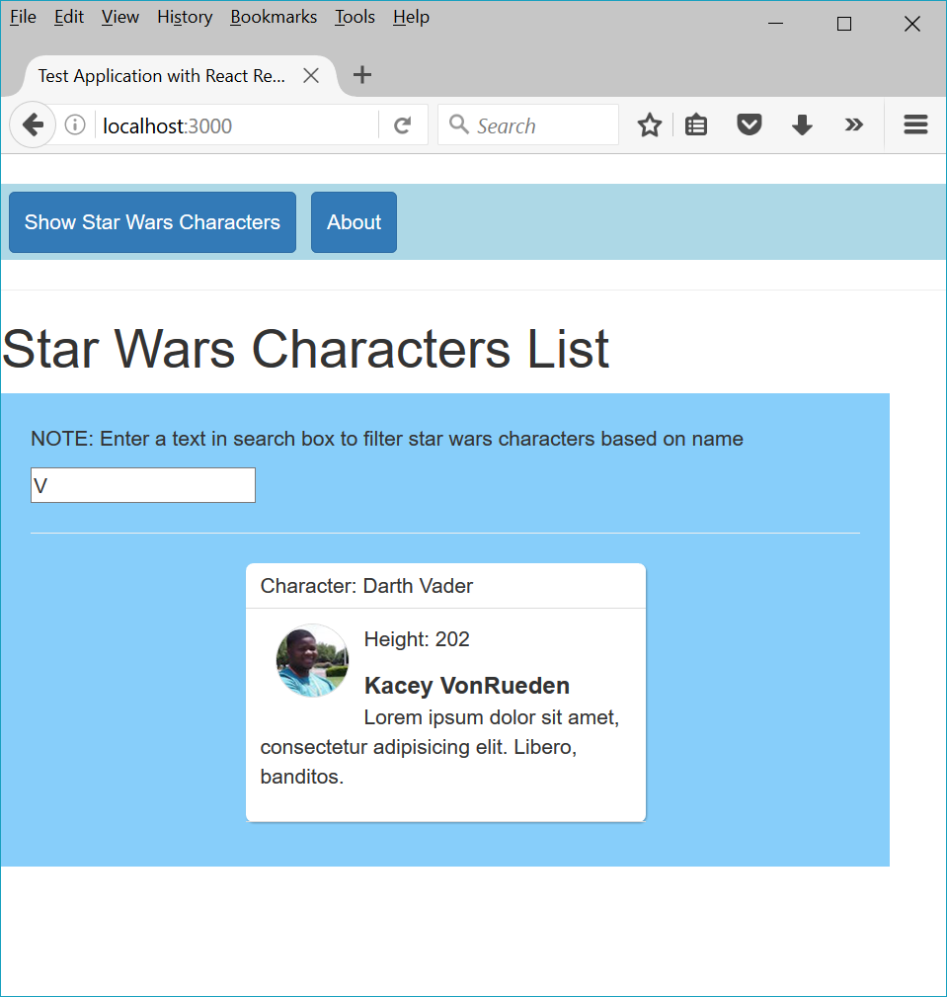

About page:

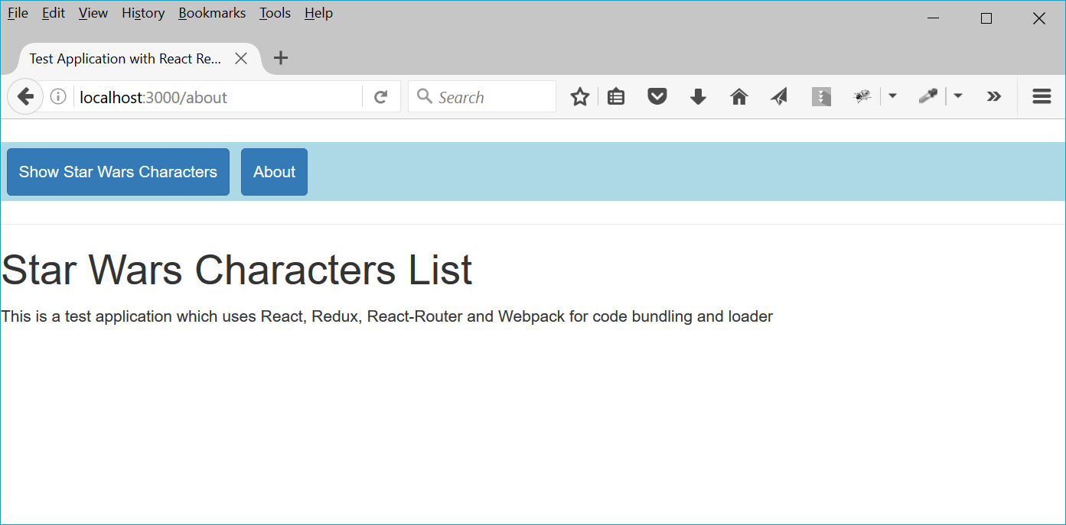

# Apply Airbnb coding style

Airbnb code style is checked by a plug-in:

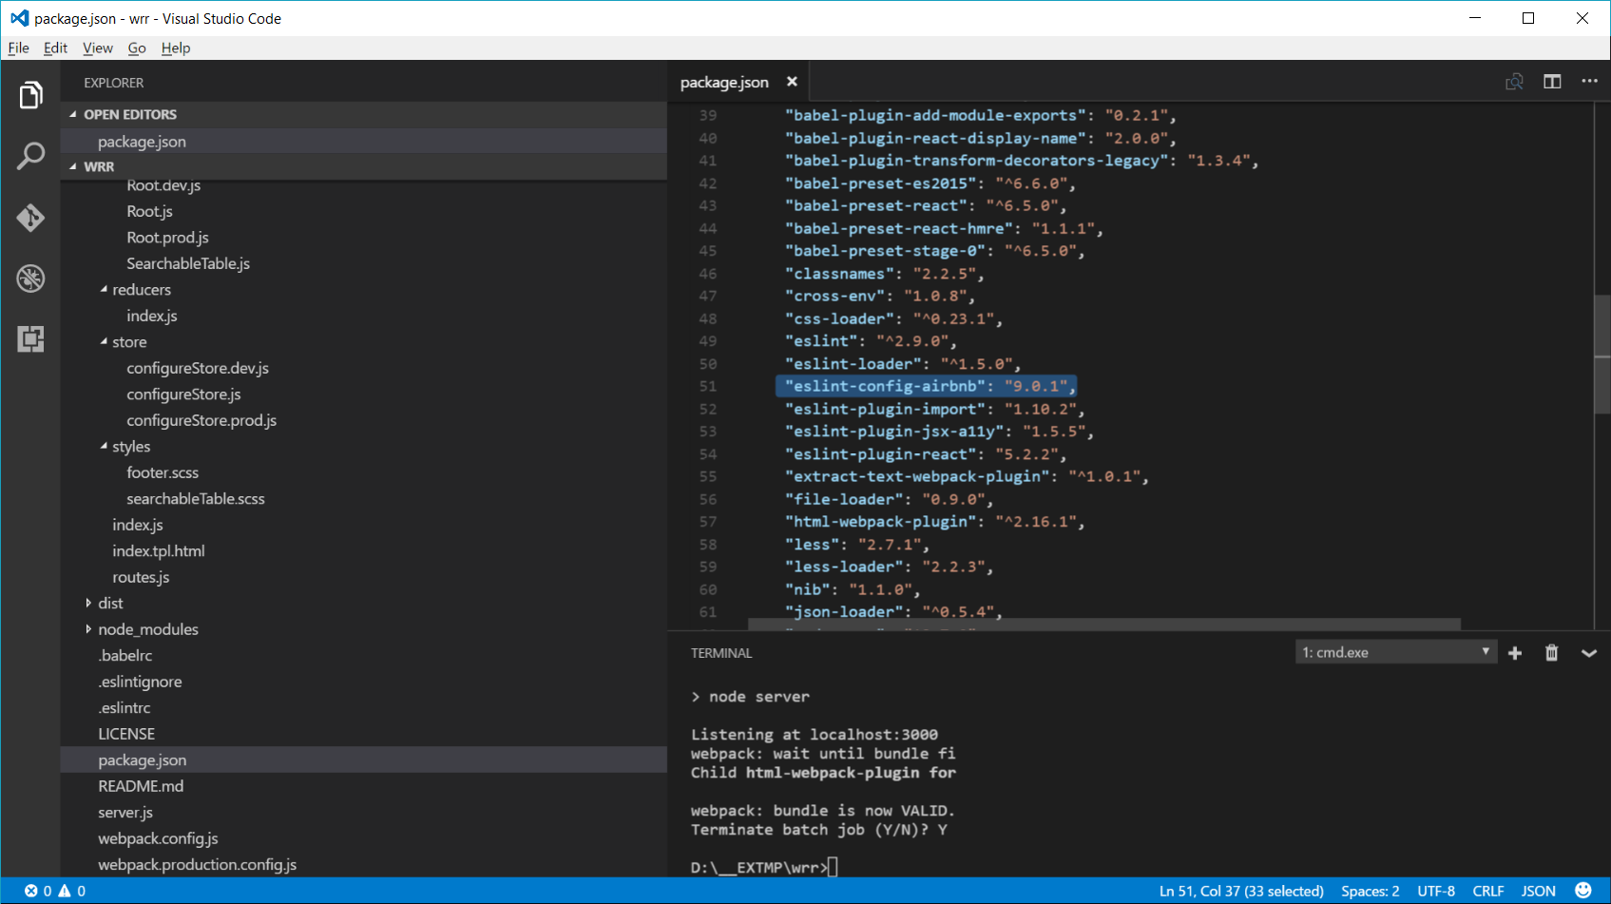

And then enabled in .eslintrc

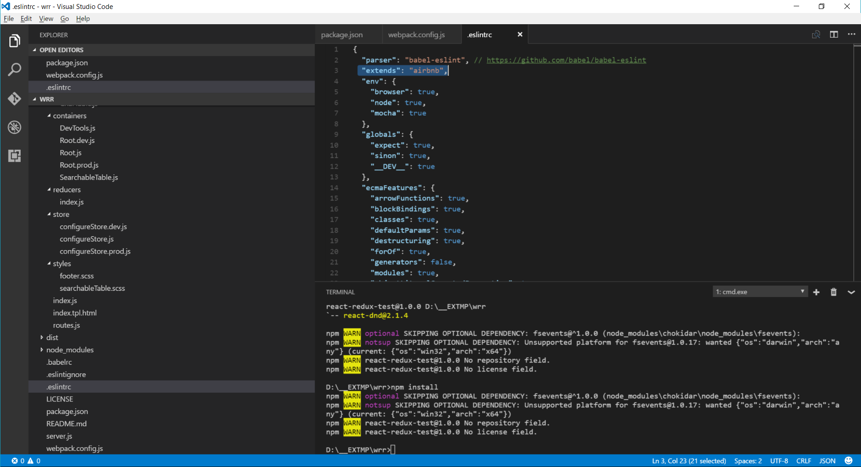

Final compile: no line errors (added few disable lint errors to avoid some refactoring)

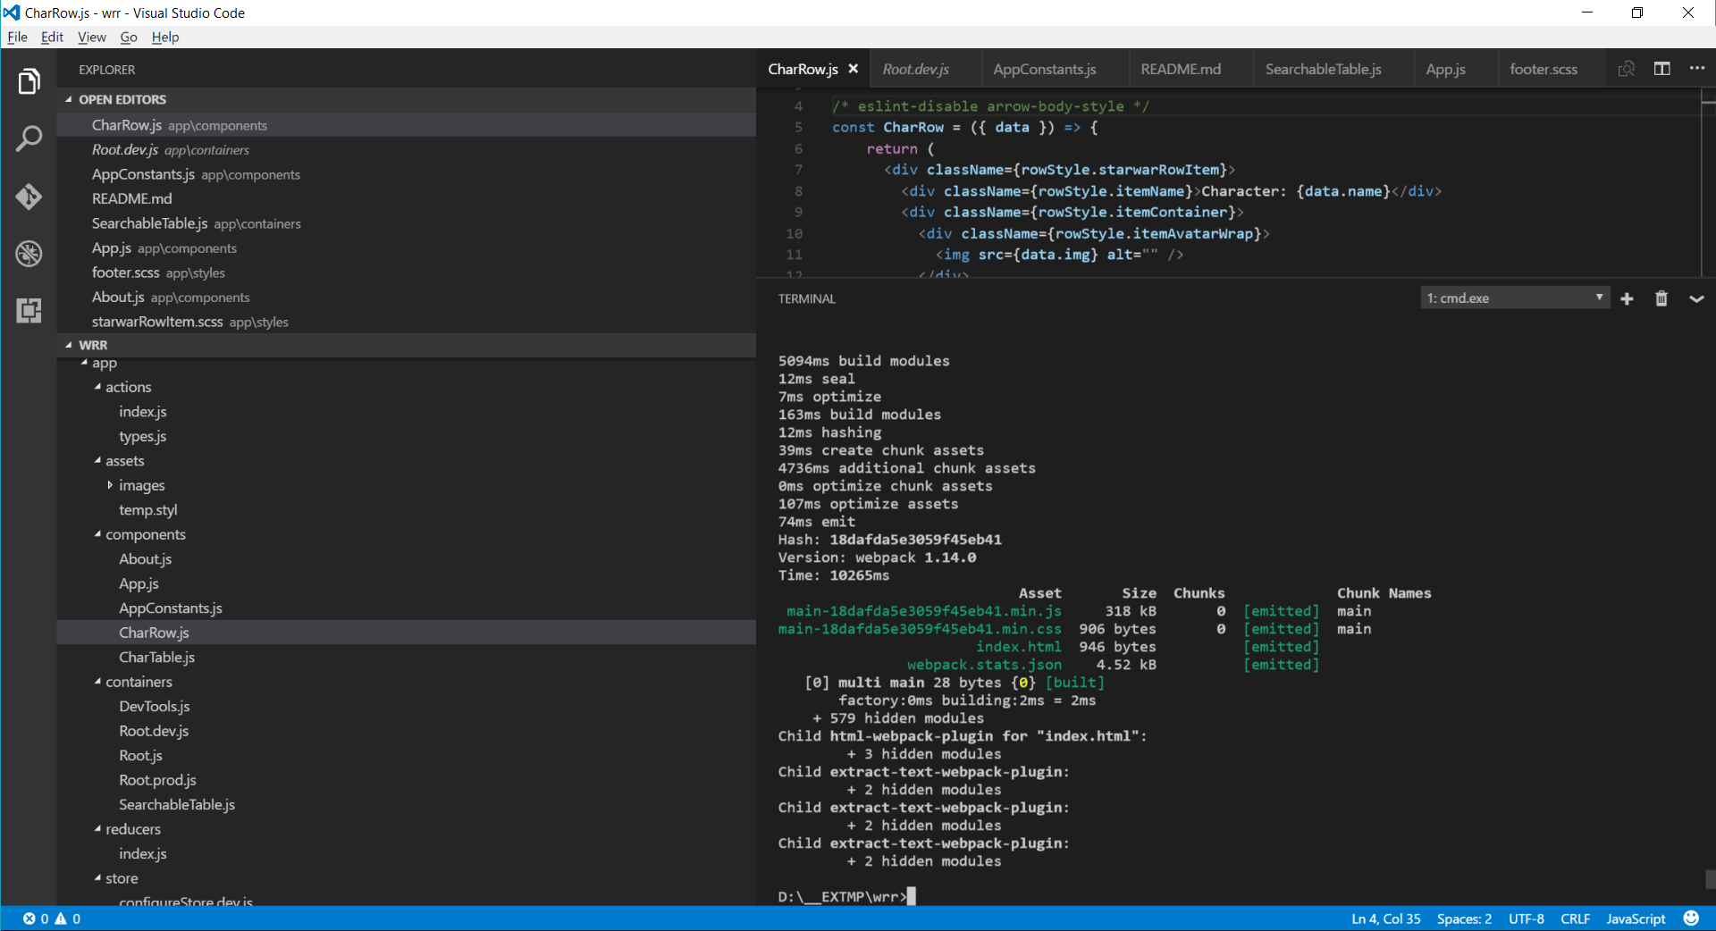

# Handling errors:

Reported on the user interface:

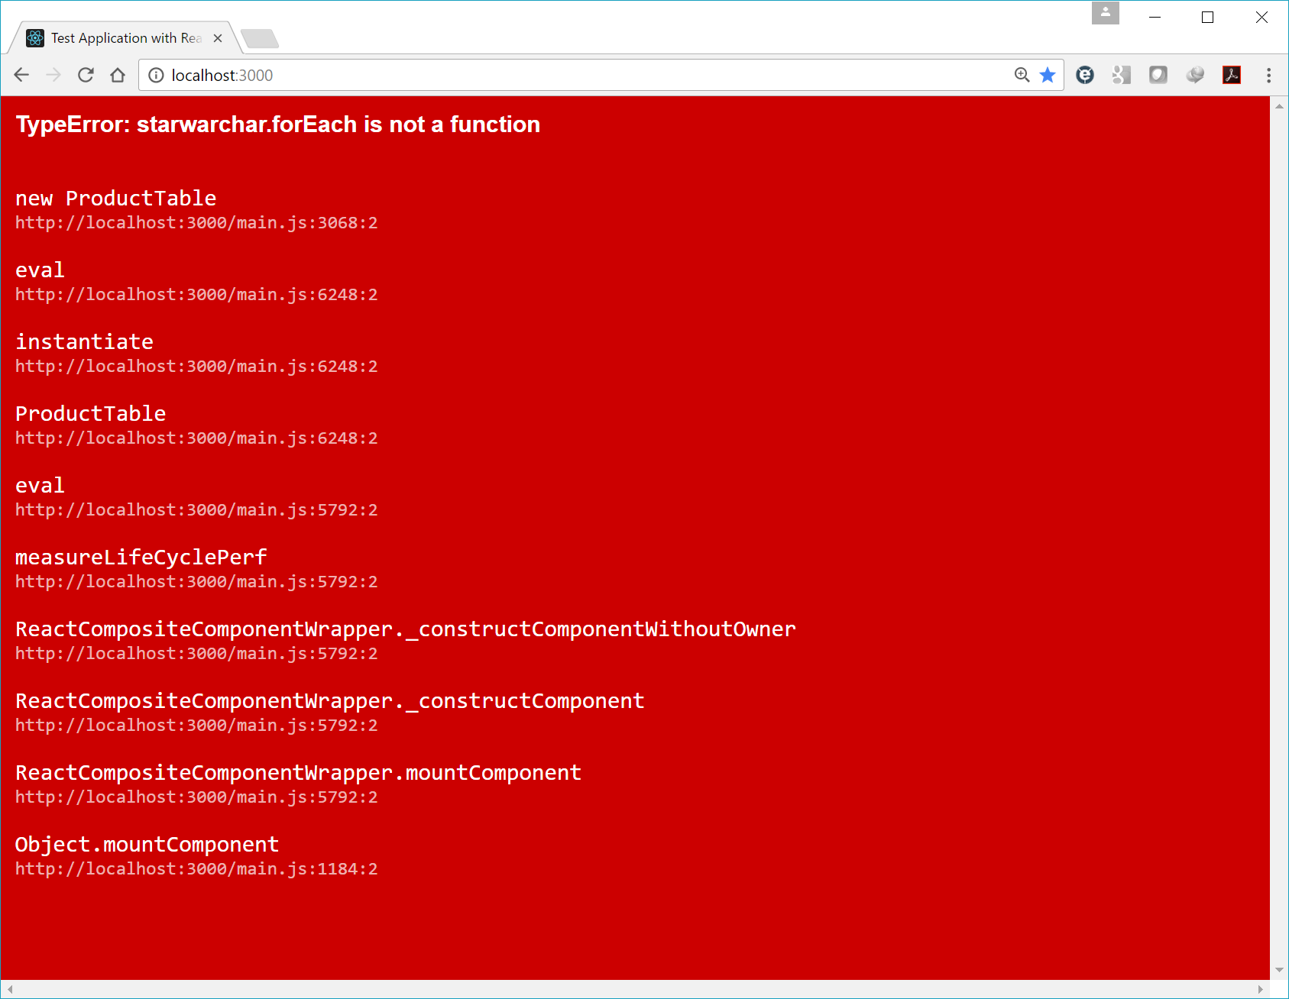

Lint error:

