**Балтийский государственный технический университет**

**«ВОЕНМЕХ» им. Д.Ф. Устинова**

**Кафедра И5**

**«Информационные системы и компьютерные технологии»**

**«Математическая статистика»**

Лабораторная работа № 1

«Методы описательной статистики в пакете STATGRAPHICS»

Вариант 7

**Выполнил:**

Студент Иванов С.А.

Группа И964

**Преподаватель:**

Черный О.Г.

Санкт-Петербург

2019

**One-Variable Analysis - Material (Material)**

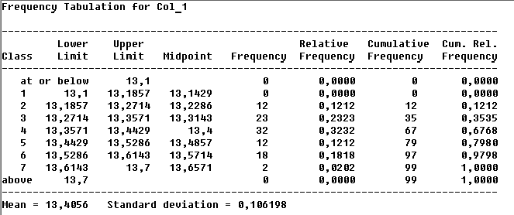Analysis Summary

Data variable: Col_1

50 values ranging from 13,2 to 13,66

**Summary Statistics for Col_1**

**Count = 50**

**Average = 13,4048**

**Median = 13,4**

**Mode = 13,34**

**Geometric mean = 13,4044**

**Variance = 0,0113357**

**Standard deviation = 0,106469**

**Standard error = 0,015057**

**Minimum = 13,2**

**Maximum = 13,66**

**Range = 0,46**

**Lower quartile = 13,33**

**Upper quartile = 13,49**

**Interquartile range = 0,16**

**Skewness = 0,229759**

**Stnd. skewness = 0,663258**

**Kurtosis = -0,656373**

**Stnd. kurtosis = -0,947394**

**Coeff. of variation = 0,794261%**

**Sum = 670,24**

**Percentiles for Col_1**

**1,0% = 13,2**

**5,0% = 13,25**

**10,0% = 13,26**

**25,0% = 13,33**

**50,0% = 13,4**

**75,0% = 13,49**

**90,0% = 13,55**

**95,0% = 13,57**

**99,0% = 13,66**

Stem-and-Leaf Display for Col_1: unit = 0,01 1|2 represents 0,12

4 132|0044

18 132|55666666888899

35 133|11333333344444444

49 133|66667777888899

(18) 134|000022223333334444

32 134|66888899

24 135|00113333334444

10 135|55557799

2 136|

2 136|66

**Confidence Intervals for Col_1**

**95,0% confidence interval for mean: 13,4056 +/- 0,0211808 [13,3844;13,4267]**

**95,0% confidence interval for standard deviation: [0,0931849;0,123469]**

**Hypothesis Tests for Col_1**

**Sample mean = 13,4056**

**Sample median = 13,4**

**t-test**

**------**

**Null hypothesis: mean = 0,0**

**Alternative: not equal**

**Computed t statistic = 1255,99**

**P-Value = 0,0**

**Reject the null hypothesis for alpha = 0,05.**

**sign test**

**---------**

**Null hypothesis: median = 0,0**

**Alternative: not equal**

**Number of values below hypothesized median: 0**

**Number of values above hypothesized median: 99**

**Large sample test statistic = 9,84937 (continuity correction applied)**

**P-Value = 0,0**

**Reject the null hypothesis for alpha = 0,05.**

**signed rank test**

**----------------**

**Null hypothesis: median = 0,0**

**Alternative: not equal**

**Average rank of values below hypothesized median: 0,0**

**Average rank of values above hypothesized median: 50,0**

**Large sample test statistic = 8,63908 (continuity correction applied)**

**P-Value = 0,0**

**Reject the null hypothesis for alpha = 0,05.**

