**Задание 1.**

*Используем команду man чтобы прочитать краткое описание команд для файлов устройств:*

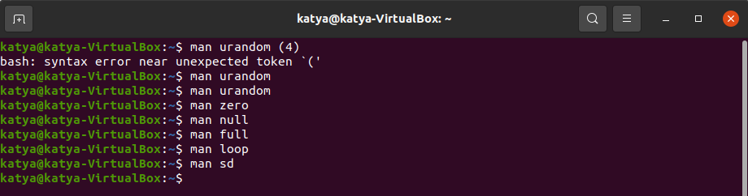

* urandom (4)

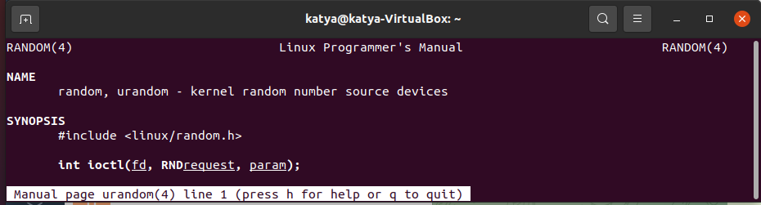

* zero (4)

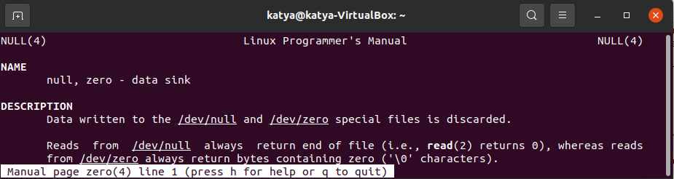

* null (4)

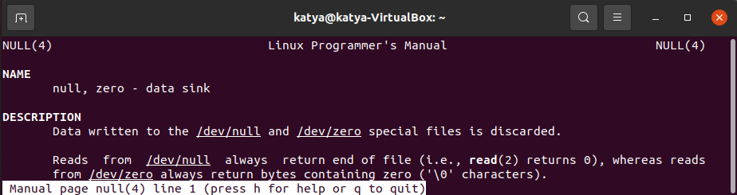

* full (4)

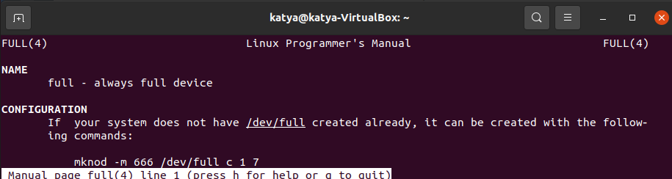

* loop (4)

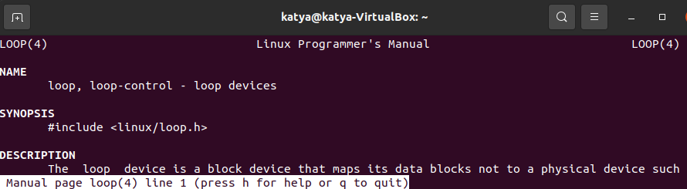

* sd (4)

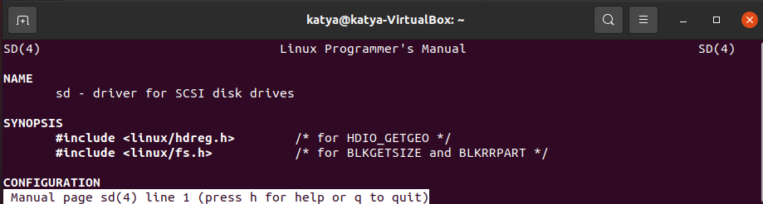

**Задание 2.**

*Используем команду man чтобы прочитать описание intro (1) Составить список всех команд, которые упоминаются на странице помощи.*

* date (that gives date and time)
* cal (that gives a calendar)
* ls (that lists the contents of the current directory)
* chown (owner can be changed)
* chmod (permissions can be changed)
* cat (that shows the contents of a file)
* cp (that copies a file)
* mv (from "move")
* diff (that lists the differences between two files)
* rm (that deletes the file)
* grep (that finds occurrences of a string in one or more files)
* pwd (that prints the current directory)
* cd (that changes the current directory)
* mkdir (that makes a new directory)
* rmdir (that removes a directory if it is empty, and complains otherwise)
* find (that find files with given name or other properties)
* mount (attach the filesystem found on some disk (or floppy, or CDROM or so) to the big filesystem hierarchy)
* df (tell you how much of your disk is still free)
* ps (show you which processes are active and what numbers these processes have)
* kill (allows you to get rid of them)
* man (document the use of the command)

**Задание 3.**

*Зайти в режим помощи man (man man; press h key for help mode):*

*заполнить таблицу (можно списком) для клавиш*

|  |  |
| --- | --- |
| Go to first line in file | g < ESC-< |
| Go to last line in file | G > ESC-> |
| Forward  one window | f ^F ^V SPACE |
| Forward  one line | e ^E j ^N CR |
| Backward one line | y ^Y k ^K ^P |
| Search forward for matching line | /pattern |
| Search backward for matching line | ?pattern |
| Repeat previous search | n |
| Repeat previous search in reverse direction | N |

**Задание 4.**

*Зайти в режим помощи командой info. Зайти на страницу *Coreutils page. Заполнить таблицу командами (можно списком)*

|  |  |
| --- | --- |
| Description | Commands |
| * Output of entire files:: |  |
| * Output of parts of files:: |  |
| * Basic operations:: |  |
| * Changing file attributes:: |  |
| * Disk usage:: |  |
| * User information:: |  |
| * System context:: |  |