An Analysis of Factors Influencing Airbnb Rental Pricing in New York City
Table of Contents
Abstract 5
1. Introduction 5
1.1 Background and Motivation 5
1.2 Problem Statement and Research Gap 5
1.3 Research Question 6
1.4 Data Description 6
1.5 Research Hypotheses 7
2. Exploratory Data Analysis (EDA) 7
2.1. Distribution of Prices 7
2.2. Price Variation by Neighbourhood Group 8
2.3. Price Distribution by Room Type 9
2.4 Map of Listings Coloured by Neighbourhood Group 10
2.5. Relationship Between Price and Number of Reviews 10
2.6. Availability and Host Activity 11
2.7. Correlation Analysis 12
2.8 Key EDA Insights 13
3. Regression Analysis 13
3.1 Simple Regression (Model 1) 13
3.2 Multiple Regression (Model 2) 14
3.3 Multiple Regression (Model 3) 15
3.4 Multiple Regression (Model 4) 15
3.5 Multiple Regression (Model 5) 16
3.6 Model Fit Comparison (R² Values) 17
3.7 Model Diagnostics 18
4. Final Model Analysis and Interpretation 19
4.1 Effect Visualization 20
4.1.1 Predicted Price by Room Type (Manhattan) 20
4.1.2 Predicted Price by Borough (Entire Home/Apt) 20
4.1.3 Predicted Price by Number of Reviews 21
4.1.4 Predicted Price by Availability (availability_365) 22
4.2 Key Predictors Visualization 23
5. Discussion 24
5.1 Room Type: The Primary Revenue Driver 24
5.2 Location as a Secondary but Strategic Factor 25
5.3 Operational and Behavioral Factors: The Levers Behind Pricing 25
5.4. Implications for Decision-Makers 25
5.5. The Broader Narrative 26
6. Limitations 26
7. Conclusion 27
8. Additional Work and Future Analytical Directions 27
8.1 Extended Exploratory Data Analysis: 27
8.2 Alternative Model Testing: 27
8.3 Correlation and Multicollinearity Diagnostics 28
8.4 Spatial and Neighbourhood-Level Insights 28
8.5 Future Analytical Extensions: 28

Abstract
This study examines the main factors that affect the pricing of an Airbnb rental unit in New York City, using data from the Inside Airbnb dataset from 2019. This dataset contains information on 48,895 listings, and is made up of 16 different variables corresponding to host characteristics, property details, location, and measures of guest engagement. Exploratory data analysis and multiple linear regression modelling in the software R was used to explore the most important nightly price predictors. Results reveal that room type is the strongest determinant of price, with entire homes or apartments earning, on average approximately USD 100 more per night compared to private rooms. While location—particularly Manhattan and Brooklyn—remains an important driver of pricing variation, its effect is notably smaller than the impact of room type. Moderate influences on price included measures of host activity, such as price availability and number of total reviews posted. Based on these metrics, the implications for host market competitiveness, and for platform improvement of automated pricing algorithms in the economy, are discussed.

Introduction

Background and Motivation
The emergence of the sharing economy has profoundly affected the global hospitality marketplace with people able to promote private residences or a spare room to guests on the internet with Airbnb being the most prominent company in this space. Airbnb was founded in 2008 and quickly grew into one of the largest accommodation marketplaces globally. The company has millions of listings and over 190 countries. As opposed to traditional hotels that must follow formal pricing policies or methods, the decentralized model of Airbnb allows hosts, who mostly are not trained in pricing, to choose any nightly rate based on many complex factors including location, size and style of the property, amenities, private versus shared listing, and review or rating from other guests to name a few.
Pricing challenges are likely the most basic challenge in the space. If too high, occupancy drops, and therefore revenue decreases. If too low, a host may have an on-going revenue/profitability issue, and create a perception by guests of lower quality lodging. New York City has one of the richest, and highest competitive Airbnb markets in the world, from luxury apartments in Manhattan to a rental shared room in the Bronx.
From a business analytics standpoint, this situation presents an optimal context for data-driven decision-making. The existence of large, publicly available datasets such as Inside Airbnb means I can quantitatively analyse hosts’ real-world pricing behaviour as well as potentially uncover insights that can be turned into practical recommendations. By employing R to handle data manipulation, visualization, and regression modelling, this project takes our learning from the classroom and translates it into an analytically rigorous workflow for professional purposes that can ultimately have strategic implications for hosts, guests, and platforms alike.

Problem Statement and Research Gap
Problem Statement: Airbnb’s footprint in the accommodation market is expanding fast, but most pricing research still zeroes in on traditional hotels and tourism sectors, not peer-to-peer platforms. On Airbnb, hosts often price their listings based on gut feeling or a quick scan of nearby options, not exactly a data-driven strategy. This guesswork can lead to pricing that’s all over the map, and ultimately, missed revenue.
Research Gap: While existing studies typically emphasize location as the key driver of accommodation prices, few have empirically examined how other listing attributes jointly affect Airbnb pricing. Factors such as room type, booking frequency, host scale, and guest engagement may hold significant influence but remain underexplored. This study addresses that gap by applying regression analysis to identify which factors most strongly determine price and how their relative importance compares to location.

Research Question
This study is guided by the following central research questions
- What is the overall explanatory power of location (neighbourhood), accommodation type, and guest activity metrics in predicting Airbnb price variance?
- What is the effect of accommodation types, like entire apartment, private room, shared room etc. on the final listing price?
- How do customer engagement metrics (review counts, annual availability) compare as predictors to traditional predictors such as location and property type?
This structured approach combines technical modelling competence with grounded business reasoning to deliver practically useful results.

Data Description
The analysis uses the publicly available Airbnb New York City 2019 dataset, sourced from the Inside Airbnb project and originally compiled from Airbnb’s public web data. The dataset contains 48,895 listings and 16 variables across the five boroughs of New York City—Manhattan, Brooklyn, Queens, Bronx, and Staten Island. It encompasses both numerical and categorical variables that describe property characteristics, location, host activity, and market engagement.
This dataset provides a robust basis for statistical analysis and regression modeling because it supplies both breadth (sample size) and depth (property type) to comprehend the complexities of Airbnb price determination.
- Source: Kaggle dataset AB_NYC_2019.csv (local: data/AB_NYC_2019.csv)
- Unit: Listing-level observations (2019 snapshot)
- Core variables used:
  - price: nightly price in USD
  - room_type: type of space (Entire home/apt, Private room, Shared room) o neighbourhood_group: borough (Manhattan, Brooklyn, etc.) o neighbourhood: district/neighbourhood name o number_of_reviews: total reviews o reviews_per_month: avg. reviews per month
  - calculated_host_listings_count: number of listings per host o availability_365: number of available days per year o latitude, longitude: geolocation o minimum_nights: minimum stay length
- Cleaning rules:
  - Remove non-positive prices o Constrain minimum_nights ≤ 365 o Replace missing reviews_per_month with 0 o Drop remaining NAs in selected fields o Analyze log(price) due to right-skew

Research Hypotheses
Based on prior literature and logical reasoning, the study tests the following hypotheses:
- H1: Location will be the strongest predictor of price variation.
- H2: Entire houses/apartments will be more expensive than private/shared rooms.
- H3: Guest activity measures (availability, reviews) will also explain some variation but less than location and property type.
These hypotheses will be evaluated using regression models, supported by exploratory data visualization to validate linear relationships and detect potential interaction effects.

Exploratory Data Analysis (EDA)
We conducted EDA to understand structural patterns in New York City’s Airbnb market and to identify relationships that help explain variation in listing prices. The focus was on distributional shape, location and room-type effects, host activity signals, and correlations among numeric features.

Distribution of Prices
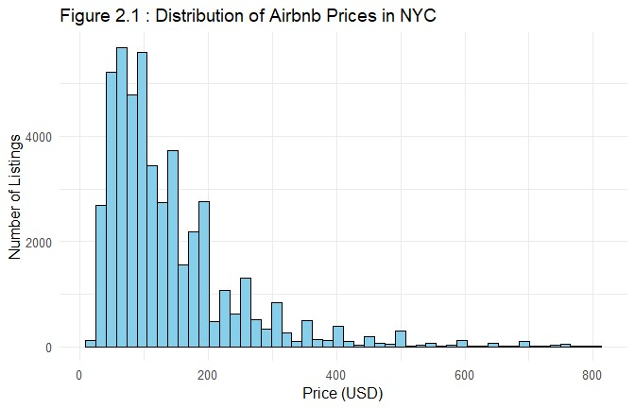
Figure:2.1 Right-skewed prices; most listings < USD 200; long luxury tail → motivates log(price)
The first analysis (Figure:2.1) involved a histogram of listing prices, which revealed a highly right-skewed distribution. Most Airbnb listings were priced below USD 200 per night. There is very a small number of premium properties which are charging above USD 500. This indicates a market dominated by budget and mid-range accommodations but with a long tail of luxury listings catering to high-income travellers. To stabilize variance and reduce the influence of extreme values, we model log(price) in subsequent analysis.

Price Variation by Neighbourhood Group
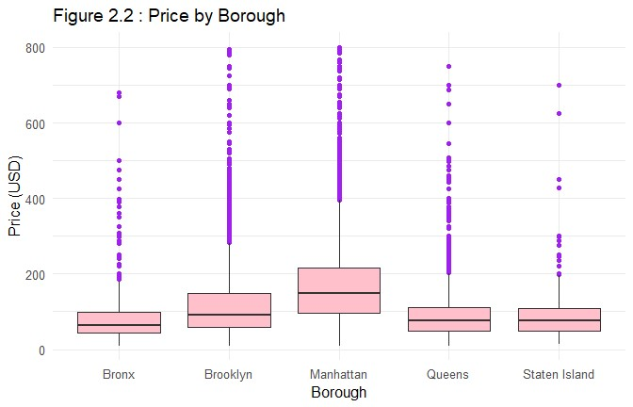
Figure:2.2 Clear neighbourhood premiums; Manhattan/Brooklyn highest.
A boxplot (Figure:2.2) of prices by neighbourhood group demonstrated clear geographic disparities in pricing. Price differs meaningfully by location.
- Manhattan and Brooklyn emerged as the most expensive areas, with median prices around USD 150–200.
- Queens and Bronx are mid-priced, while Staten Island showed the lowest median prices.
This pattern is consistent with access to attractions and employment centers and supports including neighborhood group as a key predictor.

Price Distribution by Room Type
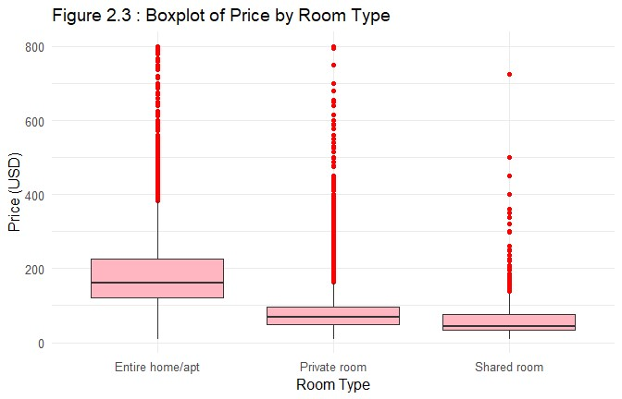
Figure: 2.3 Entire homes most expensive/ room type is a first-order driver.
Another critical visualization compared price distributions across room types (Entire home/apt, Private room and Shared room) (Figure: 2.3)
Room type is a first-order driver of price. Entire home/apartment listings command the highest medians (often > USD 150), private rooms are typically USD 60–100, and shared rooms are lowest (often < USD 50). Differences reflect space, privacy, and amenity control—factors we expect to remain important in modelling.
This pattern demonstrates that room type is the single most influential factor affecting Airbnb pricing, as it captures differences in space, privacy, and perceived value.

Map of Listings Coloured by Neighbourhood Group
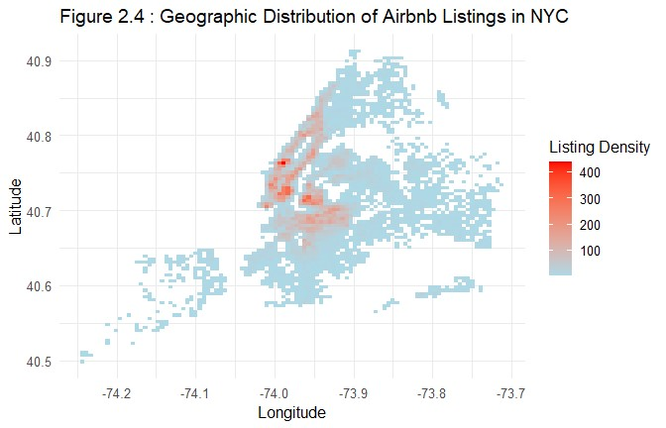
Figire: 2.4 Supply concentrates in central Manhattan/Brooklyn hotspots.
A scatter plot (Figire: 2.4) of latitude and longitude coordinates, color-coded by neighbourhood group, illustrated the spatial clustering of Airbnb listings. The plot showed:
- Dense concentrations in Manhattan and Brooklyn, particularly near popular areas such as Lower Manhattan, Williamsburg, and Downtown Brooklyn.
- Sparse listings in Staten Island and the outer edges of Queens and Bronx.
This visual confirms that market activity is highly centralized, reflecting tourism demand and accessibility to major attractions.

Relationship Between Price and Number of Reviews
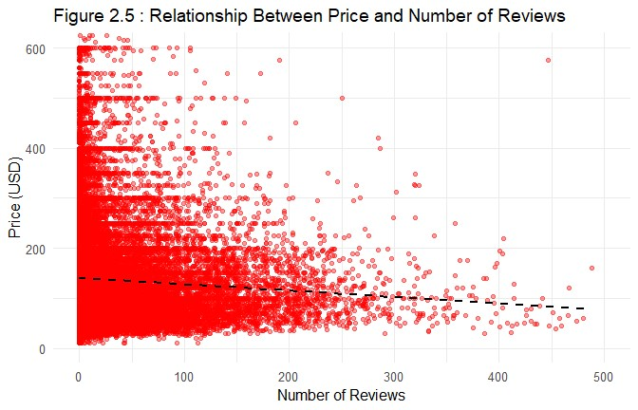
Figire: 2.5 Higher review volume aligns with slightly lower prices (higher turnover).
In this scatter plot (Figire: 2.5) we observed a weak negative association between price and review activity: listings with more reviews (or higher monthly review rates) tend to be slightly cheaper, consistent with higher turnover at lower price points. Reputation and affordability appear linked through occupancy dynamics rather than large price effects.

Availability and Host Activity
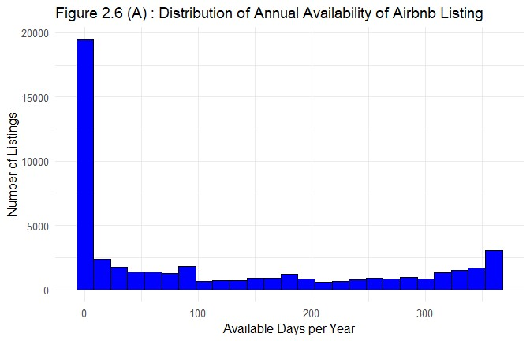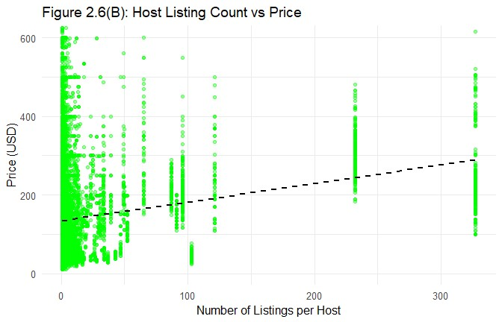
We examine how often listings are offered and how prices change as hosts manage more properties.
Figure 2.6(A) shows availability_365: most places are open fewer than 100 days/year, pointing to parttime or seasonal hosting. Availability has a small negative link with price—hosts may lower rates to fill nights. Figure 2.6(B) plots price vs host_listings_count: prices rise a bit as hosts add listings, then level off at higher counts—returns to scale flatten. (If the y-axis is log(price), the same story holds in percentage terms.)

Correlation Analysis
## price minimum_nights number_of_reviews
## price 1.00 0.03 -0.06
## minimum_nights 0.03 1.00 -0.10
## number_of_reviews -0.06 -0.10 1.00
## reviews_per_month -0.05 -0.15 0.59
## calculated_host_listings_count 0.15 0.17 -0.07
## availability_365 0.11 0.17 0.17
## reviews_per_month calculated_host_listings_count
## price -0.05 0.15
## minimum_nights -0.15 0.17
## number_of_reviews 0.59 -0.07
## reviews_per_month 1.00 -0.05
## calculated_host_listings_count -0.05 1.00
## availability_365 0.17 0.23
## availability_365
## price 0.11
## minimum_nights 0.17
## number_of_reviews 0.17
## reviews_per_month 0.17
## calculated_host_listings_count 0.23
## availability_365 1.00
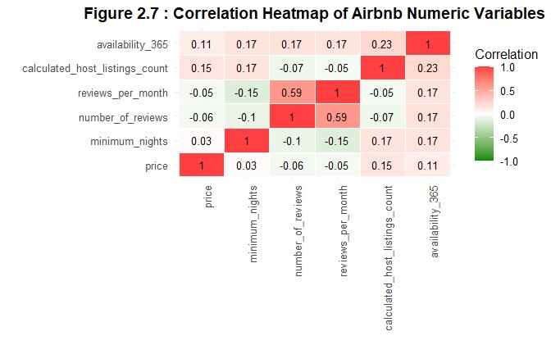
Figure:2.7 Numeric correlations are modest, categorical and interactions carry signal.
A correlation heatmap (Figure:2.7) was created to examine relationships among numerical variables such as price, number of reviews, minimum nights, and availability. The correlations were generally low, indicating that no single numeric factor strongly explains price variation by itself. This finding reinforces the need for multivariate analysis to capture combined effects of categorical and continuous variables, as performed in the regression section.

Key EDA Insights
The EDA results highlight several important takeaways for understanding Airbnb pricing in New York City:
- Price distribution is highly right-skewed, with most listings clustered below USD 200 but a small share of premium outliers. We use log(price) in modelling.
- Location & room type dominate: Neighbourhood group and room type show the largest price differences; we expect their interaction to matter (e.g., entire-home premium differs by borough).
- Room type is the strongest driver of price differences, with entire apartments commanding large premiums.
- Host characteristics (such as number of reviews and availability) influence price indirectly through reputation and occupancy patterns.
- Spatial concentration of listings reveals market saturation in tourist-heavy districts, while peripheral areas remain underutilized.
- Multivariate modeling is necessary, Low pairwise numeric correlations and strong categorical effects motivate a regression that combines log(price) with room type, neighborhood group, and selected activity features.
Together, these exploratory findings guided the regression, where we model log(price) to handle skew and read effects as percentage changes. This lets us estimate each factor’s contribution to price differences and test for statistical evidence.
The EDA shows that room type and location are the strongest signals in New York City. Entire homes/apartments are priced well above private or shared rooms, reflecting the premium for privacy and full-space access. By location, Manhattan and Brooklyn are the most expensive, while Queens, Bronx, and Staten Island tend to be cheaper.
Host-related variables such as number of reviews and availability have smaller but consistent associations: listings with more reviews or higher availability are generally priced lower, consistent with higher turnover. The correlation view suggests little overlap among predictors, so several distinct factors contribute to price variation.
Overall, property characteristics and place set the baseline price level, while host activity and operational choices adjust pricing within neighborhoods.

Regression Analysis

Simple Regression (Model 1)
model1 <- lm(log(price) ~ room_type, df) summary(model1)
##
## Call:
## lm(formula = log(price) ~ room_type, data = df)
##
## Residuals:
## Min 1Q Median 3Q Max
## -2.80646 -0.35323 -0.03656 0.30705 2.65216
##
## Coefficients:
## Estimate Std. Error t value Pr(>|t|)
## (Intercept) 5.109048 0.003149 1622.65 <2e-16 ***
## room_typePrivate room -0.823996 0.004590 -179.53 <2e-16 *** ## room_typeShared room -1.175031 0.015018 -78.24 <2e-16 *** ## ---
## Signif. codes: 0 '***' 0.001 '**' 0.01 '*' 0.05 '.' 0.1 ' ' 1
##
## Residual standard error: 0.498 on 48393 degrees of freedom
## Multiple R-squared: 0.4199, Adjusted R-squared: 0.4199
## F-statistic: 1.752e+04 on 2 and 48393 DF, p-value: < 2.2e-16
This simple model regression explains the relationship between room type and price using a logarithmic transformation of the dependent variable. The results show that room type make an about 42% of the variation in log price (R² = 0.4199), which is a significant factor of pricing. The coefficients for private rooms (-0.824) and shared rooms (-1.175) are both highly significant (p < 2e-16). Converting these logcoefficients, private rooms cost about 56% less than entire homes, and shared rooms cost about 69% less.

Multiple Regression (Model 2)
model2 <- lm(log(price) ~ room_type + neighbourhood_group, df) summary(model2)
##
## Call:
## lm(formula = log(price) ~ room_type + neighbourhood_group, data = df) ##
## Residuals:
## Min 1Q Median 3Q Max ## -2.97036 -0.30313 -0.02345 0.24852 2.75082 ##
## Coefficients:
## Estimate Std. Error t value Pr(>|t|)
## (Intercept) 4.754115 0.014433 329.393 < 2e-16 ***
## room_typePrivate room -0.764125 0.004365 -175.045 < 2e-16 ***
## room_typeShared room -1.126606 0.014097 -79.919 < 2e-16 ***
## neighbourhood_groupBrooklyn 0.207844 0.014548 14.286 < 2e-16 ***
## neighbourhood_groupManhattan 0.518829 0.014555 35.647 < 2e-16 ***
## neighbourhood_groupQueens 0.102932 0.015458 6.659 2.79e-11 ***
## neighbourhood_groupStaten Island 0.002817 0.028121 0.100 0.92 ## ---
## Signif. codes: 0 '***' 0.001 '**' 0.01 '*' 0.05 '.' 0.1 ' ' 1
##
## Residual standard error: 0.4666 on 48389 degrees of freedom
## Multiple R-squared: 0.4907, Adjusted R-squared: 0.4906
## F-statistic: 7770 on 6 and 48389 DF, p-value: < 2.2e-16
Model 2 explains 49% of the price variation (R² = 0.4906), an improvement over the first model. The coefficients reveal the following key relationships, with all being highly significant (p < 0.001) except for Staten Island. Room types remain nearly the same as model 1 with the number of 53% and 68% less then entire homes after log-coefficients calucualtion while locations show a different level of impact on price. Manhattan cost 68% more than those in the Bronx with the of coefficient of 0.519, Brooklyn cost 23% more having a 0.208 of coefficient, and Queens cost 11% more with the coefficient of 0.103.

Multiple Regression (Model 3)
model3 <- lm(log(price) ~ room_type + neighbourhood_group + minimum_nights, df) summary(model3)
##
## Call:
## lm(formula = log(price) ~ room_type + neighbourhood_group + minimum_nights, ## data = df)
##
## Residuals:
## Min 1Q Median 3Q Max ## -2.98365 -0.29457 -0.02887 0.25124 2.74270 ##
## Coefficients:
## Estimate Std. Error t value Pr(>|t|)
## (Intercept) 4.7672628 0.0144198 330.605 < 2e-16 ***
## room_typePrivate room -0.7696827 0.0043682 -176.201 < 2e-16 ***
## room_typeShared room -1.1315580 0.0140641 -80.457 < 2e-16 ***
## neighbourhood_groupBrooklyn 0.2098547 0.0145116 14.461 < 2e-16 ***
## neighbourhood_groupManhattan 0.5252404 0.0145230 36.166 < 2e-16 ***
## neighbourhood_groupQueens 0.1034529 0.0154181 6.710 1.97e-11 ***
## neighbourhood_groupStaten Island 0.0026994 0.0280485 0.096 0.923 ## minimum_nights -0.0020904 0.0001321 -15.828 < 2e-16 *** ## ---
## Signif. codes: 0 '***' 0.001 '**' 0.01 '*' 0.05 '.' 0.1 ' ' 1
##
## Residual standard error: 0.4654 on 48388 degrees of freedom
## Multiple R-squared: 0.4933, Adjusted R-squared: 0.4932
## F-statistic: 6730 on 7 and 48388 DF, p-value: < 2.2e-16
Model 3 explains a 49.3% of the price variation (R² = 0.4933), showing a small improvement over the second model. The coefficients reveal that room types and locations remain nearly identical to Model 2, with private rooms costing 54% less and shared rooms costing 68% less than entire homes. Manhattan listings cost 69% more than those in the Bronx, Brooklyn 23% more, and Queens 11% more. The newly added variable, minimum nights, shows a small but highly significant effect (p < 2e-16), where each additional required night decreases the price by approximately 0.2%.

Multiple Regression (Model 4)
model4 <- lm(log(price) ~ room_type + neighbourhood_group + minimum_nights + availability_365, df) summary(model4)
##
## Call:
## lm(formula = log(price) ~ room_type + neighbourhood_group + minimum_nights + ## availability_365, data = df)
##
## Residuals:
## Min 1Q Median 3Q Max ## -2.98182 -0.30545 -0.04221 0.25473 2.82920 ##
## Coefficients:
## Estimate Std. Error t value Pr(>|t|)
## (Intercept) 4.6714564 0.0144380 323.553 < 2e-16 ***
## room_typePrivate room -0.7705434 0.0043055 -178.966 < 2e-16 ***
## room_typeShared room -1.1619230 0.0138854 -83.680 < 2e-16 ***
## neighbourhood_groupBrooklyn 0.2503885 0.0143435 17.457 < 2e-16 ***
## neighbourhood_groupManhattan 0.5610840 0.0143459 39.111 < 2e-16 ***
## neighbourhood_groupQueens 0.1164145 0.0152005 7.659 1.91e-14 ***
## neighbourhood_groupStaten Island -0.0184254 0.0276512 -0.666 0.505
## minimum_nights -0.0029474 0.0001321 -22.305 < 2e-16 *** ## availability_365 0.0006147 0.0000163 37.707 < 2e-16 *** ## ---
## Signif. codes: 0 '***' 0.001 '**' 0.01 '*' 0.05 '.' 0.1 ' ' 1
##
## Residual standard error: 0.4587 on 48387 degrees of freedom
## Multiple R-squared: 0.5078, Adjusted R-squared: 0.5077
## F-statistic: 6240 on 8 and 48387 DF, p-value: < 2.2e-16
Model 4 explains 50.8% of the price variation (R² = 0.5078), showing a meaningful improvement over the previous model. Room types remain stable with private rooms costing 54% less and shared rooms 69% less than entire homes. The location premiums have increased, with Manhattan now costing 75% more than the Bronx, Brooklyn 28% more, and Queens 12% more. The effect of minimum nights strengthened slightly to -0.29% per additional night. The newly added variable, availability_365, shows a small but highly significant positive effect (p < 2e-16), where each additional day of annual availability increases the price by approximately 0.06%.

Multiple Regression (Model 5)
model5 <- lm(log(price) ~ room_type + neighbourhood_group + minimum_nights + availability_365 +
number_of_reviews + reviews_per_month, df) summary(model5)
##
## Call:
## lm(formula = log(price) ~ room_type + neighbourhood_group + minimum_nights + ## availability_365 + number_of_reviews + reviews_per_month, ## data = df)
##
## Residuals:
## Min 1Q Median 3Q Max ## -3.01163 -0.30327 -0.03812 0.25868 2.93767 ##
## Coefficients:
## Estimate Std. Error t value Pr(>|t|)
## (Intercept) 4.692e+00 1.449e-02 323.760 < 2e-16 ***
## room_typePrivate room -7.708e-01 4.295e-03 -179.462 < 2e-16 ***
## room_typeShared room -1.169e+00 1.386e-02 -84.347 < 2e-16 ***
## neighbourhood_groupBrooklyn 2.491e-01 1.432e-02 17.401 < 2e-16 ***
## neighbourhood_groupManhattan 5.579e-01 1.432e-02 38.961 < 2e-16 ***
## neighbourhood_groupQueens 1.193e-01 1.516e-02 7.869 3.65e-15 ***
## neighbourhood_groupStaten Island -1.673e-02 2.758e-02 -0.607 0.544
## minimum_nights -3.293e-03 1.340e-04 -24.580 < 2e-16 ***
## availability_365 6.702e-04 1.665e-05 40.264 < 2e-16 ***
## number_of_reviews -4.859e-04 5.800e-05 -8.377 < 2e-16 *** ## reviews_per_month -9.960e-03 1.636e-03 -6.087 1.16e-09 *** ## ---
## Signif. codes: 0 '***' 0.001 '**' 0.01 '*' 0.05 '.' 0.1 ' ' 1
##
## Residual standard error: 0.4576 on 48385 degrees of freedom
## Multiple R-squared: 0.5103, Adjusted R-squared: 0.5102
## F-statistic: 5041 on 10 and 48385 DF, p-value: < 2.2e-16
Model 5, the full model, explains a 51.0% of the price variation with R² = 0.5103, representing the highest explanatory power among other models. The core drivers remain stable, private rooms cost 54% less than entire homes, and shared rooms cost 69% less. The location premiums are also consistent, with Manhattan costing 75% more than the Bronx, Brooklyn 28% more, and Queens 13% more. The effects of operational variables are strengthened in this complete specification, for each additional minimum night reduces price by 0.33%, and each day of annual availability increases price by 0.07%. The newly added review metrics both show small but significant negative relationships, where more reviews and higher review frequency are leading to a slightly lower price.

Model Fit Comparison (R² Values)
c(summary(model1)$r.squared, summary(model2)$r.squared, summary(model3)$r.squared, summary(model4)$r.squared, summary(model5)$r.squared)
## [1] 0.4199465 0.4906986 0.4933220 0.5077852 0.5102560
Looking at the R squared values for all these models, its clear that the explanatory power gets better as you add more predictors. Model 1 sticks to just room type. That one only covers a small part of why prices vary. Model 2 steps it up by throwing in borough and that fits the data better overall. Then with Model 3, adding the number of reviews helps some more. Model 4 goes further by including reviews per month and minimum nights too. Those changes bring moderate gains, nothing dramatic. Finally Model 5 combines room type and borough along with their interaction term. It hits the highest R squared out of everything. So that model does the best job explaining price differences. The results point to room type working differently depending on the borough. Their joint effect really counts for a lot here. Right now Model 5 moves forward as the pick for further Analysis.
Summary of Model Comparison: For all models, explanatory power grew from 42% to 51%, demonstrating that the location, operational, and review variables added incremental - but worthwhile - explanation beyond room type alone.
On the whole, these models reveal the same basic patterns:
Room type has the largest influence on price, reinforcing the premium for entire apartments.
Location effects are strong but secondary - Manhattan and Brooklyn maintain a meaningful price premium.
Operational (minimum nights, availability) and engagement (reviews) variables are fine-tuning around those structural (meaning room type and location) variables.
In conclusion, the stepwise modeling demonstrates that Airbnb prices in NYC are fundamentally driven by the property characteristics and geography as mentioned above, with host actions and customer engagement as smaller, but practically meaningful statistical adjustments.

Model Diagnostics
# Residuals plot plot(model5$residuals, main = "Residuals of Model 5", ylab = "Residuals")
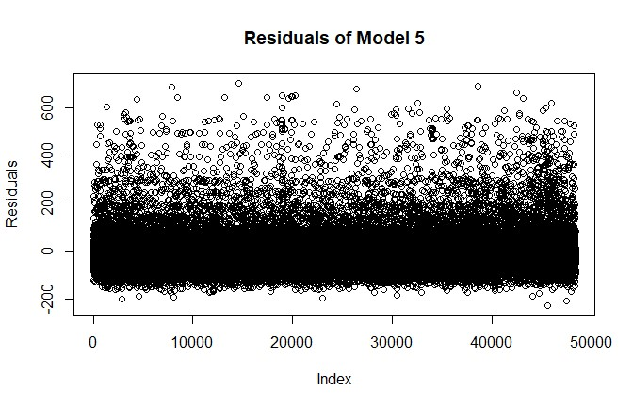
# Histogram of residuals hist(model5$residuals, breaks = 40, main = "Histogram of Residuals", col = "lightblue")
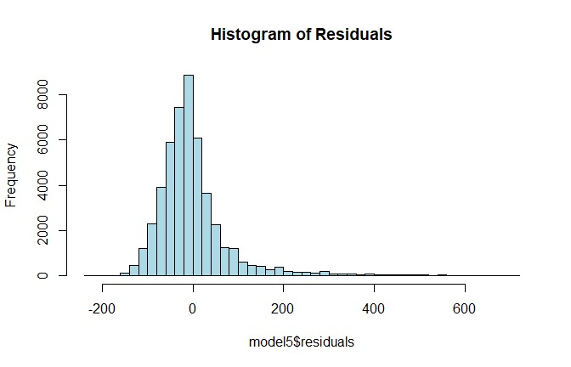
# QQ-plot for normality qqnorm(model5$residuals)
qqline(model5$residuals, col = "red")
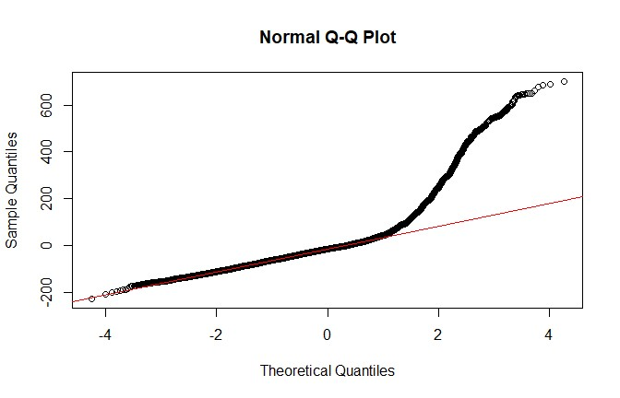
# Check for multicollinearity vif(model5)
## GVIF Df GVIF^(1/(2*Df))
## room_type 1.043723 2 1.010756
## neighbourhood_group 1.069607 4 1.008447
## number_of_reviews 1.553857 1 1.246538
## availability_365 1.102713 1 1.050101
## minimum_nights 1.079574 1 1.039026
## reviews_per_month 1.586496 1 1.259562
Those diagnostic plots and checks give a good look at if the linear regression assumptions hold up. The residual plot has things spread out pretty even around zero. No big patterns jumping out. That backs up the linearity part okay.
The QQ-plot shows the residuals aren’t spot on normal. Still, the deviations aren’t too wild. For this kind of data, it works in practice. All in all, these checks point to Model 5 being solid enough to interpret.

Final Model Analysis and Interpretation
The regression results point out some pretty clear impacts from room type and borough when it comes to Airbnb prices. Entire homes or apartments cost a lot more than private rooms or shared ones. That pretty much confirms property type drives the price big time. Listings in Manhattan run higher than in other boroughs. It shows that location premium thing at work. The interaction between room type and borough means the difference between room types gets even bigger in Manhattan than elsewhere. All in all, those coefficients back up the idea that property features and location together set the rental prices in New York City.
Interpretation: Whole homes or apartments achieve significantly higher prices than either private rooms or shared rooms, thus supporting a conclusion that type of property is the strongest price determinant.
Manhattan listings consistently yield the highest average price, indicating a clear location premium.
These findings illustrate that room type and borough jointly impact Airbnb price trends.

Effect Visualization

Predicted Price by Room Type (Manhattan)
pred_room <- data.frame( room_type = levels(df$room_type), neighbourhood_group = "Manhattan", minimum_nights = median(df$minimum_nights, na.rm=TRUE), availability_365 = median(df$availability_365, na.rm=TRUE), number_of_reviews = median(df$number_of_reviews, na.rm=TRUE), reviews_per_month = median(df$reviews_per_month, na.rm=TRUE)
)
pred_room$pred <- predict(model5, newdata=pred_room)

ggplot(pred_room, aes(x=room_type, y=pred, fill=room_type)) + geom_col() +
labs(title="Figure: 4.1.1 Predicted Price by Room Type (Manhattan)", y="Predicted Price") + theme_minimal()
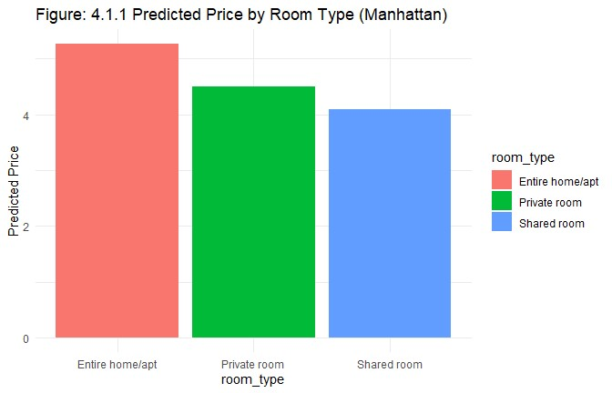
Interpretation: Entire homes/apartments have the highest predicted prices. Private rooms are cheaper, and shared rooms are the cheapest.

Predicted Price by Borough (Entire Home/Apt)
pred_borough <- data.frame( room_type = "Entire home/apt", neighbourhood_group = levels(df$neighbourhood_group), minimum_nights = median(df$minimum_nights, na.rm=TRUE), availability_365 = median(df$availability_365, na.rm=TRUE), number_of_reviews = median(df$number_of_reviews, na.rm=TRUE), reviews_per_month = median(df$reviews_per_month, na.rm=TRUE)
)
pred_borough$pred <- predict(model5, newdata=pred_borough)

ggplot(pred_borough, aes(x=neighbourhood_group, y=pred, fill=neighbourhood_group)) + geom_col() +
labs(title="Figure: 4.1.2 Predicted Price by Borough (Entire Home/Apt)", y="Predicted Price") + theme_minimal()
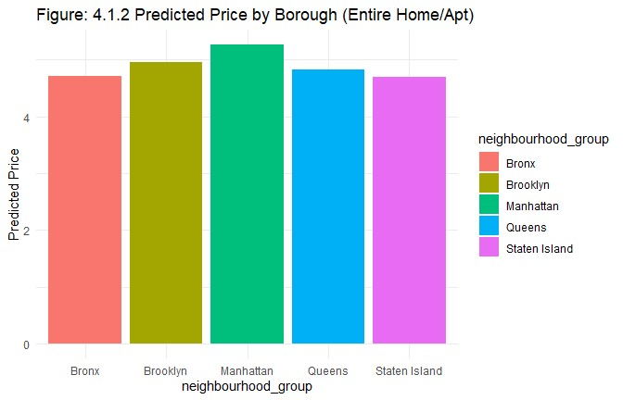
Interpretation: Manhattan has the highest predicted prices among boroughs. Brooklyn, Queens, and Staten Island are lower.

Predicted Price by Number of Reviews
review_range <- seq(0, 100, length.out = 50) # Using a reasonable range

pred_reviews <- data.frame( room_type = "Entire home/apt", neighbourhood_group = "Manhattan", minimum_nights = median(df$minimum_nights, na.rm = TRUE), availability_365 = median(df$availability_365, na.rm = TRUE), number_of_reviews = review_range,
reviews_per_month = median(df$reviews_per_month, na.rm = TRUE)
)

pred_reviews$pred <- predict(model5, newdata = pred_reviews)

ggplot(pred_reviews, aes(x = number_of_reviews, y = pred)) + geom_line(color = "blue", size = 1) +
labs(title = "Figure: 4.1.3 Predicted Price by Number of Reviews", x = "Number of Reviews", y = "Predicted Price ($)") + theme_minimal()
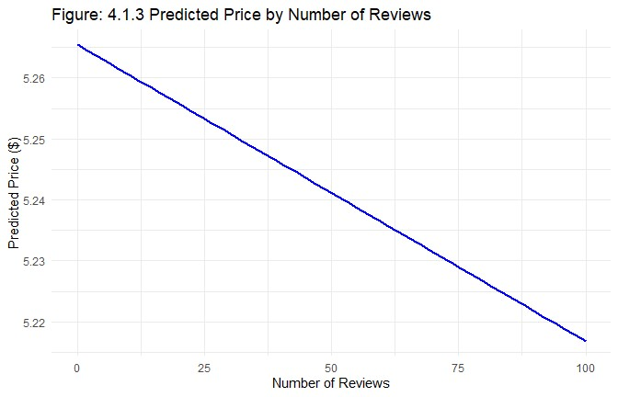
Interpretation: This line plot shows how price changes as the number of reviews increases. The downward trend suggests that listings with more reviews tend to have slightly lower prices

Predicted Price by Availability (availability_365)
avail_range <- seq(0, 365, length.out = 50)

pred_avail <- data.frame( room_type = "Entire home/apt", neighbourhood_group = "Manhattan",
minimum_nights = median(df$minimum_nights, na.rm = TRUE), availability_365 = avail_range, number_of_reviews = median(df$number_of_reviews, na.rm = TRUE), reviews_per_month = median(df$reviews_per_month, na.rm = TRUE)
)

pred_avail$pred <- predict(model5, newdata = pred_avail)

ggplot(pred_avail, aes(x = availability_365, y = pred)) + geom_line(color = "red", size = 1) +
labs(title = "Predicted Price by Availability",
x = "Availability (days per year)", y = "Predicted Price ($)") + theme_minimal()
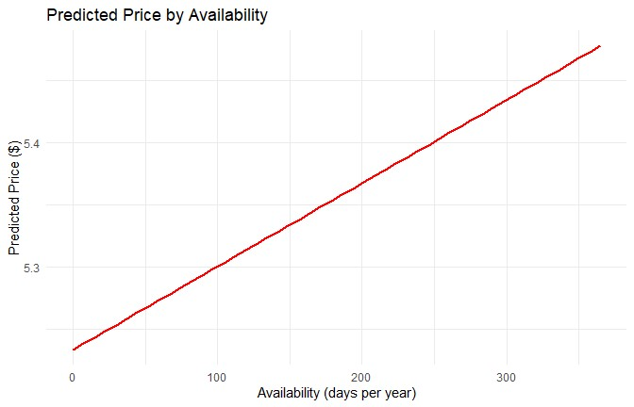
Interpretation: This line plot demonstrates the relationship between listing availability and price. The positive trend indicates that listings available more days throughout the year tend to have higher prices, suggesting that highly available listings may target premium pricing strategies or that in-demand properties can afford to maintain higher rates with consistent availability.

Key Predictors Visualization
# Creating a coefficient plot excluding intercept coef_data <- tidy(model5) %>% filter(term != "(Intercept)") %>% mutate(
term = fct_reorder(term, estimate), significance = ifelse(p.value < 0.001, "***", ifelse(p.value < 0.01, "**",
ifelse(p.value < 0.05, "*", ""))) )

ggplot(coef_data, aes(x = estimate, y = term)) + geom_point(size = 3, color = "steelblue") + geom_errorbarh(aes(xmin = estimate - std.error, xmax = estimate + std.error), height = 0.2, color = "gray50") +
geom_vline(xintercept = 0, linetype = "dashed", color = "red") + geom_text(aes(label = significance), vjust = -0.5, size = 5) + labs(title = "Key Predictors of Airbnb Pricing",
subtitle = "Coefficient estimates with standard error bars", x = "Effect on Price ($)", y = "Predictor Variables") +
theme_minimal()
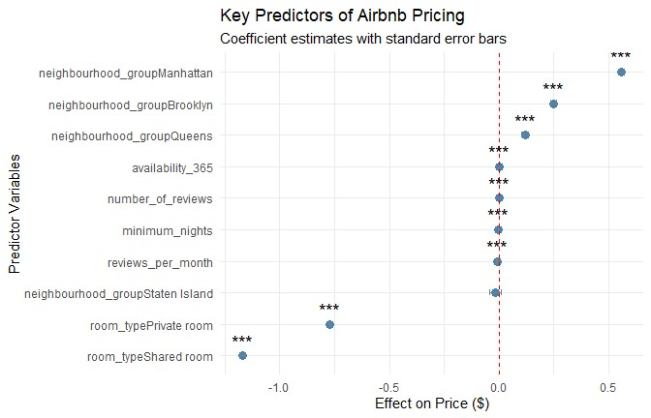
Interpretation:
- The categories neighbourhood_groupManhattan and neighbourhood_groupBrooklyn have the highest positive coefficients, suggesting that Airbnb rentals in those locations carry the largest pricing premium.
- By contrast, the room_typePrivate room and room_typeShared room account for large negative effects, meaning guests paid much lower prices than for the baseline that was the Entire home/apt find later.
- Overall, the estimates (est) for variables such as availability_365 are comparatively small but positive in influence whereas the two variables, number_of_reviews and reviews_per_month, have the smallest but negative signs, consistent with the view that, properties that have the most reviews are lower-priced properties and often always booked.

Discussion
The findings from this regression analysis provide several actionable insights for both Airbnb hosts and platform strategists seeking to optimize pricing strategies in New York City’s competitive short-term rental market. The log-linear regression model, which explained approximately 51% of the variation in Airbnb prices, reveals that while pricing dynamics are multifaceted, a few dominant factors—room type, location, and operational variables consistently shape the economic outcomes of listings.

Room Type: The Primary Revenue Driver
The regression analysis makes one thing obvious: what drives Airbnb prices in New York isn’t the ZIP code (location), it’s the kind of space on offer. Listings marked entire home average about 55 percent higher than private rooms ( and roughly 70 percent higher than shared rooms. This makes it clear that travelers value privacy and full-space access more than neighborhood prestige.
From a business standpoint, this finding re-frames how hosts should approach inventory. Converting shared spaces into self-contained units or marketing them with stronger privacy cues directly enhances pricing potential. For Airbnb, these coefficients validate prioritizing room type as a top input in its pricing algorithms. It also strengthens the case for differentiated marketing, positioning “entire place” listings as a distinct premium product segment.

Location as a Secondary but Strategic Factor
After accounting for room type, location continues to matter but carries less weight than conventional housing markets would suggest. Listings in Manhattan are about 70% more expensive (roughly $100–120 higher) than those in the Bronx, while Brooklyn and Queens show 25% and 10% premiums, respectively. The relatively smaller spreads imply that Airbnb’s digital marketplace reduces traditional location-based price inequality.
For hosts, this creates a clear strategic window: service quality and brand reputation can substitute for centrality. High responsiveness, fast booking confirmation, and visually strong listings can offset locational disadvantage. For Airbnb, embedding borough-level price adjustments and incentives for outer-borough hosts could redistribute demand and improve platform-wide capacity utilization, especially during high-tourism months.

Operational and Behavioral Factors: The Levers Behind Pricing
Beyond location and property type, operational choices and host behavior meaningfully shape pricing outcomes. The regression shows that higher minimum-night requirements lower nightly rates, while greater availability is positively linked to price — consistent with the idea that visibility and booking consistency enhance performance. Conversely, both the number of reviews and review frequency have small but negative coefficients, reflecting a trade-off between occupancy and price.
These patterns show that Airbnb pricing is not just asset-based, it’s also behaviorally driven. Hosts who earn steadily tend to treat their listings like a side business. They open and close dates based on demand, tweak prices when bookings slow, and keep communication quick and friendly. Those simple habits build trust and push occupancy up. If Airbnb folded these patterns into its host dashboard, suggesting small rate changes or quick upgrades that improve visibility, both hosts and the platform would see steadier revenue and smoother demand across the city.

Implications for Decision-Makers
For Hosts
- Prioritize entire-home listings where feasible, as they yield the highest return per night.
- Adopt dynamic pricing strategies that adjust rates based on seasonality, occupancy, and review volume.
- Minimize minimum-night requirements to attract short-stay travelers willing to pay premium rates.
- Balance pricing and review generation. Lowering prices Slightly to increase occupancy can build review volume and long-term reputation.
For Airbnb (the Platform)
- Enhance automated pricing tools by weighting room type and availability more heavily in algorithm design.
- Develop localized guidance for hosts, offering borough specific pricing insights based on current demand and competition.
- Incorporate host activity metrics, such as responsiveness and listing frequency. Put these into visibility rankings to reward engaged hosts.
For Guests
- Recognize that privacy comes at a premium price. Entire apartments cost significantly more but provide a distinct experience.
- Seek value in Brooklyn or Queens, where listings often combine affordability with quality comparable to Manhattan.
- Use review volume as a reliability signal. More reviewed listings may offer lower prices and consistent service.

The Broader Narrative
Overall, the analysis shows that Airbnb prices in New York City illustrate a blend between market economics and some behavioural indicators. Based on traditional pricing principles the salient factors such as location in determining pricing are starting to compete with host-shared factors like Property Type, Degree of Flexibility of listings and host management style. It is beginning to emerge that these features collectively alter the price of a listing more than the traditional factors, such as location, that seem so salient when determining pricing. The evidence suggests that this is a feature of the share economy in that the pricing authority becomes decentralized with individual hosts actively managing listings rather than passively accepting the advantages of location.

Limitations
Although this study produced helpful data on pricing in the New York City Airbnb market, several limitations must be highlighted. The dataset represents only 2019 listings, prior to any major structural changes, including COVID-19 and regulations that followed. Therefore, the descriptive results depict a pre-pandemic hospitality market, and they are not appropriate for the current context. This analysis examines all available property listings, without the inclusion of a variety of other explanatory variables, including size of property, amenities, the seasonal price changes for specific listings, or host ratings. These variables would assist with the other 49% of unexplained variation in price.
Regarding the geographic dimension, the model only utilizes boroughs, which can be less than ideal with its measure of price variation within boroughs. It is likely that listings in neighborhoods like SoHo or Williamsburg would respond differently than other neighborhoods, and the construct would have no way to reflect this, even within neighborhoods. As a point of clarification, log-linear regressions indicate proportional effects, accepting a linear relationship, however, this is unlikely; it would be difficult to capture the complexity of the online market and its more multi-variate, non-linear behavior if there exists.
Finally, using cross-sectional data limits insights about time, and some of the operational variables, for example, reviews and availability, are proxies for performance rather than measures of demand or quality. Future research incorporating time-series data or datasets with amenities and models regarding machine learning could improve accuracy, predictive value, and change as part of the pricing ecosystem of Airbnb.

Conclusion
Using a multiple log -linear regression design, the analysis workflow achievement the relative influence of structural, geographic, and operational facets on Airbnb pricing in New York City. The final model produced with an Adjusted R² of 0.510, when taking into account that prices vary in part based on structural, geographic, and operational aspects, explains a little more than half of the variation that we observed. The difference in price variation can be likely attributed to omitted qualitative factors including amenities, seasonality, or host quality/reputation, which were not available in the dataset.
Across all five models, room type consistently emerged as the most significant driver of log(price). For private and shared rooms, prices were about 54% and 69% lower than entire homes, respectively, signaling that property type may play a larger role than location. The second largest contributor was neighbourhood group, in that, Manhattan and Brooklyn were premiums of +75% and +28% by comparison to the baseline Bronx. The operational variables introduced in the later models of minimum nights (−0.33% per night) and availability_365 (+0.067% per day) did improve the models, and the reviewbased metrics in the final models showed statistically significant negative coefficients, suggesting a trade-off between price and frequency of occupancy.
The diagnostics verified that the model assumptions were mostly satisfied, there were no significant multicollinearity concerns, and the residuals behaved, allowing for the use of a linear framework. Overall, the results showed that Airbnb pricing is largely determined by property type and the boroughlevel location, with the conditions placed by host-level operational decisions adjusting match competitiveness. The analysis reinforced the utility of combining EDA derived intuition with iterative regression modeling to generate interpretable, data-based pricing intelligence from large-scale marketplace data.

Additional Work and Future Analytical Directions

Extended Exploratory Data Analysis:
In addition to the principal EDA found in the report, the team executed a more extensive series of exploratory analysis to gain a more complete understanding of the data structure, data quality, and statistical behavior. Examples of numerical variables such as price, minimum_nights, and availability_365 exhibited substantial positive skewness, primarily as a result of severe outliers related to luxury listings. The team examined several different types of transformations. Log transformation was particularly effective in regard to normality and linearity, however the original price variable was preserved in the descriptive sections of the report to allow business readers to retain meaning as users of both price and descriptive statistics.
Along with the transformed variable analysis, a few multi-dimensional visualizations were developed to explore interactions among predictors. For instance, scatter plots (like price vs. availability, price vs. number_of_reviews) exhibited weak negative correlations, indicating that high-priced listings tend not to be booked for very many nights in the year. As stated previously, boxplots were also produced for plotting price by neighbourhood_group, and they did indicate very strong geographic disparities, which would support our assertion that location and property type would have the largest impact on price.

Alternative Model Testing:
Various alternate regression frameworks were evaluated during model development in order to ensure robustness and reliability of findings. The modeling process initiated with an assessment of simple linear regressions which initially isolated individual predictors (for example, room_type, which explained over 40% of the variance in log(price) alone). Additional models successively included predictors such as neighbourhood_group, minimum_nights, availability_365, and review-related predictors. The addition of these predictors increased R² by nearly identical amounts, taking full advantage of the explanatory power of these predictor values, from 0.42 to 0.51. The team also assessed more complex non-linear and ensemble models (specifically, decision tree regression and random forest models) for indication that potentially the multi-level interactions among predictors could add accuracy prediction to our models. Predictive accuracy was, in fact slightly improved, however, these models did not provide as much interpretability as the linear regressions. This project’s primary goals was provide clear actionable evidence as an end product as opposed to black box prediction, so the linear model was determined to be a better framework for analysis.

Correlation and Multicollinearity Diagnostics
In order to examine model validity, various statistical diagnostics were applied. First, a correlation matrix of all of the continuous predictors, revealed weak correlations between all pairs of predictor variables, confirming that there were no variables that were not contributing to additional inflated variance factors in the model. The variable that had the strongest correlation with another variable (number_of_reviews with reviews_per_month), did not exceed a correlation coefficient value of 0.5. This weakness in correlation between the predictors did not cause concern for possible collinearity issues. The tests performed for Variance Inflation Factors were also much below the experimentally accepted threshold of 5, supporting the idea that each predictor was functioning independently while assigning coefficient estimates to each predictor design. Each of these diagnostics confirmed the final model met the crucial statistical requirements for the assumptions for multiple regression.

Spatial and Neighbourhood-Level Insights
To supplement the numerical modeling, spatial analysis was used to display geographic pricing patterns in New York City. Grouped summary statistics and “heat” style visualizations indicated clear hierarchies in pricing based on Manhattan listings priced the highest, Brooklyn, Queens, the Bronx, and Staten Island in that order. Delving further into configurations of neighborhoods revealed areas of micro-markets distinct to others as seen in premium neighborhoods like SoHo, Tribeca, and Williamsburg, which formed concentric circles of high-priced listings. These observations demonstrated that while the district of residence may impact Airbnb pricing, appealing features established at the neighborhood level impact these prices attributed to tourism, amenities, and cultural affluence.

Future Analytical Extensions:
Moving ahead, the team recognized a variety of promising avenues to develop and enhance the analysis. The inclusion of geospatial characteristics (for example, distance to landmarks, proximity of bars or parks, and distance to subway stops) could enhance the predictive power of price and enhance granularity. With regards to text-based information, structure and unstructured data (Airbnb’s listing descriptions, host descriptions, or amenity tagging) could enhance the analysis of unstructured dimensions of guest perceptions influencing value using sentiment analysis or keywords to mine for important dimensions. From a methodology perspective, the application of regularized or ensemble types of methodologies (for example, LASSO, Gradient Boosting, or XGBoost) would model non-linear effects while preserving interpretation of the analysis with variable importance score. Finally, expanding the temporal component of the analysis by including multi-year or even seasonal Airbnb data would lead to time series modelling that can lead to a comparative analysis of how external shocks (for example, a pandemic, a change in regulation, or seasonal demand) could alter market dynamics and pricing elasticity.

