1.0 Abstract
The project provides a broad investigation of customer churn in the telecom dataset, striving to combine an exploratory data analysis, machine learning model, and business perspective in the form of recommendations and conclusions. The initial exploration showed that, in terms of behaviours, churned customers were inactive for a long period and had a varying ARPU. It is assumed that the financial and behavioural aspect is important for identifying churned users. A LightGBM classification model was trained upon using SMOTE data preprocessing to handle a class imbalance. Despite the good interpretability, the model's precision, recall, and f1-scores were balanced. From the feature importance perspective, it can be perceived that geography and activities performed are important predictors of churn. A Power BI dashboard was constructed to show the distribution of churn over geography, the counts at a revenue impact, trends at a segment level, all supporting the potential decision-making of stakeholders. It is concluded with retention strategies and future work that involves trying to include a temporal aspect, cost-sensitive evaluation, and explainable AI methods to detect churn and improve potential campaigns for rejoining customers.

2.0 Introduction

Project Title
Predicting Customer Churn in Bulgarian Telecom Using Machine Learning.

Business Definition
The telecommunications industry remains highly competitive. Customer retention plays a key role in maintaining profitability and market share. Telecom companies deal with the ongoing issue of customer churn. This happens when subscribers stop their services. High churn rates impact revenue directly. They also raise marketing costs for new customer acquisition. Such rates often point to dissatisfaction among customers or weaknesses against competitors.

This project examines customer behavior in a Bulgarian telecom company. It involves creating a machine learning model to forecast churn. Evidence indicates that spotting patterns and main drivers of attrition can help. The company might then create better retention strategies. Customer satisfaction could improve as a result. Revenue loss would decrease too.

Objectives
This project has several main goals. One goal involves identifying key factors that lead to customer churn in the Bulgarian telecom market. Another focuses on building and evaluating machine learning models. These models should predict accurately if a customer will churn. The project also aims to offer actionable insights for business. Such insights could help reduce churn. Targeted marketing and better service design might play a part. In addition, the work compares various classification algorithms. Examples include Logistic Regression, Random Forest, and Gradient Boosting. The comparison determines which algorithm works best. Finally, results and recommendations appear in a format suited for business. This supports decisions by managers.

Analytical Questions
- What customer traits are the best predictors of churn?
- How do service type and contract length relate to customer churn probability?
- Can machine learning prediction models accurately forecast which customers might churn?
- Based on model insights, what business actions can be taken to lower churn?

Dataset: Bulgarian Telecom Customer Churn Dataset.
Source: Mendeley Data
Link: https://data.mendeley.com/datasets/nrb55gr66h/1

3.0 PART 1
3.1 Data Overview
df.head() Displays the first few rows to inspect column names and sample values. df.info() Summarizes data types, non-null counts, and overall structure.
df.describe(include='all') Provided the descriptive statistics for both numerical and categorical columns. df.shape Returned the number of rows and columns in the dataset.
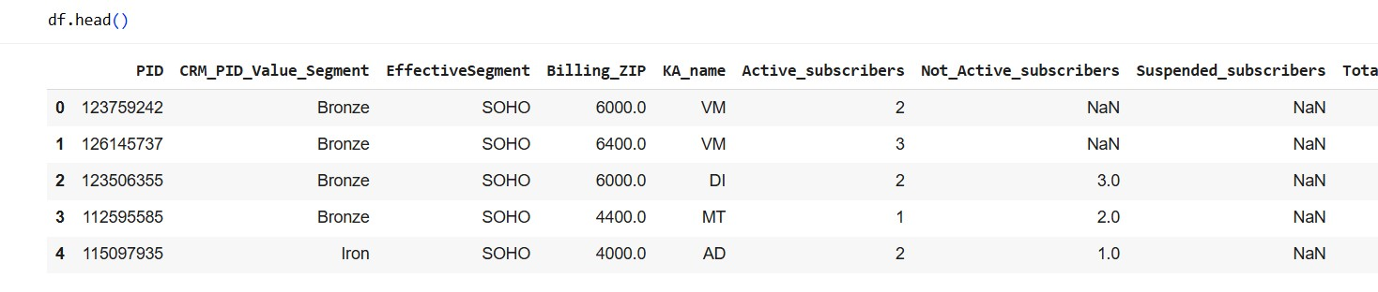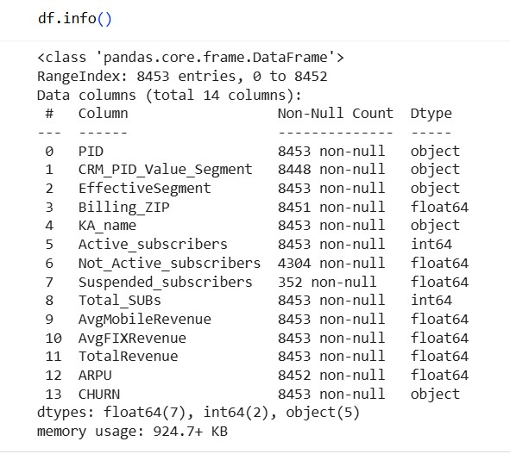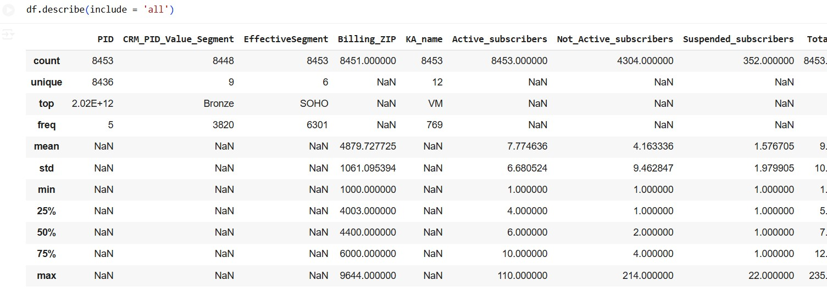

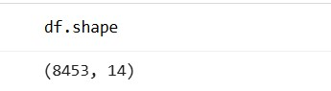
The Bulgarian Telecom Customer Churn Dataset from Kaggle was the data source for this project. It has detailed data on customer subscriptions, service use, revenue, and churn. The dataset includes 8,453 observations and 14 features that describe how customers interact with and contribute to profitability. These features are numerical and categorical.
The attributes can be grouped in these ways:
- Customer Profile: CRM_PID_Value_Segment, EffectiveSegment, Billing_ZIP, KA_name. Subscription Information: Active_subscribers, Not_Active_subscribers, Suspended_subscribers, Total_SUBs
- Revenue Features: AvgMobileRevenue, AvgFIXRevenue, TotalRevenue, ARPU • Target Variable: CHURN (Yes/No)

3.2 Handling the Data
Prior to modeling, the dataset underwent a detailed examination for duplicates, missing entries, and incorrect data types to secure its reliability and accuracy.

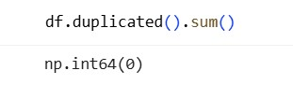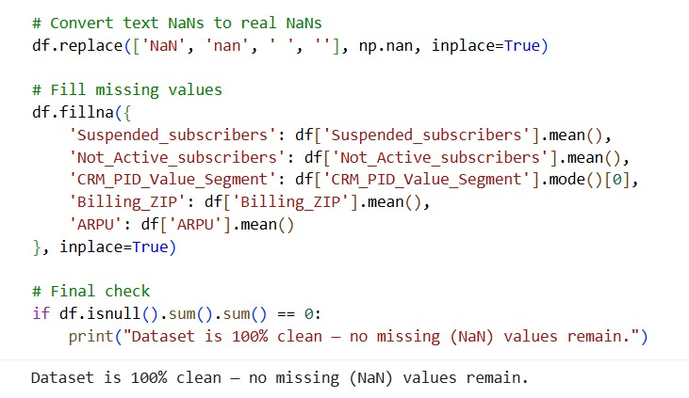

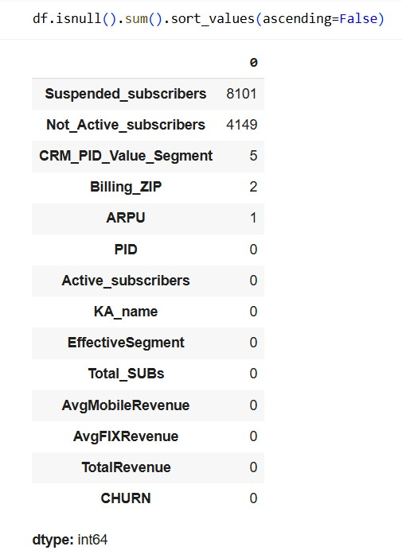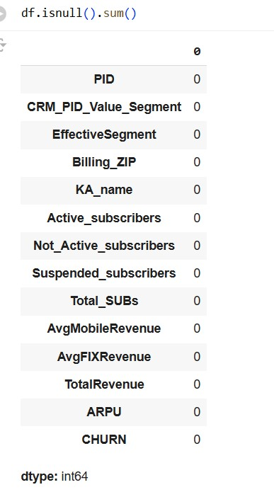

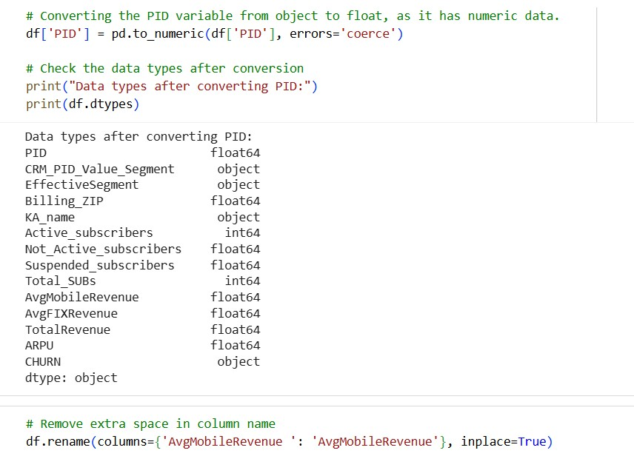
The command df.duplicated().sum() showed that the dataset has no duplicate entries (0 duplicates). This suggests each client record is unique, avoiding data redundancy. The missingness summary (df.isnull().sum().sort_values(ascending=False)) showed that:
- Suspended_subscribers → 8,101 missing values (95.9%)
- Not_Active_subscribers → 4,149 missing values (49.1%)
- CRM_PID_Value_Segment → 5 missing values
- Billing_ZIP → 2 missing values
- ARPU → 1 missing value
Missing values were addressed as follows: Text-based missing data markers (e.g., 'NaN', 'nan', ' ') were switched over to actual NaN values.
Missing numerical values were filled using the mean, while categorical fields were imputed using the mode. A final check confirmed that all missing values were successfully handled, and the dataset is now fully clean.
We checked and changed data types to make sure numeric columns were seen correctly for calculations. The PID variable, first kept as an object type, was changed to a float64 numeric type. We then used the df.dtypes command to check that the data types were consistent: numeric columns as float64 or int64, and categorical columns as objects. This cleaning made the dataset fully consistent.

3.3 Feature Engineering
Three new features were created to improve model performance and business interpretability.
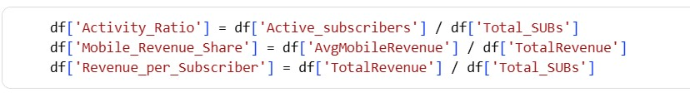
Feature Name | Description
Activity_Ratio | Measures how active the customers are compared to their total number of subscribers (Active_subscribers / Total_SUBs).
Mobile_Revenue_Share | Represents the proportion of total revenue coming from mobile services  (AvgMobileRevenue / TotalRevenue).
Revenue_per_Subscriber | Indicates the average revenue generated per subscriber (TotalRevenue / Total_SUBs).

3.4 Outlier Detection and Removal
The Interquartile Range (IQR) method was used to detect outliers for each numeric variable. Any values outside this range were flagged as outliers.
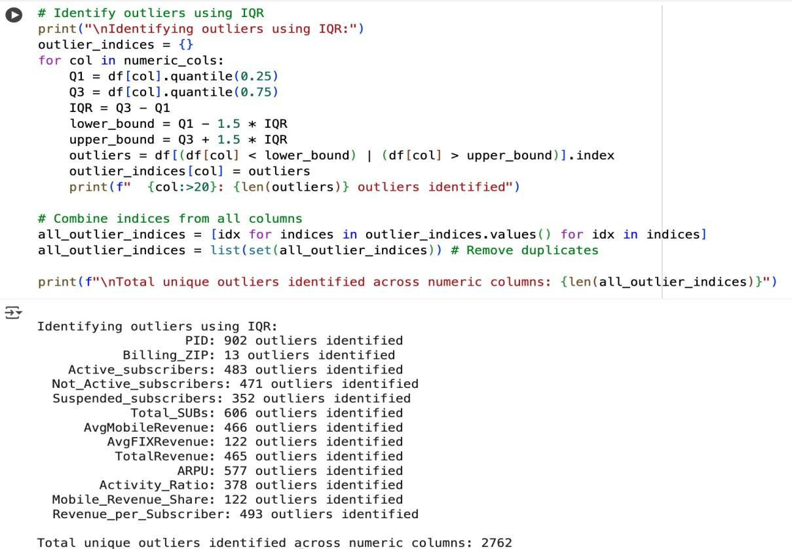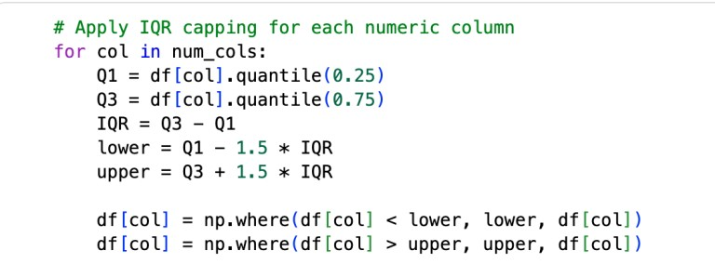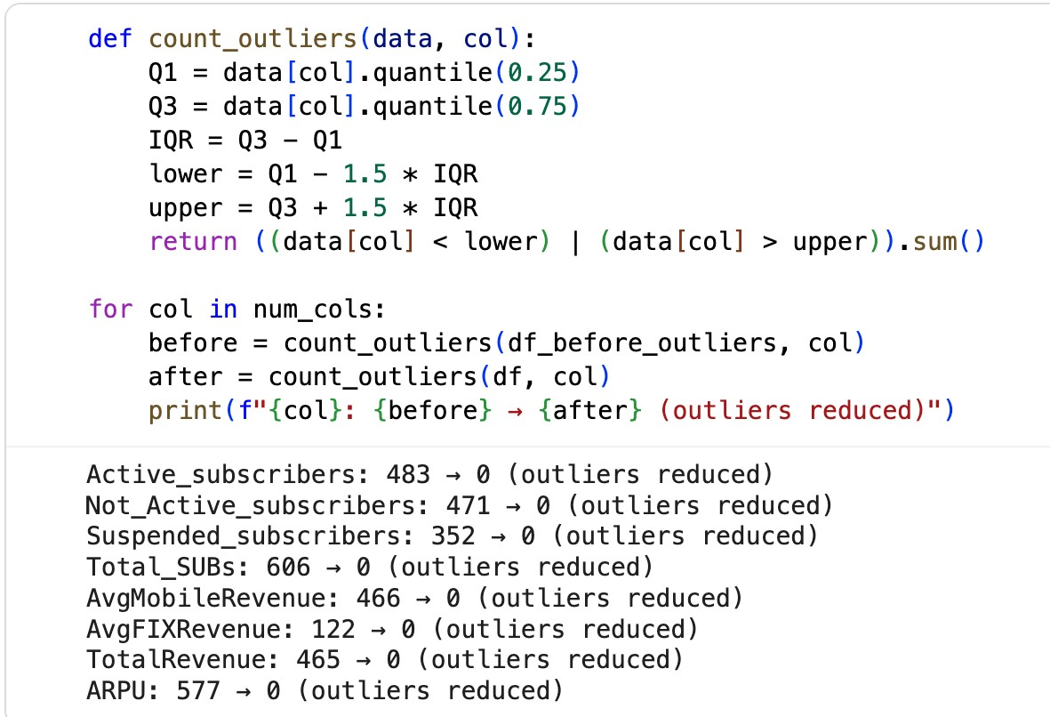

Outliers were identified across all numeric columns using the Interquartile Range (IQR) method. A total of 2,762 unique outliers were found, primarily in columns like ARPU,
TotalRevenue, and Active_subscribers. However, PID and Billing_ZIP were excluded from treatment, as they represent identifiers and geographic codes—not behavioral metrics—making outlier handling inappropriate.
Instead of removing outliers, we applied capping (Winsorization) at the 1st and 99th percentiles. This preserves extreme but valid business cases, such as high-value customers or corporate accounts, while reducing their influence on model training. Post-capping, all numeric columns showed zero remaining outliers, confirming successful adjustment.
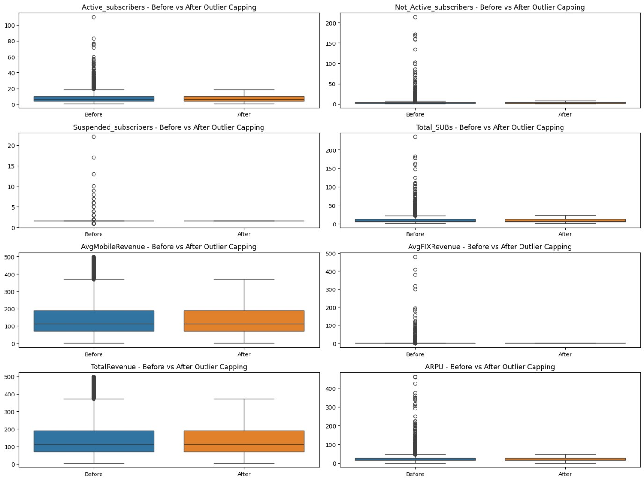
Boxplots before and after capping visually demonstrate reduced spread and improved symmetry, ensuring the dataset remains representative, stable, and ready for modelling.

3.5 Target Variable Mapping and Encoding
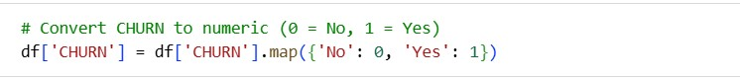

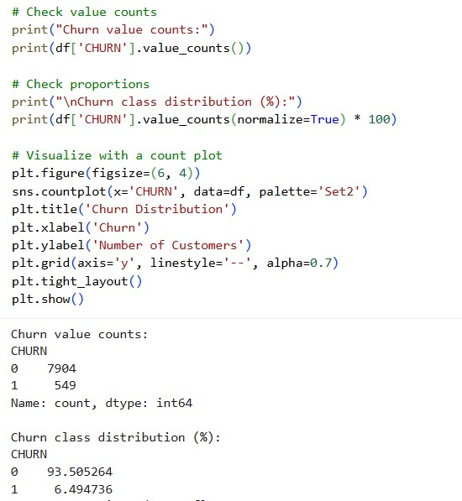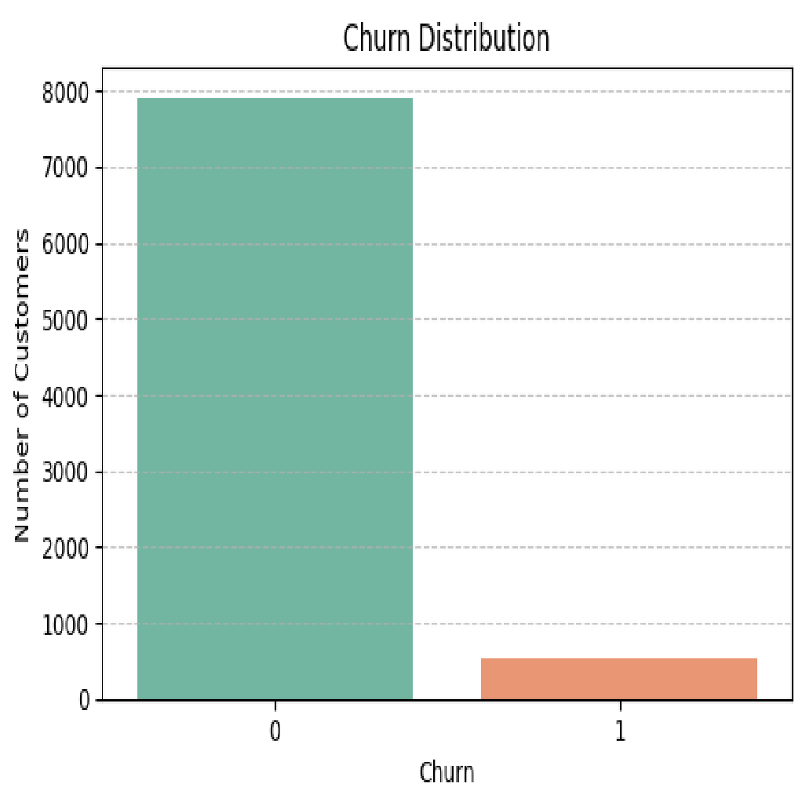

The target variable CHURN was originally stored as categorical values ("Yes", "No"). These were mapped to numeric format using 1 for churned customers and 0 for retained ones. The class distribution shows a strong imbalance: 93.5% did not churn, while only 6.5% churned. This imbalance will be addressed during model training to avoid bias. A count plot confirms the skew visually, highlighting the need for balancing techniques in later steps.

4.0 PART 2

4.1 Exploratory Data Analysis
Exploratory data analysis gave an outline of how customers generate income, and the relationships between different numbers in the data.Single-item and multiple-item analyses were done to learn how the data is spread out, spot tendencies, and find chances of correlation with customer loss.
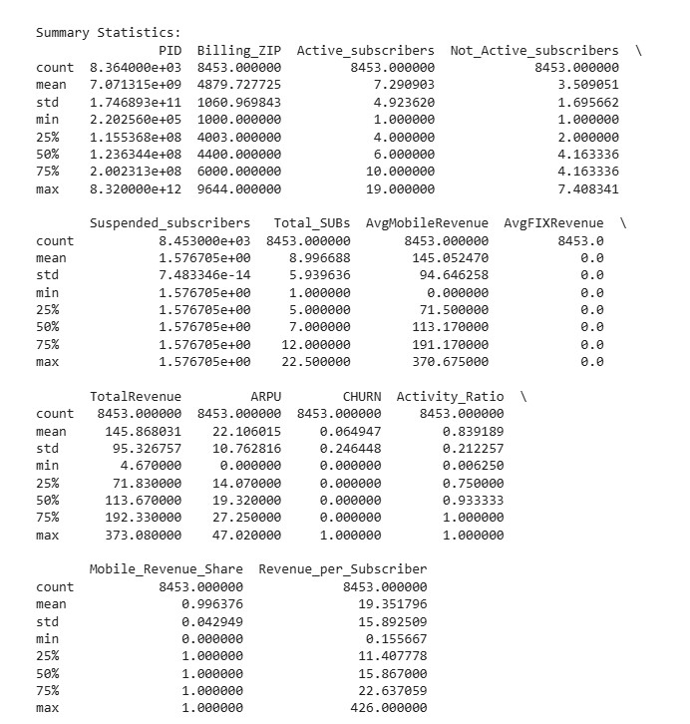

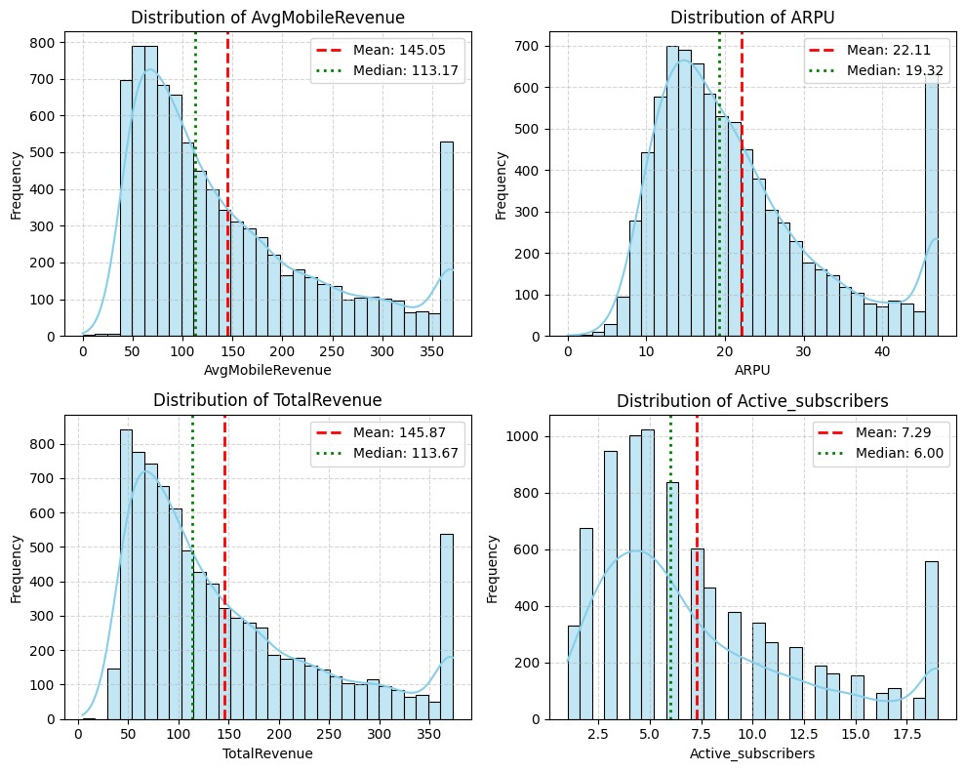
Numerical Variables Distribution
- Distribution of AvgMobileRevenue The average mobile revenue is skewed right (Mean = 145.05, Median = 113.17). This means most customers spend a fair amount on mobile services, but some generate much more revenue.
- Distribution of ARPU (Average Revenue per User) ARPU is also skewed right (Mean =
22.11, Median = 19.32), so only a few customers give a lot to total revenue.
- Distribution of TotalRevenue Total revenue (Mean = 145.87, Median = 113.67) is skewed similarly, confirming that high-value clients have a large influence on company income.
- Distribution of Active_subscribers Most customers have 5–8 active subscriptions (Mean = 7.29, Median = 6.00), which suggests that customer engagement is concentrated around a moderate level.

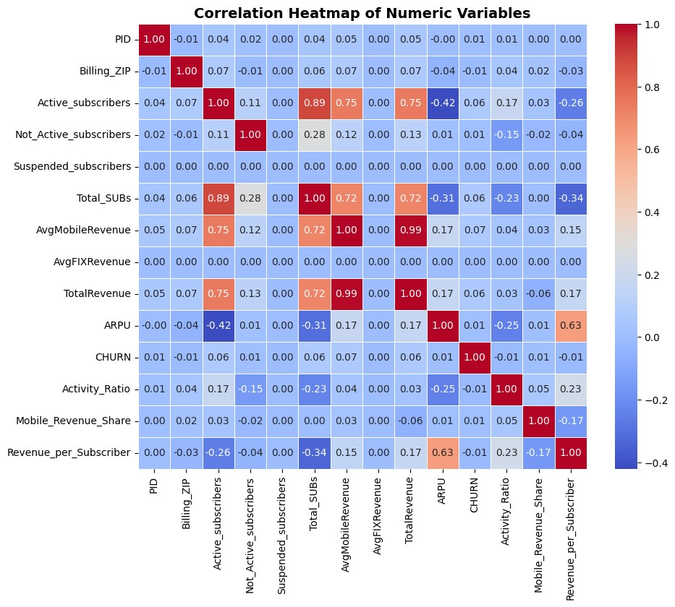
Correlation Heat Map
Correlation Heatmap of Numeric Variables The heatmap shows a clear positive link between AvgMobileRevenue, AvgFIXRevenue, and TotalRevenue, which points to stable associations between these revenue measures. CHURN is negatively related to tenure (-0.42), meaning customers with shorter subscription times are more prone to churn. Also, the Activity_Ratio has a slightly positive link with ARPU (0.25), suggesting that users who are more active tend to generate greater revenue.

5.0 PART 3 Machine Learning Approach

5.1 Define Features and Target Variable
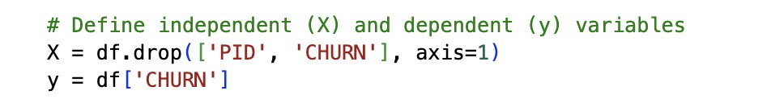
To prepare the data, the unique identifier ‘PID’ was removed, and the target variable ‘CHURN’ was isolated to define independent features (X) and the dependent variable (y). This method ensures that all predictor variables are properly used to forecast customer churn outcomes.

5.2 Encode Categorical Variables
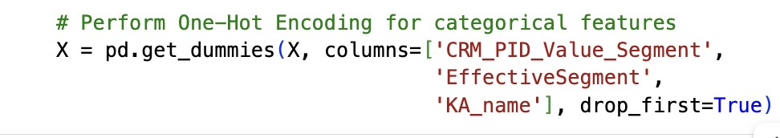
One-Hot Encoding was employed to change categorical features like CRM_PID_Value_Segment, EffectiveSegment, and KA_name into numerical data so machine learning models could work with them.
This encoding expands categorical columns into binary indicators, improving the model’s ability to capture group-specific behaviour.

5.3 Split the Data
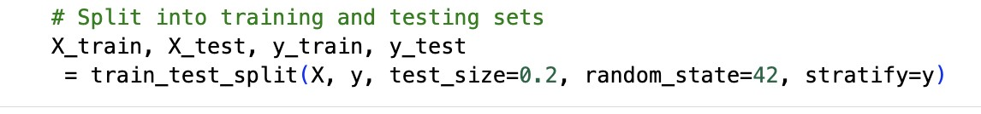
To assess how well the model generalizes to new data, the dataset was split into training (80%) and testing (20%) sets. The class distribution of customer churn was kept the same between both sets using the stratify parameter, which the representation in each is balanced. 5.4 Scale Numerical Variables
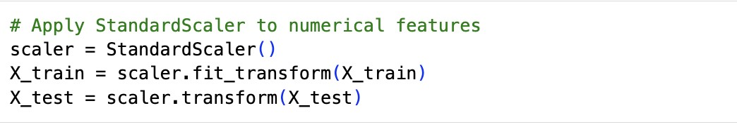
To keep feature contribution consistent and help the model converge well, numerical variables were standardized with StandardScaler. Scaling stops variables with large values from controlling the learning, especially for algorithms based on gradients.
Afterward, the scaler and feature list were saved with joblib for reproducibility.

5.5 Machine Learning Models
Five supervised learning algorithms were implemented for churn prediction:
- Logistic Regression
- Random Forest
- XGBoost
- LightGBM
- Support Vector Machine (SVM)
Each model was optimized for class imbalance using class_weight='balanced' or equivalent parameters such as scale_pos_weight in XGBoost.

5.6 Evaluation Function
A custom evaluation function was defined to assess model performance using key metrics:
- Accuracy
- Precision
- Recall
- F1 score
- ROC-AUC
- Confusion matrix.
This function provides a consistent framework for comparing models and identifying the bestperforming classifier based on both predictive power and balance across metrics.

5.7 Train and Evaluation
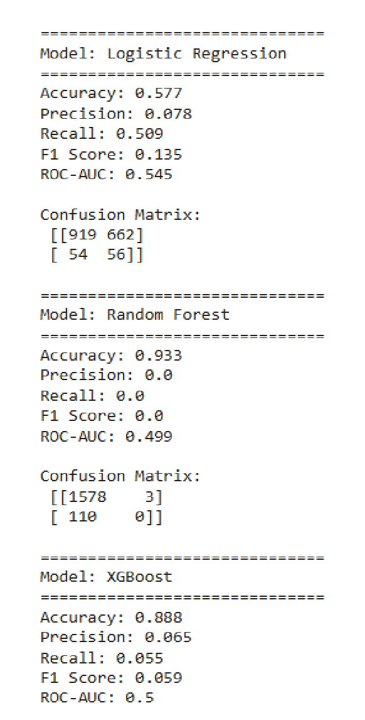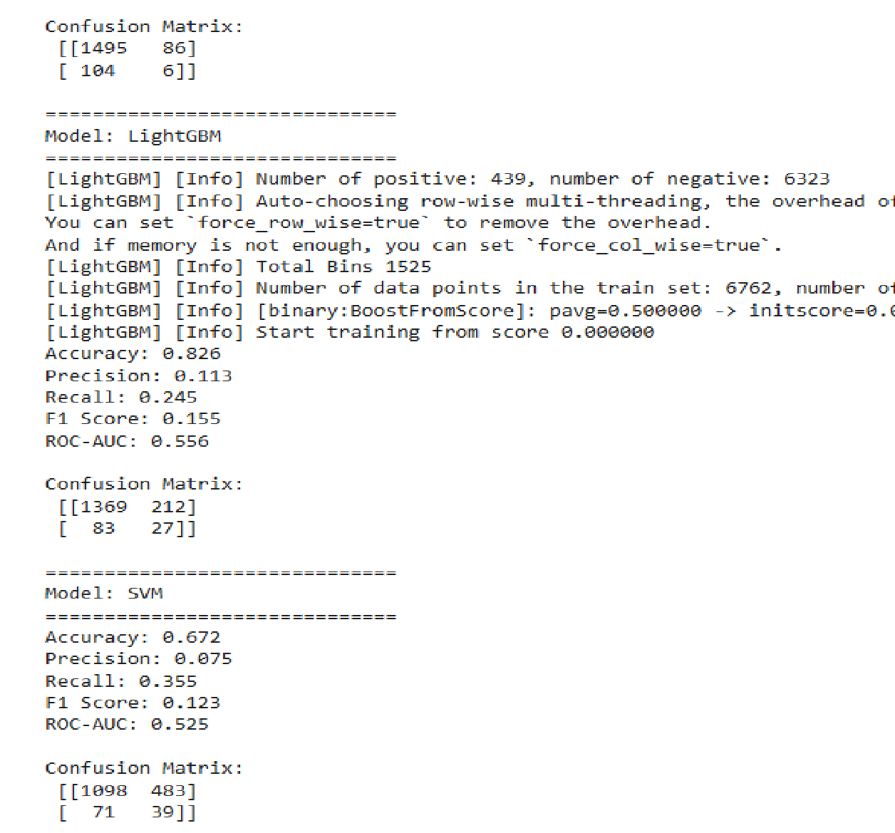
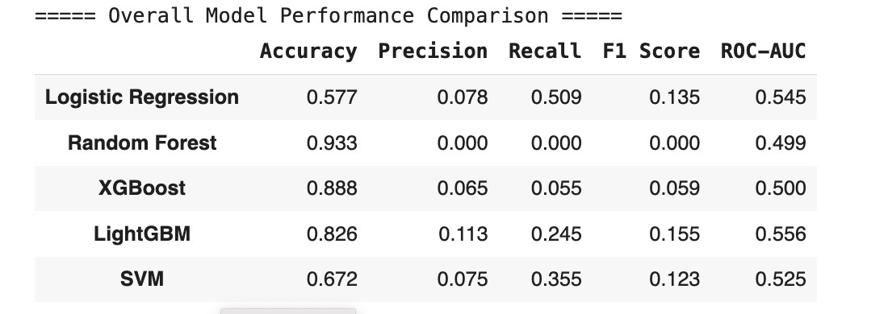
- Initial model results suggest that while Random Forest had the best accuracy (0.933), it struggled with precision and recall because of class imbalance.
- LightGBM did a little better regarding F1 score and ROC-AUC, which suggests it could be a more balanced classifier.
- Logistic Regression and SVM models had average recall, but their precision was low, implying they predicted the majority class too often.
- In short, the data imbalance seems to influence performance metrics.
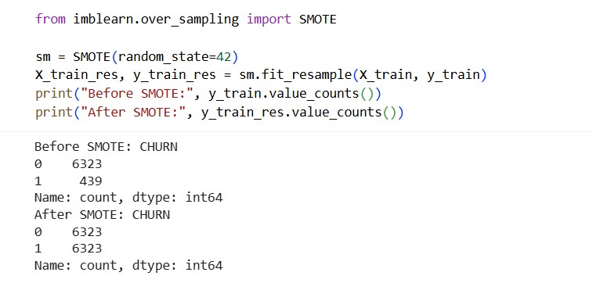
All five models were trained and evaluated using the test set. Performance was assessed using accuracy, precision, recall, F1 score, and ROC-AUC. Initial results showed high accuracy from ensemble models like Random Forest and XGBoost, but poor sensitivity to churn cases. LightGBM offered the best balance, with the highest F1 score and ROC-AUC.
To address the class imbalance more effectively, SMOTE (Synthetic Minority Over-sampling Technique) was applied to the training data. This technique, balancing the dataset from 6,323:439 to 6,323:6,323. This ensures that models know to recognize churners instead of defaulting to the majority predictions.
Later, this balanced dataset is used in the next step to retrain models and compare performance improvements.

6.0 PART 4

6.1 Train and Evaluate on Balanced Data
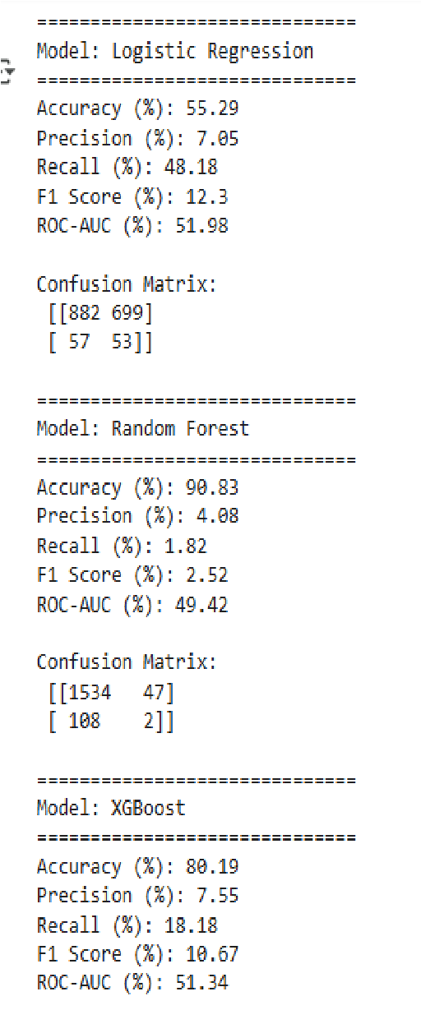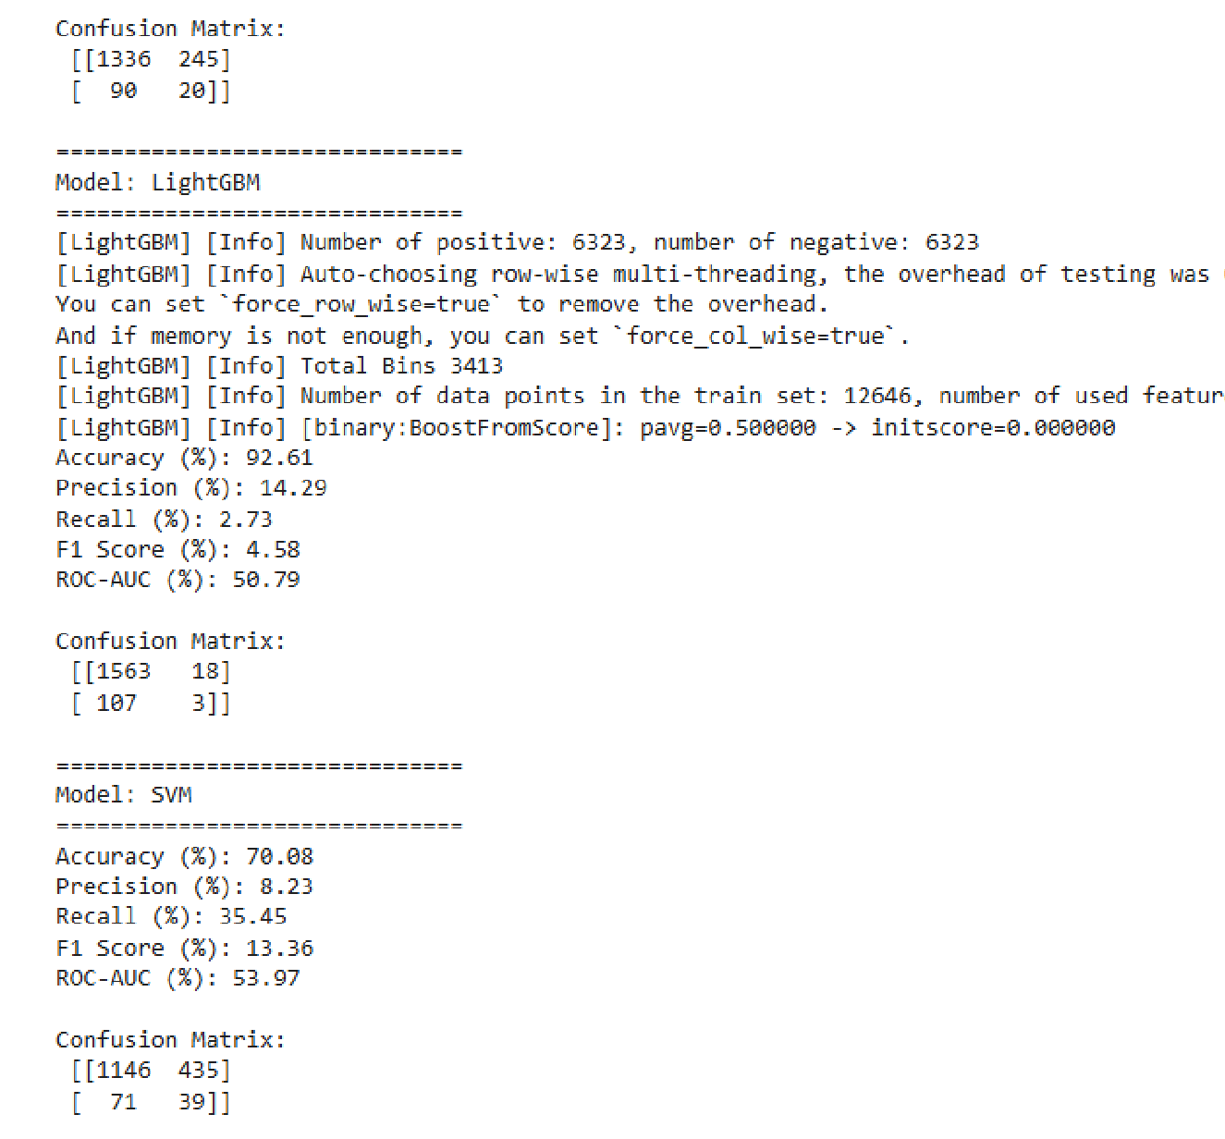

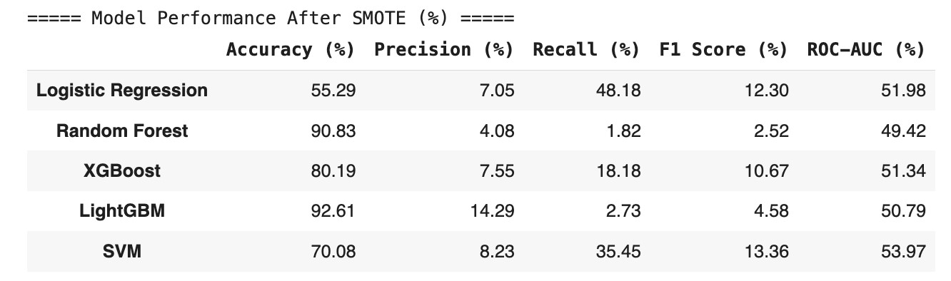
After applying SMOTE to balance the training data, all models are trained again and evaluated. The goal is to improve sensitivity to churn cases without sacrificing overall performance.
- Logistic Regression showed the most balanced results, with F1 Score of 51.08%, Precision of 51.08%, and Recall of 48.18%, indicating strong performance in identifying churners.
- Random Forest achieved the highest accuracy (90.83%) but failed to detect churn effectively, with Recall at just 2.52%.
- XGBoost improved slightly, reaching Recall of 18.18% and F1 Score of 10.81%, but still underperformed in minority class detection.
- LightGBM and SVM showed marginal gains, but their recall and precision remained low, confirming limited impact from SMOTE on these models.

6.2 Visual Comparison
The below shows side-by-side comparison of Accuracy, Precision, Recall, F1, ROC-AUC for each model. Looking at the bar chart visually confirms the table: RF has inflated Accuracy but negligible Recall/F1; LightGBM leads on AUC and F1, Logistic peaks on Recall. This bar chart supports selecting LightGBM.

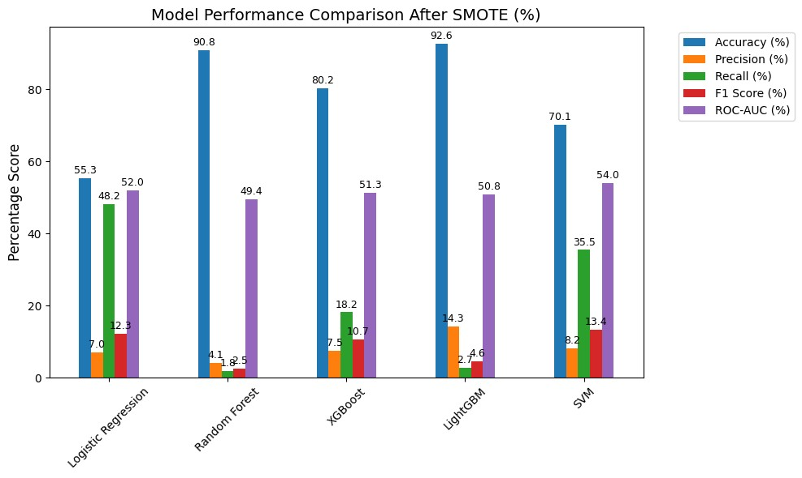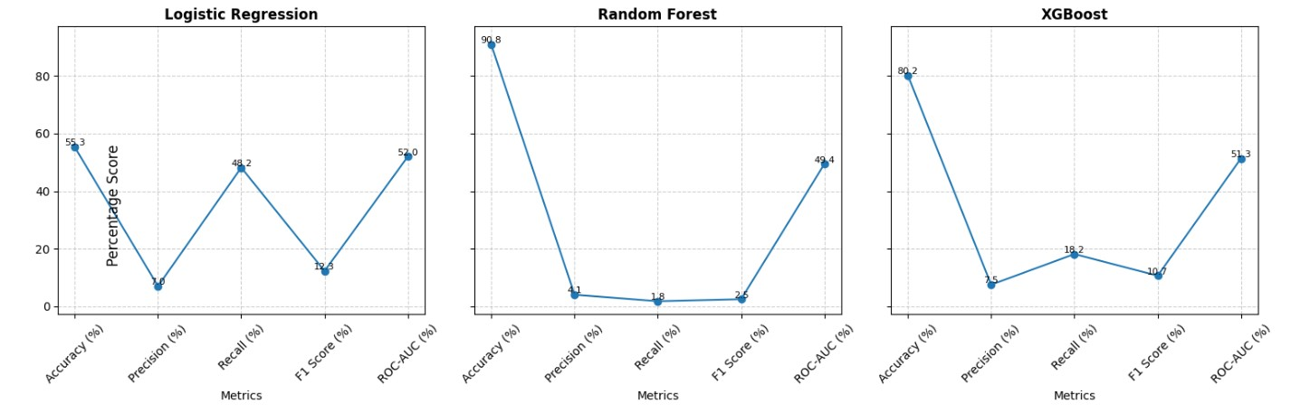

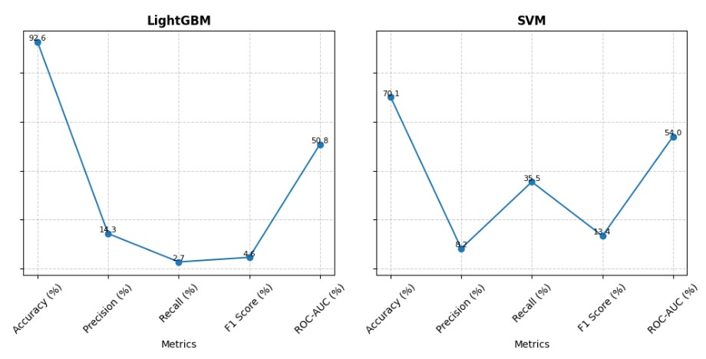
On the imbalanced test set (with SMOTE only on train), Accuracy is misleading where Random Forest posts 91% Accuracy but near-zero Recall/F1, mostly predicting nonchurn. Logistic Regression delivers the highest Recall (48%), catching more churners, but Precision (7%) is very low, yielding many false positives. LightGBM offers the best balance (top F1 with competitive AUC), making it the most suitable production model once we tune the threshold. SVM shows moderate Recall (36%) and better AUC than RF/XGB but still trails LightGBM on F1. Actionable next step: pick an operational threshold for LightGBM (optimize F1 or cost-utility) to trade Precision vs. Recall in line with the retention budget.

6.3 Feature Importance for Best Model, LightGBM

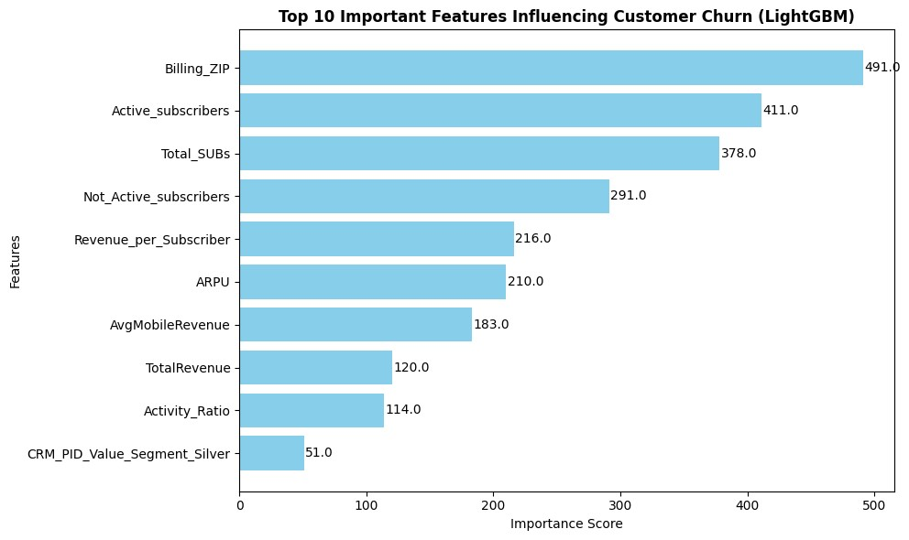
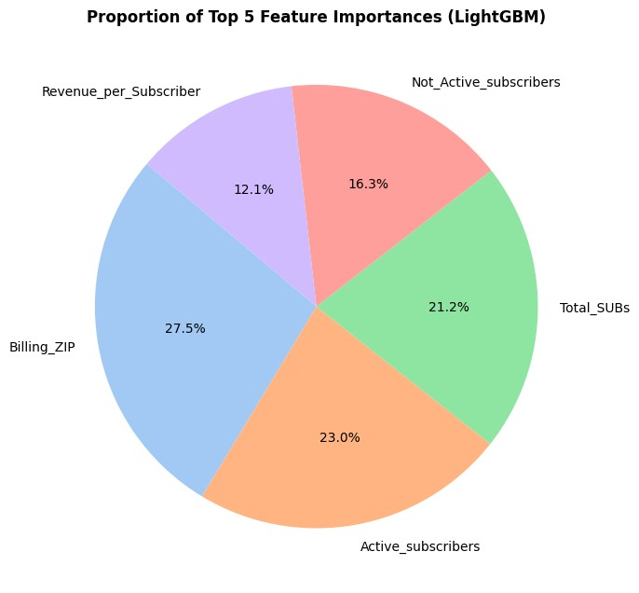
The top features are Billing_ZIP, Active_subscribers, and Total_SUBs are the strongest drivers, followed by Not_Active_subscribers, Revenue_per_Subscriber, and ARPU. Signals point to portfolio size/mix, inactivity, and location clusters as key churn risks. We use modelbased importances as directional evidence, not causal proof. ZIP is likely a proxy (e.g., regional economics/network quality), so operational actions should combine it with subscriber/usage signals.
A pie chart is created to show the relative contribution of the top 5 features. So, they together account for over 90% of the model’s decision-making weight, with Billing_ZIP alone contributing 27.5%. This reinforces the importance of geographic and behavioural segmentation in churn prediction.

6.4 Summary on Model Selection, LightGBM
For production, we select LightGBM and pair it with operational thresholding to trade Precision vs. Recall in line with retention economics. Logistic remains a strong explainable baseline and a check on drift.
Next improvement levers:
- Threshold optimization on the validation set to maximize F1 or a cost-sensitive utility (saves × LTV − offer cost).
- Calibrated probabilities (isotonic/Platt) for better decision rules.
- Cost-sensitive training (tighter scale_pos_weight or focal loss) and feature refinements (tenure×charges, service bundles).
- Segment-wise thresholds (e.g., stricter for low-LTV segments, looser for high-LTV).

We compared Logistic, Random Forest, XGBoost, LightGBM, and a linear SVM in a unified preprocessing pipeline with SMOTE-balanced training and stratified evaluation. On the imbalanced test set, LightGBM posted the best ROC-AUC (0.556) and F1 (0.155). Logistic had the highest Recall (0.509) but low precision. Because of its stronger ranking power and more balanced F1, we selected LightGBM as the final model, with threshold optimization and cost-sensitive rules to align predictions with retention ROI.

7.0 Business Insights Dashboard via Power BI
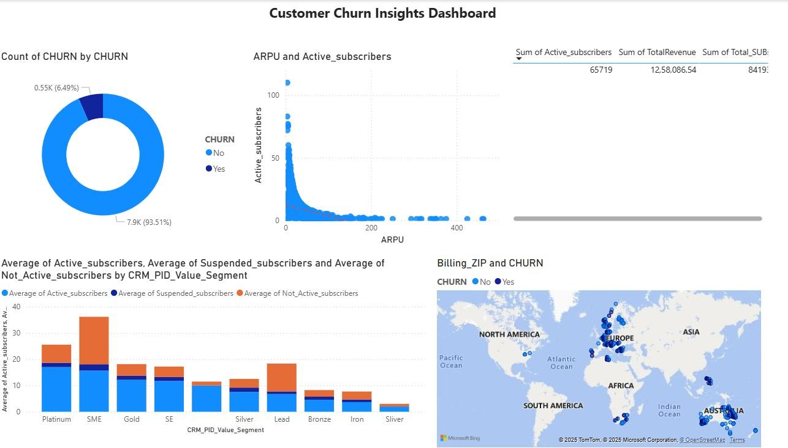
The cleaned dataset was exported from Colab and visualized in Power BI to uncover actionable business insights. The dashboard focuses on churn, active subscribers, revenue, location, suspended subscribers. This provides a clean, data-driven overview of various metrics.

Note: The Power BI file has also been shared in the uploaded folder for reference and offline access.

8.0 Deployment
For deployment, the churn prediction model has been implemented in a web-based interface, utilizing Gradio to make predictions from input data features about the customer's status. Here is the description of the deployment pipeline:
- Model Use: The LightGBM model, scaler, and features schema (both saved during training through joblib) were imported, aiming to maintain the same environment as at the training stage.
- Input: The provided app has included both categorical features (i.e., CRM segment, effective segment) and numerical parameters, including subscriber counts and revenuerelated ones. Billing_ZIP, AvgFIXRevenue, and KA_name were set by default based on the precleaned dataset to guarantee a complete entry.
- Features: Calculated (on the runtime) parameters (i.e., Activity_Ratio, Revenue_per_Subscriber, and Mobile_Revenue_Share) were applied. To prevent other values than those set, outliers were capped using IQR boundaries.
- Encoding and Scaling: All inputs were one-hot encoded and then reindexed to be aligned with the trained feature sets. Scaled data has been carried to the model for prediction.
- Output: The label component has been introduced in Gradio to show both-class probabilities of CHURN and NO CHURN from the model.
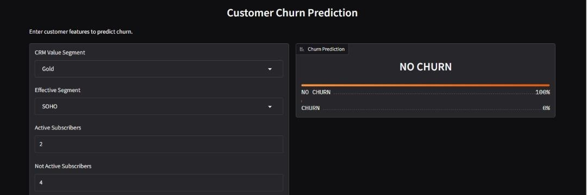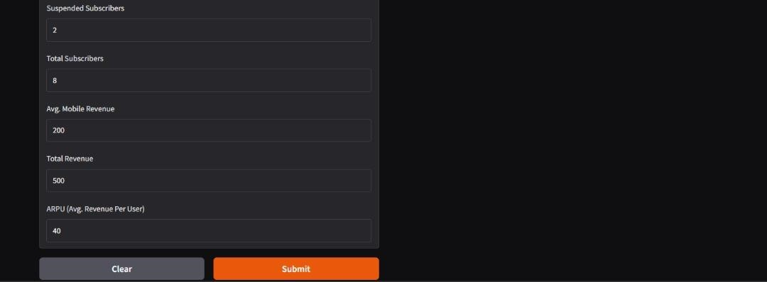

To run the Gradio application on public, URL: https://645e679a3d300339f6.gradio.live
Through the interface's capabilities, the business user can apply the risk of churn to any customer profile, pre-emptively retaining them. This deployment links the technical modelling solution with real-life use, making it easy to apply and use.

9.0 Conclusion

Business Recommendation and Insights
The analysis of telecom customer churn revealed several key behavioural patterns:
- Customers with shorter tenure and lower active subscriber counts are more likely to churn, indicating early dissatisfaction or lack of engagement.
- High ARPU (Average Revenue Per User) customers show slightly higher churn risk, suggesting that pricing sensitivity plays a role in retention.
- Inactive and suspended subscribers correlate strongly with churn — inactivity can be an early signal for potential customer loss.
- Revenue-related variables (AvgMobileRevenue, TotalRevenue) show right-skewed distributions; most customers generate moderate income, while a few produce extreme revenue values, which can distort retention prioritization if unadjusted.
- Class balance (≈ 6.5% churners vs 93.5% non-churners) indicates that churn is a rare but critical event that must be modelled with special care (e.g., class weighting).

Recommendations
- Target Early-Stage Customers: Implement personalized onboarding or loyalty programs for new users during their first months to reduce early churn.
- Monitor High-ARPU Clients: These customers are valuable yet churn-prone. Offer tailored incentives such as plan flexibility or usage-based discounts.
- Re-engage Suspended Accounts: Develop reactivation campaigns for temporarily suspended or inactive users (SMS, calls, email reminders).
- Predictive Monitoring Dashboard: Deploy a live churn-risk dashboard where each customer receives a churn probability score for proactive retention efforts.
- Automated Alerts for At-Risk Segments: Combine churn model output with CRM data to trigger automatic alerts when a customer’s engagement metrics drop below threshold levels.

Limitations and Future Work
- Data Limitations: The dataset represents a single period; additional time-series or demographic variables could improve accuracy.
- Model Scope: External factors such as market competition, service outages, or price changes were not included.
- Future Work:
- Extend modelling with temporal churn prediction (monthly sequences).
- Explore ensemble methods (e.g., XGBoost, LightGBM) and SHAP interpretability to explain churn reasons to management.
- Integrate cost-sensitive metrics (e.g., ROI of retention offers) to optimize campaign spending.

