Cyclistic: Navigating Speedy Success
  - A Data-Driven User Behavior Analysis, by Eleni Vasiliu

Executive Summary

Cyclistic’s long-term growth strategy focuses on converting casual riders into long-term annual members. To support this goal, this case study analyzes historical trip data to identify the distinct behavioral trends between these two user groups. The following insights provide a data-driven foundation for marketing strategies aimed at maximizing membership conversions.

The Core Insight
Annual Members and Casual Riders use Cyclistic for entirely different purposes. Our data reveals that Members are “Utility Riders” (commuters) while Casual Riders are “Leisure Riders” (sightseers and weekenders).

Key Findings
User Personas: “The Commuter” vs. “The Explorer”: The data reveals a stark contrast in how these two groups interact with the bike-share ecosystem:
- Annual Members (The Commuters):
  - Behaviour: Highly disciplined and utility driven.
  - Patterns: Peak activity occurs during weekday rush hours (8 AM – 5 PM)
  - Consistency: Trip durations remain remarkably stable (~12-13 minutes) year-round, regardless of weather or day of the week, suggesting fixed routes like office or school commutes.
- Casual Riders (The Explorers):
  - Behaviour: Leisure-oriented and weather-dependent.
  - Patterns: Usage peaks on weekends and during the afternoon (11 AM – 5 PM).
  - Elasticity: Trip durations are significantly longer (20-27 minutes) and highly seasonal, spiking in the summer months and nearly disappearing in the winter.

Business Task Statement
“How do annual members and casual riders use Cyclistic bikes differently?”

Data Source
Historical Trip Data: 5,552,994, observations with 13 fields.
- Source: Index of Divvy Trip Data, Made available by Motivate International Inc. under this licence.
- Data collection period: January 2025 - December 2025
- Relevance: Includes dates, times, routes, user demographics that provide insights to ridership.

Data Cleaning and Manipulation
To ensure the highest level of analytical accuracy, the raw dataset underwent a rigorous cleaning process using Python. This phase focused on removing "noise"—data points that do not represent intentional user behavior—to prevent skewed aggregations.
I. Handling "False Starts" and Accidental Unlocks
During the initial data audit, a subset of records showed a ride_length of less than one minute.
- The Logic: Trips lasting under 60 seconds are statistically unlikely to represent a functional transit or recreational journey. These typically occur when a user tests a bike's seat height, encounters a mechanical issue immediately after unlocking, or accidentally triggers the docking sensor.
- The Action: All trips with a duration of less than one minute were filtered out of the final analysis to ensure the average ride durations remained reflective of actual usage.
II. Removing Technical Anomalies
The dataset contained instances where the ‘ended_at’ timestamp preceded the ‘started_at’ timestamp, resulting in negative ride durations.
- The Logic: These represent system maintenance logs or technical synchronization errors rather than human trips.
- The Action: These records were purged to maintain the integrity of the temporal analysis.
III. Attribute Scoping & Feature Engineering
To optimize processing efficiency and uncover deeper behavioral insights, the following manipulations were performed:
- Geographic Stripping: Longitudinal and latitudinal data fields were dropped, as they were determined to be irrelevant to the core business task of comparing user frequency and duration.
- Temporal Extraction: New calculated fields for Day of Week, Day, Month, and Year were engineered from the ‘started_at’ timestamp. This allowed for the identification of the "Commuter Peak" versus the "Weekend Surge".
- Duration Calculation: A ‘duration’ attribute was created to quantify the exact intensity of each trip, by calculating the difference between ‘ended_at’ and ‘started_at’ timestamps, providing the basis for the "Duration vs. Frequency" findings.

Analysis Summary

Temporal Patterns: The Commuter vs. The Explorer
The Commuter Peak (Members): Member activity is heavily concentrated during standard weekday “Rush Hour” windows (7:00 AM – 9:00 AM and 4:00 PM to 6:00 PM). This suggests that members primarily use Cyclistic as a reliable utility for daily transit and work commutes.
The Weekend Surge (Casual Riders): Conversely, casual ridership is most active on Friday, Saturday, Sunday. Such trends are indicative of recreational utility.

Usage Intensity: Duration vs. Frequency
Frequency: Annual members demonstrate a higher frequency of trips, reinforcing their status as “power users” who integrate the service into their daily routines.
Duration: While members ride more often, casual riders travel 2x-3x longer per trip on average. This high duration suggests that casual riders are utilizing the bikes for sightseeing or longer weekend excursions, rather than quick point-to-point transit.

Environmental Impact: Seasonal Resilience
Climate Sensitivity: Casual ridership is highly volatile and tightly correlated with the Chicago climate. There is a significant drop-off in activity during late Q4 and Q1, suggesting that casual use is weather dependent.
Stability: Annual members show much higher Seasonal Resilience. Their ridership remains more stable during off-peak months, proving that membership is a strong predictor of year-round retention despite adverse weather.

Visualizations and Key Findings

Temporal Patterns: The Commuter vs. The Explorer
The time of day in which each user-type initiates their rides provides us information about the motive behind the user’s ridership. By plotting the frequency of the Hour of the ‘started_at’ field by day and user-type, we can gain valuable insight as to purpose of the rides being taken.

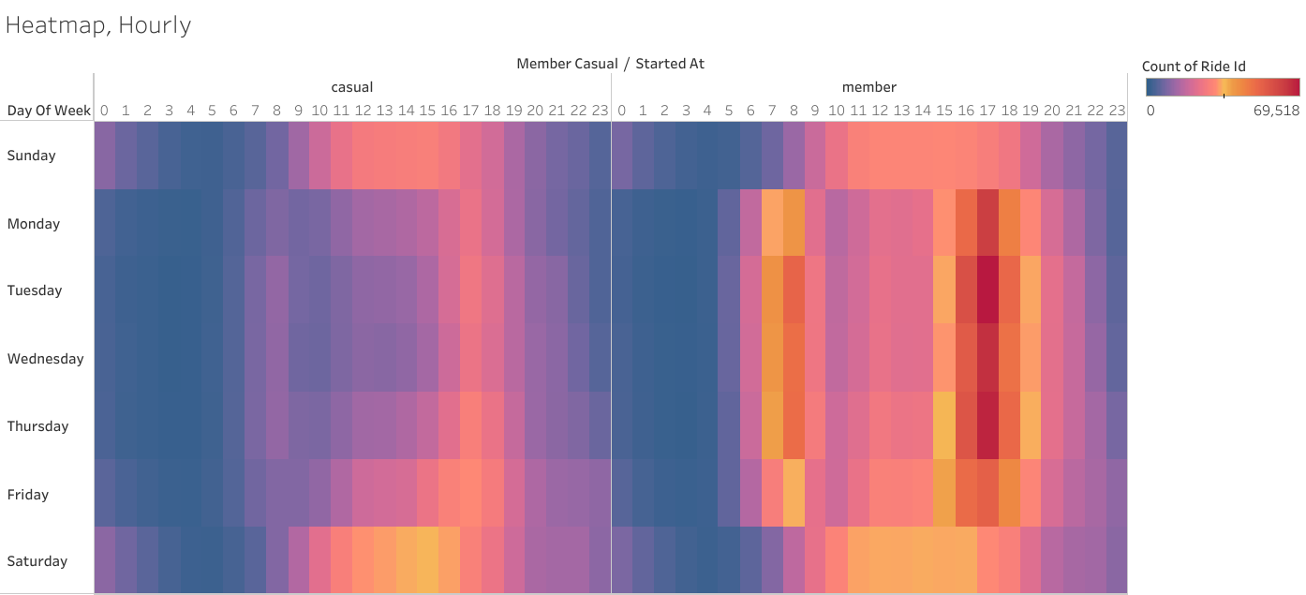
Members (The Commuters)
- The data reveals a higher frequency of Member rides surrounding “Rush Hour” times (7 AM – 9AM and 4PM – 6PM) on Weekdays (Monday – Friday).
- These hourly trends are indicative of members primarily utilizing the service for commuting purposes.
Casual Riders (The Explorers)
- Conversely, Casual riders have a higher frequency of rides in the mid-late afternoon (1 PM – 4 PM) on Weekends (Saturday, Sunday).
- This evidence suggests that the behaviour of Casual Riders is more leisure and recreational based.
The Opportunity: There is a significant “Commuter Gap” among Casual riders. By highlighting the health and efficiency benefits of biking, we can incentivize these users to integrate Cyclistic into their professional routines rather than just their weekend leisure.

Usage Intensity: Duration vs Frequency
Opposing trends are evident between the Members and Causal Riders in terms of Duration and Frequency. While Members appear to take a significantly higher number of rides than Casual Riders, their rides are comparatively shorter and more stable.
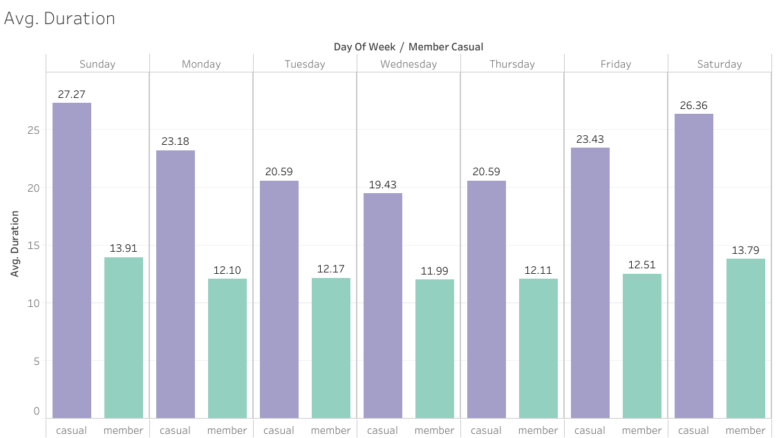
Duration
- Members maintain stable duration: Consistently ~12 minutes regardless of the day, this suggests they are traveling to specific destinations, rather than riding for fun.
- Casual riders sustain double the duration, with variability: Ranging between 20 -27 minutes, this evidence points to leisurely ridership, as opposed to point-to-point travel.
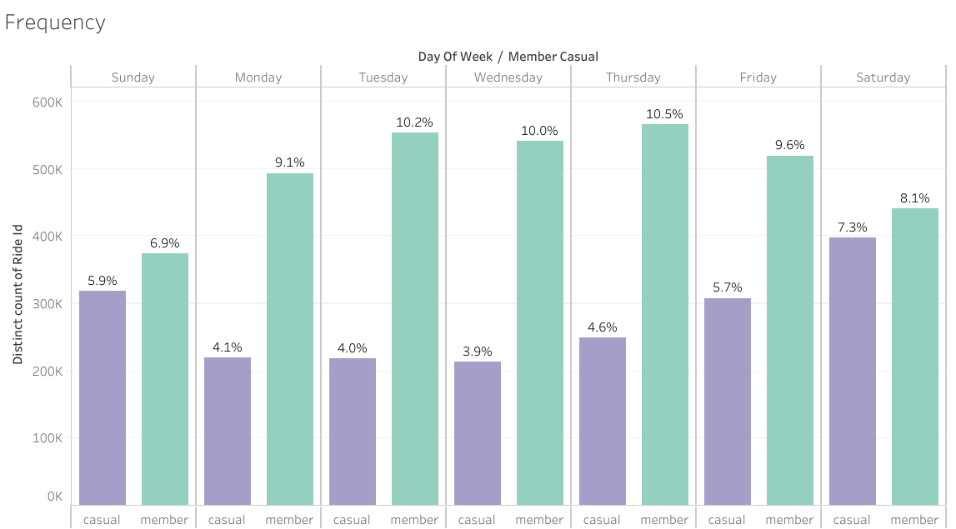
Frequency
- Members consistently surpass: Members take more rides than Casual riders every day of the week. Peak days are present from Tuesday – Thursday, reinforcing the work/school commute pattern.
- Casual Riders surge on weekends: Ride count dips to their lowest during the workweek, particularly from Monday – Wednesday. There exists a more gradual increase toward the Saturday peak day, on which volume nearly doubles.
The Opportunity: The distinct patterns in ride duration and frequency provide a framework for hyper-tailored marketing. By identifying the unique value drivers for each segment, we can implement a 'value-crossover' strategy. This aims to broaden user perspectives, encouraging members to embrace the service for leisure and casual riders to adopt it for utility.

Environmental Impact: Seasonal Resilience
This seasonality analysis reveals that while both user segments are affected by the weather, their commitment to the service varies drastically throughout the year.
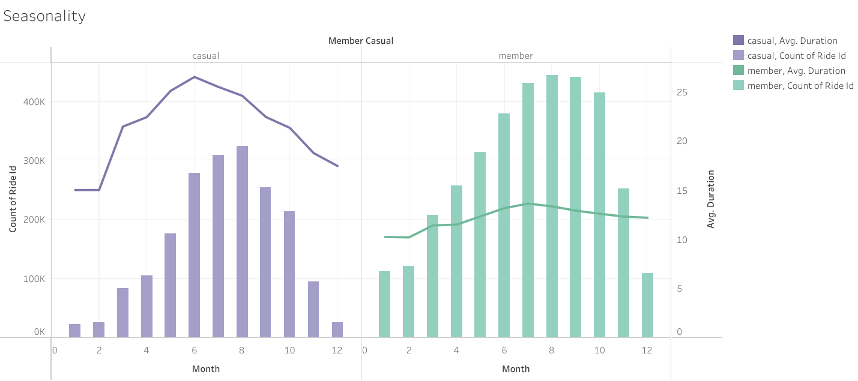
Members are Year-Round “Resilient” Commuters
- The Baseline: Even in the dead of winter (Months 1, 2, and 12), members are still taking roughly 100k rides per month. This reinforces the idea that members rely on these bikes for essential travel (work/school) and will ride even during un-ideal weather conditions.
- Peak Consistency: Similarly to Casual Riders, Member ride counts peak in August. However, their average duration (line) remains incredibly flat, only fluctuating between roughly 10 and 14 minutes. This proves that regardless of weather, members are generally traveling the same fixed distances.
Casual Riders are “Fair-Weather” Users
- Ride Count (Bars): Usage is almost non-existent in January and February, then explodes in the summer, peaking in August. The drop-off in November and December is equally sharp.
- Ride Duration (line): There exists an early and sharp rise in duration occurring in the warmer months, from approximately 15 minutes in January to over 25 minutes in June/July. This suggests summer casual riding is heavily recreational (e.g. sightseeing, park visits).
The Opportunity: In August, Casual ride counts reach their highest point (nearly 300k), yet they are still choosing not to be members. This suggests that the current membership model might feel too “permanent” or “commuter-focused” for someone who only wants to ride for 3 months of the year.

Strategic Recommendations
Based on these findings, the conversion strategy should focus on bridging the gap between “leisure” and “utility”

The “Wellness-at-Work” Initiative
Observation: Data indicates a significant “Commuter Gap”, where casual ridership is significantly lower during weekday morning and evening peaks (7:00 AM– 9:00 AM and 4:00 PM – 6:00 PM). Conversely, these users engage in long-duration weekend rides, suggesting they value biking for physical activity but have not yet integrated it into their professional routines.
Recommendation: “Trade the Train for a Lane” Campaign
- Launch a multi-channel marketing campaign positioned at the intersection of productivity and personal health. The campaign will incentivize casual riders to replace their stationary transit (trains/cars) with a dynamic bike commute.
- Value Proposition: Focus on the mental clarity, cardiovascular benefits, and “stress-free” nature of biking compared to congested public transit.
Tactical Execution:
- The “First Mile” Discount: Offer a 20% discount on Annual Memberships for users who complete at least three “Rush Hour” trips in a single work week.
- Health Tracking Integration: Partner with fitness apps (like Strava or Apple Health) to show casual riders how many calories they could burn by switching their daily commute to a Cyclistic bike.
- Corporate Partnerships: Target office hubs in downtown Chicago with “Bike to Work” week events, offering on-site sign-up bonuses for employees of partner companies.
Goal: To shift the perception of Cyclistic from a “Weekend Luxury” to a “Weekday Necessity”, specifically targeting health-conscious casual riders.

The “Flex-Pass” Framework (The Weekend & Seasonal Membership)
Observation: Data reveals that casual ridership is heavily concentrated on Friday, Saturday, and Sunday. Additionally, casual ridership drops off significantly in the colder months of Q4/Q1. Currently, these riders must purchase multiple single-ride or day passes, which creates a high-friction (and high-cost) user experience for consistent recreational riders.
Recommendation: Launch introductory tiers of subscriptions.
- “Weekend Warrior” Membership: This subscription would offer unlimited rides from Friday at 5:00 PM through Sunday at 11:59 PM.
- “Summer Surge” 3-month pass: Discounted membership that automatically rolls into a full Annual Membership to capture the Chicago summer surge.
Tactical Execution:
- The Conversion Credit: Allow users to “convert” the cost of a Saturday Day pass into a credit toward a Weekend Membership if they upgrade within 48 hours.
- Targeted In-App Notifications: Trigger a “Save More This Weekend” notification to casual riders once they hit their second “Long Duration” trip (30+ minutes) in a single weekend.
- Early-Bird Lock-In: Promote these flexible tiers in late February to secure users before the May weather warms up. Offer discounted “Early Bird” annual membership renewal or sign-up.
Goal: To capture the high-frequency recreational segment that is currently deterred by the high cost of daily passes but isn’t ready for a full 365-day commitment. This creates a recurring revenue stream from a previously volatile “casual” segment and builds brand loyalty that can eventually be nurtured into a full Annual Membership.

Duration Incentives: Cost Comparison Marketing
Observation: Descriptive statistics show that while Annual Members take frequent, short-utility trips, Casual Riders average 2-3x the trip duration of members. Under the current pay-per-trip or day-pass model, these “Long Duration” rides are paying a significant premium for their leisure and exploration. This represents a “price pain point” that can be leveraged to demonstrate the superior value of an annual subscription.
Recommendation: Implement a “Value Transparency” Marketing Campaign. This strategy uses personalized data to show casual riders their individual spending patterns and compares them directly to the “Unlimited” cost-savings of an Annual Membership.
Tactical Execution:
- The “Monthly Recap” Email: Send automated summaries to casual riders who have taken more than three long-duration trips in a 30-day period
  - Example: “You spent $48 on 3 rides this month. An annual membership would have cost you $0 for those same trips!”
- In-App “Savings Calculator”: Add a feature to the Cyclistic mobile app where a user can input their typical ride length and frequency to see their “Break-Even-Point” (the exact moment a membership becomes cheaper than individual passes).
- Tiered Milestone Rewards: Offer a “Long-Ride Credit”. If a casual rider completes a trip over 60 minutes, send a push notification: “That was a great ride! Apply today’s trip cost toward an Annual Membership in the next 24 hours.”
Goal: To trigger a “rational” conversion by moving the user’s focus from a per-use expense to a long-term investment. By proving that the membership pays for itself within just a few long rides, we remove the financial hesitation of the casual “Explorer” segment.

Conclusion: A Data-Driven Path to Growth
The analysis of over 5.4 million trips throughout 2025 confirms that while Annual Members and Casual Riders share the same infrastructure, they occupy two distinct behavioural ecosystems. Annual Members provide the reliable, year-round “base load” through disciplined commuting habits. In contract, Casual Riders represent a high-volume, high-duration “growth engine” that remains largely untapped by the current membership model.
By implementing the three refined strategies––The Wellness-at-Work Initiative, The Flex-Pass Framework, and Value Transparency Marketing––Cyclistic can effectively bridge the gap between leisure and utility.
Summary of Strategic Impact
- Routine Integration: Shifting the perception of the service from a “weekend luxury” to a “weekday necessity” creates consistent ridership during underutilized morning and evening peaks.
- Lowering Barriers: Introducing flexible weekend and seasonal tiers captures the high-frequency recreational segment that is currently deterred by the perceived “permanence” of a 365-day commitment.
- Financial Rationalization: Using personalized “Value Transparency” data moves the user from a high-friction, per-use expense to a low-friction long-term investment.
Ultimately, these recommendations do not just aim to sell more passes; they are designed to expand the user’s perspective and integrate Cyclistic into the fabric of their daily lives. By evolving the membership structure to match the diverse ways people actually ride, Cyclistic will secure the recurring revenue necessary for its next phase of speedy success.

Appendix: Technical Documentation

Data Processing Script (Python)
The following script was developed to aggregate, clean, and transform the raw Cyclistic trip data from January 2025 through December 2025. The primary objective of this code was to ensure data integrity by removing outliers and to perform feature engineering for temporal analysis.
Key Operations Performed:
- Data Aggregation: Concatenated twelve individual monthly dataframes into a single unified dataset.
- Attribute Scoping: Removed irrelevant geographic data (latitude/longitude) to optimize processing speed.
- Feature Engineering: Extracted day_of_week, day, month, year, and hour from timestamps to identify user patterns.
- Duration Calculation: Engineered a ride_length variable to quantify trip intensity.
- Data Sanitization: Filtered out trips lasting less than one minute to exclude "accidental" bike unlocks.

# 1. Load and Combine Data
data_path = 'C:/Users/vasil/OneDrive/Documents/Capstone_Cyclistic/2025_raw_data_csv/'
files = ['202501-divvy-tripdata.csv','202502-divvy-tripdata.csv','202503-divvy-tripdata.csv',
'202504-divvy-tripdata.csv','202505-divvy-tripdata.csv','202506-divvy-tripdata.csv',
'202507-divvy-tripdata.csv','202508-divvy-tripdata.csv','202509-divvy-tripdata.csv',
'202510-divvy-tripdata.csv','202511-divvy-tripdata.csv','202512-divvy-tripdata.csv']
trips_2025 = pd.concat([pd.read_csv(os.path.join(data_path, f)) for f in files])

# 2. Data Cleaning
# Drop irrelevant geographic columns
trips_2025 = trips_2025.drop(columns=['start_lat','start_lng','end_lat','end_lng'],
errors='ignore')

# 3. Feature Engineering
# Convert to datetime
trips_2025['started_at'] = pd.to_datetime(trips_2025['started_at'])
trips_2025['ended_at'] = pd.to_datetime(trips_2025['ended_at'])

# Calculate duration in minutes
trips_2025['duration'] = ((trips_2025['ended_at'] - trips_2025['started_at']).dt.total_seconds())/60

# Extract temporal components
trips_2025['date'] = trips_2025['started_at'].dt.date
trips_2025['day'] = trips_2025['started_at'].dt.day
trips_2025['month'] = trips_2025['started_at'].dt.month
trips_2025['year'] = trips_2025['started_at'].dt.year
trips_2025['day_of_week'] = trips_2025['started_at'].dt.day_name()

# Label the values in the day_of_week field
days_order = ['Sunday','Monday','Tuesday','Wednesday','Thursday','Friday','Saturday']
trips_2025['day_of_week'] = pd.Categorical(trips_2025['day_of_week'],
categories=days_order,
ordered=True)
# 4. Filter Outliers
trips_2025_v2 = trips_2025[(trips_2025['duration'] > 1)].copy()

# 5. Export for Visualization
trips_2025_v2.to_csv('divvy_trips_2025.csv', index=False)

