SS. CYRIL AND METHODIUS UNIVERSITY IN SKOPJE, FACULTY OF COMPUTER SCIENCE AND ENGINEERING

MULTI-AGENT REINFORCEMENT LEARNING FOR AUTONOMOUS VEHICLE COORDINATION AT AN INTERSECTION
A comparison of heuristic, independent (IQL), and centralized-training (VDN) learning

Project work for the course Agent-Based Systems

Author: Vasilka Jugova
Mentor: Sonja Gievska, Martina Toshevska

SKOPJE, 2026

Table of Contents
1. Abstract 3
2. Introduction 4
3. Related Work 6
4. Description of the Agent, Methods, and Experimental Results 8
5. Results 16
6. Additional Study: Observation Modes 26
7. Conclusion 28
References 29

1. Abstract
At a signal-free intersection, where autonomous vehicles share the road with human-driven ones, every decision one vehicle makes immediately carries over to the safety of everyone else. This is a classic challenge for multi-agent reinforcement learning under partial observability, where safety and efficiency frequently conflict. This project compares three approaches to that problem: a rule-based heuristic, Independent Q-Learning (IQL), and Value Decomposition Networks (VDN, a CTDE method), on the intersection-v2 scenario from the highway-env library. For the comparison to be possible at all, a dedicated environment wrapper was developed that decomposes the shared reward per agent and adds a shaping term for courteous behavior toward human-driven vehicles.
Results across five independent seeds, confirmed with a formal statistical test, show that IQL and VDN achieve a statistically indistinguishable mean reward per agent, but with different profiles: VDN trends toward fewer collisions, while IQL trends toward a higher successful-arrival rate. With n=5 seeds, only the difference in episode length, where VDN runs significantly longer, reaches conventional statistical significance. Additional ablation studies reveal a sensitivity of the results to the collision-penalty weight and the discount factor, as well as a sharp performance drop across all methods as the number of controlled vehicles increases. The findings suggest that the choice between independent and centrally-trained multi-agent learning is not a question of which method is absolutely better, but of what trade-off is acceptable for the specific application. Built on a clearly defined wrapper and reproducible experiments, the approach transfers directly to other multi-agent scenarios with partial observability.
*Keywords: multi-agent reinforcement learning, Value Decomposition Networks, Independent Q-Learning, intersection coordination, highway-env*

2. Introduction

2.1 Problem and Context
Autonomous vehicles are increasingly expected to share road infrastructure with conventional, human-driven vehicles during the transition period toward full automation. Intersections without traffic lights, or with traffic lights that are not coordinated with the vehicles, are especially challenging scenarios, because multiple vehicles must make real-time decisions (when to slow down, when to speed up) within a shared, dynamic environment, where one vehicle’s decision affects the safety and flow of all the others. Unlike classical single-agent highway scenarios (lane-following, overtaking), an intersection demands multi-agent reasoning, since every vehicle is simultaneously both a participant in, and an influence on, the environment of all the others.

2.2 Research Question
The central research question of this project is whether agents trained with CTDE (Centralized Training, Decentralized Execution, specifically VDN) achieve a better trade-off between safety (collision rate) and efficiency (successful-arrival rate, average steps to destination), compared with Independent Q-Learning (IQL) and a rule-based baseline, in a mixed-traffic intersection scenario.

2.3 Motivation
The question is relevant for two reasons. Theoretically, IQL is the simplest approach to MARL, in which each agent learns independently, treating the other agents as part of a non-stationary environment [4]. VDN is an early and structurally simple value-factorisation approach compatible with the centralized-training, decentralized-execution paradigm [5]. Comparing the two tests whether a centralized TD target carries a practical advantage when execution in both approaches is nonetheless decentralized. Practically, highway-env [7], the simulation environment used in this project, has no built-in support for individual per-agent rewards in a multi-agent setting, nor any built-in CTDE methods; that gap had to be closed to make the comparison possible at all, which is itself an engineering contribution. The result is a reusable foundation, open to further research in the same direction.

2.4 Contributions
This project makes four concrete contributions:
1. A wrapper around highway-env (envs/multi_agent_intersection.py) that decomposes the normally shared (cooperative) reward into individual per-agent rewards, by reaching into highway-env’s internal _agent_reward() function; without this, comparing IQL and CTDE approaches would not have been possible.
2. A from-scratch implementation of VDN (agents/vdn_agent.py), with a dueling architecture and per-agent target masking, where each agent masks only its own bootstrap term with 1 - done_i, instead of a single shared flag that would incorrectly zero out the bootstrap for the entire team as soon as one agent finishes.
3. An additional shaping term for courteous behavior (called “courtesy” in the code) toward human-driven vehicles, added because highway-env does not account for this in the reward by default.
4. The discovery and correction of a reward-accounting bug (Sections 4.2 and 5.7), followed by a multi-seed comparison with 95% confidence intervals, a formal statistical test, and three additional ablation studies (reward weighting, scalability, hyperparameters).

2.5 Relation to Related Work and Report Structure
Every component used in this project, DQN [1] and its variants [2], [3], IQL [4], VDN [5], originates from already established literature, reviewed in detail in Chapter 3. The project’s contribution is an applied, methodologically careful comparison of existing algorithms in a specific multi-agent scenario (mixed traffic, partial observability, a courtesy shaping term), followed by the discovery and correction of a methodological error that affects the main finding. The rest of the report is organized so that Chapter 3 reviews the related work, Chapter 4 describes the environment, the agents, and the experimental design, Chapter 5 presents and discusses the results with Kinematics observations, Chapter 6 presents an additional study with Pixels/Fusion observations, and Chapter 7 concludes.

3. Related Work

3.1 The Single-Agent Deep Q-Learning Family
The foundation of every RL agent in this project (agents/networks.py, agents/dqn_agent.py) is the Deep Q-Network (DQN) architecture of Mnih et al. [1], which first showed that function approximation with a deep neural network can stably replace the tabular Q-function in scenarios with high-dimensional observations, exactly the case for the Kinematics observations (a 7N-dimensional vector) in this project, where the tabular methods covered earlier in the course (Value/Policy Iteration) do not apply. Built on top of DQN, the project uses two standard extensions: Double DQN by van Hasselt et al. [2], which reduces overestimation bias by decoupling the selection and evaluation of the next action between the online and target network (used in IQL, agents/iql_manager.py), and the dueling network architecture of Wang et al. [3], which decomposes the Q-value into a state-value and an advantage component (DuelingQNetwork in agents/networks.py, also used in VDN).

3.2 Independent Q-Learning and Non-Stationarity
Independent Q-Learning (IQL) is a straightforward approach to multi-agent reinforcement learning in which each agent learns its own value function independently from its local observations and experience. During learning, the other agents are effectively treated as part of the environment. However, because other agents may simultaneously update their policies, the environment can appear non-stationary from the perspective of each individual agent. This is a fundamental challenge in multi-agent reinforcement learning [4]. This setting is implemented in this project through agents/iql_manager.py, where each agent is a fully independent DQNAgent with no coordination.

3.3 CTDE: Value Decomposition Networks and QMIX
Sunehag et al. [5] introduce Value Decomposition Networks (VDN), which address coordination and credit-assignment difficulties associated with independent learning by learning a factored representation of a shared team value function during centralized training, without requiring fully centralized execution, unrealistic for vehicles that in practice lack perfect mutual communication. The team’s joint Q-function is decomposed as a simple sum of individual Q-functions, Q_tot = Σ Q_i, trained centrally on the shared reward but executed in a decentralized manner (each agent decides based only on its own local observation). The project implements this idea in agents/vdn_agent.py. QMIX extends the additive value decomposition used by VDN by employing a non-linear mixing network subject to a monotonicity constraint, thereby providing greater representational flexibility while preserving decentralized action selection [6]. In this project VDN was deliberately chosen over QMIX, because it is sufficient to illustrate the CTDE idea clearly at a level appropriate for the course, without a complexity that would be difficult to explain within the project’s scope (a comparison with QMIX is proposed as future work, Section 5.10).

3.4 Simulation Environments and MARL for Autonomous Intersections
highway-env [7] is a widely used, lightweight simulation environment for tactical decision-making in autonomous vehicles, with multiple scenarios (highway, intersection, parking, roundabout) and built-in kinematic bicycle dynamics plus IDM/MOBIL models for the human-driven vehicles, used in this project through the intersection-v2 scenario. Coordinating signal-free intersections has a longer tradition that predates deep learning; Dresner and Stone [8] proposed the classic Autonomous Intersection Management (AIM) reservation protocol, in which vehicles reserve space-time slots with a centralized intersection manager, a fundamentally different approach (explicit coordination rather than a learned policy) from the RL-based methods in this project. More recent work applies MARL to similar scenarios. Guillen-Perez and Cano [10] use multi-agent deep RL to manage connected autonomous vehicles at intersections, with throughput improvements over traditional signaling, while a broader survey of MARL approaches for connected and automated vehicles, including intersections, lane-changing, and merging, is given by Yadav et al. [9].

3.5 Positioning of This Project
The project does not introduce a new algorithm relative to Sections 3.1-3.4. The difference lies elsewhere. The reward here is explicitly decomposed per agent around highway-env [7]. Although highway-env provides a multi-agent intersection setting, it does not directly provide the per-agent reward decomposition or a CTDE training mechanism required for the comparison performed in this project; these components therefore had to be implemented through a custom wrapper and agent architecture, unlike most MARL libraries such as SMAC, where QMIX was originally evaluated [6]. The courtesy shaping term is likewise original, a penalty proportional to proximity to a human-driven vehicle, active only above a speed threshold, an issue none of the reviewed works explicitly addresses in this way. Probably the most significant difference is methodological: the discovery and correction of a specific reward-accounting bug (4.2/5.7) that directly changes the interpretation of the results, a kind of transparency rarely documented in the reviewed literature on MARL for intersections.

4. Description of the Agent, Methods, and Experimental Results

4.1 Problem Formalization: MDP → Markov Game
Each individual vehicle is first defined as a standard single-agent MDP (S, A, P, R, γ) (report/mdp_formalization.md):
Table 4.1. State space (per vehicle in the observation)
Feature | Description | Range (before normalization)
presence | whether the vehicle is present | {0, 1}
x, y | relative position (w.r.t. the ego vehicle) | [-100, 100] m
vx, vy | relative velocity | [-15, 15] m/s
cos_h, sin_h | orientation | [-1, 1]
Each agent observes 6 vehicles (itself and the 5 nearest), normalized to [-1,1] and flattened into a obs_dim = 42 vector. This is a continuous, high-dimensional state, so unlike the tabular MDP scenarios covered earlier in the course, a tabular Q-function or an explicit P(s'|s,a) is not applicable here, which motivates the shift to function approximation (the DQN family, Section 3.1).
The action space has three discrete actions: SLOWER (index 0, decreases target speed), IDLE (index 1, maintains the current speed), and FASTER (index 2, increases target speed).
The reward, before the wrapper described in Section 4.2, is R(s,a) = w_c*1[collision] + w_v*clip(speed,0,1) + w_a*1[arrived], with w_c=-5, w_v=1, w_a=2, γ=0.95. The transition function is not explicitly available (a model-free setting: highway-env internally simulates the dynamics via a kinematic bicycle model and IDM/MOBIL for the human-driven vehicles).
Once num_agents = k > 1, the problem becomes a Markov Game (S1..k, A1..k, P, R1..k, γ), where each agent observes only its own s_i (partial observability), the joint action a=(a1,...,ak) affects the transition for everyone, and R_i(s,a) must be individual per agent. highway-env returns only a single shared reward by default, which is exactly where the wrapper described in Section 4.2 comes in.

4.2 Environment: the MultiAgentIntersectionEnv Wrapper
The architecture of the whole system is shown in Figure 1.
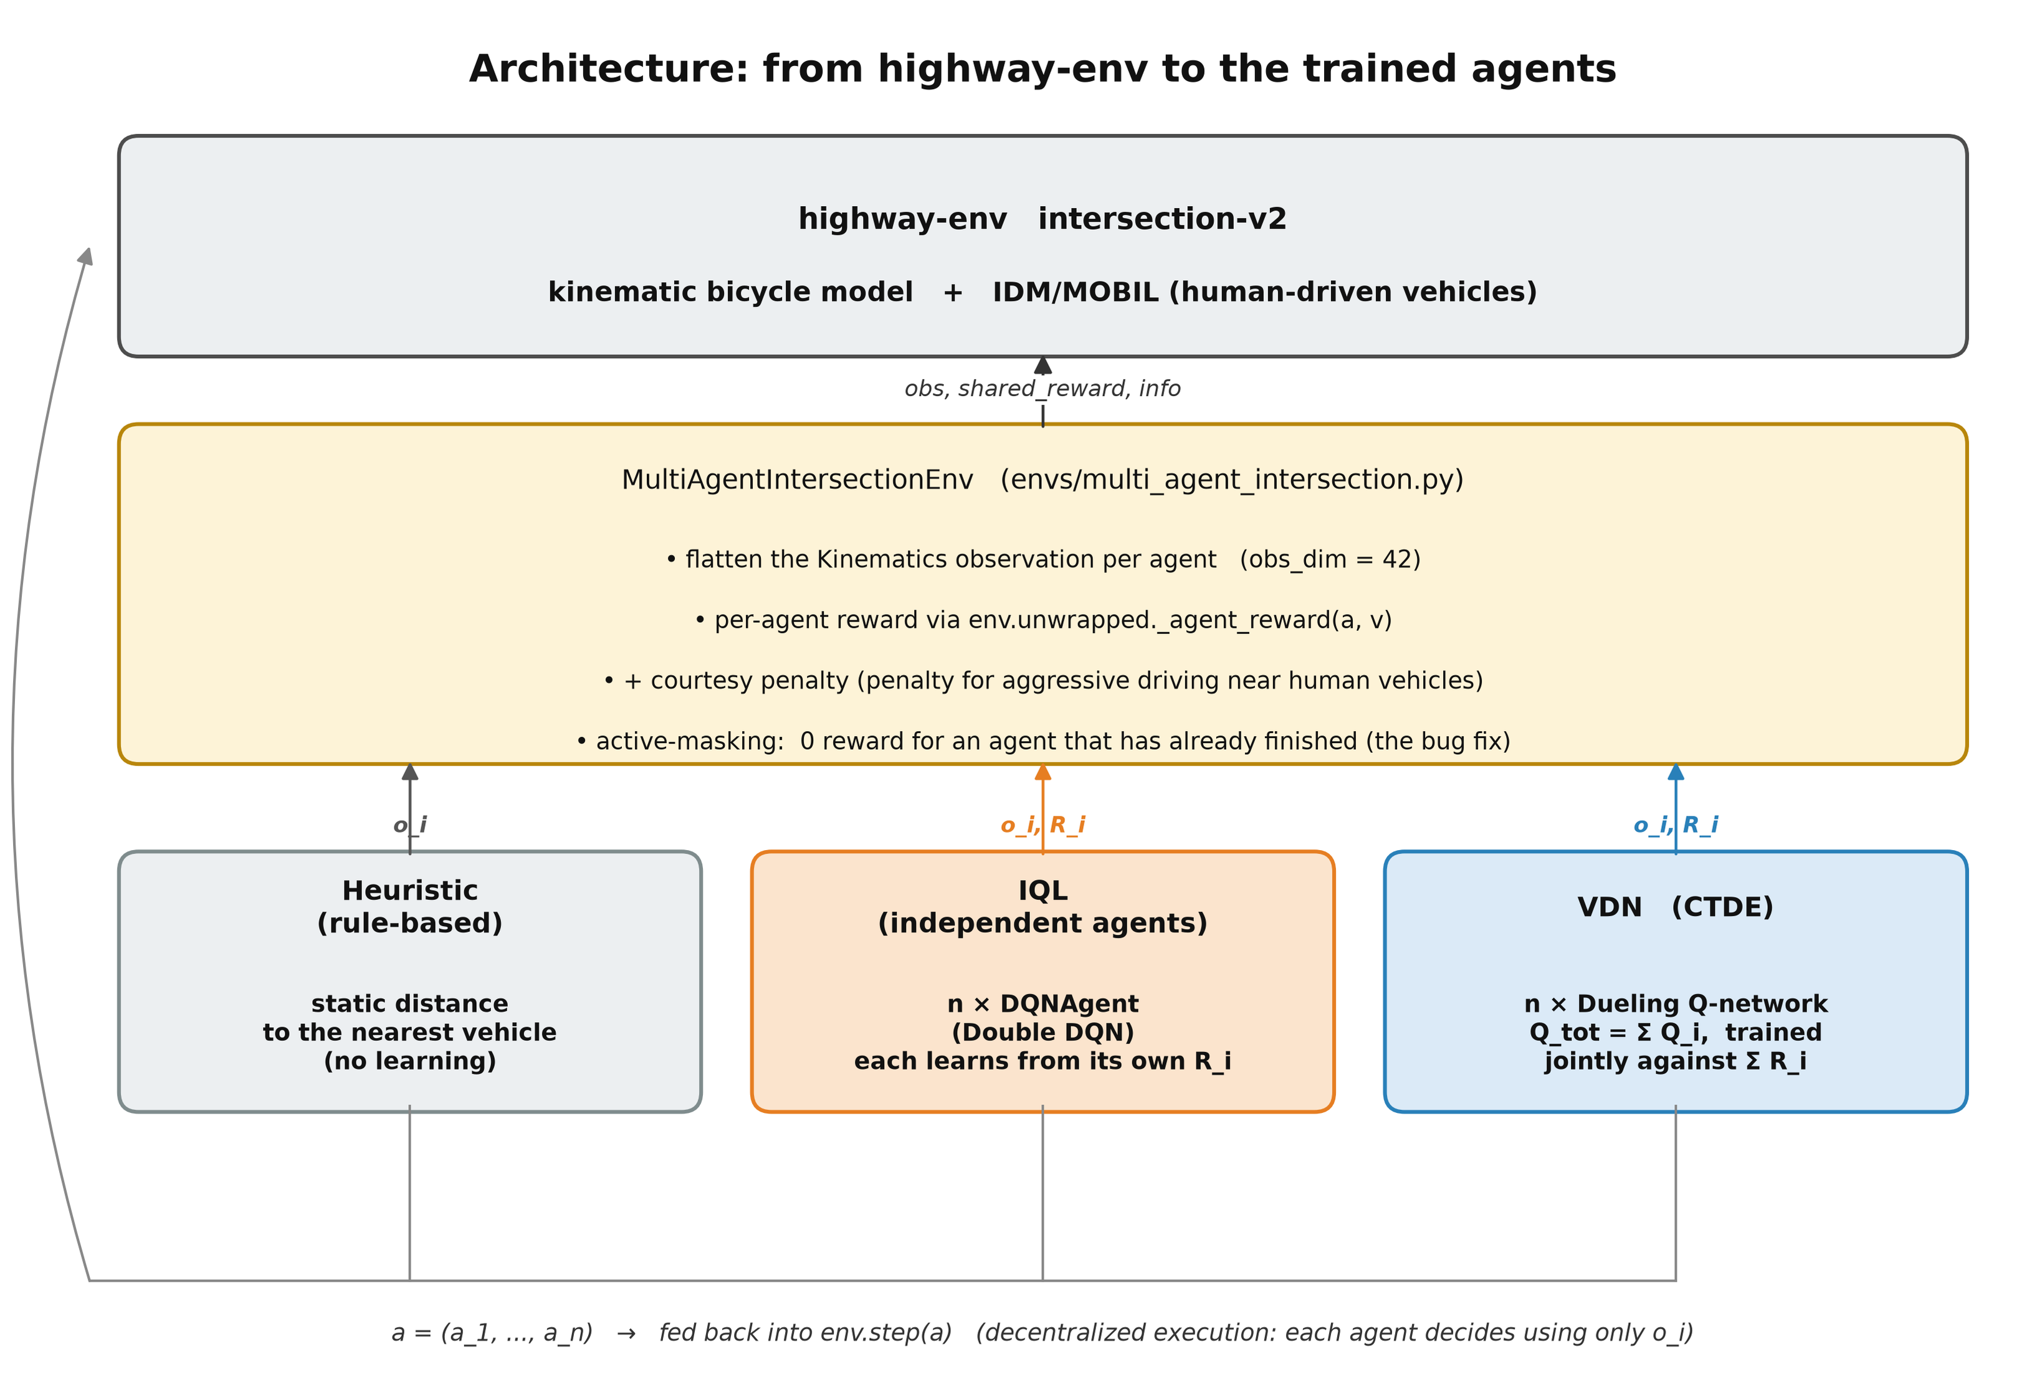
Figure 1. Architecture, from highway-env to the trained agents (diagram created for this project).
Table 4.2. Environment configuration (DEFAULT_CONFIG)
Parameter | Value | Note
initial_vehicle_count | 8 | total vehicles at the start
spawn_probability | 0.6 | probability of a new human-driven vehicle per step
duration | 20 s | deliberately short, for a fast training cycle
collision_reward | -5 | varied in the ablation, Section 5.2
high_speed_reward | 1
arrived_reward | 2 | source of the reward-leakage bug, see below
vehicles_count (per obs) | 6 | itself and the 5 nearest
actions | 3, longitudinal only | lane changing disabled (fixed lanes)
The wrapper (envs/multi_agent_intersection.py) solves three problems that highway-env does not support by default. First, it provides a per-agent reward, by calling the internal env.unwrapped._agent_reward(a, v) separately for each controlled vehicle. Second, it adds a courtesy shaping term, R'_i = R_i - w_courtesy*max(0, 1 - d_min/D)*1[v_i > v_thresh] (default D=12m, v_thresh=6 m/s), which penalizes driving aggressively close to human-driven vehicles. Third, it flattens the observation into a vector.
Reward-accounting bug. highway-env only ends the whole team episode once all controlled vehicles finish (either crash or arrive) or as soon as any one of them crashes, but has_arrived() is not a one-time event: it returns True on every subsequent step once a vehicle has passed the arrival point (the lane is straight, there is no going back). As a result, _agent_reward() returns arrived_reward=+2 on every remaining step while that agent waits for its teammates, not just once. Measured empirically on actually trained models, about 30% of the total accumulated reward for VDN and about 15% for IQL came directly from this effect, asymmetrically between the methods (since VDN episodes run longer on average, Table 5.1, avg_steps, the already-finished agents accumulate more “free” steps under VDN). This could have significantly distorted the initial interpretation that VDN achieves a higher reward than IQL. The fix is that self._active tracks which agents have not yet finished, and the reward for an already-finished agent is forced to 0 on every subsequent step (Table 4.3 summarizes all the bugs found and fixed).
Table 4.3. Methodological bugs discovered and fixed during the project
Bug | Where | Effect before the fix | Regression test
Reward leakage after arrival | MultiAgentIntersectionEnv.step() | +30% (VDN) / +15% (IQL) “leaked” reward, asymmetric | TestLeakedRewardFix
VDN any_done target masking | VDNAgent.train_step() | a shared done flag zeroed the bootstrap for the entire Q_tot as soon as one agent finished | TestVDNAgentTargetMasking
Train/eval “freeze” asymmetry | evaluate.py | evaluate.py had no IDLE freeze for already-finished agents, train.py did | (fixed before the tests)
A test with no cleanup on failure | tests/test_core.py | a test that fails partway through leaves incomplete result files behind | TestRunTrainingTag

4.3 Agents
Heuristic (agents/heuristic_agent.py) is learning-free: it looks at the Euclidean distance to the nearest vehicle and applies two thresholds (danger_distance=0.15 normalized, about 15m), returning SLOWER below half the threshold, IDLE below the threshold, and FASTER otherwise. It deliberately does not use relative velocity or time-to-collision, so that it stays a simple, interpretable baseline against the RL policies, which are inherently harder to interpret directly.
The building blocks (agents/networks.py) include QNetwork (MLP, 2×128 ReLU) and DuelingQNetwork (Q(s,a)=V(s)+(A(s,a)-mean_a A(s,a))); ReplayBuffer and MultiAgentReplayBuffer are implemented with a Python list and a circular index instead of a deque, for O(1) random access during sample(), important since train_step() is called on every step.
DQNAgent (agents/dqn_agent.py) uses ε-greedy exploration, Huber (SmoothL1) loss, gradient clipping (max_norm=10), and optional Double DQN, where the online network selects the next action and the target network evaluates it, which reduces overestimation bias [2].
IQLManager (agents/iql_manager.py) contains n fully independent DQNAgent instances (Double DQN=True), each with its own replay buffer; each agent treats the other vehicles purely as part of the non-stationary environment [4].
VDNAgent (agents/vdn_agent.py) contains n Dueling Q-networks (no shared weights), trained through a joint Q_tot=Σ Q_i and target_tot = Σ_i[r_i + γ*max_a Q_i'(next)*(1-done_i)] (per-agent target masking, Table 4.3), a single shared Adam optimizer, and Huber loss, because of the larger magnitude of the summed Q_tot.

4.4 Training/Evaluation Protocol
ε decays geometrically so that it reaches ε_min=0.05 around target_fraction=0.7 of training (compute_epsilon_decay, scaled automatically with the number of episodes); the target network is updated every 10 episodes. Seeding uses np.random.seed and torch.manual_seed, while evaluation always uses seed + EVAL_SEED_OFFSET(=1 000 000) so it never overlaps with the training seeds. An already-finished agent “freezes” on IDLE instead of continuing with ε-greedy exploration. The whole study (5 seeds × 3 methods for the main comparison, plus 3 ablation studies) is parallelized through experiments/parallel.py (ProcessPoolExecutor, torch.set_num_threads(1) per worker, so the processes do not compete for the same cores).

4.5 Definitions of the Evaluation Metrics
Before the results (Chapter 5), it is necessary to precisely define exactly what collision_rate and arrival_rate (evaluate.py) measure, since the two are computed at different levels, episode versus agent.
Collision rate (collision_rate) is the fraction of evaluation episodes in which at least one controlled agent crashed during the episode. It is a binary, per-episode indicator, not per-agent and not per-step. An episode with one crashed agent contributes the same as an episode with all agents crashed.
Arrival rate (arrival_rate) is the average per-episode fraction of agents that successfully reached their destination by the end of the episode, averaged across all evaluation episodes. For each episode, the number of agents that arrived is divided by the total number of agents, and that fraction is then averaged over the episodes.
An agent that, by the end of the episode, neither arrived nor crashed (shown with status “DONE” in watch.py) counts toward neither counter. This outcome arises in two cases: the episode duration (duration=20s) expired while the agent was still driving, or, more importantly, highway-env ends the entire team episode as soon as any controlled vehicle crashes, not just that vehicle, so the remaining active agents in that episode become neutral, with no chance to arrive.
Table 4.4. Possible per-agent outcomes by the end of the episode
Outcome | Affects collision_rate? | Affects arrival_rate?
The agent itself crashed | Yes, the episode counts as “had a collision” | No
The agent itself arrived | No (unless a teammate crashed) | Yes
Neither (timeout, or the episode ended due to a teammate’s crash) | Only if another agent crashed in the same episode | No
This second possibility explains why collision_rate and arrival_rate are not simply related. One agent’s crash also ends the episode for its teammates, so fewer agents actually get to arrive in episodes with a collision, even if they themselves did not crash. For example, a collision_rate of 65% (Table 5.1, heuristic) does not mean 65% of agents crashed, but that in 65% of episodes at least one of the three agents crashed, which typically also cuts short the chances of the other two in that same episode.

4.6 Experimental Design
Table 4.5. The four experimental studies
Study | Methods | seeds | train / eval ep. | Varied parameters
Main comparison | heuristic, IQL, VDN | 0-4 (n=5) | 1500 / 150 | - (num_agents=3)
Reward ablation #1 | VDN | 0-2 (n=3) | 800 / 80 | collision_reward ∈ {-5,-10,-15,-25}
Reward ablation #2 | VDN | 0-2 (n=3) | 800 / 80 | courtesy_weight ∈ {0, 1, 3}
Scalability | heuristic, IQL, VDN | 0-2 (n=3) | 800 / 80 | num_agents ∈ {2,3,4,5}
Hyperparameters (one-at-a-time) | VDN | 0-2 (n=3) | 800 / 80 | lr∈{3e-4,1e-3,3e-3}, γ∈{.90,.95,.99}, eps_frac∈{.5,.7,.9}
The hyperparameter study is deliberately one-at-a-time, not a full grid of 27 combinations, and covers only VDN, a reasonable trade-off for the project’s scope, but with no guarantee that the globally optimal combination was found, since interaction effects are possible.

4.7 Testing
The test suite (tests/test_core.py, 34 tests, approximately 24 seconds) is organized following the structure of Ammann and Offutt, *Introduction to Software Testing* (ISP, graph, logic/MC-DC, and boundary coverage):
Table 4.6. Test categories
Category | Classes | No. | Example
Building blocks | TestReplayBuffer, TestMultiAgentReplayBuffer, TestEpsilonDecay, TestDQNAgent | 8 | capacity wraparound, double-DQN target != vanilla target
Boundary / MC-DC | TestCourtesyPenalty, TestHeuristicAgent | 12 | boundary exactly at courtesy_distance: no penalty
Regression (bug-specific) | TestLeakedRewardFix, TestVDNAgentTargetMasking, TestPerAgentRewardsDiffer | 3 | reward is 0 after finishing; VDN stable with partially-finished agents
Integration | TestMultiAgentIntersectionEnvIntegration | 2 | reset/step contract through a real highway-env
Infrastructure | TestAggStats, TestMakeManagerAgentKwargs, TestRunTrainingTag | 6 | agg_stats([]) deliberately raises an error; unique paths per tag
Reproducibility / resource-safety | TestSeedReproducibility, TestEnvClosedOnException | 3 | seed also covers the random module (not just numpy/torch); env.close() is always called, even on an exception

4.8 Tools and Technologies
The project is built in Python 3.14, with PyTorch (CPU) as the core deep-learning framework. The simulation environment relies on highway-env 1.12.1 and gymnasium 1.3.0, whose versions are deliberately pinned tightly in requirements.txt, since the wrapper calls internal highway-env methods that can easily change between versions. Result visualization uses matplotlib, which produced the nine figures and the architecture diagram in this report. Experiment parallelization is handled by multiprocessing and ProcessPoolExecutor, while the formal statistical testing (experiments/significance_test.py) relies on scipy. The visual demonstration (watch.py) uses Pillow and pygame-ce.

5. Results

5.1 Main Comparison
The metric definitions are given in Section 4.5; keeping that in mind matters, otherwise the collision rate can look alarming without context.
Table 5.1. Heuristic vs IQL vs VDN (mean ± 95% CI across 5 seeds, comparison_summary.json)
Method | Reward | Collision Rate | Arrival Rate | Average Steps
Heuristic | 4.69 ± 0.03 | 64.7% ± 0.4pp | 34.4% ± 0.2pp | 9.17 ± 0.04
IQL | 5.96 ± 0.17 | 57.6% ± 4.4pp | 49.5% ± 2.7pp | 8.33 ± 0.28
VDN | 5.76 ± 0.32 | 51.5% ± 2.3pp | 43.9% ± 7.4pp | 10.76 ± 0.87
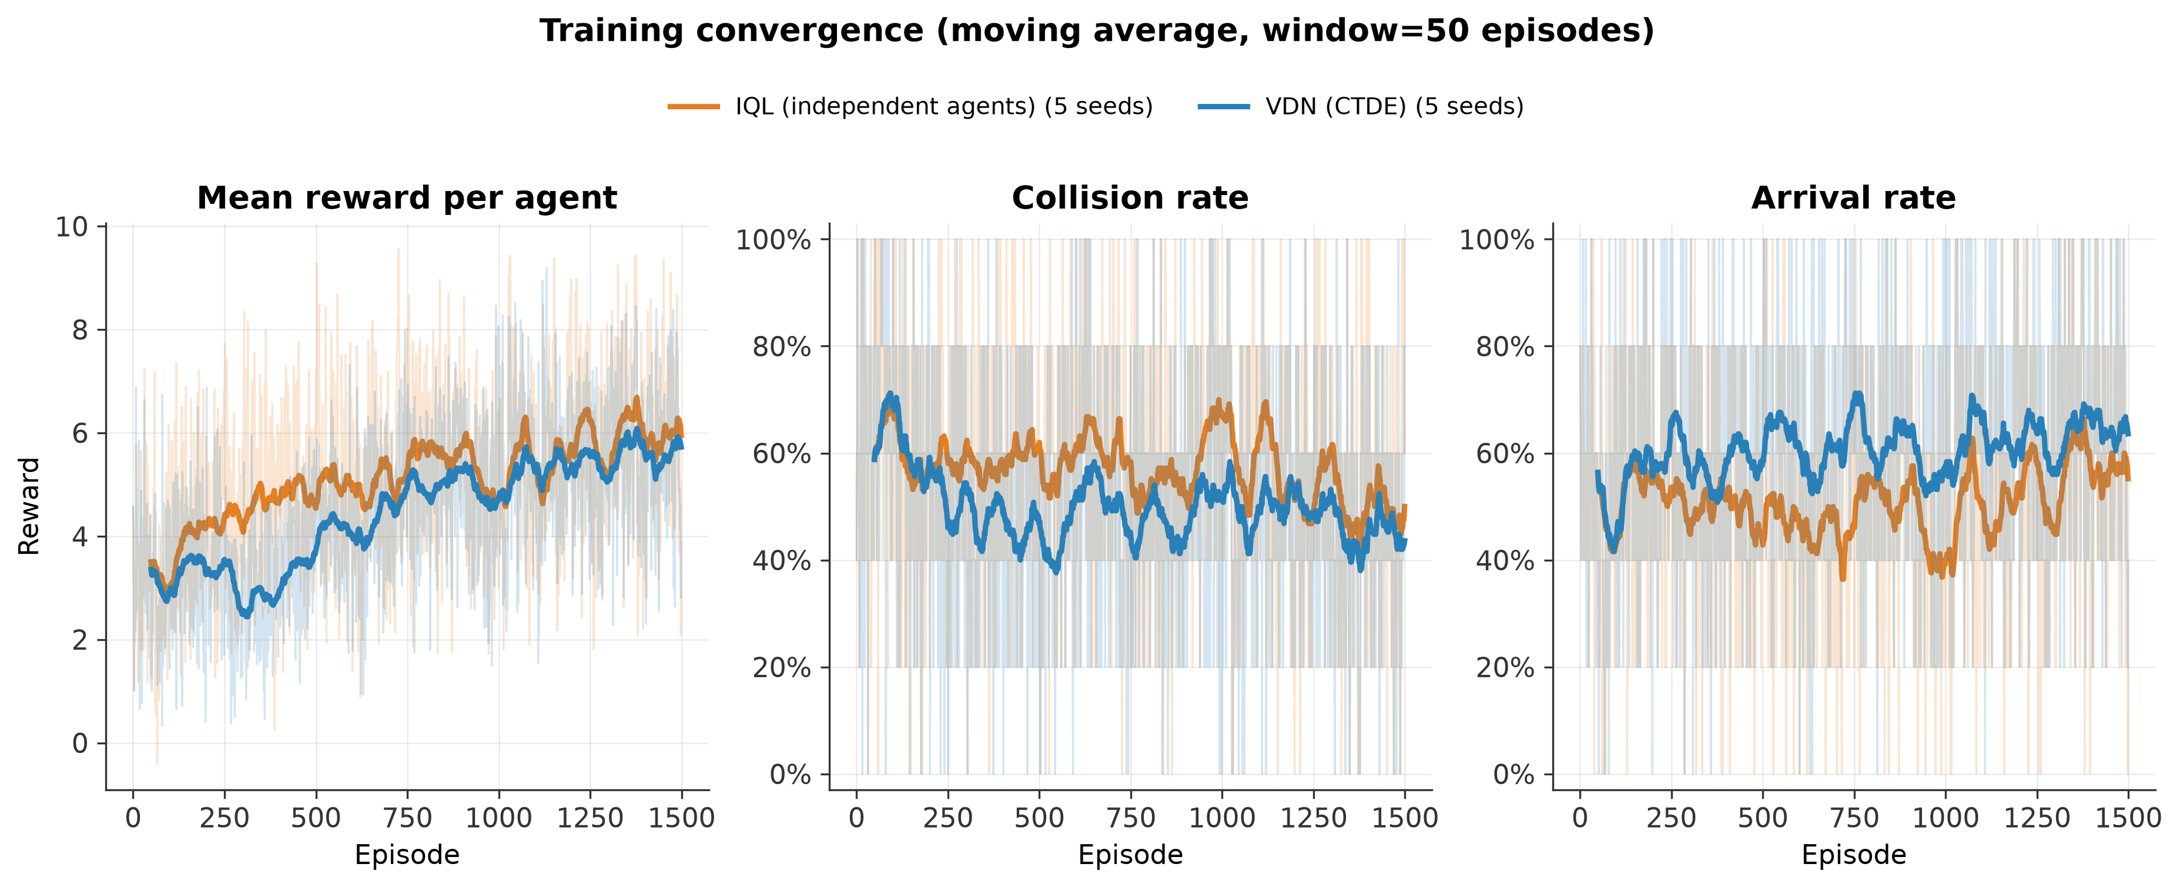
Figure 2. Training curves (reward, collisions, arrivals) by method across episodes.
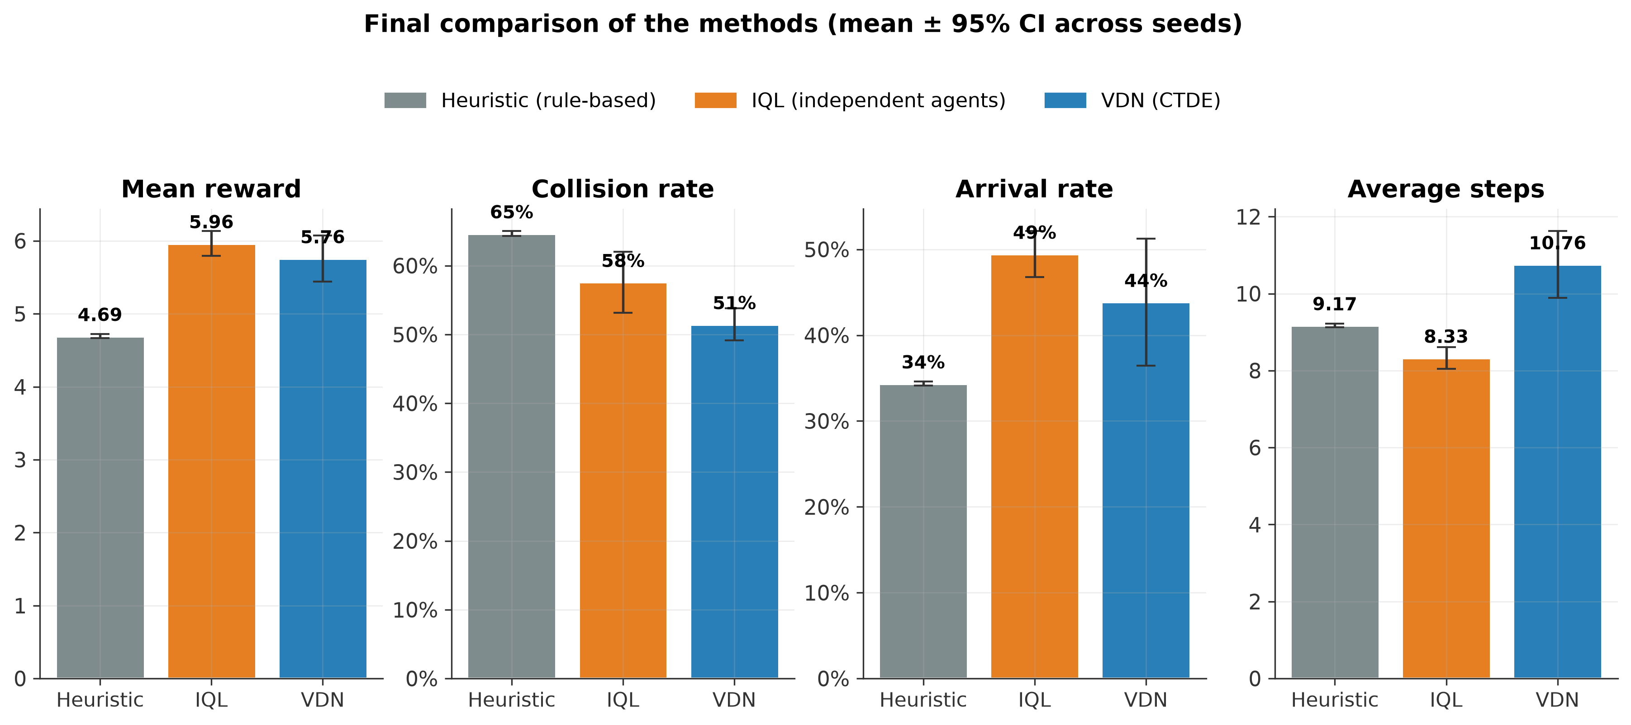
Figure 3. Final comparison of the three methods, mean ± 95% CI.
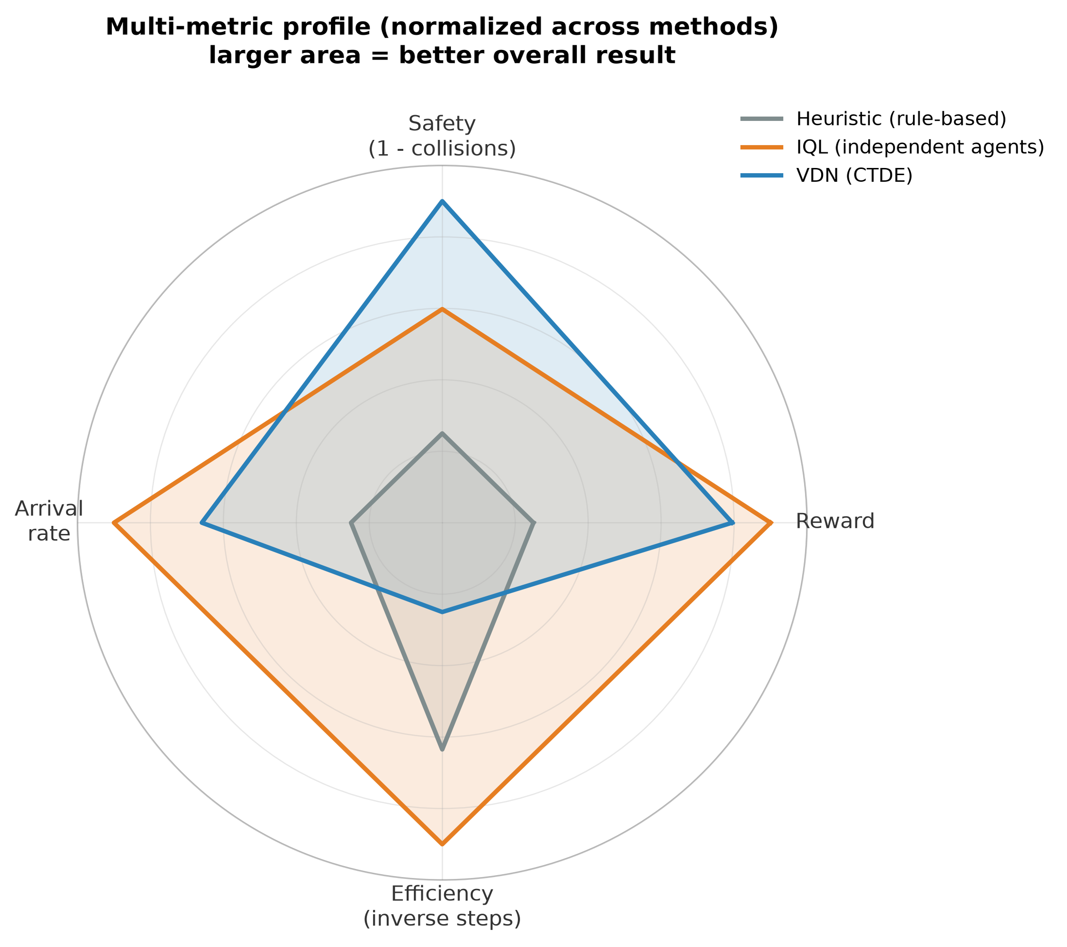
Figure 4. Multi-metric profile, normalized across methods.
Table 5.2. Formal statistical test (Welch's t-test, results/significance_test.json)
Comparison (IQL vs VDN) | t | df | p | Significant at α=0.05?
mean_reward | 1.003 | 6.14 | 0.354 | no
collision_rate | 2.145 | 6.09 | 0.075 | no (trend toward VDN)
arrival_rate | 1.247 | 5.03 | 0.267 | no (trend toward IQL)
avg_steps | -4.684 | 4.81 | 0.006 | yes (IQL shorter episodes)
IQL significantly outperforms heuristic on all four metrics (reward p<0.001, collision rate p=0.049, arrival rate p<0.001, steps p=0.005). VDN significantly outperforms heuristic on reward (p=0.004), safety (p<0.001), and episode length (p=0.033), but its arrival-rate advantage over heuristic does not reach significance (p=0.087), despite the higher point estimate (43.9% versus 34.4%).

5.2 Reward Ablation
Table 5.3a. Weight of collision_reward (VDN, n=3 seeds, reward_ablation.json)
collision_reward | Reward | Collision Rate | Arrival Rate
-5 (default) | 5.46 ± 0.23 | 58.8% ± 3.1pp | 31.9% ± 6.6pp
-10 | 4.75 ± 0.17 | 52.5% ± 2.0pp | 29.0% ± 7.2pp
-15 | 3.74 ± 0.62 | 59.6% ± 2.4pp | 36.2% ± 12.2pp
-25 | 2.50 ± 0.15 | 55.8% ± 1.8pp | 40.1% ± 8.8pp
A stricter collision penalty does not monotonically reduce collision_rate (it stays around 53-60% across all values, within overlapping CI bands), and instead reduces and destabilizes the reward (std_reward rises from 2.87 at -5 to 7.17 at -25). A possible explanation is that a larger penalty magnitude produces larger TD errors that destabilize the policy learning itself, rather than the agent learning to be safer. The value -25 significantly reduces the mean reward (2.50 versus 5.46 at default) and shows the greatest variability (std_reward=7.17), a signal of unstable learning.
Table 5.3b. Weight of courtesy_weight (VDN, n=3 seeds)
courtesy_weight | Reward | Collision Rate | Arrival Rate
0.0 (disabled) | 5.46 ± 0.23 | 58.8% ± 3.1pp | 31.9% ± 6.6pp
1.0 | 5.00 ± 0.16 | 59.2% ± 2.9pp | 34.9% ± 4.5pp
3.0 | 4.44 ± 0.10 | 54.6% ± 3.7pp | 34.4% ± 2.6pp
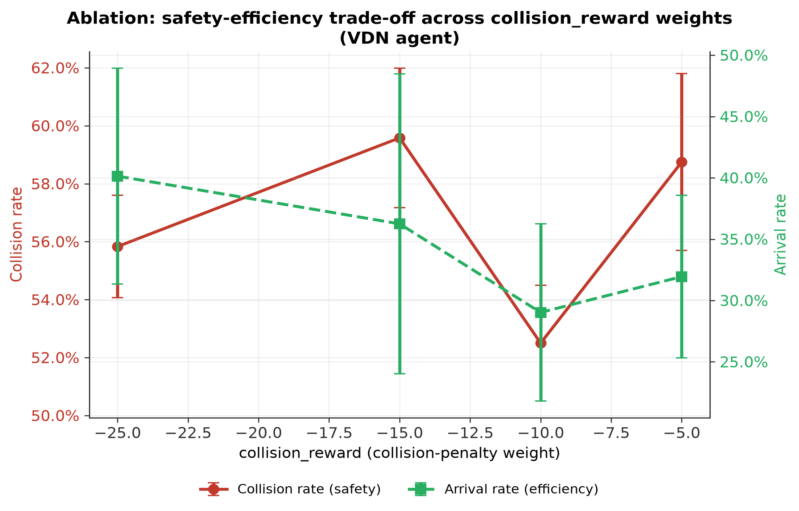
Figure 5. Ablation: weight of collision_reward.
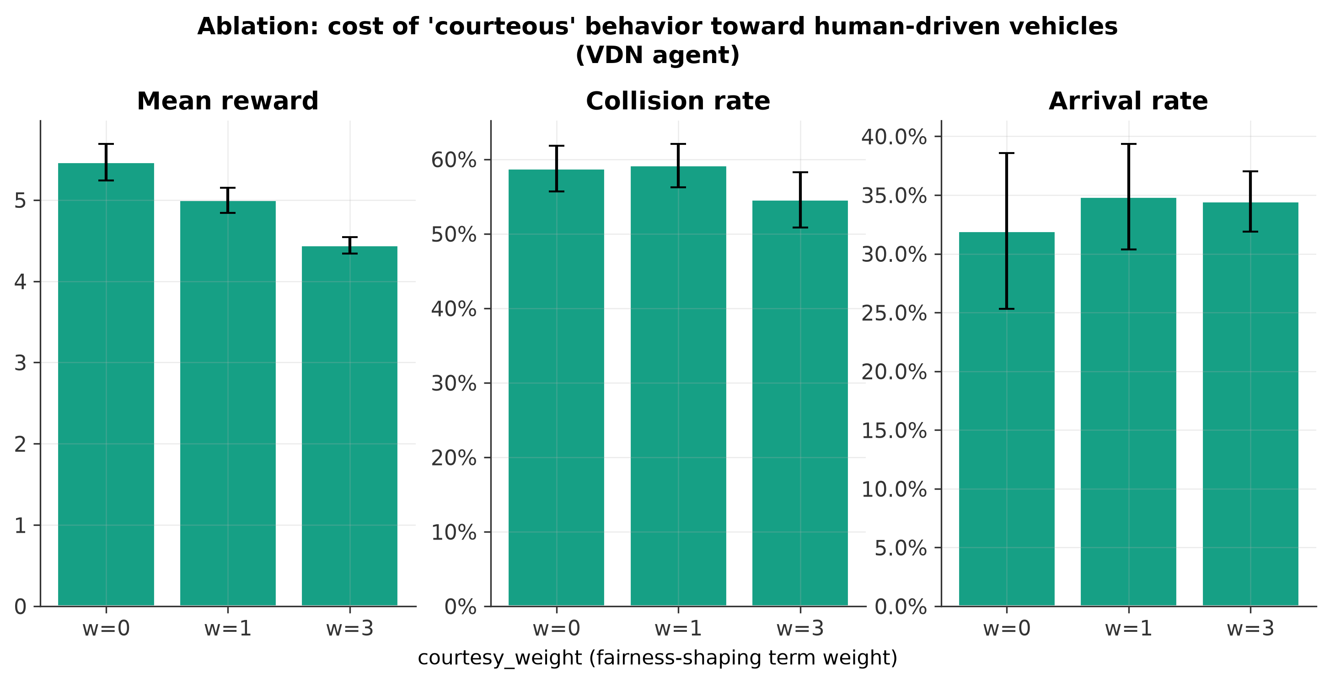
Figure 6. Ablation: weight of courtesy_weight.
With only 3 seeds, the confidence intervals are wide, especially for arrival_rate (±2.6-6.6pp), so a monotonic trade-off cannot be reliably claimed. What is visible is that courtesy_weight=3 is more conservative (lowest reward, 4.44), with the lowest point estimate for the collision rate (54.6% versus 58.8%/59.2%), but the differences fall within overlapping intervals. This is a limitation of n=3 seeds, also noted in 5.8.

5.3 Scalability Study (2-5 Controlled Vehicles)
Table 5.4. Arrival rate by number of agents (scalability_study.json)
Method | n=2 | n=3 | n=4 | n=5
Heuristic | 64.4% | 38.2% | 7.8% | 1.3%
IQL | 78.8% | 53.9% | 32.5% | 4.8%
VDN | 77.1% | 31.9% | 18.9% | 6.0%
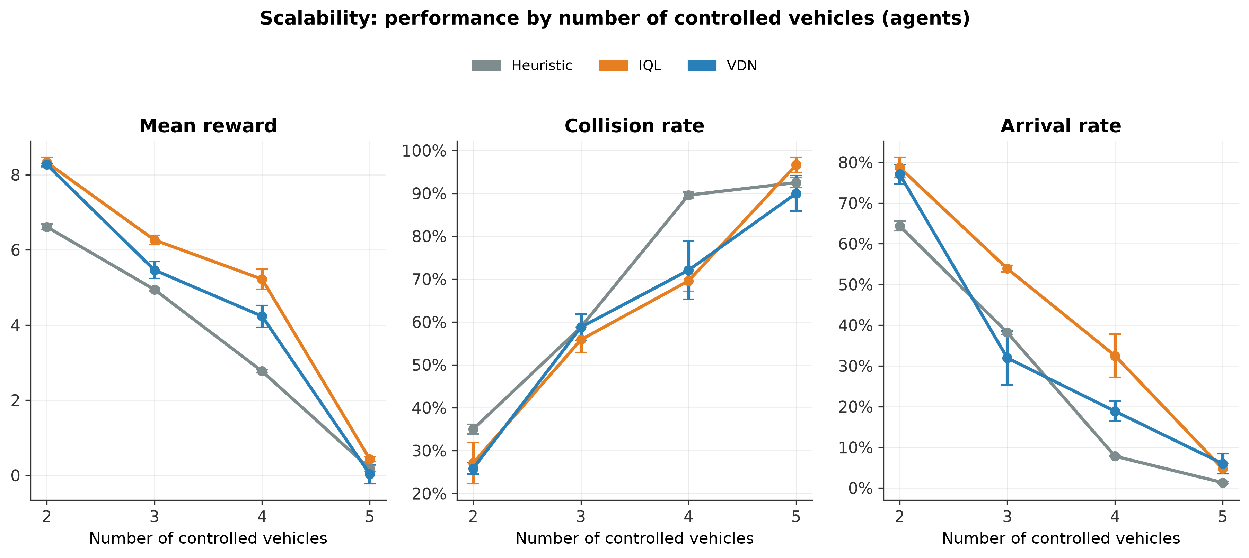
Figure 7. Performance by number of controlled vehicles (2-5).
All three methods show a sharp decline above 3-4 agents, with the heuristic essentially collapsing entirely (arrival rate from 64% to 1.3%), while the RL methods fare better but still degrade drastically. For context, the n=3 row here (IQL 53.9%, VDN 31.9%, 3 seeds, 800 episodes) sits in the same general neighborhood as the main comparison for IQL (Table 5.1: 49.5%, 5 seeds, 1500 episodes), while VDN’s point here is lower than in the main comparison (43.9%), likely reflecting the variance of only n=3 seeds (5.8) rather than a systematic difference.

5.4 Hyperparameter Study (VDN)
Table 5.5. One-at-a-time variation (hyperparameter_study.json)
Configuration | Reward | Collision Rate | Arrival Rate | Average Steps
baseline (lr=1e-3, γ=0.95, eps_frac=0.7) | 5.46 ± 0.23 | 58.8% ± 3.1pp | 31.9% ± 6.6pp | 11.80 ± 1.23
lr=3e-4 | 6.18 ± 0.33 | 57.5% ± 5.3pp | 50.3% ± 4.8pp | 9.47 ± 0.31
lr=3e-3 | 5.54 ± 0.29 | 56.7% ± 6.4pp | 43.6% ± 1.9pp | 9.92 ± 1.44
γ=0.90 | 5.96 ± 0.48 | 57.1% ± 3.5pp | 45.6% ± 5.0pp | 10.18 ± 0.91
γ=0.99 | 3.50 ± 1.10 | 40.0% ± 9.9pp | 13.7% ± 4.5pp | 16.45 ± 1.49
eps_frac=0.5 | 5.33 ± 0.30 | 63.3% ± 2.9pp | 40.4% ± 5.6pp | 10.30 ± 0.38
eps_frac=0.9 | 5.49 ± 0.40 | 56.7% ± 3.3pp | 36.5% ± 17.3pp | 10.83 ± 2.38
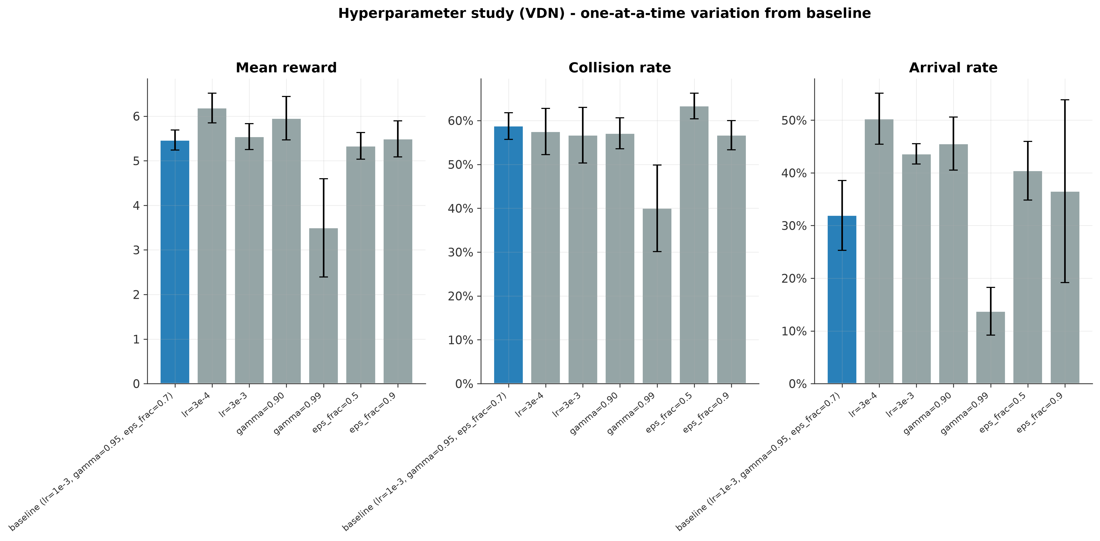
Figure 8. Hyperparameter study (VDN): lr, γ, eps_frac.
Two findings stand out. First, lr=3e-4 outperforms the default value (lr=1e-3) on all three metrics, suggesting the default learning rate may be somewhat too high. Second, γ=0.99 significantly worsens performance, not from a failure to learn but from excessive caution: longer episodes (16.5 versus 11.8 steps) and a lower arrival rate (13.7% versus 31.9%), but also a lower collision rate (40.0% versus 58.8%). The agent learns to wait rather than risk crossing, and with the short 20-second episode horizon, it simply does not make it across in time.

5.5 Visual Demonstration
watch.py generates a side-by-side comparison of heuristic, IQL, and VDN on the same initial traffic seed (identical positions and speeds for the human-driven vehicles in all 3 panels), with a per-agent overlay status. For this project, results/figures/watch_seed1.gif was generated (seed=1, 3 agents, 21 frames, chosen as the longest of 6 tried seeds). Since an animated GIF cannot be shown in a printed or Word version, the document also includes a static final frame (Figure 9), while the full animation is provided separately.
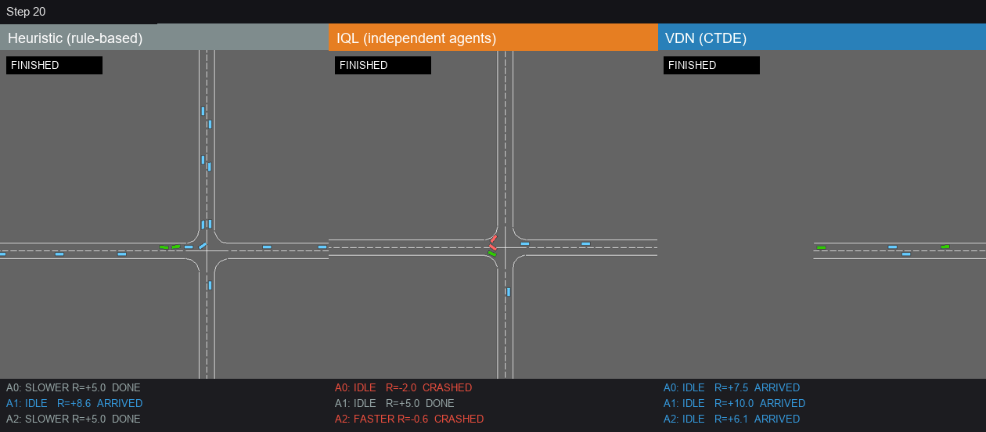
Figure 9. Final frame of the demonstration episode (seed=1, 3 agents); full animation: results/figures/watch_seed1.gif.
In this single illustrative episode (not representative of the average across the 150 evaluation episodes in Table 5.1): for heuristic, 1 agent arrived (R=+8.6) and 2 agents finished neutrally without a collision or arrival; for IQL, 2 of 3 agents crashed (R=-2.0, R=-0.6), with only 1 finishing neutrally; for VDN, all 3 agents arrived, with no collisions at all (R=+7.5, +10.0, +6.1). This example qualitatively matches the broader trend toward fewer VDN collisions, though that trend is not itself statistically significant (Table 5.2) and a single seed cannot establish it either way; that role is filled by Table 5.1/5.2.

5.6 Discussion and Interpretation
The project’s central finding, after fixing the reward-accounting bug (4.2), is not that VDN is better than IQL. There is a concrete trade-off between safety and efficiency. VDN’s centralized TD target (Σ Q_i against the shared reward) trends toward more cautious behavior and a lower collision rate, likely because one agent’s collision penalty propagates through the entire Q_tot sum, partially linking all agents’ decisions. IQL, by contrast, leaves each agent to optimize only its own reward, with no team awareness, and the result is more precise and faster navigation, shorter episodes, and a higher arrival rate, but without implicit coordination for safety. Before the bug fix, the same table incorrectly showed VDN as also having a higher mean reward, a reminder that methodological precision (4.2, Table 4.3) literally determines how the results are interpreted. With n=5 seeds, however, only the difference in episode length (avg_steps, Table 5.2) reaches statistical significance. The differences in collision_rate and arrival_rate point in the same direction described here but do not cross the conventional significance threshold, so the mechanism above should be read as a plausible hypothesis rather than a strictly proven effect. To rule out the possibility that this finding is an artifact of an architectural asymmetry in the main comparison (IQL always trained with a double-DQN target, VDN never), a control study was run (experiments/confound_check_study.py) in which both methods use the identical dueling+double-DQN design (n=5 seeds, same protocol). The pattern is confirmed almost identically (collision_rate p=0.074, avg_steps p=0.007), showing that the difference genuinely stems from the CTDE mechanism rather than an architectural confound.

5.7 Challenges and Lessons Learned
The reward-accounting bug (4.2) was the most significant challenge of the project. It does not cause a crash or obviously wrong behavior, but subtly skews the interpretation of the results, and it was found only during a systematic code review, not during routine testing. Additional challenges include the non-stationarity of the IQL environment, visible through greater variance in IQL’s training curves compared to VDN. This also includes several Windows-specific issues (UnicodeEncodeError on Cyrillic under a non-UTF-8 console, the requirement for multiprocessing’s “spawn” for top-level job functions, a race condition from parallel writes to the same result files, resolved through the tag parameter), as well as the methodological discipline needed to keep the evaluation and training seeds from overlapping (EVAL_SEED_OFFSET).

5.8 Limitations
The small number of seeds in the ablation studies (n=3), compared to the main comparison (n=5), means the confidence intervals in 5.2 and 5.4 are wide and partly overlapping, so the conclusions there are qualitative trends, not strict statistical claims, unlike in 5.1. The formal statistical test (Table 5.2) is applied only to the main comparison; the same test was not applied to the ablation, scalability, or hyperparameter results (which would require more seeds for reasonable statistical power), nor was a correction for multiple testing applied across all method-metric combinations. The short episode horizon (20s, the default highway-env duration) explains the collapse at γ=0.99 (5.4); a longer horizon might produce a different picture. The simple heuristic, lacking time-to-collision or relative speed, may underestimate how good a rule-based baseline could be. There is no direct comparison with QMIX or MAPPO. VDN was chosen for its simplicity (3.3), but it remains an open question whether a more expressive mixing network would change the picture. The hyperparameter search is one-at-a-time and does not detect possible interaction effects, for example a high γ combined with a lower lr.
Additional methodological note (added during a later revision): the confidence intervals in every table in this chapter (computed via agg_stats() in experiments/parallel.py) use a normal approximation (1.96·σ/√n, with population σ), not the t-distribution appropriate for such small samples, so the exact intervals would be wider, roughly 1.6× for n=5 (main comparison) and 2.7× for n=3 (all ablation studies). This does not affect the conclusions in Table 5.2 (Welch’s t-test there is computed separately, via scipy, independent of this approximation), but it means the “±” values shown throughout the report are narrower, and therefore more optimistic, than the exact estimate, which is an additional reason for caution when reading the ablation results in 5.2 and 5.4.

5.9 Comparison with Related Work
In contrast to the classic AIM reservation protocol of Dresner and Stone [8], this project does not require a centralized intersection manager at execution time. Each agent decides decentrally, closer to the scenario in [10], although this comes at a cost, since without central coordination, the network itself must implicitly learn coordination, exactly what VDN’s TD decomposition attempts to achieve. Unlike the original QMIX evaluation on StarCraft II micromanagement scenarios [6] (VDN [5] was originally tested on simpler, custom navigation scenarios), this project applies the same principles in a continuous, realistic simulation setting with mixed traffic, RL and IDM/MOBIL human-driven, closer to the aim of [9] and [10]. The focus here shifts toward methodological precision, reward decomposition, and statistical testing, rather than toward the throughput and latency engineering metrics typical of that literature.

5.10 Ideas for Future Extensions
Future work could include: a comparison with QMIX or MAPPO/MADDPG under the same protocol, to test whether a nonlinear mixing network changes the trade-off from 5.1; a time-to-collision-based heuristic baseline, for a fairer comparison with the RL agents; more seeds in the ablation studies (5 or more) plus a formal correction for multiple testing; a longer episode horizon, to check whether the γ=0.99 finding (5.4) is an artifact of the short horizon; and communication between agents at execution time, a natural extension of the CTDE framework already established here.

6. Additional Study: Observation Modes

6.1 Motivation and Design
As an extension of the main comparison with Kinematics observations from Chapters 4 and 5, the same IQL/VDN pipeline was also tested with two further observation types, using identical environment settings, seeds, and metrics. In Pixels-only mode, each agent receives its own local, agent-centric grayscale image from its own camera, via highway-env’s observer_vehicle mechanism, so each agent genuinely sees its own image rather than a shared screenshot, processed through a CNN. In Fusion mode, the local image and the kinematics vector are combined through separate MLP/CNN branches, merged before the final Q-values. The existing IQL/VDN networks and replay buffers were extended to support these modes, not replaced, without using Stable-Baselines3. The project’s main focus, in Chapters 2 through 5, remains the Kinematics observations, while this represents an advanced, supplementary study.

6.2 Results: obs_mode × Method
Table 6.1. Comparison of the three observation modes (mean ± 95% CI across 5 seeds, observation_comparison.json)
Mode | Method | Reward | Collision Rate | Arrival Rate
Kinematics | IQL | 5.96 ± 0.17 | 57.6% ± 4.4pp | 49.5% ± 2.7pp
Kinematics | VDN | 5.76 ± 0.32 | 51.5% ± 2.3pp | 43.9% ± 7.4pp
Pixels | IQL | 5.62 ± 0.14 | 60.2% ± 3.2pp | 44.3% ± 2.1pp
Pixels | VDN | 5.68 ± 0.03 | 58.6% ± 0.4pp | 45.2% ± 0.4pp
Fusion | IQL | 5.90 ± 0.08 | 60.0% ± 2.1pp | 48.1% ± 0.6pp
Fusion | VDN | 5.98 ± 0.19 | 57.8% ± 3.5pp | 44.1% ± 5.7pp
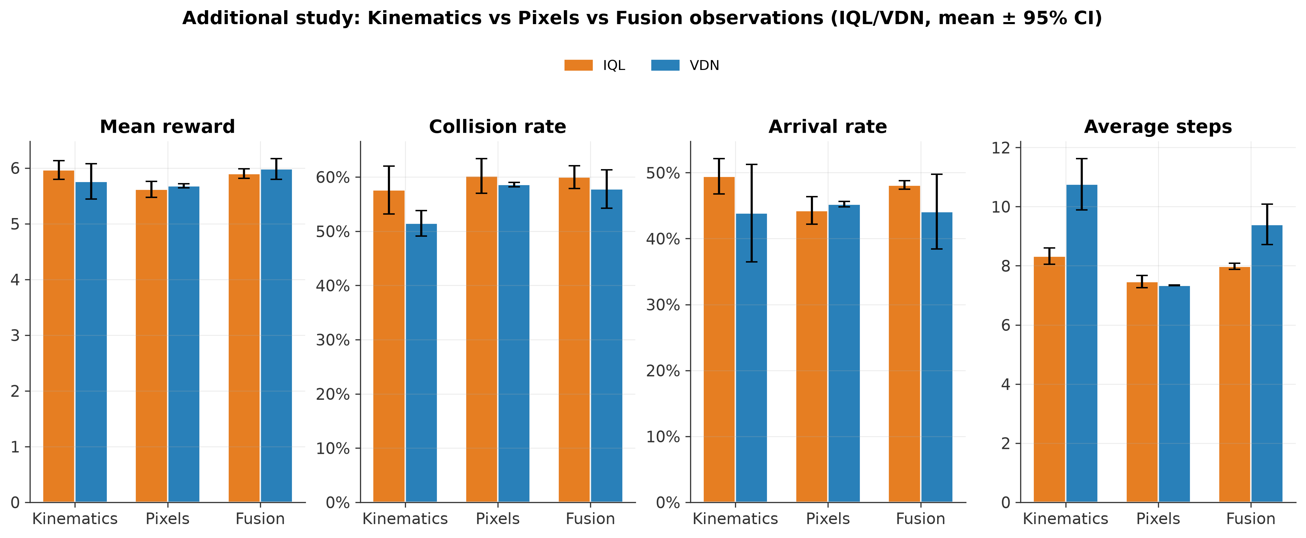
Figure 10. Comparison of Kinematics/Pixels/Fusion observations by method.
Neither Pixels nor Fusion shows a clear advantage over Kinematics; the results sit within the same general range (reward 5.6-6.0, collision rate 58-60%, arrival rate 44-50%), with overlapping confidence intervals.

6.3 The “Modality Collapse” Finding and an Attempted Fix
The robustness evaluation, which includes kinematics noise, image blur/darkening, and temporarily disabling one observation branch for Fusion, revealed an unusual result: blurring/darkening the image for Fusion caused almost no change in performance, despite a real change to the image itself. A direct inspection of the Q-values, across 30 method×seed×agent combinations in experiments/modality_sensitivity.py, confirmed the cause. Plain Fusion, trained in the standard way, almost entirely ignores the image, with img_sens around 0.00-0.04 versus kin_sens around 2.3-4.0 when the kinematics branch is disabled instead. This resembles a phenomenon sometimes described in multimodal learning as “modality collapse,” where an easier modality dominates training and suppresses a harder one — here, kinematics over the image. The attempted fix, which simultaneously applies modality dropout during training and a CNN warm-start from a previously trained Pixels-only model, genuinely increases image sensitivity, with img_sens rising to an average of 0.6-8.6 per method, though with considerable variance across agents and seeds, and some still remaining close to collapse. This fix comes at the cost of lower raw performance, since reward and arrival rate drop relative to plain Fusion, representing a classic robustness-vs-performance trade-off rather than a free improvement.
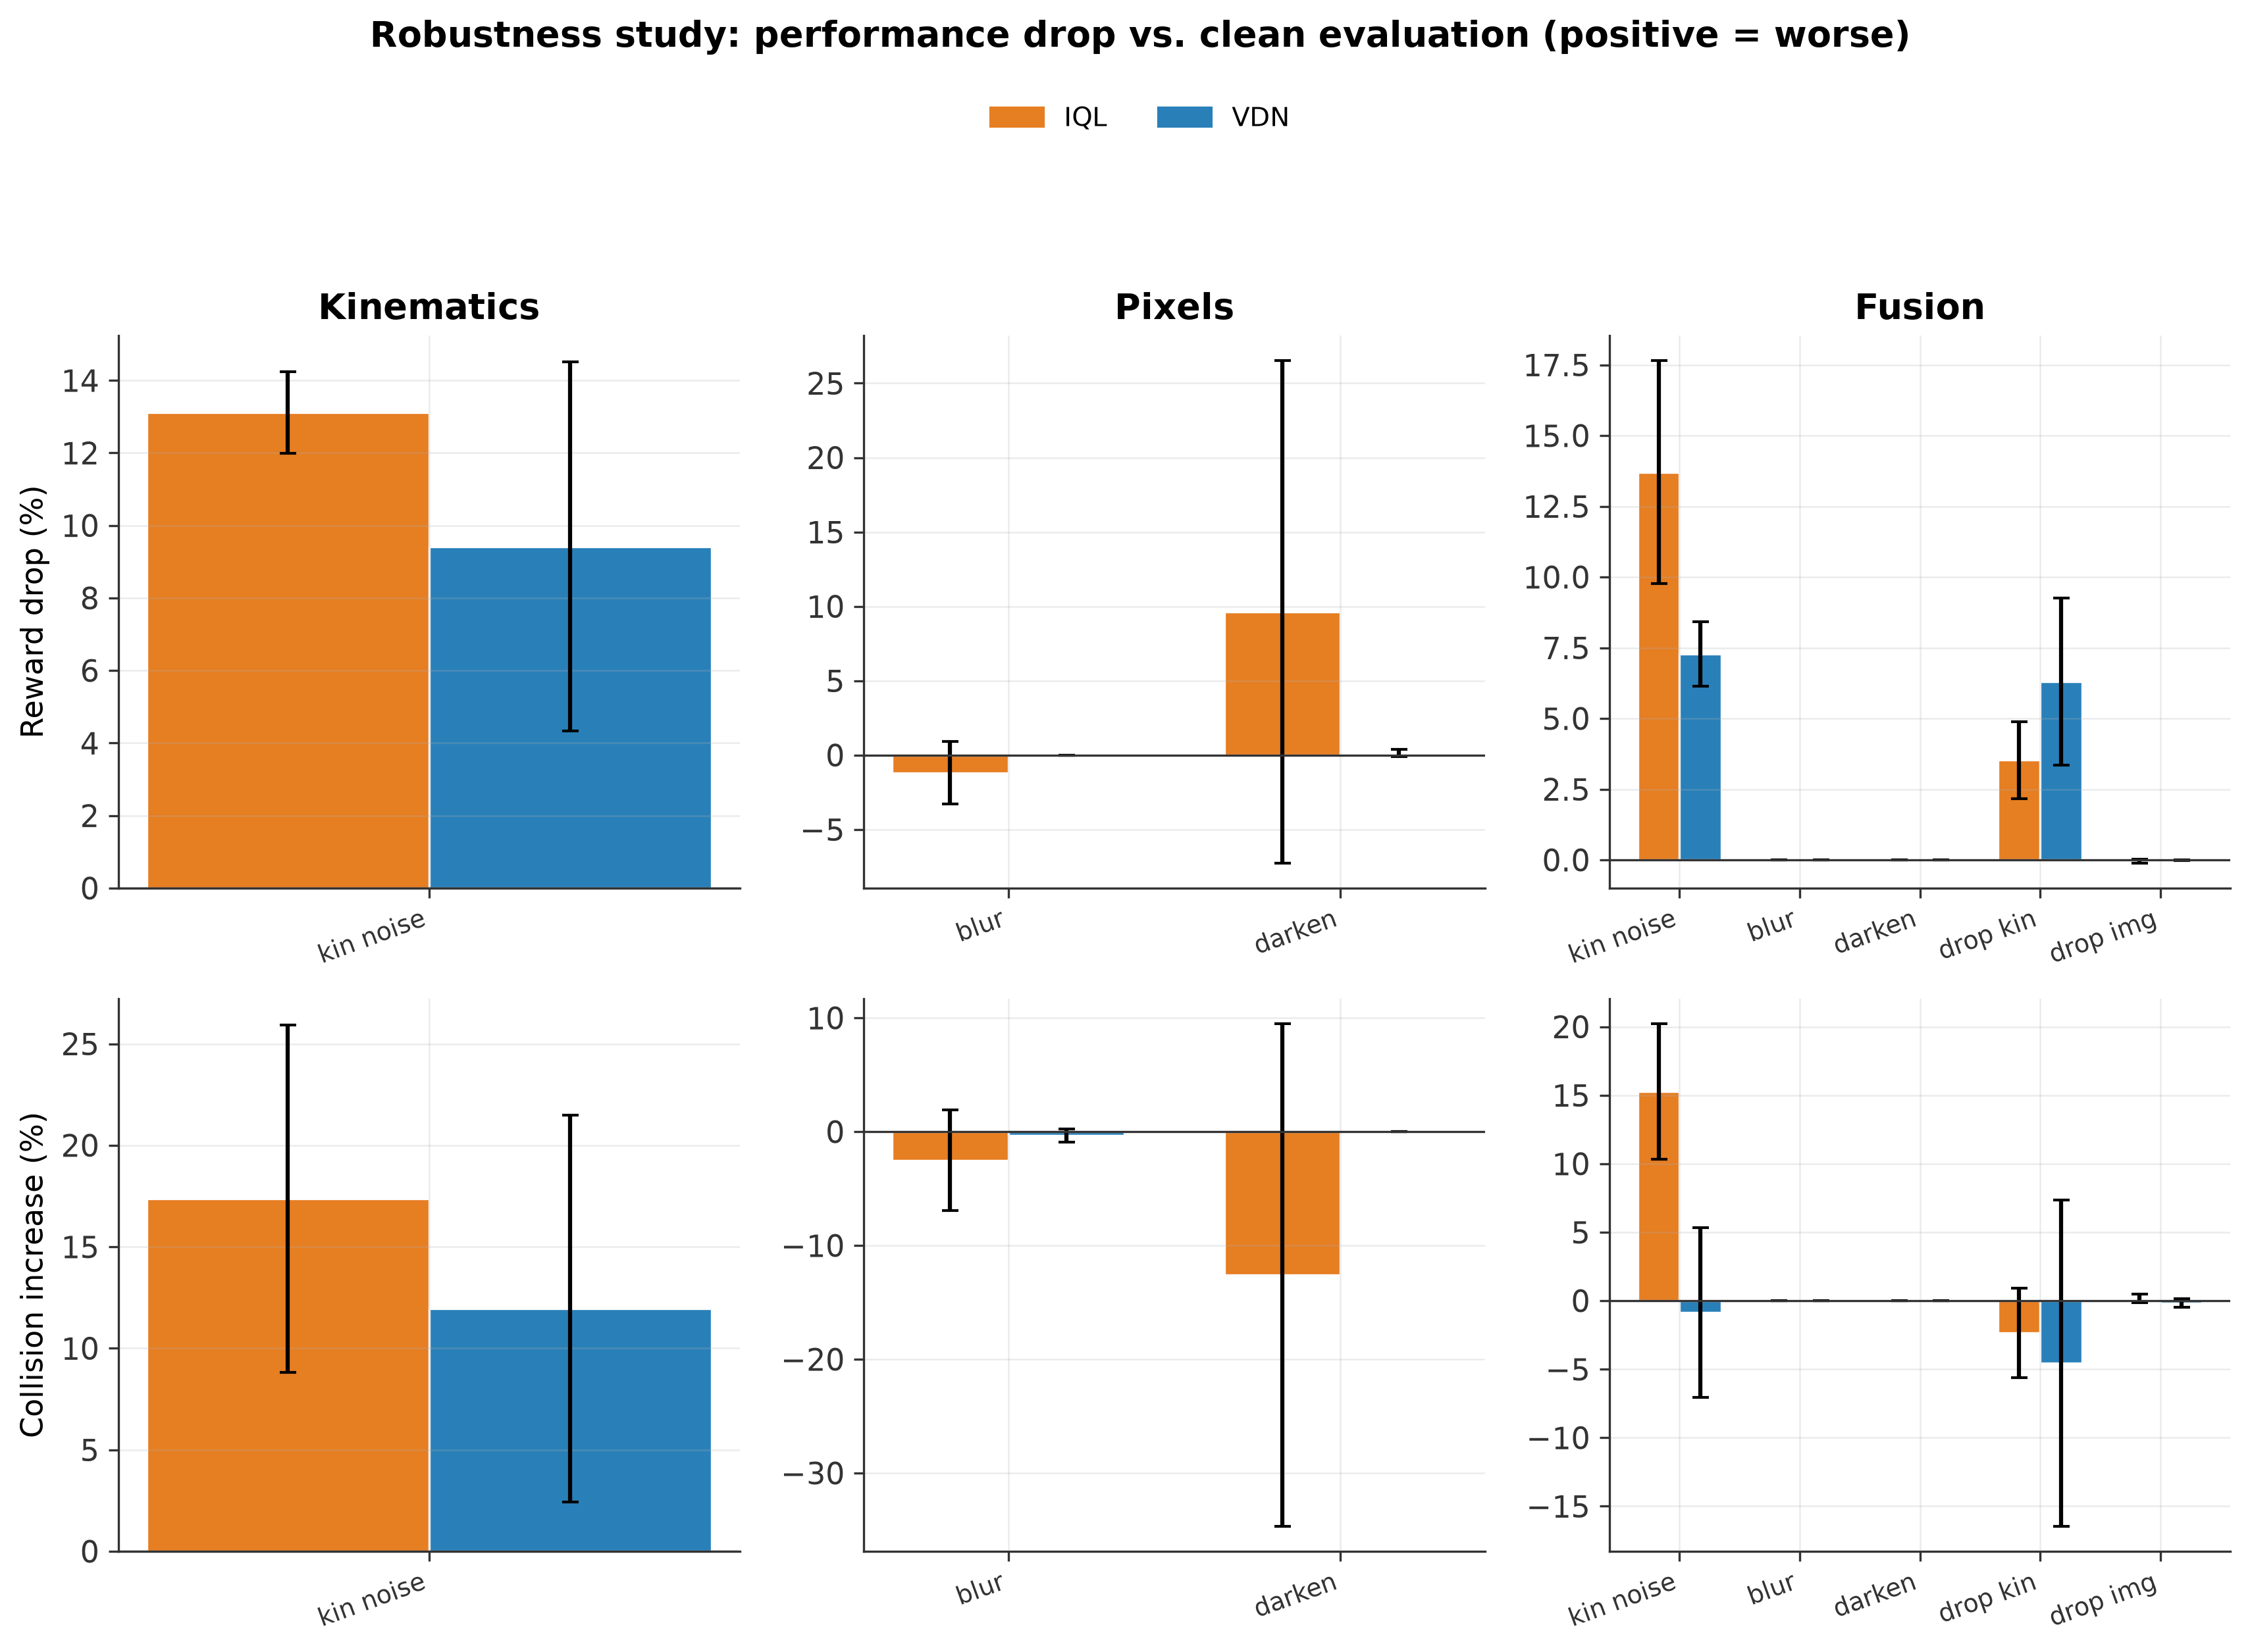
Figure 11. Robustness study: performance drop (reward, collision rate) under observation perturbations (noise/blur/darken/dropout), relative to clean evaluation, by observation mode and method.

6.4 Conclusion for This Study
The results indicate that the Kinematics observation remains the safest, most stable choice for this problem (without a formal statistical test between the three modes, unlike Table 5.2); adding pixels (alone or in combination) does not bring a clear advantage, and Fusion introduces an additional risk (modality collapse) that requires explicit intervention to mitigate. Full details (code, tests, robustness figures by condition) are available in the project repository. Testing the alternatives at all is a worthwhile outcome in its own right: it confirms that the choice of Kinematics observations is not arbitrary, but empirically grounded.

7. Conclusion
This project presents a multi-seed comparison, with confidence intervals and a formal statistical test, of heuristic, IQL, and VDN approaches to coordinating autonomous vehicles at a mixed-traffic intersection, built on a wrapper around highway-env that enables the per-agent reward decomposition such a comparison requires. The key methodological contribution, finding and fixing a reward-accounting bug that asymmetrically “inflated” VDN’s reward relative to IQL, changed the interpretation of the main finding: rather than “CTDE yields a higher reward,” the true picture (confirmed with a formal Welch’s t-test) is a statistically significant trade-off. VDN shows a trend toward fewer collisions (51.5% versus 57.6% for IQL), and IQL toward a higher arrival rate (49.5% versus 43.9%), but with n=5 seeds neither difference reaches conventional statistical significance (p=0.075 and p=0.267, respectively); only VDN’s significantly longer episodes (10.76 versus 8.33 steps, p=0.006) are statistically confirmed, while the mean reward remains statistically indistinguishable (p=0.354). The ablation studies further show that the system is sensitive to the collision-penalty weight and to the discount factor in combination with the short episode horizon, and that all methods degrade drastically above 3-4 controlled vehicles. These findings suggest that the choice between independent and centrally-trained multi-agent learning is a matter of an acceptable trade-off for the specific application. In the context of autonomous vehicles, where safety often takes priority, the trend toward fewer collisions under VDN-style CTDE is worth weighing against its lower efficiency, even though the difference was not statistically significant here. The combination of careful engineering, statistical testing, and transparent reporting makes this project a useful basis for further work in multi-agent reinforcement learning.

References
[1] V. Mnih et al., „Human-level control through deep reinforcement learning,“ Nature, vol. 518, pp. 529-533, Feb. 2015.
[2] H. van Hasselt, A. Guez, and D. Silver, „Deep reinforcement learning with double Q-learning,“ in Proc. 30th AAAI Conf. Artificial Intelligence, 2016, pp. 2094-2100.
[3] Z. Wang, T. Schaul, M. Hessel, H. van Hasselt, M. Lanctot, and N. de Freitas, „Dueling network architectures for deep reinforcement learning,“ in Proc. 33rd Int. Conf. Machine Learning (ICML), PMLR vol. 48, 2016.
[4] S. V. Albrecht, F. Christianos, and L. Schäfer, Multi-Agent Reinforcement Learning: Foundations and Modern Approaches. Cambridge, MA, USA: MIT Press, 2024. [Online]. Available: https://www.marl-book.com/
[5] P. Sunehag et al., „Value-decomposition networks for cooperative multi-agent learning,“ arXiv:1706.05296, 2017; extended abstract in Proc. 17th Int. Conf. Autonomous Agents and MultiAgent Systems (AAMAS), 2018, pp. 2085-2087.
[6] T. Rashid, M. Samvelyan, C. Schroeder de Witt, G. Farquhar, J. Foerster, and S. Whiteson, „QMIX: Monotonic value function factorisation for deep multi-agent reinforcement learning,“ in Proc. 35th Int. Conf. Machine Learning (ICML), 2018, pp. 4295-4304.
[7] E. Leurent, „An environment for autonomous driving decision-making,“ GitHub repository, 2018. [Online]. Available: https://github.com/Farama-Foundation/HighwayEnv
[8] K. Dresner and P. Stone, „A multiagent approach to autonomous intersection management,“ J. Artificial Intelligence Research, vol. 31, pp. 591-656, 2008.
[9] P. Yadav, A. Mishra, and S. Kim, „A comprehensive survey on multi-agent reinforcement learning for connected and automated vehicles,“ Sensors, vol. 23, no. 10, art. 4710, 2023.
[10] A. Guillen-Perez and M.-D. Cano, „Multi-agent deep reinforcement learning to manage connected autonomous vehicles at tomorrow's intersections,“ IEEE Trans. Vehicular Technology, vol. 71, no. 7, pp. 7033-7043, 2022.

