**PLEASE NOTE: THE MATTER PRODUCED BELOW IS REFERENCE MATERIAL ONLY FOR PREPARING THE PROJECT REPORT. IT IS NOT THE COMPLETE PROJECT REPORT.**

A PROJECT REPORT ON

IOT BASED SMART CAR PARKING SYSTEM

Submitted in partial fulfillment of the requirements

For the award of the degree

BACHELOR OF ENGINEERING

IN

\_\_\_\_\_\_\_\_\_\_\_\_\_\_\_\_\_\_\_\_\_\_\_\_\_\_\_\_\_\_\_\_\_\_\_\_ ENGINEERING

SUBMITTED BY

-------------------- (--------------)

--------------------- (---------------)

--------------------- (---------------)

DEPARTMENT OF \_\_\_\_\_\_\_\_\_\_\_\_\_\_\_\_\_\_\_\_\_\_\_ ENGINEERING

\_\_\_\_\_\_\_\_\_\_COLLEGE OF ENGINEERING

AFFILIATED TO \_\_\_\_\_\_\_\_\_\_\_ UNIVERSITY

**CERTIFICATE**

This is to certify that the dissertation work entitled “IOT BASED SMART CAR PARKING SYSTEM**”** is the work done by \_\_\_\_\_\_\_\_\_\_\_\_\_\_\_\_\_\_\_\_\_\_\_\_\_\_\_\_\_\_\_\_\_\_\_\_\_\_\_\_\_\_\_\_\_\_\_submitted in partial fulfillment for the award of ‘BACHELOR OF ENGINEERING (B.E)’in \_\_\_\_\_\_\_\_\_\_\_\_\_\_\_\_\_\_\_\_\_\_\_\_\_\_Engineering from\_\_\_\_\_\_\_\_\_\_\_\_\_\_ College of Engineering affiliated to \_\_\_\_\_\_\_\_\_ University.

**\_\_\_\_\_\_\_\_\_\_\_\_\_\_\_\_ \_\_\_\_\_\_\_\_\_\_\_\_**

**(Head of the department, ECE) (Assistant Professor)**

**EXTERNAL EXAMINER**

**ACKNOWLEDGEMENT**

The satisfaction and euphoria that accompany the successful completion of any task would be incomplete without the mentioning of the people whose constant guidance and encouragement made it possible. We take pleasure in presenting before you, our project, which is result of studied blend of both research and knowledge.

We express our earnest gratitude to our internal guide, Assistant Professor \_\_\_\_\_\_\_\_\_\_\_\_\_\_, Department of ECE, our project guide, for his constant support, encouragement and guidance. We are grateful for his cooperation and his valuable suggestions.

Finally, we express our gratitude to all other members who are involved either directly or indirectly for the completion of this project.

**DECLARATION**

We, the undersigned, declare that the project entitled **‘**IOT BASED SMART CAR PARKING SYSTEM**’**, being submitted in partial fulfillment for the award of Bachelor of Engineering Degree in Electronics and Communication Engineering, affiliated to \_\_\_\_\_\_\_\_\_ University, is the work carried out by us.

\_\_\_\_\_\_\_\_\_\_ \_\_\_\_\_\_\_\_\_ \_\_\_\_\_\_\_\_\_

\_\_\_\_\_\_\_\_\_\_ \_\_\_\_\_\_\_\_\_ \_\_\_\_\_\_\_\_\_

**Abstract**

|  |
| --- |
| Car parking is a major issues in modern congested cities of today. There simply are too many vehicles on the road and not enough parking space. This has led to the need for efficient parking management systems. Thus we demonstrate the use of IOT based parking management system that allows for efficient parking space utilization using IOT technology. To demonstrate the concept we use IR sensors for sensing parking slot occupancy along with a dc motors to simulate as gate opener motors. We now use a wifi modem for internet connectivity and an AVR microcontroller for operating the system. We use IOTGecko for online connectivity and IOT management GUI design. The system detects if parking slots are occupied using IR sensors. Also it uses IR technology to sense if a vehicle has arrived on gate for automated gate opening. The system reads the number of parking slots available and updates data with the cloud server to allow for checking parking slot availability online. This allows users to check for available parking spaces online from anywhere and avail hassle free parking. Thus the system solves the parking issue for cities and get users an efficient IOT based parking management system. |
|  |
|  |

The term Internet of Things (often abbreviated IoT) was coined more than ten years ago by industry researchers but has emerged into mainstream public view only more recently. Some claim the Internet of Things will completely transform how computer networks are used for the next 10 or 100 years, while others believe IoT is simply hype that won't much impact the daily lives of most people.

### What Is IoT?

Internet of Things represents a general concept for the ability of network devices to sense and collect data from the world around us, and then share that data across the Internet where it can be processed and utilized for various interesting purposes.

Some also use the term industrial Internetinterchangeably with IoT. This refers primarily to commercial applications of IoT technology in the world of manufacturing. The Internet of Things is not limited to industrial applications, however.

### What the Internet of Things Can Do for Us

Some future consumer applications envisioned for IoT sound like science fiction, but some of the more practical and realistic sounding possibilities for the technology include:

* receiving warnings on your phone or wearable device when IoT networks detect some physical danger is detected nearby
* self-parking automobiles
* automatic ordering of groceries and other home supplies
* automatic tracking of exercise habits and other day-to-day personal activity including goal tracking and regular progress reports

Potential benefits of IoT in the business world include:

* location tracking for individual pieces of manufacturing inventory
* fuel savings from intelligent environmental modeling of gas-powered engines
* new and improved safety controls for people working in hazardous environments

Network Devices and the Internet of Things

All kinds of ordinary household gadgets can be modified to work in an IoT system. [Wi-Fi](http://compnetworking.about.com/cs/wireless80211/g/bldef_wifi.htm)network adapters, motion sensors, cameras, microphones and other instrumentation can be embedded in these devices to enable them for work in the Internet of Things. [Home automation systems](http://compnetworking.about.com/od/homeautomationsystems/a/what-is-home-automation.htm) already implement primitive versions of this concept for things like light bulbs, plus other devices like wireless scales and wireless blood pressure monitorsthat each represent early examples of IoT gadgets. Wearable computing devices like watches and glasses are also envisioned to be key components in future IoT systems.

The same wireless communication protocols like Wi-Fi and [Bluetooth](http://compnetworking.about.com/cs/bluetooth/g/bldef_bluetooth.htm) naturally extend to the Internet of Things also.

Issues Around IoT

Internet of Things immediately triggers questions around the privacy of personal data. Whether real-time information about our physical location, or updates about our weight and blood pressure that may be accessible by our health care providers, having new kinds and more detailed data about ourselves streaming over wireless networks and potentially around the world is an obvious concern.

Supplying power to this new proliferation of IoT devices and their network connections can be expensive and logistically difficult. Portable devices require batteries that someday must be replaced. Although many mobile devices are optimized for lower power usage, energy costs to keep potentially billions of them running remains high.

Numerous corporations and start-up ventures have latched onto the Internet of Things concept looking to take advantage of whatever business opportunities are available. While competition in the market helps lower prices of consumer products, in the worst case it also leads to confusing and inflated claims about what the products do.

IoT assumes that the underlying network equipment and related technology can operate semi-intelligently and often automatically. Simply keeping mobile devices connected to the Internet can be difficult enough much less trying to make them smarter. People have diverse needs that require an IoT system to adapt or be configurable for many different situations and preferences. Finally, even with all those challenges overcome, if people become too reliant on this automation and the technology is not highly robust, any technical glitches in the system can cause serious physical and/or financial damage.

**2.INTRODUCTION TO EMBEDDED SYSTEMS**

**What is embedded system?**

An Embedded System is a combination of computer hardware and software, and perhaps additional mechanical or other parts, designed to perform a specific function. An embedded system is a microcontroller-based, software driven, reliable, real-time control system, autonomous, or human or network interactive, operating on diverse physical variables and in diverse environments and sold into a competitive and cost conscious market.

An embedded system is not a computer system that is used primarily for processing, not a software system on PC or UNIX, not a traditional business or scientific application. High-end embedded & lower end embedded systems. High-end embedded system - Generally 32, 64 Bit Controllers used with OS. Examples Personal Digital Assistant and Mobile phones etc .Lower end embedded systems - Generally 8,16 Bit Controllers used with an minimal operating systems and hardware layout designed for the specific purpose.

**SYSTEM DESIGN CALLS:**

Figure 3(a): Embedded system design calls

**EMBEDDED SYSTEM DESIGN CYCLE**

Figure 3(b) “V Diagram”

**Characteristics of Embedded System**

* An embedded system is any computer system hidden inside a product other than a computer.
* They will encounter a number of difficulties when writing embedded system software in addition to those we encounter when we write applications.
  + Throughput – Our system may need to handle a lot of data in a short period of time.
  + Response–Our system may need to react to events quickly.
  + Testability–Setting up equipment to test embedded software can be difficult.
  + Debugability–Without a screen or a keyboard, finding out what the software is doing wrong (other than not working) is a troublesome problem.
  + Reliability – embedded systems must be able to handle any situation without human intervention.
  + Memory space – Memory is limited on embedded systems, and you must make the software and the data fit into whatever memory exists.
  + Program installation – you will need special tools to get your software into embedded systems.
  + Power consumption – Portable systems must run on battery power, and the software in these systems must conserve power.
  + Processor hogs – computing that requires large amounts of CPU time can complicate the response problem.
  + Cost – Reducing the cost of the hardware is a concern in many embedded system projects; software often operates on hardware that is barely adequate for the job.
* Embedded systems have a microprocessor/ microcontroller and a memory. Some have a serial port or a network connection. They usually do not have keyboards, screens or disk drives.

**APPLICATIONS**

1. Military and aerospace embedded software applications
2. Communication Applications
3. Industrial automation and process control software
4. Mastering the complexity of applications.
5. Reduction of product design time.
6. Real time processing of ever increasing amounts of data.
7. Intelligent, autonomous sensors.

**CLASSIFICATION**

* Real Time Systems.
* RTS is one which has to respond to events within a specified deadline.
* A right answer after the dead line is a wrong answer.

**RTS CLASSIFICATION**

* Hard Real Time Systems
* Soft Real Time System

**HARD REAL TIME SYSTEM**

* "Hard" real-time systems have very narrow response time.
* Example: Nuclear power system, Cardiac pacemaker.

**SOFT REAL TIME SYSTEM**

* "Soft" real-time systems have reduced constrains on "lateness" but still must operate very quickly and repeatable.
* Example: Railway reservation system – takes a few extra seconds the data remains valid.

**BLOCK DIAGRAM**

**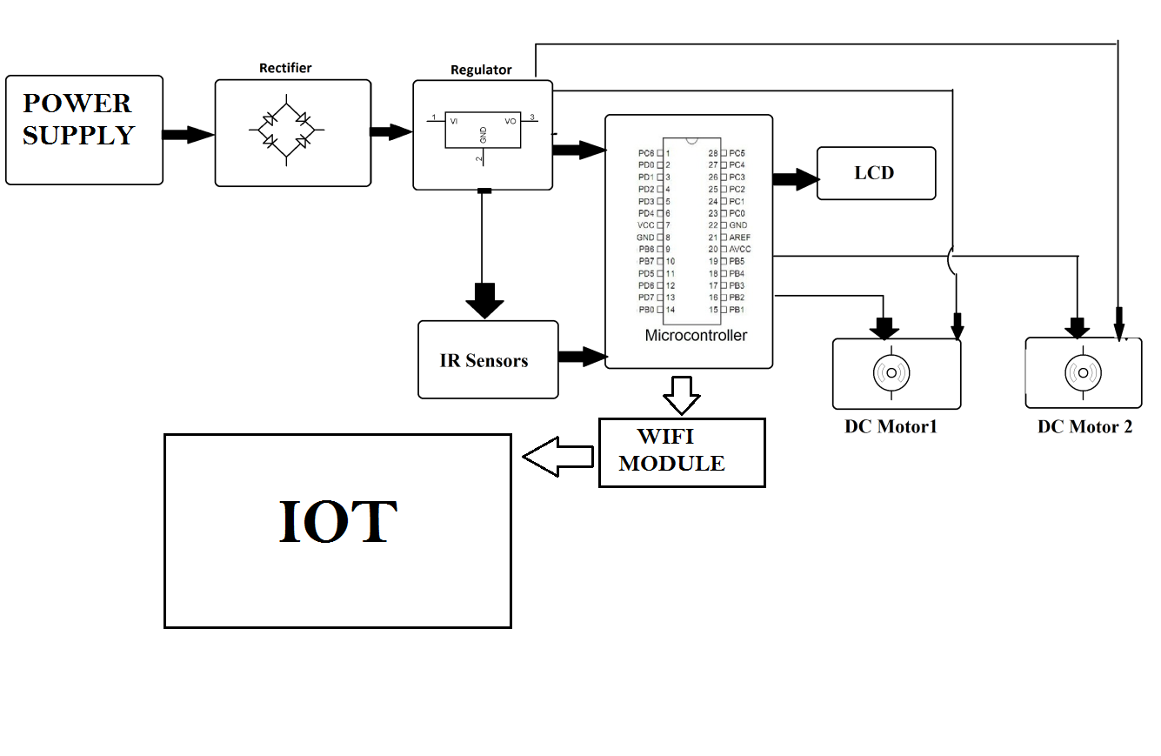**

**HARDWARE REQUIREMENTS**

* Atmega 328 Microcontroller
* WIFI MODULE
* LCD Display
* IR Sensors
* Motors
* Transformer
* Resistors
* Capacitors
* Diodes

**BATTERY**

An electrical battery is a combination of one or more electrochemical cells, used to convert stored chemical energy into electrical energy. The battery has become a common power source for many household and industrial applications.

Batteries may be used once and discarded, or recharged for years as in standby power applications. Miniature cells are used to power devices such as hearing aids and wristwatches; larger batteries provide standby power for telephone exchanges or computer data centers.

**WORKING OF BATTERY:**

A battery is a device that converts chemical energy directly to electrical energy. It consists of a number of voltaic cells; each voltaic cell consists of two half cells connected in series by a conductive electrolyte containing anions and cat ions. One half-cell includes electrolyte and the electrode to which anions (negatively-charged ions) migrate, i.e. the anode or negative electrode; the other half-cell includes electrolyte and the electrode to which cat ions (positively-charged ions) migrate, i.e. the cathode or positive electrode. In the red ox reaction that powers the battery, reduction (addition of electrons) occurs to cat ions at the cathode, while oxidation (removal of electrons) occurs to anions at the anode. The electrodes do not touch each other but are electrically connected by the electrolyte. Many cells use two half-cells with different electrolytes. In that case each half-cell is enclosed in a container, and a separator that is porous to ions but not the bulk of the electrolytes prevents mixing.

Each half cell has an electromotive force (or emf), determined by its ability to drive electric current from the interior to the exterior of the cell. The net emf of the cell is the difference between the emfs of its half-cells. Therefore, if the electrodes have emfs and, in other words, the net emf is the difference between the reduction potentials of the half-reactions.

The electrical driving force or across the terminals of a cell is known as the terminal voltage (difference) and is measured in volts. The terminal voltage of a cell that is neither charging nor discharging is called the open-circuit voltage and equals the emf of the cell. Because of internal resistance, the terminal voltage of a cell that is discharging is smaller in magnitude than the open-circuit voltage and the terminal voltage of a cell that is charging exceeds the open-circuit voltage. An ideal cell has negligible internal resistance, so it would maintain a constant terminal voltage of until exhausted, then dropping to zero. If such a cell maintained 1.5 volts and stored a charge of one Coulomb then on complete discharge it would perform 1.5 Joule of work. In actual cells, the internal resistance increases under discharge, and the open circuit voltage also decreases under discharge. If the voltage and resistance are plotted against time, the resulting graphs typically are a curve; the shape of the curve varies according to the chemistry and internal arrangement employed.

An electrical battery is one or more [electrochemical cells](http://en.wikipedia.org/wiki/Electrochemical_cell) that convert stored chemical [energy](http://en.wikipedia.org/wiki/Energy) into electrical energy. Since the invention of the first battery (or "[voltaic pile](http://en.wikipedia.org/wiki/Voltaic_pile)") in 1800 by [Alessandro Volta](http://en.wikipedia.org/wiki/Alessandro_Volta), batteries have become a common power source for many household and industrial applications. According to a 2005 estimate, the worldwide battery industry generates [US$](http://en.wikipedia.org/wiki/United_States_dollar)48 [billion](http://en.wikipedia.org/wiki/1000000000_%28number%29) in sales each year, with 6% annual growth. There are two types of batteries: [primary batteries](http://en.wikipedia.org/wiki/Primary_battery) (disposable batteries), which are designed to be used once and discarded, and [secondary batteries](http://en.wikipedia.org/wiki/Secondary_battery) (rechargeable batteries), which are designed to be recharged and used multiple times. Miniature cells are used to power devices such as hearing aids and wristwatches; larger batteries provide standby power for telephone exchanges or computer data centers.

## Principle of operation

A battery is a device that converts chemical energy directly to electrical energy. It consists of a number of voltaic cells; each voltaic cell consists of two [half cells](http://en.wikipedia.org/wiki/Half_cell) connected in series by a conductive electrolyte containing anions and cations. One half-cell includes electrolyte and the electrode to which [anions](http://en.wikipedia.org/wiki/Ion#Ions) (negatively charged ions) migrate, i.e., the [anode](http://en.wikipedia.org/wiki/Anode) or negative electrode; the other half-cell includes electrolyte and the electrode to which [cations](http://en.wikipedia.org/wiki/Ion#Ions) (positively charged ions) migrate, i.e., the [cathode](http://en.wikipedia.org/wiki/Cathode) or positive electrode. In the [redox](http://en.wikipedia.org/wiki/Redox) reaction that powers the battery, cations are reduced (electrons are added) at the cathode, while anions are oxidized (electrons are removed) at the anode. The electrodes do not touch each other but are electrically connected by the [electrolyte](http://en.wikipedia.org/wiki/Electrolyte). Some cells use two half-cells with different electrolytes. A separator between half cells allows ions to flow, but prevents mixing of the electrolytes.

Each half cell has an electromotive force (or emf), determined by its ability to drive electric current from the interior to the exterior of the cell. The net emf of the cell is the difference between the emfs of its half-cells, as first recognized by Volta. Therefore, if the electrodes have emfs \mathcal{E}_1and \mathcal{E}_2, then the net emf is \mathcal{E}_{2}-\mathcal{E}_{1}; in other words, the net emf is the difference between the [reduction potentials](http://en.wikipedia.org/wiki/Reduction_potential) of the [half-reactions](http://en.wikipedia.org/wiki/Half-reaction). The electrical driving force or \displaystyle{\Delta V_{bat}}across the terminals of a cell is known as the terminal voltage (difference) and is measured in [volts](http://en.wikipedia.org/wiki/Volt). The terminal voltage of a cell that is neither charging nor discharging is called the [open-circuit voltage](http://en.wikipedia.org/wiki/Open-circuit_voltage) and equals the emf of the cell. Because of internal resistance, the terminal voltage of a cell that is discharging is smaller in magnitude than the open-circuit voltage and the terminal voltage of a cell that is charging exceeds the open-circuit voltage. An ideal cell has negligible internal resistance, so it would maintain a constant terminal voltage of \mathcal{E}until exhausted, then dropping to zero. If such a cell maintained 1.5 volts and stored a charge of one [coulomb](http://en.wikipedia.org/wiki/Coulomb) then on complete discharge it would perform 1.5 [joule](http://en.wikipedia.org/wiki/Joule) of work. In actual cells, the internal resistance increases under discharge, and the open circuit voltage also decreases under discharge. If the voltage and resistance are plotted against time, the resulting graphs typically are a curve; the shape of the curve varies according to the chemistry and internal arrangement employed.

As stated above, the voltage developed across a cell's terminals depends on the energy release of the chemical reactions of its electrodes and electrolyte. Alkaline and [carbon-zinc](http://en.wikipedia.org/wiki/Zinc-carbon_battery) cells have different chemistries but approximately the same emf of 1.5 volts; likewise [NiCd](http://en.wikipedia.org/wiki/Nickel-cadmium_battery) and [NiMH](http://en.wikipedia.org/wiki/Nickel-metal_hydride_battery) cells have different chemistries, but approximately the same emf of 1.2 volts. On the other hand the high electrochemical potential changes in the reactions of [lithium](http://en.wikipedia.org/wiki/Lithium) compounds give lithium cells emfs of 3 volts or more.

**Lead-acid**

Tried, tested, and trusted, lead-acid batteries have been with us since the middle of the 19th century. With an overall rating of 12 volts, they have six separate cells, each producing 2 volts. Crudely reduced to its basic components, each cell has a "spongy" [lead](http://www.explainthatstuff.com/lead.html) metal electrode (negative), a lead dioxide electrode (positive), and a sulfuric acid electrolyte. As the battery discharges, both electrodes become coated with lead sulfate and the sulfuric acid is largely converted into water, while electrons flow out around the external circuit to provide power.

Lead-acid batteries made it possible to start cars without the help of a dangerous and dirty hand crank. Normally, you never have to recharge them—because your car does that automatically. The battery discharges (gives up a little of its energy) to help the car's [gasoline engine](http://www.explainthatstuff.com/carengines.html) start up, and recharges (gets energy back again) when the engine begins generating electrical energy through a device called an alternator. As for disadvantages, lead-acid batteries are relatively big, surprisingly heavy (try lifting one!), expensive, and can't be fully charged and discharged too many times. Another problem is their use of toxic lead metal, which can cause environmental problems when they're dumped in landfills.

**Nickel-cadmium**

Nickel-cadmium (NiCd, pronounced "nicad") are widely used as replacements for disposable 1.5-volt batteries in things like toys, flashlights, and power tools. They're relatively cheap, can be charged and discharged hundreds of times, and, properly treated, will last about a decade.

Although very dependable, it's often said that NiCd batteries need to be discharged fully before you charge them up or the amount of charge they will store (and their effective lifespan) can be greatly reduced. Opinions vary on whether this is true and, if so, why it happens, but as a rule of thumb, regularly discharging batteries completely and then recharging them is a good practice. Another problem with NiCd batteries is the toxic cadmium metal they contain. If they are buried in a landfill, instead of properly recycled, the cadmium can escape into the soil and could potentially [pollute](http://www.explainthatstuff.com/waterpollution.html) watercourses nearby.

**Nickel-metal-hydride (NiMH)**

Nickel metal hydride batteries work in a similar way, but suffer less from the so-called "memory effect." They became a popular alternative to NiCd batteries in the 1990s, partly because of environmental concerns about cadmium. NiMH batteries work more effectively in gadgets like cellphones, which are often "topped-up" with a quick recharge instead of a complete discharge and recharge (which is more typical with something like power tools).

**Lithium-ion**

Lithium-ion batteries are the fastest-growing type of rechargeables; there are probably lithium-ion batteries in your [cellphone](http://www.explainthatstuff.com/cellphones.html), [MP3 player](http://www.explainthatstuff.com/how-mp3players-work.html), and laptop [computer](http://www.explainthatstuff.com/howcomputerswork.html). What's so good about lithium? It's a lightweight metal that easily forms ions, so it's excellent for making batteries. The latest lithium-ion batteries can store about twice as much energy as traditional NiCd rechargeables, work at higher voltages, and are more environmentally friendly, but don't last as long. Even so, they can be charged and discharged hundreds of times and typically last several years, so they're great for everyday use in electronic gadgets that aren't meant to last that long.

How do they work? When you plug a cellphone or laptop into the power supply, the lithium-ion battery inside starts buzzing with chemical activity. The battery's job is to store as much electricity as possible, as fast as possible. It does this through a chemical reaction that shunts lithium ions (lithium atoms that have lost an electron to become positively charged) from one part of the battery to another. When you unplug the power and use your laptop or phone, the battery switches into reverse: the ions move the opposite way and the battery gradually loses its charge. Read more in our main article on [how lithium-ion batteries work](http://www.explainthatstuff.com/how-lithium-ion-batteries-work.html).

**4.2 VOLTAGE REGULATOR 7805**

**Features**

• Output Current up to 1A.

• Output Voltages of 5, 6, 8, 9, 10, 12, 15, 18, 24V.

• Thermal Overload Protection.

• Short Circuit Protection.

• Output Transistor Safe Operating Area Protection.

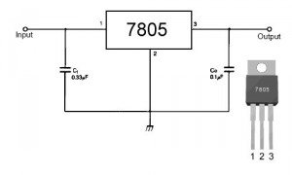

**Description**

The LM78XX/LM78XXA series of three-terminal positive regulators are available in the TO-220/D-PAK package and with several fixed output voltages, making them useful in a Wide range of applications. Each type employs internal current limiting, thermal shutdown and safe operating area protection, making it essentially indestructible. If adequate heat sinking is provided, they can deliver over 1A output Current. Although designed primarily as fixed voltage regulators, these devices can be used with external components to obtain adjustable voltages and currents.

**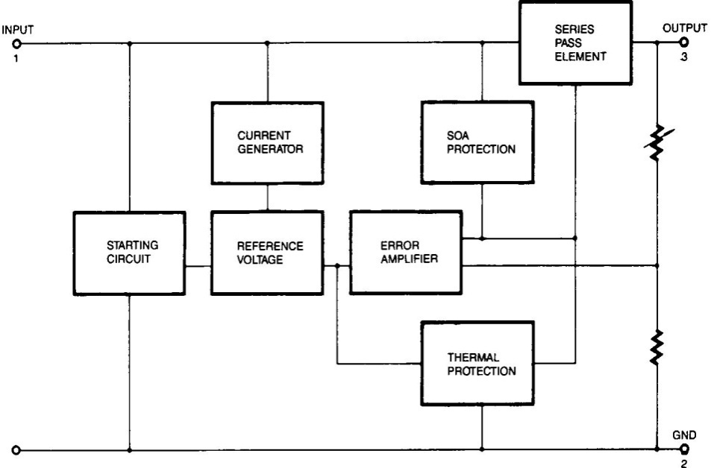Internal Block Diagram**

FIG 4.2(a): BLOCK DIAGRAM OF VOLTAGE REGULATOR

**Absolute Maximum Ratings**

**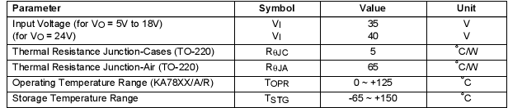**

TABLE 4.2(b): RATINGS OF THE VOLTAGE REGULATOR

[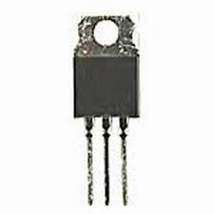](http://www.google.co.in/imgres?imgurl=http://www.evl.uic.edu/sjames/dvl/images/51262.jpg&imgrefurl=http://vinosysabores.com/voltage-regulator-7805&page=7&usg=__8M5wBB3ts7AF3gXgXNgYUtUKog4=&h=300&w=300&sz=7&hl=en&start=14&zoom=1&tbnid=gdGbqNw28x40UM:&tbnh=116&tbnw=116&ei=MRHeTdXKDo-8vgO735nABQ&prev=/search?q=voltage+regulator+7805&hl=en&sa=X&biw=1003&bih=539&tbm=isch&itbs=1)

**4.3 RECTIFIER**

A rectifier is an electrical device that converts alternating current (AC), which periodically reverses direction, to direct current (DC), current that flows in only one direction, a process known as rectification. Rectifiers have many uses including as components of power supplies and as detectors of radio signals. Rectifiers may be made of solid statediodes, vacuum tube diodes, mercury arc valves, and other components. The output from the transformer is fed to the rectifier. It converts A.C. into pulsating D.C. The rectifier may be a half wave or a full wave rectifier. In this project, a bridge rectifier is used because of its merits like good stability and full wave rectification. In positive half cycleonly two diodes( 1 set of parallel diodes) will conduct, in negative half cycle remaining two diodes will conduct and they will conduct only in forward bias only.

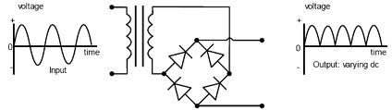

**FILTER**

Capacitive filter is used in this project. It removes the ripples from the output of rectifier and smoothens the D.C. Output received from this filter is constant until the mains voltage and load is maintained constant. However, if either of the two is varied, D.C. voltage received at this point changes. Therefore a regulator is applied at the output stage.

The simple capacitor filter is the most basic type of power supply filter. The use of this filter is very limited. It is sometimes used on extremely high-voltage, low-current power supplies for cathode-ray and similar electron tubes that require very little load current from the supply. This filter is also used in circuits where the power-supply ripple frequency is not critical and can be relatively high. Below figure can show how the capacitor changes and discharges.

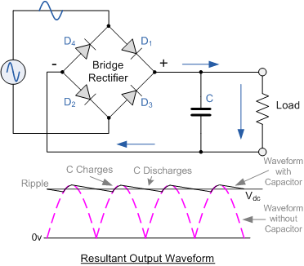

**ATMEGA328**

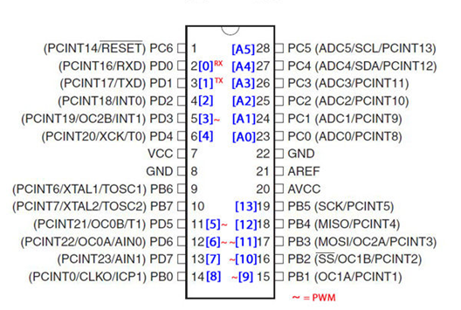

**Introduction:**

The Atmel ATmega328P is a 32K 8-bit microcontroller based on the AVR architecture. Many instructions are executed in a single clock cycle providing a throughput of almost 20 MIPS at 20MHz. The ATMEGA328-PU comes in an PDIP 28 pin package and is suitable for use on our [28 pin AVR Development Board](http://www.protostack.com/product_by_model.php?model=PB-MC-AVR28).

The computer on one hand is designed to perform all the general purpose tasks on a single machine like you can use a computer to run a software to perform calculations or you can use a computer to store some multimedia file or to access internet through the browser, whereas the microcontrollers are meant to perform only the specific tasks, for e.g., switching the AC off automatically when room temperature drops to a certain defined limit and again turning it ON when temperature rises above the defined limit.

There are number of popular families of microcontrollers which are used in different applications as per their capability and feasibility to perform the desired task, most common of these are 8051, AVR and PIC microcontrollers. In this we will introduce you with AVR family of microcontrollers.

**Features include:**

* High Performance, Low Power Design
* 8-Bit Microcontroller Atmel® AVR® advanced RISC architecture
  + 131 Instructions most of which are executed in a single clock cycle
  + Up to 20 MIPS throughput at 20 MHz
  + 32 x 8 working registers
  + 2 cycle multiplier
* Memory Includes
  + 32KB of of programmable FLASH
  + 1KB of EEPROM
  + 2KB SRAM
  + 10,000 Write and Erase Cycles for Flash and 100,000 for EEPROM
  + Data retention for 20 years at 85°C and 100 years at 25°C
  + Optional boot loader with lock bits
    - In System Programming (ISP) by via boot loader
    - True Read-While-Write operation
  + Programming lock available for software security
* Features Include
  + 2 x 8-bit Timers/Counters each with independent prescaler and compare modes
  + A single 16-bit Timer/Counter with an idependent prescaler, compare and capture modes
  + Real time counter with independent oscillator
  + 10 bit, 6 channel analog to digital Converter
  + 6 pulse width modulation channels
  + Internal temperature sensor
  + Serial USART (Programmable)
  + Master/Slave SPI Serial Interface - (Philips I2C compatible)
  + Programmable watchdog timer with independent internal oscillator
  + Internal analog comparator
  + Interrupt and wake up on pin change
* Additional Features Features
  + Internal calibrated oscillator
  + Power on reset and programmable brown out detection
  + External and internal interrupts
  + 6 sleep modes including idle, ADC noise reduction, power save, power down, standby, and extended standby
* I/O and Package
  + 23 programmable I/O lines
  + 28 pin PDIP package
* Operating voltage:
  + 1.8 - 5.5V
* Operating temperature range:
  + 40°C to 85°C
* Speed Grades:
  + 0-4 MHz at 1.8-5.5V
  + 0-10 MHz at 2.7-5.5V
  + 0-20 MHz at 4.5-5.5V
* Low power consumption mode at 1.8V, 1 MHz and 25°C:
  + Active Mode: 0.3 mA
  + Power-down Mode: 0.1 μA
  + Power-save Mode: 0.8 μA (Including 32 kHz RTC)

|  |  |
| --- | --- |
| Flash: | 32 KBytes |
| EEPROM: | 1 KBytes |
| SRAM: | 2 KBytes |
| Max I/O Pins: | 23 |
| Frequency Max: | 20 MHz |
| VCC: | 1.8-5.5 |
| 10-bit A/D Channels: | 6 |
| Analog Comparator: | Yes |
| 16-bit Timers: | 1 |
| 8-bit Timer: | 2 |
| Brown Out Detector: | Yes |
| Ext Interrupts: | 2 |
| Hardware Multiplier: | Yes |
| Interrupts: | 26 |
| ISP: | Yes |
| On Chip Oscillator: | Yes |
| PWM Channels: | 6 |
| RTC: | Yes |
| Self Program Memory: | Yes |
| SPI: | 1 |
| TWI: | Yes |
| UART: | 1 |
| Watchdog: | Yes |
| Pacakage: | Lead Free PDIP 28 |

In our days, there have been many advancement in the field of Electronics and many cutting edge technologies are being  developed every day, but still 8 bit microcontrollers have its own role in the digital electronics market dominated by 16-32 & 64 bit digital devices. Although powerful microcontrollers with higher processing capabilities exist in the market, 8bit microcontrollers still hold its value because of their easy-to-understand-operation, very much high popularity, ability to simplify a digital circuit, low cost compared to features offered, addition of many new features in a single IC and interest of manufacturers and consumers.

Today’s microcontrollers are much different from what it were in the initial stage, and the number of manufacturers are much more in count than it was a decade or two ago. At present some of the major manufacturers are Microchip (publication: PIC microcontrollers), Atmel (publication: AVR microcontrollers), Hitachi, Phillips, Maxim, NXP, Intel etc.  Our interest is upon ATmega32. It belongs to Atmel’s AVR series micro controller family. Let’s see the features.

**PIN count:** Atmega32 has got 40 pins. Two for Power (pin no.10: +5v, pin no. 11: ground), two for oscillator (pin 12, 13), one for reset (pin 9), three for providing necessary power and reference voltage to its internal ADC, and 32 (4×8) I/O pins.

**About I/O pins:** ATmega32 is capable of handling analogue inputs. Port A can be used as either DIGITAL I/O Lines or each individual pin can be used as a single input channel to the internal ADC of ATmega32, plus a pair of pins AREF, AVCC & GND (refer to [ATmega32 datasheet](http://www.atmel.com/Images/doc2503.pdf)) together can make an ADC channel.

No pins can perform and serve for two purposes (for an example: Port A pins cannot work as a Digital I/O pin while the Internal ADC is activated) at the same time. It’s the programmers responsibility to resolve the conflict in the circuitry and the program. Programmers are advised to have a look to the priority tables and the internal configuration from the datasheet.

**Digital I/O pins:** ATmega32 has 32 pins (4portsx8pins) configurable as Digital I/O pins.

**Timers:** 3 Inbuilt timer/counters, two 8 bit (timer0, timer2) and one 16 bit (timer1).

**ADC:** It has one successive approximation type ADC in which total 8 single channels are selectable. They can also be used as 7 (for TQFP packages) or 2 (for DIP packages) differential channels. Reference is selectable, either an external reference can be used or the internal 2.56V reference can be brought into action.  There external reference can be connected to the AREF pin.

**Communication Options:**  ATmega32 has three data transfer modules embedded in it. They are

* Two  Wire Interface
* USART
* Serial Peripheral Interface

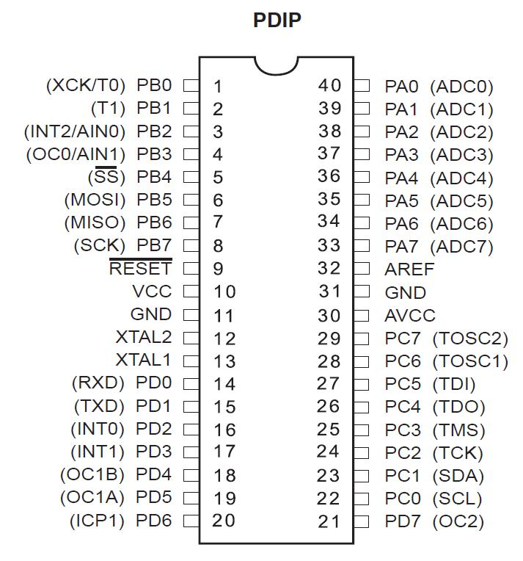

**Analog comparator:**  On-chip analog comparator is available. An interrupt is assigned for different comparison result obtained from the inputs.

**External Interrupt:** 3External interrupt is accepted. Interrupt sense is configurable.

**Memory:**  It has 32Kbytes of In-System Self-programmable Flash program memory, 1024 Bytes EEPROM, 2Kbytes Internal SRAM. Write/Erase Cycles: 10,000 Flash / 100,000 EEPROM.

**Clock:** It can run at a frequency from 1 to 16 MHz. Frequency can be obtained from external Quartz Crystal, Ceramic crystal or an R-C network. Internal calibrated RC oscillator can also be used.

**More Features**: Up to 16 MIPS throughput at 16MHz. Most of the instruction executes in a single cycle. Two cycle on-chip multiplication. 32 × 8 General Purpose Working Registers

**Debug:** JTAG boundary scan facilitates on chip debug.

**Programming:** Atmega32 can be programmed either by In-System Programming via Serial peripheral interface or by Parallel programming. Programming via JTAG interface is also possible. Programmer must ensure that SPI programming and JTAG are not be disabled using  fuse bits; if the programming is supposed to be done using SPI or JTAG.

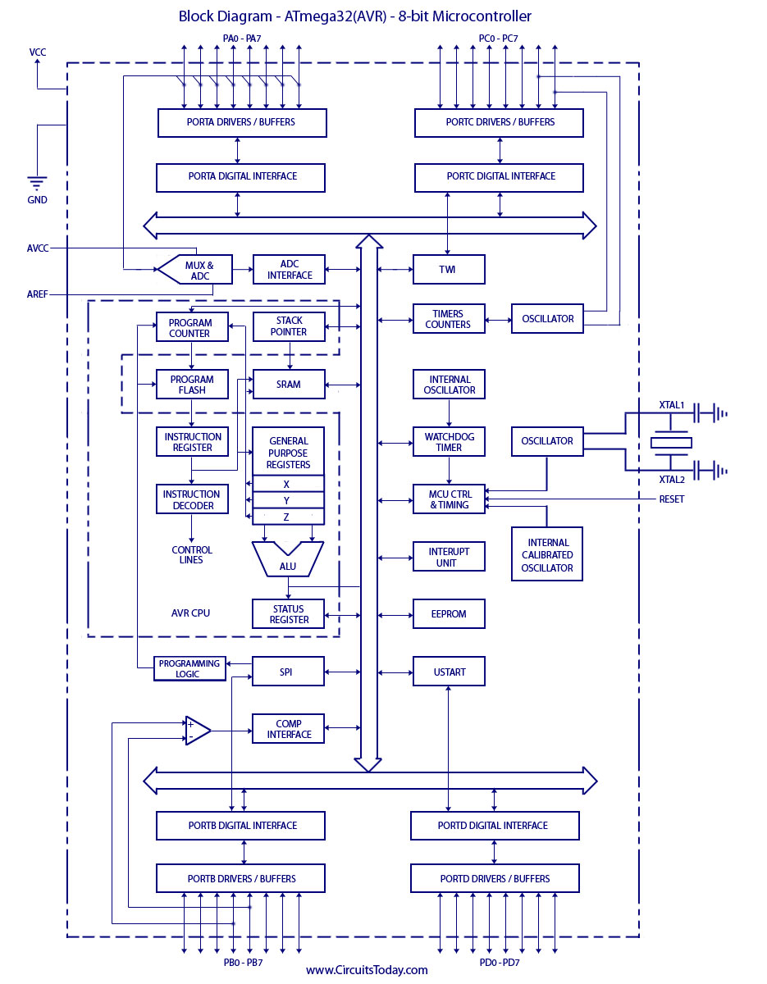

**IR LED**

An IR LED, also known as IR transmitter, is a special purpose LED that transmits infrared rays in the range of 760 nm wavelength. Such LEDs are usually made of gallium arsenide or aluminum gallium arsenide. They, along with IR receivers, are commonly used as sensors.

The appearance is same as a common LED. Since the human eye cannot see the infrared radiations, it is not possible for a person to identify whether the IR LED is working or not, unlike a common LED. To overcome this problem, the camera on a cell phone can be used. The camera can show us the IR rays being emanated from the IR LED in a circuit.

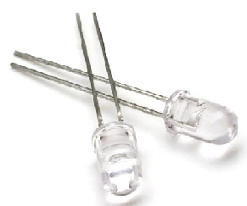

**Features**

* Extra high radiant power
* low forward voltage
* suitable for high pulse current operation intensity
* high reliability

**Chip Materials**

* Dice Material : GaA1As/GaAs
* Lens Color : Water Clear

**Difference between white LED and IR LED**

There are a couple key differences in the electrical characteristics of infrared LEDs versus visible light LEDs. Infrared LEDs have a lower forward voltage, and a higher rated current compared to visible LEDs. This is due to differences in the material properties of the junction. A typical drive current for an infrared LED can be as high as 50 milliamps, so dropping in a visible LED as a replacement for an infrared LED could be a problem with some circuit designs.

IR LEDs aren’t rated in millicandelas, since their output isn’t visible (and candelas measure light in a way weighted to the peak of the visible spectrum). They are usually rated in milliwatts, and conversions to candelas aren’t especially meaningful.

**LED**

A light-emitting diode (LED) is a [semiconductor](http://en.wikipedia.org/wiki/Semiconductor) light source. LEDs are used as indicator lamps in many devices, and are increasingly used for [lighting](http://en.wikipedia.org/wiki/Lighting). When a light-emitting [diode](http://en.wikipedia.org/wiki/Semiconductor_diode) is forward biased (switched on), [electrons](http://en.wikipedia.org/wiki/Electrons) are able to [recombine](http://en.wikipedia.org/wiki/Carrier_generation_and_recombination) with [holes](http://en.wikipedia.org/wiki/Electron_hole) within the device, releasing energy in the form of [photons](http://en.wikipedia.org/wiki/Photon).

This effect is called [electroluminescence](http://en.wikipedia.org/wiki/Electroluminescence) and the [color](http://en.wikipedia.org/wiki/Color) of the light (corresponding to the energy of the photon) is determined by the [energy gap](http://en.wikipedia.org/wiki/Energy_gap) of the semiconductor. An LED is often small in area (less than 1 mm2), and integrated optical components may be used to shape its radiation pattern. LEDs present many [advantages](http://en.wikipedia.org/wiki/Led#Advantages) over incandescent light sources including [lower energy consumption](http://en.wikipedia.org/wiki/Energy_conservation), longer [lifetime](http://en.wikipedia.org/wiki/Service_life), improved robustness, smaller size, faster switching, and greater durability and reliability.

**Types of LED’S**

[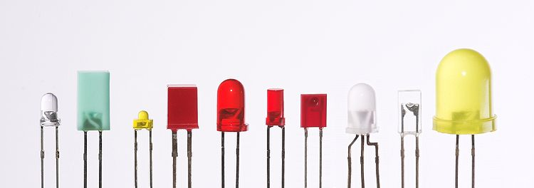](http://en.wikipedia.org/wiki/File:Verschiedene_LEDs.jpg)

Fig 4.11(a): Types of LED

Light-emitting diodes are used in applications as diverse as replacements for [aviation lighting](http://en.wikipedia.org/wiki/Navigation_light#Aviation_navigation_lights), [automotive lighting](http://en.wikipedia.org/wiki/Automotive_lighting#Light_emitting_diodes_.28LED.29) as well as in [traffic signals](http://en.wikipedia.org/wiki/Traffic_signal). The compact size, the possibility of narrow bandwidth, switching speed, and extreme reliability of LEDs has allowed new text and video displays and sensors to be developed, while their high switching rates are also useful in advanced communications technology.

**Electronic Symbol:**

[LED symbol.svg](http://en.wikipedia.org/wiki/File:LED_symbol.svg)

Fig 4.11(b): symbol of LED

**RESISTORS**

A resistor is a two-terminal electronic component designed to oppose an electric current by producing a voltage drop between its terminals in proportion to the current, that is, in accordance with Ohm's law:

V = IR

Resistors are used as part of electrical networks and electronic circuits. They are extremely commonplace in most electronic equipment. Practical resistors can be made of various compounds and films, as well as resistance wire (wire made of a high-resistivity alloy, such as nickel/chrome).

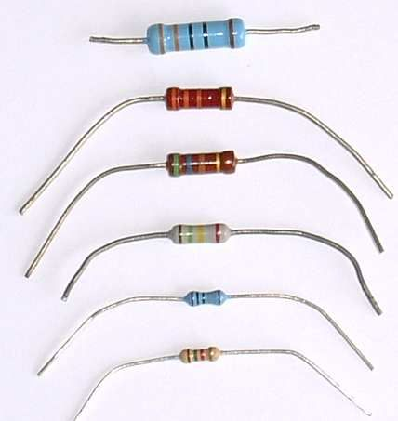

The primary characteristics of resistors are their resistance and the power they can dissipate. Other characteristics include temperature coefficient, noise, and inductance. Less well-known is critical resistance, the value below which power dissipation limits the maximum permitted current flow, and above which the limit is applied voltage. Critical resistance depends upon the materials constituting the resistor as well as its physical dimensions; it's determined by design.

Resistors can be integrated into hybrid and printed circuits, as well as integrated circuits. Size, and position of leads (or terminals) are relevant to equipment designers; resistors must be physically large enough not to overheat when dissipating their power.

A resistor is a two-terminalpassiveelectronic component which implements electrical resistance as a circuit element. When a voltage V is applied across the terminals of a resistor, a current I will flow through the resistor in direct proportion to that voltage. The reciprocal of the constant of proportionality is known as the resistance R, since, with a given voltage V, a larger value of R further "resists" the flow of current I as given by Ohm's law:

I = {V \over R}

Resistors are common elements of electrical networks and electronic circuits and are ubiquitous in most electronic equipment. Practical resistors can be made of various compounds and films, as well as resistance wire (wire made of a high-resistivity alloy, such as nickel-chrome). Resistors are also implemented within integrated circuits, particularly analog devices, and can also be integrated into hybrid and printed circuits.

The electrical functionality of a resistor is specified by its resistance: common commercial resistors are manufactured over a range of more than 9 orders of magnitude. When specifying that resistance in an electronic design, the required precision of the resistance may require attention to the manufacturing tolerance of the chosen resistor, according to its specific application. The temperature coefficient of the resistance may also be of concern in some precision applications. Practical resistors are also specified as having a maximum power rating which must exceed the anticipated power dissipation of that resistor in a particular circuit: this is mainly of concern in power electronics applications. Resistors with higher power ratings are physically larger and may require heat sinking. In a high voltage circuit, attention must sometimes be paid to the rated maximum working voltage of the resistor.

The series inductance of a practical resistor causes its behaviour to depart from ohms law; this specification can be important in some high-frequency applications for smaller values of resistance. In a low-noise amplifier or pre-amp the noise characteristics of a resistor may be an issue. The unwanted inductance, excess noise, and temperature coefficient are mainly dependent on the technology used in manufacturing the resistor. They are not normally specified individually for a particular family of resistors manufactured using a particular technology.[[1]](http://en.wikipedia.org/wiki/Resistor#cite_note-0) A family of discrete resistors is alsocharacterized according to its form factor, that is, the size of the device and position of its leads (or terminals) which is relevant in the practical manufacturing of circuits using them.

## Units

The ohm (symbol: Ω) is the SI unit of electrical resistance, named after Georg Simon Ohm. An ohm is equivalent to a volt per ampere. Since resistors are specified and manufactured over a very large range of values, the derived units of milliohm (1 mΩ = 10−3 Ω), kilohm (1 kΩ = 103 Ω), and megohm (1 MΩ = 106 Ω) are also in common usage.

The reciprocal of resistance R is called conductance G = 1/R and is measured in Siemens (SI unit), sometimes referred to as a mho. Thus a Siemens is the reciprocal of an ohm: *S* = Ω − 1. Although the concept of conductance is often used in circuit analysis, practical resistors are always specified in terms of their resistance (ohms) rather than conductance.

**4.16 CAPACITORS**

A capacitor or condenser is a passive electronic component consisting of a pair of conductors separated by a dielectric. When a voltage potential difference exists between the conductors, an electric field is present in the dielectric. This field stores energy and produces a mechanical force between the plates. The effect is greatest between wide, flat, parallel, narrowly separated conductors.

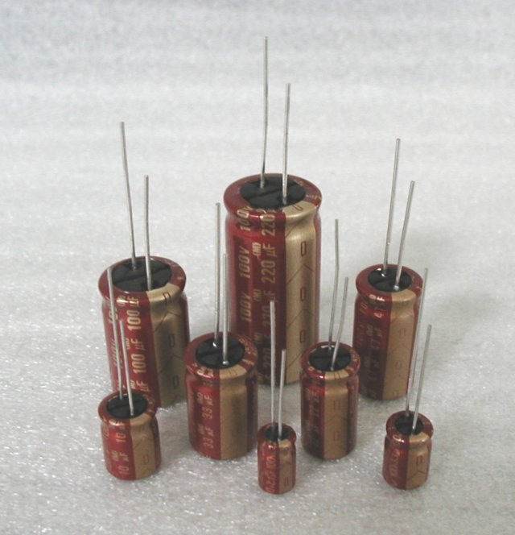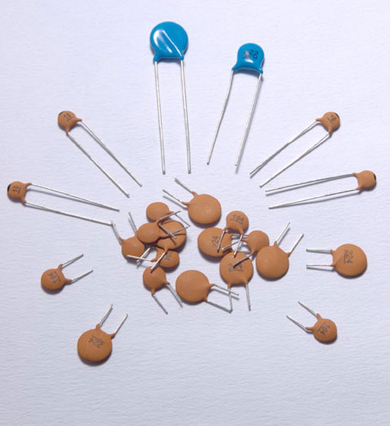

An ideal capacitor is characterized by a single constant value, capacitance, which is measured in farads. This is the ratio of the electric charge on each conductor to the potential difference between them. In practice, the dielectric between the plates passes a small amount of leakage current. The conductors and leads introduce an equivalent series resistance and the dielectric has an electric field strength limit resulting in a breakdown voltage.

The properties of capacitors in a circuit may determine the resonant frequency and quality factor of a resonant circuit, power dissipation and operating frequency in a digital logic circuit, energy capacity in a high-power system, and many other important aspects.

A capacitor (formerly known as condenser) is a device for storing electric charge. The forms of practical capacitors vary widely, but all contain at least two conductors separated by a non-conductor. Capacitors used as parts of electrical systems, for example, consist of metal foils separated by a layer of insulating film.

Capacitors are widely used in electronic circuits for blocking direct current while allowing alternating current to pass, in filter networks, for smoothing the output of power supplies, in the resonant circuits that tune radios to particular frequencies and for many other purposes.

A capacitor is a passiveelectronic component consisting of a pair of conductors separated by a dielectric (insulator). When there is a potential difference (voltage) across the conductors, a static electric field develops in the dielectric that stores energy and produces a mechanical force between the conductors. An ideal capacitor is characterized by a single constant value, capacitance, measured in farads. This is the ratio of the electric charge on each conductor to the potential difference between them.

The capacitance is greatest when there is a narrow separation between large areas of conductor, hence capacitor conductors are often called "plates", referring to an early means of construction. In practice the dielectric between the plates passes a small amount of leakage current and also has an electric field strength limit, resulting in a breakdown voltage, while the conductors and leads introduce an undesired inductance and resistance.

## Theory of operation

Capacitance

[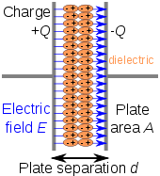](http://en.wikipedia.org/wiki/File:Capacitor_schematic_with_dielectric.svg)

Charge separation in a parallel-plate capacitor causes an internal electric field. A dielectric (orange) reduces the field and increases the capacitance.

[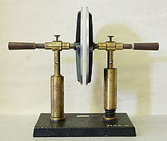](http://en.wikipedia.org/wiki/File:Plattenkondensator_hg.jpg)

A simple demonstration of a parallel-plate capacitor

A capacitor consists of two conductors separated by a non-conductive region The non-conductive region is called the dielectric or sometimes the dielectric medium. In simpler terms, the dielectric is just an electrical insulator. Examples of dielectric mediums are glass, air, paper, vacuum, and even a semiconductordepletion region chemically identical to the conductors. A capacitor is assumed to be self-contained and isolated, with no net electric charge and no influence from any external electric field. The conductors thus hold equal and opposite charges on their facing surfaces, and the dielectric develops an electric field. In SI units, a capacitance of one farad means that one coulomb of charge on each conductor causes a voltage of one volt across the device. The capacitor is a reasonably general model for electric fields within electric circuits. An ideal capacitor is wholly characterized by a constant capacitance C, defined as the ratio of charge ±Q on each conductor to the voltage V between them:

C= \frac{Q}{V}

Sometimes charge build-up affects the capacitor mechanically, causing its capacitance to vary. In this case, capacitance is defined in terms of incremental changes:

C= \frac{\mathrm{d}q}{\mathrm{d}v}

### Energy storage

Work must be done by an external influence to "move" charge between the conductors in a capacitor. When the external influence is removed the charge separation persists in the electric field and energy is stored to be released when the charge is allowed to return to its equilibrium position. The work done in establishing the electric field, and hence the amount of energy stored, is given by:

W= \int_{q=0}^Q V \text{d}q = \int_{q=0}^Q \frac{q}{C} \text{d}q = {1 \over 2} {Q^2 \over C} = {1 \over 2}  C V^2 = {1 \over 2} VQ.

### Current-voltage relation

The current i(t) through any component in an electric circuit is defined as the rate of flow of a charge q(t) passing through it, but actual charges, electrons, cannot pass through the dielectric layer of a capacitor, rather an electron accumulates on the negative plate for each one that leaves the positive plate, resulting in an electron depletion and consequent positive charge on one electrode that is equal and opposite to the accumulated negative charge on the other. Thus the charge on the electrodes is equal to the integral of the current as well as proportional to the voltage as discussed above. As with any ant derivative, a constant of integration is added to represent the initial voltage v (t0). This is the integral form of the capacitor equation,

v(t)= \frac{q(t)}{C} = \frac{1}{C}\int_{t_0}^t i(\tau) \mathrm{d}\tau+v(t_0).

Taking the derivative of this, and multiplying by C, yields the derivative form,

i(t)= \frac{\mathrm{d}q(t)}{\mathrm{d}t}=C\frac{\mathrm{d}v(t)}{\mathrm{d}t}.

The dual of the capacitor is the inductor, which stores energy in the magnetic field rather than the electric field. Its current-voltage relation is obtained by exchanging current and voltage in the capacitor equations and replacing C with the inductance L.

**TRANSISTOR (BC 547)**

**TECHNICAL SPECIFICATIONS:**

The BC547 transistor is an NPN Epitaxial Silicon Transistor. The BC547 transistor is a general-purpose transistor in small plastic packages. It is used in general-purpose switching and amplification BC847/BC547 series 45 V, 100 mA NPN general-purpose transistors.

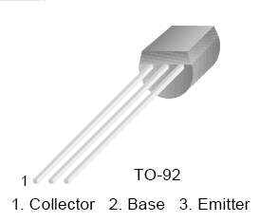

BC 547 TRANSISTOR PINOUTS

We know that the transistor is a "CURRENT" operated device and that a large current (Ic) flows freely through the device between the collector and the emitter terminals. However, this only happens when a small biasing current (Ib) is flowing into the base terminal of the transistor thus allowing the base to act as a sort of current control input. The ratio of these two currents (Ic/Ib) is called the DC Current Gain of the device and is given the symbol of hfe or nowadays Beta, (β). Beta has no units as it is a ratio. Also, the current gain from the emitter to the collector terminal, Ic/Ie, is called Alpha, (α), and is a function of the transistor itself. As the emitter current Ie is the product of a very small base current to a very large collector current the value of this parameter α is very close to unity, and for a typical low-power signal transistor this value ranges from about 0.950 to 0.999.

**An NPN Transistor Configuration**

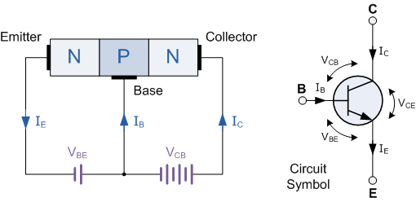

**PHOTODIODES**

A photodiode is a type of photo detector capable of converting light into either current or voltage, depending upon the mode of operation. Photodiodes are similar to regular semiconductor diodes except that they may be either exposed (to detect vacuum UV or X-rays) or packaged with a window or optical fibre connection to allow light to reach the sensitive part of the device. Many diodes designed for use specifically as a photodiode will also use a PIN junction rather than the typical PN junction.

## http://www.takeoutrecordsny.com/SEAI/ElectronicsSymbols_files/image039.gifhttp://4.bp.blogspot.com/_RA2btAL9GeE/SL1ReSw_DjI/AAAAAAAAAPA/hmpVOR-h0eA/s400/Photodiode.jpg

## Principle of operation

A photodiode is a PN junction or PIN structure. When a photon of sufficient energy strikes the diode, it excites an electron, thereby creating a mobile electron and a positively charged electron hole. If the absorption occurs in the junction's depletion region, or one diffusion length away from it, these carriers are swept from the junction by the built-in field of the depletion region. Thus holes move toward the anode, and electrons toward the cathode, and a photocurrent is produced.

### Photovoltaic mode

When used in zero bias or photovoltaic mode, the flow of photocurrent out of the device is restricted and a voltage builds up. The diode becomes forward biased and "dark current" begins to flow across the junction in the direction opposite to the photocurrent. This mode is responsible for the photovoltaic effect, which is the basis for solar cells—in fact, a solar cell is just a large area photodiode.

**Photoconductive mode**

In this mode the diode is often reverse biased, dramatically reducing the response time at the expense of increased noise. This increases the width of the depletion layer, which decreases the junction's capacitance resulting in faster response times. The reverse bias induces only a small amount of current (known as saturation or back current) along its direction while the photocurrent remains virtually the same. The photocurrent is linearly proportional to the luminance

Although this mode is faster, the photoconductive mode tends to exhibit more electronic noise. The leakage current of a good PIN diode is so low (< 1nA) that the Johnson–Nyquist noise of the load resistance in a typical circuit often dominates.

**H-BRIDGE**

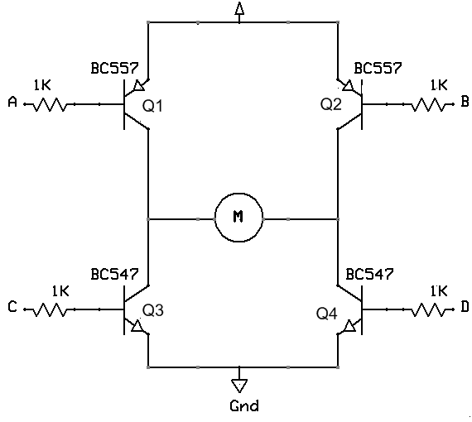These solid state circuits provide power and ground connections to the motor, as did the relay circuits. The high side drivers need to be current "sources" which is what PNP transistors and P-channel FETs are good at. The low side drivers need to be current "sinks" which is what NPN transistors and N-channel FETs are good at.

If you turn on the two upper circuits, the motor resists turning, so you effectively have a breaking mechanism. The same is true if you turn on both of the lower circuits. This is because the motor is a generator and when it turns it generates a voltage. If the terminals of the motor are connected (shorted), then the voltage generated counteracts the motors freedom to turn. It is as if you are applying a similar but opposite voltage to the one generated by the motor being turned. Vis-ã-vis, it acts like a brake.

**MOTOR DRIVER (L293D)**

**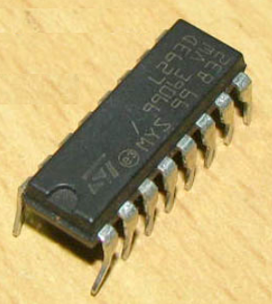Features:**

* Wide supply-voltage range: 4.5V to 36V
* Separate input- logic supply
* Internal ESD protection
* Thermal shutdown
* High-Noise-Immunity input
* Functional Replacements for SGS L293 and SGS L293D
* Output current 1A per channel (600 mA for L293D)
* Peak output current 2 A per channel (1.2 A for L293D)
* Output clamp diodes for Inductive Transient Suppression(L293D)

**DESCRIPTION:**

L293D is a dual H-bridge motor driver integrated circuit (IC). Motor drivers act as current amplifiers since they take a low-current control signal and provide a higher-current signal. This higher current signal is used to drive the motors.

L293D contains two inbuilt H-bridge driver circuits. In its common mode of operation, two DC motors can be driven simultaneously, both in forward and reverse direction. The motor operations of two motors can be controlled by input logic at pins 2 & 7 and 10 & 15. Input logic 00 or 11 will stop the corresponding motor. Logic 01 and 10 will rotate it in clockwise and anticlockwise directions, respectively.

Enable pins 1 and 9 (corresponding to the two motors) must be high for motors to start operating. When an enable input is high, the associated driver gets enabled. As a result, the outputs become active and work in phase with their inputs. Similarly, when the enable input is low, that driver is disabled, and their outputs are off and in the high-impedance state.

**Block diagram:**

**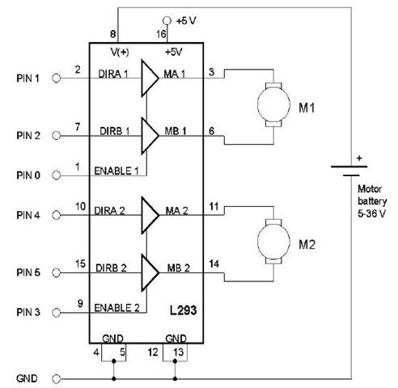**

FIG: BLOCK DIAGRAM OF L293D

**Pin Diagram:**

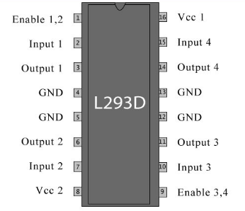

**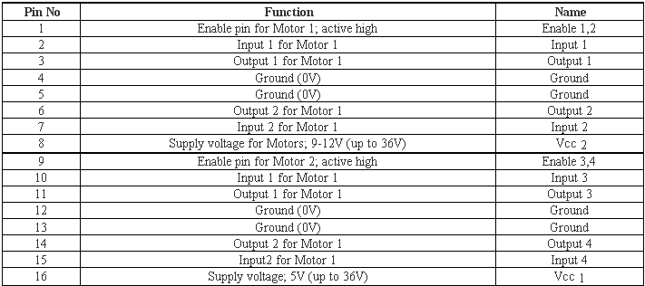 Pin description:**

**DC MOTOR**

**What is DC Motor?**

A DC motor is an electric motor that runs on direct current (DC) electricity. In any electric motor, operation is based on simple electromagnetism. A [current](http://encyclobeamia.solarbotics.net/articles/current.html)-carrying conductor generates a magnetic field; when this is then placed in an external magnetic field, it will experience a force proportional to the [current](http://encyclobeamia.solarbotics.net/articles/current.html) in the conductor, and to the strength of the external magnetic field. As you are well aware of from playing with magnets as a kid, opposite (North and South) polarities attract, while like polarities (North and North, South and South) repel. The internal configuration of a [DC](http://encyclobeamia.solarbotics.net/articles/dc.html) motor is designed to harness the magnetic interaction between a [current](http://encyclobeamia.solarbotics.net/articles/current.html)-carrying conductor and an external magnetic field to generate rotational motion.

Let's start by looking at a simple 2-pole [DC](http://encyclobeamia.solarbotics.net/articles/dc.html) electric motor (here red represents a magnet or winding with a "North" polarization, while green represents a magnet or winding with a "South" polarization).

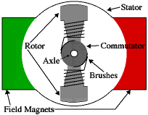

Fig.4.8(c) DC motor

Every [DC](http://encyclobeamia.solarbotics.net/articles/dc.html) motor has six basic parts -- axle, rotor (a.k.a., armature), stator, commutator, field magnet(s), and brushes. In most common DC motors, the external magnetic field is produced by high-strength permanent magnets1. The stator is the stationary part of the motor -- this includes the motor casing, as well as two or more permanent magnet pole pieces. The rotor rotates with respect to the stator. The rotor consists of windings (generally on a core), the windings being electrically connected to the commutator. The above diagram shows a common motor layout -- with the rotor inside the stator (field) magnets.

The geometry of the brushes, commutator contacts, and rotor windings are such that when power is applied, the polarities of the energized winding and the stator magnet(s) are misaligned, and the rotor will rotate until it is almost aligned with the stator's field magnets. As the rotor reaches alignment, the brushes move to the next commutator contacts, and energize the next winding. Given our example two-pole motor, the rotation reverses the direction of [current](http://encyclobeamia.solarbotics.net/articles/current.html) through the rotor winding, leading to a "flip" of the rotor's magnetic field, driving it to continue rotating.

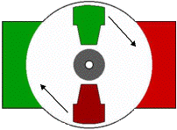

In real life, though, [DC](http://encyclobeamia.solarbotics.net/articles/dc.html) motors will always have more than two poles (three is a very common number). In particular, this avoids "dead spots" in the commutator. You can imagine how with our example two-pole motor, if the rotor is exactly at the middle of its rotation (perfectly aligned with the field magnets), it will get "stuck" there. Meanwhile, with a two-pole motor, there is a moment where the commutator shorts out the power supply (i.e., both brushes touch both commutator contacts simultaneously). This would be bad for the power supply, waste energy, and damage motor components as well. Yet another disadvantage of such a simple motor is that it would exhibit a high amount of [torque](http://encyclobeamia.solarbotics.net/articles/torque.html) "ripple".

So since most small [DC](http://encyclobeamia.solarbotics.net/articles/dc.html) motors are of a three-pole design, let's tinker with the workings of one via an interactive animation (JavaScript required):

|  |  |
| --- | --- |
| Image |  |

You'll notice a few things from this -- namely, one pole is fully energized at a time (but two others are "partially" energized). As each brush transitions from one commutator contact to the next, one coil's field will rapidly collapse, as the next coil's field will rapidly charge up (this occurs within a few microsecond). We'll see more about the effects of this later, but in the meantime you can see that this is a direct result of the coil windings' series wiring.

**LIQUID CRYSTAL DISPLAY (LCD)**

This is the first interfacing example for the Parallel Port. We will start with something simple. This example doesn't use the Bi-directional feature found on newer ports, thus it should work with most, if no all Parallel Ports. It however doesn't show the use of the Status Port as an input. For a 16 Character x 2 Line LCD Module to the Parallel Port. These LCD Modules are very common these days, and are quite simple to work with, as all the logic required running them is on board.

**LCD Background:**

Frequently, an 8051 program must interact with the outside world using input and output devices that communicate directly with a human being. One of the most common devices attached to an 8051 is an LCD display. Some of the most common LCDs connected to the 8051 are 16x2 and 20x2 displays. This means 16 characters per line by 2 lines and 20 characters per line by 2 lines, respectively.

Fortunately, a very popular standard exists which allows us to communicate with the vast majority of LCDs regardless of their manufacturer. The standard is referred to as HD44780U, which refers to the controller chip which receives data from an external source (in this case, the 8051) and communicates directly with the LCD.

[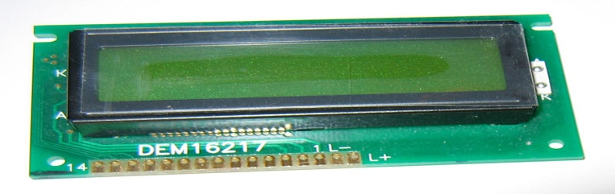](http://upload.wikimedia.org/wikipedia/commons/2/24/LCD_display_16x2_alphanumeric.jpg)

Fig 4.8: LCD

**44780 LCD BACKGROUND**

The 44780 standard requires 3 control lines as well as either 4 or 8 I/O lines for the data bus. The user may select whether the LCD is to operate with a 4-bit data bus or an 8-bit data bus. If a 4-bit data bus is used the LCD will require a total of 7 data lines (3 control lines plus the 4 lines for the data bus). If an 8-bit data bus is used the LCD will require a total of 11 data lines (3 control lines plus the 8 lines for the data bus).

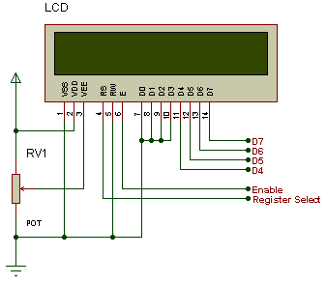

The three control lines are referred to as **EN**, **RS**, and **RW**.

The **EN** line is called "Enable." This control line is used to tell the LCD that you are sending it data. To send data to the LCD, your program should make sure this line is low (0) and then set the other two control lines and/or put data on the data bus. When the other lines are completely ready, bring **EN** high (1) and wait for the minimum amount of time required by the LCD datasheet (this varies from LCD to LCD), and end by bringing it low (0) again.

The **RS** line is the "Register Select" line. When RS is low (0), the data is to be treated as a command or special instruction (such as clear screen, position cursor, etc.). When RS is high (1), the data being sent is text data which should be displayed on the screen. For example, to display the letter "T" on the screen you would set RS high.

The **RW** line is the "Read/Write" control line. When RW is low (0), the information on the data bus is being written to the LCD. When RW is high (1), the program is effectively querying (or reading) the LCD. Only one instruction ("Get LCD status") is a read command. All others are write commands--so RW will almost always be low.

Finally, the data bus consists of 4 or 8 lines (depending on the mode of operation selected by the user). In the case of an 8-bit data bus, the lines are referred to as DB0, DB1, DB2, DB3, DB4, DB5, DB6, and DB7.

**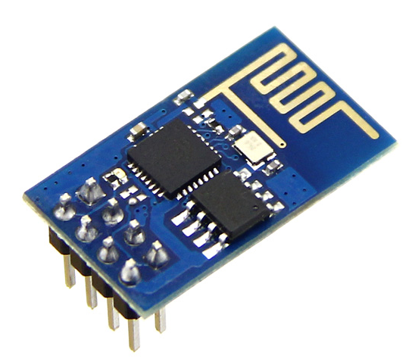WIFI Modem:**

The ESP8266 WiFi Module is a self contained SOC with integrated TCP/IP protocol stack that can give any microcontroller access to your WiFi network. The ESP8266 is capable of either hosting an application or offloading all Wi-Fi networking functions from another application processor. Each ESP8266 module comes pre-programmed with an AT command set firmware. The ESP8266 module is an extremely cost effective board with a huge, and ever growing, community.

This module has a powerful enough on-board processing and storage capability that allows it to be integrated with the sensors and other application specific devices through its GPIOs with minimal development up-front and minimal loading during runtime. Its high degree of on-chip integration allows for minimal external circuitry, including the front-end module, is designed to occupy minimal PCB area. The ESP8266 supports APSD for VoIP applications and Bluetooth co-existance interfaces, it contains a self-calibrated RF allowing it to work under all operating conditions, and requires no external RF parts.

There is an almost limitless fountain of information available for the ESP8266, all of which has been provided by amazing community support. In the Documents section below you will find many resources to aid you in using the ESP8266, even instructions on how to transforming this module into an IoT (Internet of Things) solution!

Note: The ESP8266 Module is not capable of 5-3V logic shifting and will require an external Logic Level Converter. Please do not power it directly from your 5V dev board.

**Features:**

802.11 b/g/n

Wi-Fi Direct (P2P), soft-AP

Integrated TCP/IP protocol stack

Integrated TR switch, balun, LNA, power amplifier and matching network

Integrated PLLs, regulators, DCXO and power management units

+19.5dBm output power in 802.11b mode

Power down leakage current of <10uA

1MB Flash Memory

Integrated low power 32-bit CPU could be used as application processor

SDIO 1.1 / 2.0, SPI, UART

STBC, 1×1 MIMO, 2×1 MIMO

A-MPDU & A-MSDU aggregation & 0.4ms guard interval

Wake up and transmit packets in < 2ms

Standby power consumption of < 1.0mW (DTIM3)

**SOFTWARE REQUIREMENTS**

**Arduino**

Arduino is an open-source prototyping platform based on easy-to-use hardware and software. [Arduino boards](https://www.arduino.cc/en/Main/Products) are able to read inputs - light on a sensor, a finger on a button, or a Twitter message - and turn it into an output - activating a motor, turning on an LED, publishing something online. You can tell your board what to do by sending a set of instructions to the microcontroller on the board. To do so you use the [Arduino programming language](https://www.arduino.cc/en/Reference/HomePage) (based on[Wiring](http://wiring.org.co/)), and [the Arduino Software (IDE)](https://www.arduino.cc/en/Main/Software), based on [Processing](https://processing.org/).

Over the years Arduino has been the brain of thousands of projects, from everyday objects to complex scientific instruments. A worldwide community of makers - students, hobbyists, artists, programmers, and professionals - has gathered around this open-source platform, their contributions have added up to an incredible amount of [accessible knowledge](http://forum.arduino.cc/) that can be of great help to novices and experts alike.

Arduino was born at the Ivrea Interaction Design Institute as an easy tool for fast prototyping, aimed at students without a background in electronics and programming. As soon as it reached a wider community, the Arduino board started changing to adapt to new needs and challenges, differentiating its offer from simple 8-bit boards to products for IoT applications, wearable, 3D printing, and embedded environments. All Arduino boards are completely open-source, empowering users to build them independently and eventually adapt them to their particular needs. The [software](https://www.arduino.cc/en/Main/Software), too, is open-source, and it is growing through the contributions of users worldwide.

### Why Arduino?

Thanks to its simple and accessible user experience, Arduino has been used in thousands of different projects and applications. The Arduino software is easy-to-use for beginners, yet flexible enough for advanced users. It runs on Mac, Windows, and Linux. Teachers and students use it to build low cost scientific instruments, to prove chemistry and physics principles, or to get started with programming and robotics. Designers and architects build interactive prototypes, musicians and artists use it for installations and to experiment with new musical instruments. Makers, of course, use it to build many of the projects exhibited at the Maker Faire, for example. Arduino is a key tool to learn new things. Anyone - children, hobbyists, artists, programmers - can start tinkering just following the step by step instructions of a kit, or sharing ideas online with other members of the Arduino community.

There are many other microcontrollers and microcontroller platforms available for physical computing. Parallax Basic Stamp, Netmedia's BX-24, Phidgets, MIT's Handyboard, and many others offer similar functionality. All of these tools take the messy details of microcontroller programming and wrap it up in an easy-to-use package. Arduino also simplifies the process of working with microcontrollers, but it offers some advantage for teachers, students, and interested amateurs over other systems:

* Inexpensive - Arduino boards are relatively inexpensive compared to other microcontroller platforms. The least expensive version of the Arduino module can be assembled by hand, and even the pre-assembled Arduino modules cost less than $50
* Cross-platform - The Arduino Software (IDE) runs on Windows, Macintosh OSX, and Linux operating systems. Most microcontroller systems are limited to Windows.
* Simple, clear programming environment - The Arduino Software (IDE) is easy-to-use for beginners, yet flexible enough for advanced users to take advantage of as well. For teachers, it's conveniently based on the Processing programming environment, so students learning to program in that environment will be familiar with how the Arduino IDE works.
* Open source and extensible software - The Arduino software is published as open source tools, available for extension by experienced programmers. The language can be expanded through C++ libraries, and people wanting to understand the technical details can make the leap from Arduino to the AVR C programming language on which it's based. Similarly, you can add AVR-C code directly into your Arduino programs if you want to.
* Open source and extensible hardware - The plans of the Arduino boards are published under a Creative Commons license, so experienced circuit designers can make their own version of the module, extending it and improving it. Even relatively inexperienced users can build the [breadboard version of the module](https://www.arduino.cc/en/Main/Standalone) in order to understand how it works and save money.

**Arduino Uno**  
  
The most common version of Arduino is the Arduino Uno. This board is what most people are talking about when they refer to an Arduino. In the next step, there is a more complete rundown of its features.  
  
**Arduino NG, Diecimila, and the Duemilanove (Legacy Versions)**  
  
Legacy versions of the Arduino Uno product line consist of the NG, Diecimila, and the Duemilanove. The important thing to note about legacy boards is that they lack particular feature of the Arduino Uno. Some key differences:

* The Diecimila and NG use an ATMEGA168 chips (as opposed to the more powerful ATMEGA328),
* Both the Diecimila and NG have a jumper next to the USB port and require manual selection of either USB or battery power.
* The Arduino NG requires that you hold the rest button on the board for a few seconds prior to uploading a program.

**Arduino Mega 2560**  
  
The Mega is the second most commonly encountered version of the Arduino family. The Arduino Mega is like the Arduino Uno's beefier older brother. It boasts 256 KB of memory (8 times more than the Uno). It also had 54 input and output pins, 16 of which are analog pins, and 14 of which can do PWM. However, all of the added functionality comes at the cost of a slightly larger circuit board. It may make your project more powerful, but it will also make your project larger. Check out the official [Arduino Mega 2560 page](http://arduino.cc/en/Main/ArduinoBoardMega2560) for more details.  
  
**Arduino Mega ADK**  
  
This specialized version of the Arduino is basically an Arduino Mega that has been specifically designed for interfacing with Android smartphones.  
  
**Arduino LilyPad**  
  
The LilyPad was designed for wearable and e-textile applications. It is intended to be sewn to fabric and connected to other sewable components using conductive thread. This board requires the use of a special [FTDI-USB TTL serial programming cable](http://www.ftdichip.com/Products/Cables/USBTTLSerial.htm). For more information, the [Arduino LilyPad page](http://arduino.cc/en/Guide/ArduinoLilyPad) is a decent starting point.

Some people think of the entire Arduino board as a microcontroller, but this is inaccurate. The Arduino board actually is a specially designed circuit board for programming and prototyping with Atmel microcontrollers.  
  
The nice thing about the Arduino board is that it is relatively cheap, plugs straight into a computer's USB port, and it is dead-simple to setup and use (compared to other development boards).  
  
Some of the key features of the Arduino Uno include:

* An open source design. The advantage of it being open source is that it has a [large community](http://arduino.cc/forum/) of people using and troubleshooting it. This makes it easy to find someone to help you debug your projects.
* An easy USB interface . The chip on the board plugs straight into your USB port and registers on your computer as a virtual serial port. This allows you to interface with it as through it were a serial device. The benefit of this setup is that serial communication is an extremely easy (and time-tested) protocol, and USB makes connecting it to modern computers really convenient.
* Very convenient power management and built-in voltage regulation. You can connect an external power source of up to 12v and it will regulate it to both 5v and 3.3v. It also can be powered directly off of a USB port without any external power.
* An easy-to-find, and dirt cheap, microcontroller "brain." The ATmega328 chip retails for about $2.88 on Digikey. It has countless number of nice hardware features like timers, PWM pins, external and internal interrupts, and multiple sleep modes. Check out the official [datasheet](http://www.atmel.com/Images/8271s.pdf) for more details.
* A 16mhz clock. This makes it not the speediest microcontroller around, but fast enough for most applications.
* 32 KB of flash memory for storing your code.
* 13 digital pins and 6 analog pins. These pins allow you to connect external hardware to your Arduino. These pins are key for extending the computing capability of the Arduino into the real world. Simply plug your devices and sensors into the sockets that correspond to each of these pins and you are good to go.
* An ICSP connector for bypassing the USB port and interfacing the Arduino directly as a serial device. This port is necessary to [re-bootload your chip](http://www.instructables.com/id/Bootload-an-Arduino-with-a-ZIF-Socket/) if it corrupts and can no longer talk to your computer.
* An on-board LED attached to digital pin 13 for fast an easy debugging of code.
* And last, but not least, a button to reset the program on the chip.

**DESCRIPTION**

**POWER SUPPLY**

The circuit uses standard power supply comprising of a step-down transformer from 230Vto 12V and 4 diodes forming a bridge rectifier that delivers pulsating dc which is then filtered by an electrolytic capacitor of about 470µF to 1000µF. The filtered dc being unregulated, IC LM7805 is used to get 5V DC constant at its pin no 3 irrespective of input DC varying from 7V to 15V. The input dc shall be varying in the event of input ac at 230volts section varies from 160V to 270V in the ratio of the transformer primary voltage V1 to secondary voltage V2 governed by the formula V1/V2=N1/N2. As N1/N2 i.e. no. of turns in the primary to the no. of turns in the secondary remains unchanged V2 is directly proportional to V1.Thus if the transformer delivers 12V at 220V input it will give 8.72V at 160V.Similarly at 270V it will give 14.72V.Thus the dc voltage at the input of the regulator changes from about 8V to 15V because of A.C voltage variation from 160V to 270V the regulator output will remain constant at 5V.

The regulated 5V DC is further filtered by a small electrolytic capacitor of 10µF for any noise so generated by the circuit. One LED is connected of this 5V point in series with a current limiting resistor of 330Ω to the ground i.e., negative voltage to indicate 5V power supply availability. The unregulated 12V point is used for other applications as and when required.

**STANDARD CONNECTIONS TO 8051 SERIES MICRO CONTROLLER**

ATMEL series of 8051 family of micro controllers need certain standard connections. The actual number of the Microcontroller could be “89C51” , “89C52”, “89S51”, “89S52”, andas regards to 20 pin configuration a number of “89C2051”. The 4 set of I/O ports are used based on the project requirement. Every microcontroller requires a timing reference for its internal program execution therefore an oscillator needs to be functional with a desired frequency to obtain the timing reference as t =1/f.

A crystal ranging from 2 to 20 MHz is required to be used at its pin number 18 and 19 for the internal oscillator. It may be noted here the crystal is not to be understood as crystal oscillator It is just a crystal, while connected to the appropriate pin of the microcontroller it results in oscillator function inside the microcontroller. Typically 11.0592 MHz crystal is used in general for most of the circuits using 8051 series microcontroller. Two small value ceramic capacitors of 33pF each is used as a standard connection for the crystal as shown in the circuit diagram.

**RESET**

Pin no 9 is provided with anresset arrangement by a combination of an electrolytic capacitor and a register forming RC time constant. At the time of switch on, the capacitor gets charged, and it behaves as a full short circuit from the positive to the pin number 9.After the capacitor gets fully charged the current stops flowing and pin number 9 goes low which is pulled down by a 10k resistor to the ground. This arrangement of reset at pin 9 going high initially and then to logic 0 i.e., low helps the program execution to start from the beginning. In absence of this the program execution could have taken place arbitrarilyanywhere from the program cycle.A pushbutton switch is connected across the capacitor so that at any given time as desired it can be pressed such that it discharges the capacitor and while released the capacitor starts charging again and then pin number 9 goes to high and then back to low, to enable the program execution from the beginning. This operation of high to low of the reset pin takes place in fraction of a second as decided by the time constant R and C.

For example: A 10µF capacitor and a 10kΩ resistor would render a 100ms time to pin number 9 from logic high to low, there after the pin number 9 remains low.

**External Access(EA):**

Pin no 31 of 40 pin 8051 microcontroller termed as EA¯ is required to be connected to 5V for accessing the program form the on-chip program memory. If it is connected to ground then the controller accesses the program from external memory. However as we are using the internal memory it is always connected to +5V.

**SENSING ARRANGEMENT:**

The car parking allotment system has two major sensing arrangements one at entry and another at exit. The sensing arrangement consists of one IR LED and one photo transistor both installed opposite to each other. The IR light is constantly emitted by IR LED and it is received by the photodiode, the corresponding port pin connected to photodiode becomes low.

If any car enters or exits the arrangement is such that the light is interrupted, the port pin becomes high. As per the program any change in logic at these port pins (port pins connected to collector) the microcontroller will take necessary action, like decrementing the parking space or incrementing the space if vehicle is leaving.

**BILL OF MATERIALS**

|  |  |  |  |
| --- | --- | --- | --- |
| **Bill Of Materials for** | |  |  |
| IOT Car Parking System | |  |  |
|  |  |  |  |
|  |  |  |  |
| **Category** | **Quantity** | **References** | **Value** |
| Capacitors | 1 | C1 | 470uF |
| Capacitors | 1 | C2 | 10uf |
| Capacitors | 2 | C3-C4 | 22pf |
| Capacitors | 1 | C5 | 10uF |
| Capacitors | 2 | C6-C7 | 104 |
| Resistors | 1 | R1 | 330R |
| Resistors | 3 | R2-R3,R5 | 10k |
| Resistors | 3 | R4,R8-R9 | 2.2k |
| Resistors | 12 | R6-R7,R10-R11,R14-R19,R35-R36 | 1k |
| Resistors | 6 | R12-R13,R20-R23 | 220R |
| Integrated Circuits | 1 | U1 | ATMEGA328P |
| Integrated Circuits | 1 | U2 | 7805 |
| Integrated Circuits | 1 | U4 | L293D |
| Transistors | 7 | Q2,Q4,Q8-Q12 | BC547BP |
| Diodes | 1 | D1 | DIODE-LED |
| Diodes | 1 | D3 | green led |
| Diodes | 6 | D4-D7,D10-D11 | PHOTODIODE |
| Diodes | 6 | D8-D9,D12-D15 | IR-LED |
| Miscellaneous | 1 | 2 PIN | IR-LED |
| Miscellaneous | 1 | BR1 | W04G |
| Miscellaneous | 1 | BUZ1 | BUZZER |
| Miscellaneous | 5 | IR-LED,MOTOR1-MOTOR2,PHOTODIODE,PHOTODIODE1 | 2 pin |
| Miscellaneous | 1 | J1 | 12v supply |
| Miscellaneous | 1 | J3 | wifi module |
| Miscellaneous | 1 | LCD1 | LM016L |
| Miscellaneous | 1 | LM1 | LM1117 |
| Miscellaneous | 1 | RESET |  |
| Miscellaneous | 7 | RV1-RV7 | 10K |
| Miscellaneous | 1 | X1 | 16MHZ |
|  |  |  |  |

**Arduino IDE**

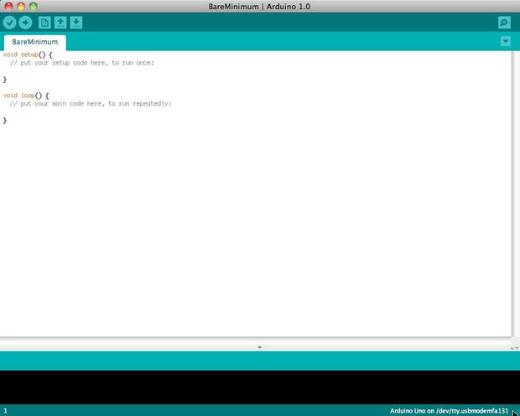

Before you can start doing anything with the Arduino, you need to download and install the [Arduino IDE](http://www.arduino.cc/en/Main/software) (integrated development environment). From this point on we will be referring to the Arduino IDE as the Arduino Programmer.  
  
The Arduino Programmer is based on the [Processing IDE](http://processing.org/) and uses a variation of the C and C++ programming languages.

## Settings

## Picture of Settings

## cap024.jpg

Before you can start doing anything in the Arduino programmer, you must set the board-type and serial port.  
  
To set the board, go to the following:

Tools --> Boards

Select the version of board that you are using. Since I have an Arduino Uno  plugged in, I obviously selected "Arduino Uno."  
  
To set the serial port, go to the following:

Tools --> Serial Port

Select the serial port that looks like:

/dev/tty.usbmodem [random numbers]

## Picture of Run a sketch

## 6B.jpg

## 6C.jpg

Arduino programs are called sketches. The Arduino programmer comes with a ton of example sketches preloaded. This is great because even if you have never programmed anything in your life, you can load one of these sketches and get the Arduino to do something.  
  
To get the LED tied to digital pin 13 to blink on and off, let's load the blink example.  
  
The blink example can be found here:

Files --> Examples --> Basics --> Blink

## The blink example basically sets pin D13 as an output and then blinks the test LED on the Arduino board on and off every second. Once the blink example is open, it can be installed onto the ATMEGA328 chip by pressing the upload button, which looks like an arrow pointing to the right. Notice that the surface mount status LED connected to pin 13 on the Arduino will start to blink. You can change the rate of the blinking by changing the length of the delay and pressing the upload button again.

## Serial monitor

## Picture of Serial monitor

## cap025.jpg

The serial monitor allows your computer to connect serially with the Arduino. This is important because it takes data that your Arduino is receiving from sensors and other devices and displays it in real-time on your computer. Having this ability is invaluable to debug your code and understand what number values the chip is actually receiving.  
  
For instance, connect center sweep (middle pin) of a potentiometer to A0, and the outer pins, respectively, to 5v and ground. Next upload the sketch shown below:

File --> Examples --> 1.Basics --> AnalogReadSerial

## Click the button to engage the serial monitor which looks like a magnifying glass.  You can now see the numbers being read by the analog pin in the serial monitor. When you turn the knob the numbers will increase and decrease.  The numbers will be between the range of 0 and 1023. The reason for this is that the analog pin is converting a voltage between 0 and 5V to a discreet number.

The Arduino has two different types of input pins, those being analog and digital.  
  
To begin with, lets look at the digital input pins.  
  
Digital input pins only have two possible states, which are on or off. These two on and off states are also referred to as:

* HIGH or LOW
* 1 or 0
* 5V or 0V.

This input is commonly used to sense the presence of voltage when a switch is opened or closed.  
  
Digital inputs can also be used as the basis for countless digital communication protocols. By creating a 5V (HIGH) pulse or 0V (LOW) pulse, you can create a binary signal, the basis of all computing. This is useful for talking to digital sensors like a PING ultrasonic sensor, or communicating with other devices.  
  
For a simple example of a digital input in use, connect a switch from digital pin 2 to 5V, a 10K resistor\*\* from digital pin 2 to ground, and run the following code:

File --> Examples --> 2.Digital --> Button

## Analog in

## Aside from the digital input pins, the Arduino also boasts a number of analog input pins. Analog input pins take an analog signal and perform a 10-bit analog-to-digital (ADC) conversion to turn it into a number between 0 and 1023 (4.9mV steps).  This type of input is good for reading resistive sensors. These are basically sensors which provide resistance to the circuit. They are also good for reading a varying voltage signal between 0 and 5V. This is useful when interfacing with various types of analog circuitry.

## Picture of Write your own code

To write your own code, you will need to learn some basic programming language syntax. In other words, you have to learn how to properly form the code for the programmer to understand it. You can think of this kind of like understanding grammar and punctuation. You can write an entire book without proper grammar and punctuation, but no one will be abler to understand it, even if it is in English.

Some important things to keep in mind when writing your own code:

* An Arduino program is called a sketch.
* All code in an Arduino sketch is processed from top to bottom.
* Arduino sketches are typically broken into five parts.

1. The sketch usually starts with a header that explains what the sketch is doing, and who wrote it.
2. Next, it usually defines global variables. Often, this is where constant names are given to the different Arduino pins.
3. After the initial variables are set, the Arduino begins the setup routine. In the setup function, we set initial conditions of variables when necessary, and run any preliminary code that we only want to run once. This is where serial communication is initiated, which is required for running the serial monitor.
4. From the setup function, we go to the loop routine. This is the main routine of the sketch. This is not only where your main code goes, but it will be executed over and over, so long as the sketch continues to run.
5. Below the loop routine, there is often other functions listed. These functions are user-defined and only activated when called in the setup and loop routine. When these functions are called, the Arduino processes all of the code in the function from top to bottom and then goes back to the next line in the sketch where it left off when the function was called. Functions are good because they allow you to run standard routines - over and over - without having to write the same lines of code over and over. You can simply call upon a function multiple times, and this will free up memory on the chip because the function routine is only written once. It also makes code easier to read. To learn how to form your own functions, check out[this page](http://arduino.cc/en/Reference/FunctionDeclaration).

* All of that said, the only two parts of the sketch which are mandatory are the Setup and Loop routines.
* Code must be written in the [Arduino Language](http://arduino.cc/en/Reference/HomePage), which is roughly based on C.
* Almost all statements written in the Arduino language must end with a ;
* Conditionals (such as [if statements](http://arduino.cc/en/Reference/If) and [for loops](http://arduino.cc/en/Reference/For)) do not need a ;
* Conditionals have their own rules and can be found under "[Control Structures](http://arduino.cc/en/Reference/HomePage)" on the [Arduino Language](http://arduino.cc/en/Reference/HomePage) page
* Variables are storage compartments for numbers. You can pass values into and out of variables. Variables must be defined (stated in the code) before they can be used and need to have a data type associated with it. To learn some of the basic data types, review the [Language Page](http://arduino.cc/en/Reference/HomePage).

Okay! So let us say we want to write code that reads a photocell connected to pin A0, and use the reading we get from the photocell to control the brightness of an LED connected to pin D9.

First, we want to open the BareMinimum sketch, which can be found at:

File --> Examples --> 1.Basic --> BareMinimum

## The BareMinimum Sketch should look like this:

<pre>void setup() {

// put your setup code here, to run once:

}

void loop() {

// put your main code here, to run repeatedly:

}

## Next, lets put a header on the code, so other people know about what we are making, why, and under what terms:

<pre>/\*

LED Dimmer

by Genius Arduino Programmer

2012

Controls the brightness of an LED on pin D9

based on the reading of a photocell on pin A0

This code is in the Public Domain

\*/

void setup() {

// put your setup code here, to run once:

}

void loop() {

// put your main code here, to run repeatedly:

}

## Once that is all squared away, let us define the pin names, and establish variables:

<pre>/\*

LED Dimmer

by Genius Arduino Programmer

2012

Controls the brightness of an LED on pin D9

based on the reading of a photocell on pin A0

This code is in the Public Domain

\*/

// name analog pin 0 a constant name

const int analogInPin = A0;

// name digital pin 9 a constant name

const int LEDPin = 9;

//variable for reading a photocell

int photocell;

void setup() {

// put your setup code here, to run once:

}

void loop() {

// put your main code here, to run repeatedly:

}

## Now that variables and pin names are set, let us write the actual code:

<pre>/\*

LED Dimmer

by Genius Arduino Programmer

2012

Controls the brightness of an LED on pin D9

based on the reading of a photocell on pin A0

This code is in the Public Domain

\*/

// name analog pin 0 a constant name

const int analogInPin = A0;

// name digital pin 9 a constant name

const int LEDPin = 9;

//variable for reading a photocell

int photocell;

void setup() {

//nothing here right now

}

void loop() {

//read the analog in pin and set the reading to the photocell variable

photocell = analogRead(analogInPin);

//control the LED pin using the value read by the photocell

analogWrite(LEDPin, photocell);

//pause the code for 1/10 second

//1 second = 1000

delay(100);

}

If we want to see what numbers the analog pin is actually reading from the photocell, we will need to use the serial monitor. Let's activate the serial port and output those numbers:

<pre>/\*

LED Dimmer

by Genius Arduino Programmer

2012

Controls the brightness of an LED on pin D9

based on the reading of a photocell on pin A0

This code is in the Public Domain

\*/

// name analog pin 0 a constant name

const int analogInPin = A0;

// name digital pin 9 a constant name

const int LEDPin = 9;

//variable for reading a photocell

int photocell;

void setup() {

Serial.begin(9600);

}

void loop() {

//read the analog in pin and set the reading to the photocell variable

photocell = analogRead(analogInPin);

//print the photocell value into the serial monitor

Serial.print("Photocell = " );

Serial.println(photocell);

//control the LED pin using the value read by the photocell

analogWrite(LEDPin, photocell);

//pause the code for 1/10 second

//1 second = 1000

delay(100);

}

**10.HARDWARE TESTING**

**10.1 CONTINUITY TEST:**

In electronics, a continuity test is the checking of an electric circuit to see if current flows (that it is in fact a complete circuit). A continuity test is performed by placing a small voltage (wired in series with an LED or noise-producing component such as a piezoelectric speaker) across the chosen path. If electron flow is inhibited by broken conductors, damaged components, or excessive resistance, the circuit is "open".

Devices that can be used to perform continuity tests include multi meters which measure current and specialized continuity testers which are cheaper, more basic devices, generally with a simple light bulb that lights up when current flows.

An important application is the continuity test of a bundle of wires so as to find the two ends belonging to a particular one of these wires; there will be a negligible resistance between the "right" ends, and only between the "right" ends.

This test is the performed just after the hardware soldering and configuration has been completed. This test aims at finding any electrical open paths in the circuit after the soldering. Many a times, the electrical continuity in the circuit is lost due to improper soldering, wrong and rough handling of the PCB, improper usage of the soldering iron, component failures and presence of bugs in the circuit diagram. We use a multi meter to perform this test. We keep the multi meter in buzzer mode and connect the ground terminal of the multi meter to the ground. We connect both the terminals across the path that needs to be checked. If there is continuation then you will hear the beep sound.

**10.2 POWER ON TEST:**

This test is performed to check whether the voltage at different terminals is according to the requirement or not. We take a multi meter and put it in voltage mode. Remember that this test is performed without microcontroller. Firstly, we check the output of the transformer, whether we get the required 12 v AC voltage.

Then we apply this voltage to the power supply circuit. Note that we do this test without microcontroller because if there is any excessive voltage, this may lead to damaging the controller. We check for the input to the voltage regulator i.e., are we getting an input of 12v and an output of 5v. This 5v output is given to the microcontrollers’ 40th pin. Hence we check for the voltage level at 40th pin. Similarly, we check for the other terminals for the required voltage. In this way we can assure that the voltage at all the terminals is as per the requirement.

**BIBLIOGRAPHY**

**TEXT BOOKS REFERED**

1. ATMEGA 328 Data Sheets.

**WEBSITES**

* www.atmel.com
* www.beyondlogic.org
* www.wikipedia.org
* www.howstuffworks.com
* www.alldatasheets.com