IOT BASED SMART CAR PARKING SYSTEM

Car parking is a major issues in modern congested cities of today. There simply are too many vehicles on the road and not enough parking space. This has led to the need for efficient parking management systems. Thus we demonstrate the use of IOT based parking management system that allows for efficient parking space utilization using IOT technology. To demonstrate the concept we use IR sensors for sensing parking slot occupancy along with a dc motors to simulate as gate opener motors. We now use a wifi modem for internet connectivity and an AVR microcontroller for operating the system. We use IOTGecko for online connectivity and IOT management GUI design. The system detects if parking slots are occupied using IR sensors. Also it uses IR technology to sense if a vehicle has arrived on gate for automated gate opening. The system reads the number of parking slots available and updates data with the cloud server to allow for checking parking slot availability online. This allows users to check for available parking spaces online from anywhere and avail hassle free parking. Thus the system solves the parking issue for cities and get users an efficient IOT based parking management system.

Block Digarm:
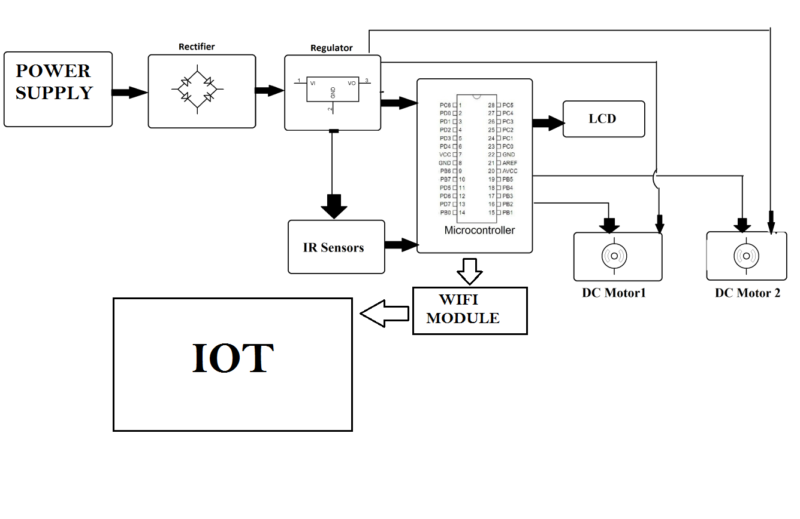
Hardware Specifications :
- Atmega 328 Microcontroller
- WIFI MODULE
- LCD Display
- IR Sensors
- Motors
- Transformer
- Resistors
- Capacitors
- Diodes
Software Specifications :
- Arduino Compiler
- MC Programming Language: C

Reference
- http://ieeexplore.ieee.org/xpl/articleDetails.jsp?arnumber=7399872&newsearch=true&queryText=parking%20sensor

- http://ieeexplore.ieee.org/xpl/articleDetails.jsp?arnumber=5557709&newsearch=true&queryText=parking%20sensor

