A Restless Disc: Testing the Drivers of Secular Disc Tilting at z=0 with TNG50
Supervisor I: Professor Vasily Belokurov (vasily@ast.cam.ac.uk)
Supervisor II: Professor Victor P. Debattista (vpdebattista@lancashire.ac.uk)
UTO: Professor Vasily Belokurov (vasily@ast.cam.ac.uk)

Project Summary
The spin axis of the Milky Way's disc is not fixed in space. Cosmological zoom-in simulations from the NIHAO suite show that even genuinely isolated Milky Way-mass discs tilt by a few degrees per gigayear at z=0, driven mainly by the accretion of gas whose angular momentum is misaligned with the disc, rather than by the dark matter halo (Earp et al. 2017, 2019). That rate sits comfortably above the roughly 0.28 degrees/Gyr floor at which Gaia's own inertial reference frame can, in principle, detect it (Perryman et al. 2014), so the effect is not only real but measurable. The NIHAO analysis, however, rests on about 100 galaxies at a single resolution, and its headline result — that only the misalignment of the accreting gas correlates with the tilting rate, while the dark matter halo does not — has not yet been tested against an independent, higher-resolution simulation suite. There is a second thread to pull on, too: Dillamore et al. (2022) find that a Gaia-Sausage-Enceladus-like merger can leave a disc's angular-momentum axis aligned with the merger's orbital axis for gigayears afterwards, raising the question of whether the direction, and not just the rate, of ongoing tilting is predictable from a galaxy's earlier accretion history.
This project re-runs the NIHAO tilting-rate analysis on TNG50 (Pillepich et al. 2024), whose public archive already holds close to 200 resolved Milky Way- and Andromeda-like discs — a sample roughly twice the size of NIHAO's, at higher resolution, and available now. The student will build a tested pipeline that measures the stellar and gas spin-axis evolution of each galaxy over the last few gigayears, use it to check whether Earp et al.'s (2019) correlations survive in TNG50, and track the evolution of the gas angular momentum that the NIHAO study identified as the main driver. The stretch goal is to test, for the first time, whether the direction a disc is tilting in can be predicted from its accretion history — a result that would feed directly into any future effort to interpret a measured tilt of the Milky Way's own disc with Gaia. The deliverable is a verified, TNG50-based catalogue of disc-tilting rates and their correlations, with an explicit verdict on which parts of the NIHAO picture hold up at higher resolution and larger sample size.

Background
A disc galaxy's spin axis is not a fossil fixed at formation; it responds to whatever torques act on the disc across cosmic time. The sharpest torques come from mergers: N-body experiments going back to Huang & Carlberg (1997) show that an infalling satellite tilts, warps and thickens a disc depending on the mass ratio and orbital geometry of the encounter, and cosmological simulations confirm that the accretion of satellites onto a Milky Way-mass disc is common enough to leave a lasting imprint (Read et al. 2008). Because the disc sits inside a dark matter halo whose own spin axis wanders — reorienting by tens of degrees over a Hubble time, occasionally in step with a merger (Bett & Frenk 2012, 2016) — a change in the halo's orientation is a second, more gradual route to tilting the disc it hosts. Dillamore et al. (2022) add a third, sharper twist: in the ARTEMIS cosmological zoom simulations, discs that experience a Gaia-Sausage-Enceladus-like radial merger can end up with their angular-momentum axis closely aligned with the merger's orbital axis, tilting at rates of up to about 60 degrees/Gyr during the encounter — evidence that a single early merger can set the direction a disc keeps tilting in long afterwards.

Mergers, however, are not required. Earp et al. (2017) measured the z=0 spin-axis drift of Milky Way-mass discs in the NIHAO suite of cosmological hydrodynamical zoom simulations — a sample chosen to be dynamically quiet, with no ongoing major merger — and still found tilting rates of order 6–8 degrees/Gyr, well above the roughly 0.28 degrees/Gyr precision Gaia's own inertial reference frame should reach (Perryman et al. 2014). A companion study, Earp et al. (2019), searched for what drives that tilting across the sample and its galaxy properties, and found only one robust correlate: the misalignment, or warp, between the angular-momentum axis of the accreting cold gas and that of the existing disc. Correlations with the dark matter halo's shape, spin, or misalignment were all consistent with zero. The picture that emerged is that isolated discs tilt chiefly because they keep accreting gas whose angular momentum does not point where the disc already points, continually nudging the disc to follow it.

Earp et al. (2019) were explicit that this result needed testing: tilting rates in simulations are sensitive to numerical resolution and to the angular-momentum content of the simulated galaxies, and their own sample was drawn from a single suite at one resolution. It is also not yet known whether the isolated, gas-driven tilting NIHAO measured and the merger-driven tilting Dillamore et al. (2022) found are two separate regimes or two ends of one continuum — a disc's gas accretion history is itself shaped by its merger history, so an early Gaia-Sausage-Enceladus-like event could plausibly set up the very gas misalignment that then drives gradual tilting for gigayears afterwards. Neither question can be answered from the NIHAO sample alone.

TNG50 (Pillepich et al. 2019; Nelson et al. 2019) offers an independent, higher-resolution check that is available today. Pillepich et al. (2024) have already identified and catalogued almost 200 Milky Way- and Andromeda-mass disc galaxies in the public TNG50 archive — roughly twice the NIHAO sample, run with a different code, feedback model and mass resolution, with full particle data and merger trees ready to download. This is exactly the independent replication the NIHAO result needs, and it carries no data-release risk: everything the core project needs is public now. The student can spend Michaelmas building and validating the pipeline against the published NIHAO numbers, use Lent to run the full ~200-galaxy TNG50 analysis and the gas angular-momentum tracking, and reserve Easter for the tilt-direction predictability test and write-up.

Project details
The project turns a well-defined replication task into an independent test of the NIHAO tilting results, then pushes beyond them. The core — reproducing and re-testing the NIHAO correlations in TNG50 — is guaranteed to work on data that are public now; the tilt-direction predictor is the stretch goal.
- Build the TNG50 sample. Download the particle data, subhalo catalogues and merger trees for the ~200 Milky Way- and Andromeda-like disc galaxies identified by Pillepich et al. (2024) from the public TNG50 archive (Nelson et al. 2019), covering at least the last ~3 Gyr of evolution down to z=0, with deeper merger-tree access for the later stages of the project.
- Reproduce the NIHAO benchmark. Before trusting any new number, re-implement Earp et al.'s (2017, 2019) tilting-rate measurement — the drift of a galaxy's stellar spin-axis unit vector over gigayear baselines — well enough to recover their published rates (~6–8 degrees/Gyr) and their Gaia-detectability comparison. This locked benchmark exposes any error in units, baseline choice, or spin-axis definition before it reaches the TNG50 sample.
- Measure tilting rates and test the NIHAO correlations. Compute stellar and gas spin-axis tilting rates for all ~200 TNG50 discs over the past ~3 Gyr, and test directly whether Earp et al.'s (2019) correlations reproduce at higher resolution and larger sample size: does the gas-disc misalignment remain the dominant correlate, and do the halo shape, spin and misalignment remain uncorrelated?
- Track the gas angular-momentum history. Extend beyond a single z=0 snapshot by following each galaxy's gas (and stellar) angular-momentum axis and its misalignment with the disc back through cosmic time, to see when the gas warp that NIHAO identified as the driver builds up, and whether it connects to identifiable earlier accretion events.
- Test whether the tilt direction is predictable. Using each galaxy's merger and gas-accretion history, and motivated by Dillamore et al.'s (2022) finding that a Gaia-Sausage-Enceladus-like merger sets the disc's angular-momentum axis, test whether the sign and direction of a galaxy's ongoing tilt can be predicted from properties of its dominant earlier accretion event(s).
- Validate against nulls and resolution checks. Test the robustness of any new correlation — including the tilt-direction predictor — against reshuffled or permuted galaxy properties and against changes in the tilting-rate baseline and subhalo particle selection, so that no claim rests on a single choice of pipeline settings.
- Interpret and deliver. Produce a documented pipeline; a public, TNG50-based catalogue of disc-tilting rates and gas angular-momentum histories for ~200 Milky Way-like galaxies; an explicit verdict on which of the NIHAO correlations survive independent replication; and, if it passes the null tests, a diagnostic for predicting tilt direction from accretion history, of direct use to future Gaia-based measurements of the Milky Way's own disc tilt.

Prerequisite skills required
The student must be comfortable with scientific Python, since the whole project consists of extracting and analysing particle data from large cosmological simulation snapshots and merger trees. Basic vector algebra, as used to define and rotate angular-momentum axes, is required. No prior experience with cosmological simulations, IllustrisTNG-format data, or Galactic dynamics is assumed; the necessary tools and background will be learned during the project.

Other skills used in the project
- Querying and handling large cosmological hydrodynamical simulation snapshots and merger trees (the TNG50/IllustrisTNG Python API).
- Computing angular momentum, spin axes, and disc/gas geometry from N-body and hydrodynamical particle data.
- Statistical correlation analysis, including bootstrap and permutation-based significance testing.
- Cross-validating results against an independent, published simulation suite (NIHAO).
- Reproducible scientific Python workflows and visualisation of time-evolving 3D quantities.

Acceptable Programming Languages
Python is preferred.

Useful references (List of important papers/review articles relevant to the project)
- Bett, P. E. & Frenk, C. S. (2012), ‘Spin flips – I. Evolution of the angular momentum orientation of Milky Way-mass dark matter haloes’, MNRAS, 420, 3324. https://doi.org/10.1111/j.1365-2966.2011.20275.x
- Bett, P. E. & Frenk, C. S. (2016), ‘Spin flips – II. Evolution of dark matter halo spin orientation, and its correlation with major mergers’, MNRAS, 461, 1338. https://doi.org/10.1093/mnras/stw1395
- Dillamore, A. M., Belokurov, V., Font, A. S. & McCarthy, I. G. (2022), ‘Merger-induced galaxy transformations in the ARTEMIS simulations’, MNRAS, 513, 1867. https://doi.org/10.1093/mnras/stac1038
- Earp, S. W. F., Debattista, V. P., Macciò, A. V. & Cole, D. R. (2017), ‘The tilting rate of the Milky Way’s disc’, MNRAS, 469, 4095. https://doi.org/10.1093/mnras/stx1143
- Earp, S. W. F., Debattista, V. P., Macciò, A. V., Wang, L., Buck, T. & Khachaturyants, T. (2019), ‘Drivers of disc tilting I: correlations and possible drivers for Milky Way analogues’, MNRAS, 488, 5728. https://doi.org/10.1093/mnras/stz2109
- Huang, S. & Carlberg, R. G. (1997), ‘Sinking Satellites and Tilting Disk Galaxies’, ApJ, 480, 503. https://doi.org/10.1086/303977
- Perryman, M., Spergel, D. N. & Lindegren, L. (2014), ‘The Gaia Inertial Reference Frame and the Tilting of the Milky Way Disk’, ApJ, 789, 166. https://doi.org/10.1088/0004-637X/789/2/166
- Pillepich, A., Sotillo-Ramos, D., Ramesh, R., et al. (2024), ‘Milky Way and Andromeda analogues from the TNG50 simulation’, MNRAS, 535, 1721. https://doi.org/10.1093/mnras/stae2165
- Read, J. I., Lake, G., Agertz, O. & Debattista, V. P. (2008), ‘Thin, thick and dark discs in ΛCDM’, MNRAS, 389, 1041. https://doi.org/10.1111/j.1365-2966.2008.13643.x

General References (List of papers referred to in the project)
- Pillepich, A., Nelson, D., Springel, V., et al. (2019), ‘First results from the TNG50 simulation: the evolution of stellar and gaseous discs across cosmic time’, MNRAS, 490, 3196. https://doi.org/10.1093/mnras/stz2338
- Nelson, D., Springel, V., Pillepich, A., et al. (2019), ‘The IllustrisTNG simulations: public data release’, Computational Astrophysics and Cosmology, 6, 2. https://doi.org/10.1186/s40668-019-0028-x
- Wang, L., Dutton, A. A., Stinson, G. S., et al. (2015), ‘NIHAO project – I. Reproducing the inefficiency of galaxy formation across cosmic time with a large sample of cosmological hydrodynamical simulations’, MNRAS, 454, 83. https://doi.org/10.1093/mnras/stv1937

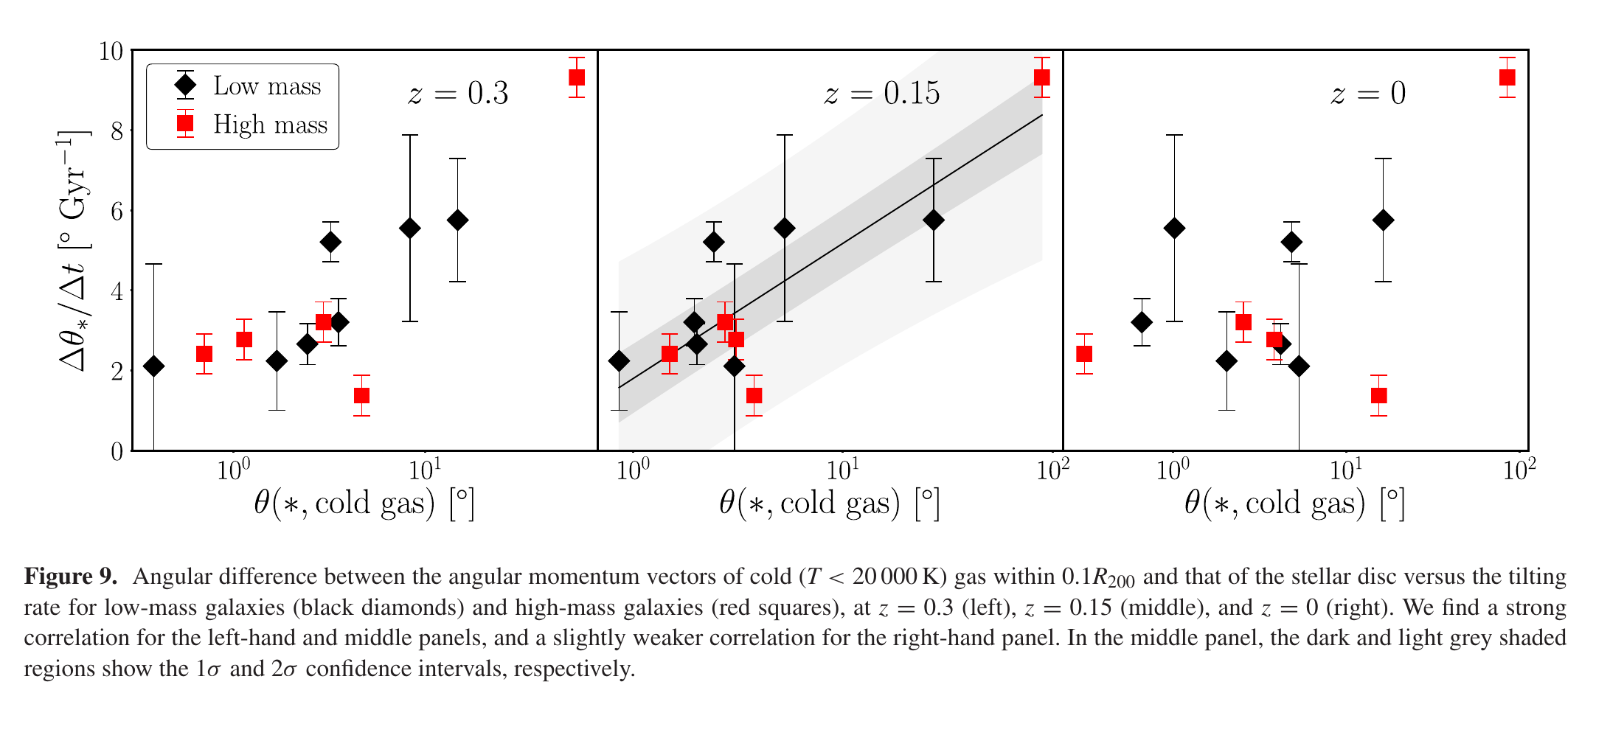
Figure 1. Cold-gas misalignment versus stellar disc tilting rate for the NIHAO Milky Way-mass sample, at z = 0.3, 0.15, and 0 (left to right): galaxies whose cold gas arrives with angular momentum more misaligned from the disc (larger θ) tilt faster. This is the one robust driver Earp et al. (2019) find — the dark matter halo's shape, spin and alignment show no such correlation — and it is the correlation this project re-tests on TNG50's larger, higher-resolution sample. From Earp et al. (2019).

