Project 1: Are planetary systems aligned with their binary companions? A Gaia DR4 census
Supervisors: Dr. Dolev Bashi (db975@cam.ac.uk), Dr. Mika Kontiainen (mvk26@cam.ac.uk), Prof. Vasily Belokurov (vasily@ast.cam.ac.uk), Prof. Simon Hodgkin (sth@ast.cam.ac.uk). Prof. Cathie J. Clarke (cclarke@ast.cam.ac.uk)
UTO: Prof. Vasily Belokurov (vasily@ast.cam.ac.uk)
Project Summary
Most exoplanets are studied as if their host stars were isolated, even though stellar companions are common and can strongly affect how planets form and survive. Gaia Data Release 4 (DR4) is expected to provide orbital solutions for more than 3.5 million astrometric binaries, transforming a question previously addressed with samples of tens of systems into a population-level experiment. The student will cross-match the Gaia DR4 Non-Single Star (NSS) catalogue with confirmed transiting planets and high-quality planet candidates, build a validated sample of planet-hosting binaries, and separate circumstellar (S-type) planets from circumbinary (P-type) planets. The project will test the reliability of the Gaia binary periods, assess the dynamical stability of each planetary architecture, and compare the inclination distribution of planet-hosting astrometric binaries with a carefully matched control sample of Gaia binaries. An analogous experiment using eclipsing binaries (EBs) will provide a larger, planet-independent control on the alignment of hierarchical stellar systems.
The main outcome will be the first homogeneous Gaia DR4 census of the stability and orbital architecture of transiting planets in astrometric binary systems. The dependence of alignment on binary separation, eccentricity, mass ratio, planet size and planet period will distinguish signatures inherited during star and planet formation from those produced later by secular dynamics, scattering and tides.
Background
Binary companions can truncate, warp or disperse a protoplanetary disc and can subsequently excite planetary eccentricities and inclinations. The surviving systems therefore preserve information about both their formation environment and their later dynamical evolution. Recent observations suggest that this information is encoded in orbital orientation. Christian et al. (2022) used Gaia astrometry and a matched field-binary sample to find an excess of planet-binary alignment. Dupuy et al. (2022) independently rejected isotropically oriented binary orbits at 4.7 sigma in a five-year astrometric study of 45 Kepler planet-hosting binaries. More recent work found that wide binaries below about 700 au are preferentially aligned with small-planet systems, whereas hot-Jupiter systems show no comparable signal (Christian et al. 2025). Visual-orbit monitoring is now extending the result to binaries within 100 au (Lester et al. 2026). Together these studies motivate a much larger and more uniform test with Gaia DR4.
The interpretation is not unique. Alignment may be primordial if the binary, disc and planets inherit a common angular-momentum direction. It may also be strengthened during the disc phase: Gerbig et al. (2024) showed that dissipative precession of a warped circumstellar disc can move an initially broad distribution toward alignment for favourable binary separations, disc viscosities and stellar mass ratios. Conversely, a misaligned companion can drive von Zeipel-Lidov-Kozai cycles, planet-planet scattering and tidal migration. Such later processing should be most visible in eccentric binaries, dynamically hot systems and hot-Jupiter hosts. Comparing these sub-populations is therefore more informative than measuring a single global alignment fraction.
P-type planets offer a complementary test. Transiting circumbinary planets are observed close to, but outside, the critical stability boundary and are usually nearly coplanar with their host binaries. Their apparent absence around the shortest-period binaries may reflect formation, detectability or later evolution. Mogan & Zanazzi (2025), for example, showed that tidal circularisation and shrinkage of the stellar binary can lower the probability of observing a previously formed circumbinary planet in transit. A joint analysis of binary period, eccentricity, orbital orientation and distance from the stability boundary can therefore constrain both planet formation and subsequent tidal processing.
There are already intriguing hints in Gaia data. Bashi & Tokovinin (2024) found that the outer astrometric orbits of inner compact binary systems, i.e., compact hierarchical triple (CHT) candidates, were more concentrated near edge-on orientations than the full astrometric-binary sample (see Fig. 1). Because the large RV signal used to select those CHTs originates in an inner close binary, the result is suggestive of alignment between the inner and outer stellar orbits.
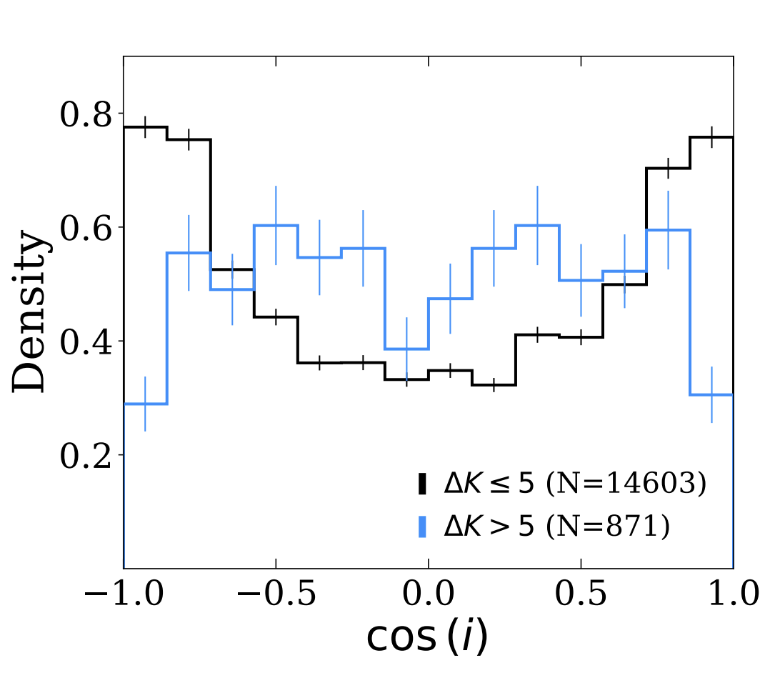
Figure 1. Distribution of cos(i) for Gaia DR3 astrometric binaries (black) and compact hierarchical triple candidates (CHTs; blue), where (i) is the inclination of the outer astrometric orbit. The parent astrometric-binary sample preferentially contains face-on orbits (cos(i)~1), whereas the CHT candidates show an excess of edge-on outer orbits (cos(i)~0). Because the candidates are selected through large radial-velocity variations produced by the unresolved inner binary, a method preferentially sensitive to edge-on inner orbits, the corresponding excess of edge-on outer orbits is suggestive of mutual alignment between the inner and outer orbital planes. Reproduced from Bashi & Tokovinin (2024).
An inclination near 90 degrees is not, by itself, a measurement of the true mutual inclination. Transit observations usually do not determine the planet's longitude of ascending node. This project will therefore infer alignment statistically from the full population, and will calculate individual mutual inclinations only for the small subset with sufficient information on both orbital nodes.
Project Details
The project will proceed through the following stages:
- Construct a reproducible planet-hosting binary sample. Query the Gaia DR4 NSS two-body-orbit products and retain robust astrometric or combined solutions. Cross-match them to the NASA Exoplanet Archive and vetted Kepler, K2 and TESS/TOI samples. Resolve identifiers and host components using coordinates, Gaia source IDs, high-resolution imaging catalogues and published validation information. Each system will receive a provenance and quality flag so that confirmed planets and candidates can be analysed separately.
- Validate the binary orbit and its period. Apply the DR4 quality flags and inspect the orbital signal-to-noise, goodness of fit, astrometric jitter, scanning-law aliases and period relative to the Gaia observing baseline. For the cross-matched sample, refit or posterior-sample the Gaia epoch astrometry where practical, and compare alternative period modes
- Classify S-type and P-type architectures. S-type planets orbit one component of a wider binary; P-type planets orbit both stars of an inner binary. Classification will combine host-component information with the stellar and planetary periods, physical semimajor axes, literature vetting and, where available, eclipse/transit morphology. Ambiguous systems will be retained with probabilistic or explicit uncertainty flags rather than forced into a class.
- Test dynamical stability. Propagate the posterior uncertainties in stellar masses, periods, eccentricities and semimajor axes. As a first diagnostic, compare each planet with the critical S-type or P-type stability boundary (e.g., Holman & Wiegert 1999. Systems near the boundary, highly inclined systems and dynamically packed multi-planet systems will be followed with direct N-body integrations using REBOUND. The student will measure both a stability probability and the planet's distance from the critical boundary.
- Measure the inclination distribution. Compare cos(i_bin) for planet hosts with the corresponding distribution for all reliable Gaia astrometric binaries. The control sample will be matched or reweighted in binary period, eccentricity, distance, magnitude, colour, astrometric signal-to-noise and solution type. A hierarchical or mixture model will estimate the fractions consistent with aligned and isotropic populations while forward-modelling the Gaia and transit selection functions. S-type and P-type systems will be analysed separately, followed by subdivisions in planet radius/period and binary separation/eccentricity.
- Use eclipsing binaries as a complementary experiment. Cross-match the astrometric-orbit catalogue with Gaia and TESS EB catalogues. The nearly edge-on inner EB supplies the same geometric reference provided by a transiting planet, but with a much larger sample. Comparing the outer astrometric inclinations of EBs, CHT candidates and transiting-planet hosts will test whether any edge-on excess is specific to planet formation or is a more general property of hierarchical stellar formation. Bashi & Tokovinin (2024) provide the first hint and a direct methodological starting point.
If time permits, the student will fit a joint model in which the aligned fraction varies with binary periastron, stellar mass ratio, age proxy and planet class. A primordial or disc-driven origin predicts stronger alignment among dynamically cold, low-eccentricity systems and may depend on mass ratio. Later secular evolution predicts stronger misalignment among eccentric binaries and hot-Jupiter hosts. For P-type systems, the distribution relative to the stability boundary and the short-period-binary deficit will test migration and tidal-shrinkage scenarios.
Prerequisite Skills Required
Basic Python programming and familiarity with undergraduate orbital mechanics and statistics are required. No previous experience with Gaia archive queries, Bayesian inference or N-body integrations is assumed; however, Part III courses in Astrostatistics and Planetary System Dynamics are recommended.
Other Skills Used in the Project
- Querying large astronomical catalogues with ADQL and performing robust cross-matches.
- Working with astrometric orbital elements, covariance matrices and posterior samples.
- Time-series/period validation and treatment of survey selection functions.
- Hierarchical Bayesian modelling and hypothesis testing.
- Optional N-body integrations with REBOUND.
- Scientific visualisation and construction of a publication-quality catalogue.
Acceptable Programming Languages
Python.
Useful References
- Christian, S. et al. 2022, A Possible Alignment Between the Orbits of Planetary Systems and their Visual Binary Companions, AJ, 163, 207. https://doi.org/10.3847/1538-3881/ac517f
- Dupuy, T. J. et al. 2022, Orbital Architectures of Planet-Hosting Binaries II. Low Mutual Inclinations Between Planetary and Stellar Orbits, MNRAS, 512, 648. https://doi.org/10.1093/mnras/stac306
- Christian, S. et al. 2025, Wide Binary Orbits Are Preferentially Aligned with the Orbits of Small Planets, but Probably Not Hot Jupiters, AJ, 169, 308. https://doi.org/10.3847/1538-3881/adc933
- Bashi, D. & Tokovinin, A. 2024, Searching for Compact Hierarchical Triple System Candidates in Astrometric Binaries and Accelerated Solutions, A&A, 692, A247. https://doi.org/10.1051/0004-6361/202452637
- Gerbig, K. et al. 2024, Aligning Planet-Hosting Binaries via Dissipative Precession in Circumstellar Disks, ApJ, 972, 161. https://doi.org/10.3847/1538-4357/ad5f2b
- Mogan, S. & Zanazzi, J. J. 2025, Concealing Circumbinary Planets with Tidal Shrinkage, ApJ, 988, 150. https://doi.org/10.3847/1538-4357/ade2e8
General References
- Holman, M. J. & Wiegert, P. A. 1999, Long-Term Stability of Planets in Binary Systems, AJ, 117, 621. https://doi.org/10.1086/300695
- Quarles, B. et al. 2018, Stability Limits of Circumbinary Planets: Is There a Pile-up in the Kepler CBPs?, ApJ, 856, 150. https://doi.org/10.3847/1538-4357/aab264
- Czekala, I. et al. 2019, The Degree of Alignment between Circumbinary Disks and Their Binary Hosts, ApJ, 883, 22. https://doi.org/10.3847/1538-4357/ab287b
- Lester, K. V. et al. 2026, Visual Orbits and Alignments of Planet-hosting Binary Systems, accepted in AJ. https://arxiv.org/abs/2308.16826
- ESA Gaia DR4 content and data-model overview. https://www.cosmos.esa.int/web/gaia/dr4

