Project 2: Uncovering Quintuple and Higher-Order Stellar Systems with Gaia DR4
Supervisor I: Dr. Dolev Bashi (db975@cam.ac.uk)
Supervisor II: Prof. Vasily Belokurov (vasily@ast.cam.ac.uk)
Supervisor II: Prof. Vasily Belokurov (vasily@ast.cam.ac.uk)
Supervisor III: Prof. Cathie J. Clarke (cclarke@ast.cam.ac.uk)
UTO: Prof. Vasily Belokurov (vasily@ast.cam.ac.uk)

Project summary
Stellar systems containing five or more stars are rare laboratories for star formation and few-body dynamics, yet the present census is highly incomplete. Gaia Data Release 4 (DR4) creates a new route to finding them. Its planned non-single-star products include a catalogue of physically bound resolved pairs (nss_resolved_pair) and a multiplicity table that records all resolved pairs involving a given source (nss_multiplicity). The same release is also expected to provide epoch astrometry and epoch radial-velocity (RV) measurements.
This project will connect overlapping resolved pairs into graphs and select systems in which at least one source belongs to more than one common-proper-motion pair. Every resolved member will then be searched for additional, unresolved companions using the epoch astrometry and RV time series themselves, independently of the Gaia NSS orbital-solution catalogues. For example, a wide triple in which two components each host an inner binary is a 2+2+1 quintuple system. The most informative systems will be integrated with an N-body code to assess stability, eccentricity evolution, close encounters and possible ejections. The final products will be a reproducible search pipeline, a vetted catalogue of new high-order systems, and a quantitative estimate of how much Gaia DR4 extends the known population.
Background
Most long-lived multiple stars are hierarchical: short-period subsystems orbit one another on progressively wider orbits. Their architecture records how fragmentation, accretion, migration and dynamical decay operate during star formation. High-order systems are especially valuable because a single hierarchy can contain several formation scales, while secular coupling between its nested orbits can drive eccentricity growth, tidal interactions, mass transfer or instability (Mardling & Aarseth 2001). The probability of strong interaction and dynamical instability increases with multiplicity. Integrations of systems in the Multiple Star Catalogue (MSC) find substantially larger unstable fractions for quintuples and sextuples than for triples (Hamers 2020).
The MSC (Tokovinin 2018) is the principal catalogue of physical hierarchical systems with three or more components. The latest update (dated 19 June 2026) contains 6,080 grade-3-to-5 physical systems. Counting its Ncomp field gives 154 quintuples, 28 sextuples, five septuples and one octuple: 188 systems with at least five components. Nevertheless, the catalogue is not volume-limited, and its author explicitly stresses its incompleteness and strong observational selection.
Wide common-proper-motion systems provide an efficient scaffold for extending this census. Gaia-based searches already contain of order one million wide-binary candidates (El-Badry, Rix & Heintz 2021), and studies of close binaries show that wide tertiaries are common enough to connect close and wide multiplicity regimes (Hwang 2023). Until now, many searches have combined a wide-pair catalogue with summary indicators such as RUWE, RV scatter, eclipses or published NSS solutions. DR4 changes the problem by publishing the lower-level time series needed to search each wide component directly.
The official expected-content page for Gaia DR4 lists nss_resolved_pair as physically bound resolved pairs, in contrast to the separate optical_pair table of chance alignments. It also lists nss_multiplicity for sources involved in more than one resolved pair, together with epoch_astrometry and FOV-transit-level RV parameters for single- and double-lined transits. These planned products are an unusually close match to the proposed workflow: the resolved-pair tables define the outer hierarchy, while the epoch data reveal hidden inner companions.
Project details
The project is organised as a sequence of increasingly selective stages. The analysis will begin with a controlled, nearby or high-signal-to-noise subset and expand only after the false-positive rate and computational cost are understood.
- Establish the baseline and validation set. Review the current MSC and reproduce the present 5+ census by multiplicity, quality grade and architecture. Cross-match known systems to Gaia identifiers and reserve a subset as a blinded recovery sample. Before DR4 is available, the graph-building and validation machinery can be prototyped with Gaia DR3 and the El-Badry et al. wide-binary catalogue.
- Construct the resolved common-proper-motion graph. Query nss_resolved_pair and nss_multiplicity. Treat Gaia source identifiers as graph nodes and physically bound resolved-pair associations as edges. Connected components with at least three resolved nodes, or nodes of degree two or more, form the parent sample. Reassess every edge using the full astrometric covariance, projected separation, relative tangential velocity, colour-magnitude consistency and, where available, systemic RV. The optical_pair catalogue and sky-shifted controls will provide empirical chance-alignment samples.
- Search independently for inner companions. For every resolved member, download only the relevant epoch_astrometry and RVS DataLink products. Compare a five-parameter astrometric plus constant-RV null model with acceleration and Keplerian photocentre models, and compare constant, single-lined and double-lined RV models. Period searches and orbit fitting will include the actual Gaia sampling, astrometric covariance, scan-angle systematics, RV uncertainties, aliases and outlier models.
- Infer the hierarchy and physical parameters. Combine the resolved graph with posterior probabilities for the inner companions. Use Gaia photometry and, when helpful, external spectral-energy-distribution information to estimate stellar masses and luminosity ratios. RV mass functions and astrometric photocentre amplitudes will constrain companion masses and inclinations. Each candidate will receive a machine-readable hierarchy such as 2+2+1 or 3+2, a physical membership probability, a component count, and a quality grade that distinguishes secure systems from follow-up targets.
- Measure completeness and the catalogue extension. Inject synthetic astrometric and RV signals into representative DR4 sampling and noise, then recover them with the same pipeline. This yields detection efficiency as a function of magnitude, distance, period, mass ratio, hierarchy and projected separation. Recovery of the reserved MSC systems will test end-to-end performance.
- Assess stability and dynamical evolution. Apply an analytic hierarchical-stability screen at every nested level, then sample the observational posterior for the highest-priority systems. Direct integrations with REBOUND and its adaptive IAS15 integrator will test hierarchy preservation, close approaches and ejections over a tractable number of outer periods. A hierarchical secular code will extend the calculation to stellar-age timescales, with direct N-body integrations used to validate systems near the stability boundary. For the widest systems, optional experiments will include the Galactic tide and impulsive stellar encounters. The outputs will include survival probability, maximum eccentricities, inclination evolution, instability time and the sensitivity of each result to unconstrained orbital angles.

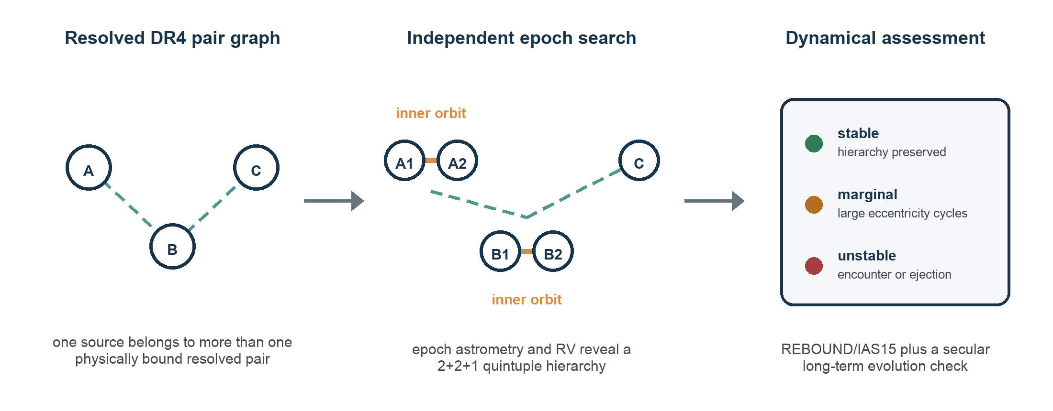
Figure 1: Conceptual workflow. Overlapping physically bound resolved pairs define a wide three-source graph. Independent fits to the DR4 epoch astrometry and RV data reveal inner companions around two nodes, converting the system into a 2+2+1 quintuple. Posterior-sampled integrations then classify the hierarchy as stable, marginal or unstable.

Expected outcomes and scope control
- A catalogue of candidate quintuple-and-higher systems with Gaia identifiers, hierarchy graphs, discovery channels, membership probabilities, orbit and mass constraints, selection flags and stability classifications.
- A reproducible Python/ADQL pipeline that performs server-side preselection and downloads epoch data only for the short candidate list, avoiding an impractical bulk download of the DR4 epoch archive.
- A measured recovery function and a defensible estimate of the increase over the MSC, separated into secure additions and candidates requiring follow-up.
- Detailed dynamical case studies of the most compact, most weakly bound and most unusual architectures.
If DR4 access is delayed or an epoch product proves more restricted than presently planned, the project remains viable as a DR3 proof of concept using published wide-pair catalogues, Gaia summary diagnostics and external multi-epoch RVs; the pipeline will be structured so the DR4 epoch layer can be substituted as soon as it becomes available.
Prerequisite Skills Required
- A working knowledge of orbital mechanics and stellar or binary astrophysics at undergraduate level.
- Willingness to engage with Bayesian inference and measurement uncertainties; prior experience is useful but not essential.
- Relevant Part III courses include Astrostatistics, which provides useful foundations in Bayesian inference, hierarchical modelling, measurement-error models and model comparison and Planetary System Dynamics, whose treatment of Keplerian orbits, barycentric motion and three-body stability is directly applicable to binaries and possible higher-order stellar systems.
Other skills used in the project
The student will gain experience with Gaia archive queries (ADQL/TAP), RV extraction, joint Keplerian orbit fitting, catalogue cross-matching, stellar-mass inference, hierarchical Bayesian modelling, selection functions, and reproducible scientific software. TOPCAT may be useful for rapid catalogue inspection but is not mandatory.
Acceptable Programming Languages
Python is preferred. C or C++ may be used for performance-critical extensions.
Useful References (List of important papers/review articles relevant to the project)
- Gaia DR4 expected contents - official Gaia/ESA data-product table
https://www.cosmos.esa.int/web/gaia/dr4
- Tokovinin, A. (2018), The Updated Multiple Star Catalog, ApJS, 235, 6
https://ui.adsabs.harvard.edu/abs/2018ApJS..235....6T/abstract
- Multiple Star Catalog - current machine-readable release and web interface
https://www.ctio.noirlab.edu/~atokovin/stars/
- Hamers, A. S. (2020), A census of main-sequence interactions in the Multiple Star Catalogue, MNRAS, 494, 5298
https://ui.adsabs.harvard.edu/abs/2020MNRAS.494.5298H/abstract
- El-Badry, K., Rix, H.-W. & Heintz, T. M. (2021), A million binaries from Gaia eDR3, MNRAS, 506, 2269
https://ui.adsabs.harvard.edu/abs/2021MNRAS.506.2269E/abstract
- Andrew, S. et al. (2022), Binary parameters from astrometric and spectroscopic errors, MNRAS, 516, 3661
https://ui.adsabs.harvard.edu/abs/2022MNRAS.516.3661A/abstract
- Hwang, H.-C. (2023), The mystery in Gaia DR3 triples, MNRAS, 518, 1750
https://ui.adsabs.harvard.edu/abs/2023MNRAS.518.1750H/abstract
General References (List of papers referred to in the project)
- Rein, H. & Liu, S.-F. (2012), REBOUND: an open-source multi-purpose N-body code, A&A, 537, A128
https://ui.adsabs.harvard.edu/abs/2012A%26A...537A.128R/abstract
- Rein, H. & Spiegel, D. S. (2015), IAS15: a fast, adaptive, high-order integrator, MNRAS, 446, 1424
https://ui.adsabs.harvard.edu/abs/2015MNRAS.446.1424R/abstract
- Mardling, R. A. & Aarseth, S. J. (2001), Tidal interactions in star cluster simulations, MNRAS, 321, 398
https://ui.adsabs.harvard.edu/abs/2001MNRAS.321..398M/abstract
- Gonzalez-Payo, J., Caballero, J. A. & Cortes-Contreras, M. (2024), The widest WDS systems in Gaia DR3, A&A, 689, A302
https://ui.adsabs.harvard.edu/abs/2024A%26A...689A.302G/abstract

