Project 3: Characterising the neutron-star-to-black-hole mass gap with Gaia DR4
Supervisor I: Dr. Dolev Bashi (db975@cam.ac.uk)
Supervisor II: Prof. Vasily Belokurov (vasily@ast.cam.ac.uk)
Supervisor III: Prof. Simon Hodgkin (sth@ast.cam.ac.uk)
UTO: Prof. Vasily Belokurov (vasily@ast.cam.ac.uk)

Project summary
What lies between the most massive neutron stars (NSs) and the least massive black holes (BHs)? Taking the lower compact-object mass gap as a working hypothesis, this project will measure its location, depth, and occupancy in the detached binary population observed by Gaia. Gaia Data Release 4 (DR4) provides the discovery tool: its non-single-star astrometric orbits identify luminous stars moving around faint companions. The key measurement will be the astrometric mass function, strengthened wherever possible by radial velocities (RVs) and a joint astrometric-spectroscopic orbit. The student will isolate systems whose dark-companion mass lies between the NS and BH populations and determine whether each companion is a single massive NS or low-mass BH, or instead an unresolved compact inner binary such as WD-WD or NS-WD. The resulting Galactic mass distribution will be compared with LIGO-Virgo-KAGRA measurements of merging compact objects. Building a wider DR4 census of dormant compact companions is therefore the means to answer the mass-gap question, not the scientific endpoint of the project.

Background
The transition from NSs to BHs encodes the maximum stable NS mass, the outcome of core collapse, fallback during supernovae, and natal kicks. Dynamical masses in Galactic X-ray binaries historically suggested a shortage of remnants between roughly 3 and 5 solar masses. The boundaries are not fundamental numbers, however: they depend on the NS equation of state, the stellar population, and observational selection. In this project, the gap is treated as a potentially deep under-density whose edges and residual population must be measured, rather than as an interval assumed to be perfectly empty.
Gravitational-wave observations show that the transition is populated, although sparsely. The secondary in GW190814 has a mass of about 2.6 solar masses, and GW230529 contained a 2.5-4.5 solar-mass object merging with an approximately 1.2-2.0 solar-mass NS. Current LIGO-Virgo-KAGRA population analyses based on GWTC-4 disfavour a completely empty gap while retaining strong structure between the NS and BH peaks. Pulsar timing provides an independent example: the companion to PSR J0514-4002E has a mass of 2.09-2.71 solar masses and could be either an unusually massive NS or a low-mass BH (Barr et al. 2024). The 2026 GWTC-5 update contains no new NS-bearing sources, so it does not yet sharpen the low-mass transition established by GWTC-4.
Gaia probes a complementary population: nearby, non-interacting compact objects in wide binaries, rather than the short-period binaries that merge within the age of the Universe. Gaia DR3 and the preliminary DR4 release have already revealed three dormant BHs above 9 solar masses and 21 wide-orbit NS candidates clustered near 1.4 solar masses. The lack of intermediate objects in that sample tentatively supports a bimodality across a very different period range from the LIGO sources (El-Badry et al. 2024). Conversely, the proposed G3425 system has a joint Gaia-LAMOST mass of 3.6 (+0.8/-0.5) solar masses, placing it directly in the gap (Wang et al. 2024). DR4 should turn these isolated examples into a population-level experiment.
Companion mass may not be the only observable that changes across the NS–BH transition. Orbital period and eccentricity preserve information about prior mass transfer, common-envelope evolution, supernova mass loss and natal kicks. Systems containing genuine massive NSs or low-mass BHs may therefore occupy a different region of period–eccentricity (P- e) space from ordinary WD binaries or hierarchical WD–WD and NS–WD systems. Gaia DR4 will make it possible to search for such differences statistically.
For an astrometric orbit, the direct starting point is the astrometric mass function. If the secondary contributes negligible light, the photocentric semi-major axis a₀ is the barycentric orbit of the visible star and
f_{M,a} = (a₀ / ϖ_{corr})³ (P / yr)⁻² M⊙
where a₀ and the corrected parallax ϖ_{corr} are expressed in the same angular units and P is the orbital period. This quantity equals M₂^{^3}/(M₁+M₂)^{^2} for a dark companion. It therefore provides a direct dynamical constraint before adopting a primary mass, while M₁ is needed to convert it into a companion mass.
RVs make the measurement substantially stronger. The spectroscopic mass function is
f_{M,RV} = P K₁³ (1 - e²)^{3/2} / (2πG) = f_{M} sin³ i
and Gaia astrometry supplies the inclination i. A joint fit to epoch astrometry and RVs can therefore remove the sin i ambiguity, improve P and e, validate the orbital solution, and yield a much tighter posterior for the unseen mass. Agreement between the astrometric and deprojected spectroscopic mass functions also tests the assumption that the companion is optically dark.
A mass in the gap does not by itself prove the existence of a single low-mass BH. In a hierarchical system, the unseen outer companion may be a close WD-WD or NS-WD binary whose combined mass drives the luminous star's orbit. A double WD can reach the lower edge of the gap while remaining very faint, and an NS-WD pair can occupy a still broader range. Resolving this ambiguity is one of the project's main scientific goals.
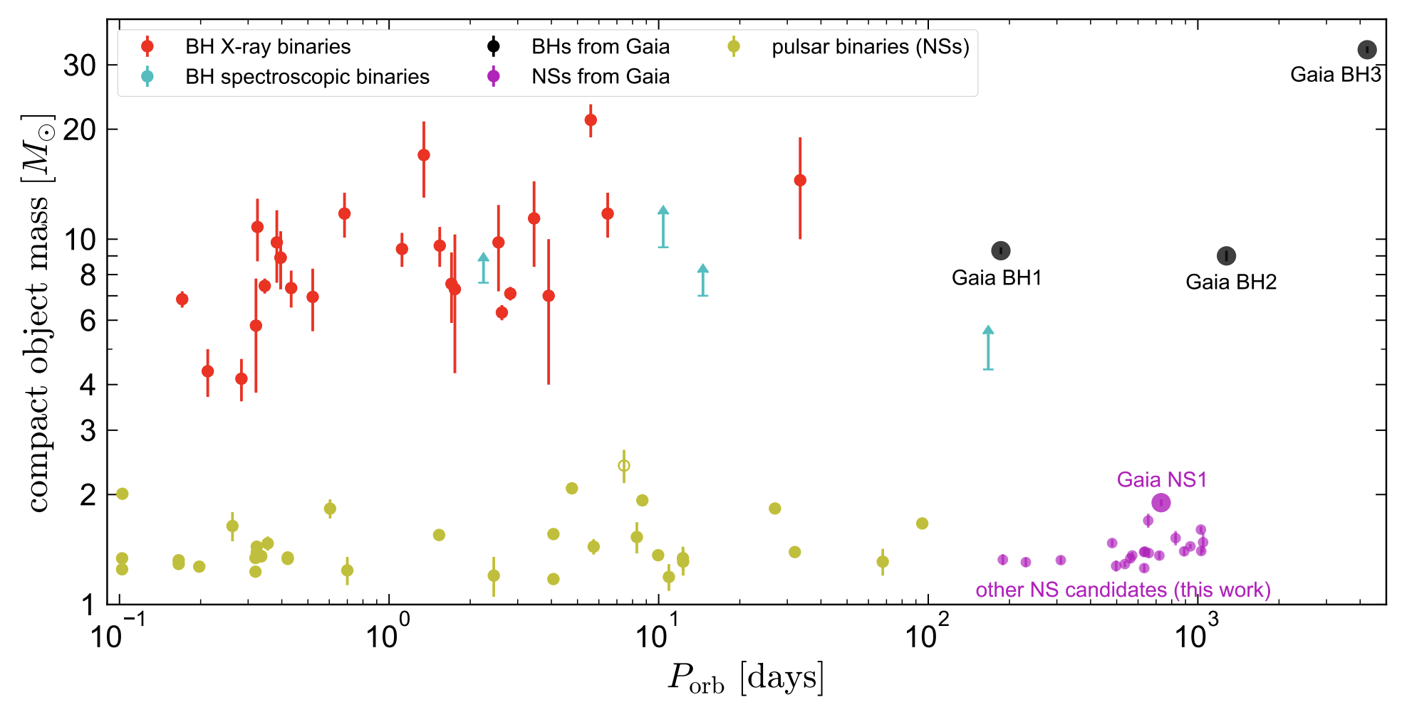
Figure 1. Masses and orbital period of Galactic BHs and NSs in binaries with well-constrained masses. The Gaia DR3 NSs candidates are shown in magenta and are compared to NSs in pulsar binaries (yellow), BHs in astrometric binaries (black), BHs in X-ray binaries (red), and BHs in spectroscopic binaries (cyan). A mass bimodality exists over at least 4 orders of magnitude in orbital period. Reproduced from El-Badry et al. (2024).

Project details
The analysis will be developed first on Gaia DR3 and known benchmark systems, then transferred to DR4 when the final archive products are available. The broader compact-object census may contain hundreds of WD binaries and a few tens each of NS and BH candidates, but the primary science sample will be the systems whose mass posterior overlaps the NS-BH transition.
- Build the astrometric mass-function sample. Select robust orbital and astrometric-spectroscopic solutions from the Gaia DR4 non-single-star tables. Correct the parallax zero point, propagate the full orbital covariance, and calculate f_{M},a for every system. Apply tests based on orbit significance, goodness of fit, phase and scan coverage, period aliases, duplicated sources, and variability-induced motion. The DR3 compact-companion samples and known Gaia BHs will provide validation cases.
- Add RVs and jointly fit the orbits. Assemble Gaia epoch RVS measurements and cross-match the targets with public surveys such as LAMOST, APOGEE, GALAH, and DESI. For high-priority candidates, assess whether targeted RV follow-up is feasible. Fit a single Keplerian model to the astrometric and RV data, sharing P, e, phase, and orientation. Compare fM,a with the inclination-corrected RV mass function and quantify how much the joint solution reduces each companion's mass uncertainty.
- Infer companion masses and select the gap sample. Determine M1 from Gaia photometry/XP spectra, stellar models, and survey spectroscopy, with particular care for giants and unresolved light. Combine the M1 posterior with the joint dynamical mass function to obtain p(M2) rather than a single best-fitting mass. Prioritise systems with substantial probability between the empirical upper NS boundary and lower BH boundary. Use AMRF and spectral-energy-distribution checks only to reject luminous single stars or main-sequence multiples that violate the dark-companion assumption.
- Determine what is inside the gap. For every candidate, compare four physical hypotheses: a massive NS, a low-mass BH, an unresolved WD-WD inner binary, and an unresolved NS-WD inner binary. Use the mass posterior, hierarchical stability, astrometric-RV consistency, Gaia XP and broadband spectral-energy distributions, GALEX ultraviolet flux, TESS/ZTF variability, spectral line searches, and radio/X-ray catalogues. Model the expected total-mass distributions of WD-WD and NS-WD binaries. A non-detection of ultraviolet light will not by itself exclude old, cool WDs. If an inner binary is sufficiently compact, its possible detectability by LISA can be explored as an extension.
- Characterise the gap and compare it with LIGO. Fit a hierarchical population model that includes NS and BH mass distributions, a suppressed gap component, WD-WD and NS-WD contaminants, individual mass uncertainties, and the Gaia/RV selection function. Measure the gap edges, depth, and occupancy, and test how the answer changes with orbital period, eccentricity, metallicity, and Galactic population. Compare these results with GWTC-4 and specific mass-gap events such as GW190814 and GW230529. Because Gaia and LIGO observe different evolutionary populations, compare distribution shapes and forward-modelled formation predictions rather than their raw object counts.
The main deliverables will be:
- a catalogue of robust f_{M}, measurements and, where RVs exist, joint dynamical mass posteriors.
- a ranked sample of Gaia DR4 systems in the NS-BH transition;
- posterior probabilities for the single-NS, single-BH, WD-WD, and NS-WD interpretations; and
- population constraints on the mass gap and a physically controlled comparison with LVK results.

Prerequisite Skills Required
- Basic Python programming and experience manipulating tabular data.
- A working knowledge of orbital mechanics and stellar or binary astrophysics at undergraduate level.
- Willingness to engage with Bayesian inference and measurement uncertainties; prior experience is useful but not essential.
- Relevant Part III courses include Astrostatistics, which provides useful foundations in Bayesian inference, hierarchical modelling, measurement-error models and model comparison; Structure and Evolution of Stars, which gives the physical background for white-dwarf, neutron-star and black-hole formation; and Planetary System Dynamics, whose treatment of Keplerian orbits, barycentric motion and three-body stability is directly applicable to astrometric binaries and possible hierarchical companions.

Other skills used in the project
The student will gain experience with Gaia archive queries (ADQL/TAP), RV extraction, joint Keplerian orbit fitting, catalogue cross-matching, stellar-mass inference, hierarchical Bayesian modelling, selection functions, and reproducible scientific software. TOPCAT may be useful for rapid catalogue inspection but is not mandatory.

Acceptable Programming Languages
Python.

Useful References (List of important papers/review articles relevant to the project)
- Andrews et al. (2019), 'Weighing the Darkness: Astrometric Mass Measurement of Hidden Stellar Companions using Gaia', ApJ, 886, 68.
https://arxiv.org/abs/1909.05606
- El-Badry et al. (2024), 'A population of neutron star candidates in wide orbits from Gaia astrometry'.
https://arxiv.org/abs/2405.00089
- Wang et al. (2024), 'A potential mass-gap black hole in a wide binary with a circular orbit', Nature Astronomy, 8.
https://arxiv.org/abs/2409.06352
- LIGO Scientific Collaboration, Virgo Collaboration & KAGRA Collaboration (2025), 'GWTC-4.0: Population Properties of Merging Compact Binaries'.
https://arxiv.org/abs/2508.18083
- LIGO Scientific Collaboration, Virgo Collaboration & KAGRA Collaboration (2024), 'Observation of Gravitational Waves from the Coalescence of a 2.5-4.5 solar-mass Compact Object and a Neutron Star'.
https://arxiv.org/abs/2404.04248
- Barr et al. (2024), 'A pulsar in a binary with a compact object in the mass gap between neutron stars and black holes', Science, 383, 275.
https://arxiv.org/abs/2401.09872

General References (List of papers referred to in the project)
- Gaia Collaboration et al. (2023), 'Gaia Data Release 3: Stellar multiplicity, a teaser for the hidden treasure', A&A, 674, A34.
https://www.aanda.org/articles/aa/full_html/2023/06/aa43782-22/aa43782-22.html
- LIGO Scientific Collaboration, Virgo Collaboration & KAGRA Collaboration (2026), 'GWTC-5.0: Population Properties of Merging Compact Binaries'.
https://arxiv.org/abs/2605.27226
- ESA/Gaia/DPAC, 'Gaia DR4 content' (expected archive tables and products).
https://www.cosmos.esa.int/web/gaia/dr4

